Mini Review

Molecular hydrogen may activate the transcription factor Nrf2 to alleviate oxidative stress through the hydrogen-targeted porphyrin

Shigeo Ohta^{a,b}
ª Department of Neurology Medicine, Juntendo University, Graduate School of Medicine, Tokyo, 113-8421, Japan,
^{b} Department of Cell Biology, Graduate School of Medicine, Nippon Medical University, Tokyo, 113-8602 Japan

Correspondence to: Prof./Dr. Shigeo Ohta, Department of Neurology Medicine, Juntendo University Graduate School of Medicine, 2-1-1 Hongo, Bunkyo-ku, Tokyo, 113-8421, Japan

E-mail: ohta@nms.ac.jp

Abstract
Oxidative stress is one of the major causes for most age-dependent neurodegenerative disorders. Neurons accumulate oxidative damage over time due to postmitotic cells. Thus, modulation of oxidative stress is essential to overcome these disorders. Molecular hydrogen (H₂) has great potential for treating various diseases and improving quality of life by exerting multiple functions including anti-oxidation, ant-inflammation, and energy metabolism promotion. Among these functions, H₂ activates a transcription factor, nuclear factor erythroid 2-related factor 2 (Nrf2) to transcribe antioxidant enzymes. There was an elusive contradiction between H₂ and Nrf2 because Nrf2 is activated in response to oxidative stress, whereas H₂ has a reductive potential against oxidative stress. The target molecule for H₂ has recently been identified as the oxidized form of Fe-porphyrin conjugated with the -OH group (PrP-Fe(III)-OH). As the initial step, the hydroxyl radical (•OH) oxidizes heme (PrP-Fe(II)) to form PrP-Fe(III)-OH. Then, H₂ reacts with PrP-Fe(III)-OH to produce PrP-Fe(III)-H and H₂O. In turn, Fe(III) with H can act as an electrophile to oxidize Kelch-like ECH-associated protein 1 (Keap1), resulting in activating Nrf2. Thus, •OH can indirectly activate Nrf2 to alleviate oxidative stress when the highly potent and harmful oxidative activity of •OH was buffered through H₂ and its target porphyrin. We propose that, instead of low doses, the relieved oxidative potent of •OH can serve as a hermetic-like to activated Nrf2.

Keywords: hematin, hydroxyl radical, molecular hydrogen, Nrf2, oxidative stress, porphyrin.

INTRODUCTION
Molecular hydrogen (dihydrogen; H₂) is an inert molecule in the absence of a catalyst. It has long been believed that H₂ has no biological function in mammalian cells because mammals lack the genes encoding hydrogenases that catalyze reactions involving H₂ [1, 2]. In 2007, we overturned this concept by publishing an article entitled “Hydrogen acts as a therapeutic antioxidant by selectively reducing cytotoxic oxygen radicals” [3]. This paper served as a trigger for the initiation of a new field of “hydrogen medicine and agriculture” [4, 5]. Subsequently, in addition to its antioxidant action, H₂ has been revealed to exert multiple functions such as anti-inflammatory, anti-allergic, anti-cell death, and metabolic stimulating effects by modulating various intracellular signal transductions [5, 6]. H₂ has no adverse effects, leading to extensive clinical studies for various diseases [5, 6]. In addition, H₂ not only improve patients with various diseases, but also support the quality-of-life（QOL） of healthy people in various fields such as healthcare, sports, and beauty [5]. In 2014, the US Food Drug Administration (FDA) approved H₂ as generally recognized as safe (GRAS), allowing hydrogen-infused water to be marketed as a drink. In 2016, H₂ gas inhalation therapy was approved by the Japanese government as an advanced treatment for post-cardiac arrest syndrome [7]. Furthermore, H₂ is beneficial not only to animals and humans, but also to higher plants. Therefore, H₂ can have a strong impact on agriculture [8].
However, the molecular mechanism by which H₂ exerts multiple functions remained unclear. In the current mini-review article, we discuss and propose a molecular mechanism by which H₂ with the hydrogen-targeted porphyrin activates the transcription factor, nuclear factor erythroid 2-related factor 2 (Nrf2) to alleviate oxidative stress, suggesting a hormesis-like effect.

H₂ selectively reacts with hydroxyl radicals in living cells.
Oxidative stress is derived by excessive generation of reactive oxygen species (ROS) such as superoxide anion radical (•O₂⁻), hydrogen peroxide (H₂O₂), nitric oxide (NO), and hydroxyl radical (•OH) [9-10]. As neurons are postmitotic cells, they accumulate oxidative damage over many years. However, ROS such as H₂O₂ and •O₂⁻ and NO play important physiological roles in signaling cascades and biological processes such as cell proliferation, differentiation, apoptosis, and immunomodulation [12-14], and thus, excessive antioxidant-intake is not beneficial and induces mortality as shown [15, 16].
Molecular hydrogen (H₂) selectively reduces highly toxic ROS, •OH and peroxynitrite (ONOO⁻), but neither •O₂⁻, H₂O₂, nor NO [3]. In cell culture experiments, H₂ decreased the fluorescence signal of 3'-p-(hydroxyphenyl)fluorescein (HPF) when oxidative stress induced by various ways [3]. HPF is an intracellular marker for •OH [17, 18]. Decrease in this fluorescent signal by H₂ was not only observed in cultured cells, but also in various tissues as shown in testicular radioprotection [19], hematopoietic stem cell damage by total body irradiation [20], and hyperoxia in cultured cells [21], lung hypoxia/reoxygenation [22], retinal ischemia-reperfusion [23], and retinal sonication [24].
H₂ can be infused into water (hydrogen water) up to a maximum of 0.8 mM at atmospheric pressure. After drinking H₂ water or inhaling H₂ gas, measuring the H₂ content revealed that H₂ is consumed in the human body [25, 26]. Deuterium gas (D₂) was used in rats as a metabolic tracer to monitor D₂ oxidation, indicating that molecular hydrogen is indeed oxidized in vivo [27].
Thus, H₂ was confirmed to decrease cellular •OH in a variety of ways across cell types and tissues although •OH is the most oxidative molecule to damage the cell components in a chaotic manner [10].
By the way, in homogeneous aqueous kinetics, the reaction rate of •OH with H₂ is much slower (the kinetic rate is 0.35 x 10⁻⁸ M⁻¹s-¹) than those with other antioxidants [28]. For example, •OH reacts with glucose and glutathione with kinetic rates (15 x 10⁻⁸ M⁻¹s⁻¹), and (230 x 10⁻⁸ M⁻¹s⁻¹), respectively [29]. The other biomolecules also react with •OH much faster than H₂. The contradiction between homogeneous aqueous solutions and living organisms has been debated for a long time.
Although H₂ cannot react with most molecules without a metal catalyst, effective amounts of metals such as Cu, Fe, Ni, and Pt are unlikely to be present in living cells. In addition, there is no report indicating the discovery of an organo-catalyst for H₂. Despite extensive world-wide researches, it was actually hard to discover a catalyst that facilitates the reaction of H₂ with •OH. An H₂-target molecule as described below has recently identified, providing a clue to explain the underlying contradiction of H₂.

Aging is associated with increased incidence of neurodegenerative diseases
Aging is associated with an increased incidence of neurodegenerative disorders. This is because neurons accumulate oxidative damage due to postmitotic cells over a long period of time [30]. Oxidative stress is one of the leading causes of most neurodegenerative disorders [31, 32]. A number of animal studies indicate that H₂-treatment is potentially applicable to alleviate neurodegenerative disorders and improving the quality of life in the elderly [33-37]. Thus, H₂ is expected to ameliorate aging-related neurodegeneration. In particular, overcoming Alzheimer's disease (AD) is one of the most important challenges in the world's aging society [38].
We have shown that drinking H₂ water reduces oxidative stress and ameliorated cognitive deficits in AD model mice [39]. Subsequently, a randomized, placebo-controlled, double-blind clinical trial was conducted in subjects with mild cognitive impairment (MCI), who drank H₂ water (approximately 300 mL per day; 0.6 mM) for 1 year [39]. A sub-analysis showed that subjects with the apolipoprotein E (APOE4) genotype, a well-known genetic factor for AD [40, 41], were significantly improved. Improvement was assessed by Alzheimer's Disease Assessment Scale-Cognitive Subscale (ADAS-cog), one of the most reliable ways to assess cognition [42, 43].
H₂ inhalation has been applied in several clinical areas [5, 7, 44-46]. The most important feature of H₂ gas inhalation therapy is that it is non-cytotoxic and safe for humans, as approved in phase I clinical trials [47].
A patient with severe Alzheimer's continued to inhale 3% hydrogen gas twice for one hour a day for two years. Diffusion tensor imaging (DTI) [48, 49] then visualized the activation of neurons of the patient, and urinary and fecal incontinence was improved [38]. This case report is of value even for a single case, as it is commonly understood that patients with severe AD are irreversible [38].

H₂ activates Nrf2 to function to reduce oxidative stress
Nrf2 transcribes the expression of several antioxidant enzymes to protect cells against oxidative stress [50, 51]. Nrf2 targets are the genes encoding NAD (P) H quinone oxidoreductase 1 (Nqo1), thioredoxin, reductase 1 (TXNRD1), heme oxygenase-1 (HO-1), glutathione S-transferase (GST), and so on [50-52]. Nrf2 is maintained in an inactive form in the cytosol when it forms a complex with the Kelch-like ECH-associated protein 1 (Keap1). Upon oxidation of the essential cysteine residues of Keap1 by electrophiles, Nrf2 is released from Keap1 and then translocated into the nucleus, enabling the transcriptions [50-52].
H₂ can induce the activity of Nrf2, as shown in many publications. In Nrf2 knockout mice, the effects of H₂ were at least partially attenuated, in protecting various cells and tissues in response to various stressors [21, 53]. These findings are consistent with subsequent publications that the Nrf2-activation is one of the antioxidant effects of H₂ [22, 54-65]. Therefore, it is concluded that activation of Nrf2 is involved in one of the H₂ functions.
As a molecular mechanism, it is unlikely that H₂ directly influences Nrf2. H₂ must indirectly activate Nrf2 through multiple steps. One idea was proposed that H₂ enhances mitochondrial respiratory activity to generate excess ROS, which in turn oxidizes intracellular Keap1 to release Nrf2 [66]. Alternatively, H₂ opens mitochondria-(ATP) K⁺ channels [67, 68] to induce ROS [69]. However, although there is no doubt that H₂ activates Nrf2, there is no direct evidence that mitochondria-derived ROS can oxidize the residues of cytosolic Keap1. Moreover, an elusive contradiction exists between Nrf2 activation and H₂; activation of Nrf2 requires Keap1 oxidation, whereas H₂ has a reductive potential.

Target discovery of hydrogen molecules
Professor Qianjun He's Shanghai and Shenzhen groups have recently published a paper in Nano Research entitled "Fe-porphyrins: redox-related biosensors of molecular hydrogen'" [70], showing that molecular target/biosensor for H₂ is the oxidized form of Fe-porphyrins (designate "hematin"). This paper has provided a discovery that addresses the fundamental questions about the mechanisms in which H₂ is involved.
Hematin is an oxidized form of Fe(III)-containing porphyrin (PrP) converted from Fe(II)-containing porphyrin (heme) [71, 72]. Prof. He and his coworkers discovered a novel reaction showing that H₂ replaces the hydroxy group (-OH) conjugated to hematin Fe(III) with the hydrogen group (-H). The atom H of this -H group should behave as a hydride (H⁻) and in fact, due to its high reactivity, •OH was rapidly converted to H₂O by this catalyst (Figure 1).
Thus, heme (PrP-Fe(II)) has been shown to act as a catalyst for the following reaction (Figure 1).
(1) PrP-Fe(II) + •OH → PrP-Fe(III)-OH
(2) PrP-Fe(III)-OH + H₂ → PrP-Fe(III)-H + H₂O
(3) PrP-Fe(III)-H + •OH → PrP-Fe(II) + H₂O
The overall equation (4) indicates that heme (PrP-Fe(II)) catalyzed the following reactions:
(4) 2 •OH + H₂ → 2H₂O
As noted above, the unresolved discrepancy between aqueous and live-cell reactions can be explained by the catalytic reaction according to the above equations (2) and (3).
At the same time, H₂ can reduce the oxidized porphyrin with Fe(III) to restore heme, the reduced form of Fe(II).

Proposal of a mechanism to elucidate the mechanism by which reducing H₂ activates Nrf2
Porphyrins are distributed everywhere inside and outside the living cells in the body. Heme is present in hemoglobin in the blood and myoglobin in muscles, and is responsible for delivering molecular oxygen (O₂) throughout the body [73]. Thus, heme is frequently exposed to O₂ or H₂O₂, and thus, Fe(II) of heme can frequently catalyze the formation of •OH by the Fenton reaction or its mimic reactions [74-76]. Porphyrins are located as cytochromes in the electron transport chain of the mitochondrial inner membrane, and play a role for electron-transport by converting Fe(II) to/from Fe(III) [77]. In the intracellular cytosol, the antioxidant enzymes such as catalase [78] and peroxidase [79], P450 [80] and nitric oxide (NO) synthase [81] have porphyrins as an essential component [82]. These porphyrins with Fe(II)/(III) act as mediators of redox reactions and are subjected to oxidative stress.
Hematin (PrP-Fe(III)-OH) is converted from hemin (PrP-Fe(III)-Cl) [83, 84]. We noted reports that hemin (PrP-Fe(III)-Cl) activate Nrf2 [85-87] (Figure 2). The Fe(III) of hemin probably functions as an electrophile, oxidizing the residues of Keap1 and activating Nrf2. The electronegativities of H and Cl are 2.2 and 3.16, respectively. Thus, Fe(III) containing H should be more electrophilic than Fe(III) containing Cl, and may be able to oxidize Keap1 more efficiently according to the equation of PrP-Fe(III)-H +e⁻ →PrP-Fe(II) + 1/2 H₂ (Figure 2).
As mentioned in the above equation (1) PrP-Fe(II) + •OH → PrP-Fe(III)-OH, hematin (PrP-Fe(III)-OH) was originally formed by oxidizing heme (PrP-Fe(II)) by •OH. •OH is the most oxidative molecule to damage biomolecules indiscriminately [10], but in the presence of H₂ and Fe-porphyrin, the potent activity of •OH can be buffered and contribute to activating Nrf2, resulting in reducing oxidative stress.
The current proposal needs to be examined in more details in the future, but it seems likely because it is based on published findings.
Hormesis is a term used by toxicologists to refer to a biphasic dose response to an environmental agent characterized by a low dose stimulation or beneficial effect and a high dose inhibitory or toxic effect [88] or defined as the paradoxical beneficial effects of low-dose stressors, which can be better defined as the biphasic dose-effect or time-effect relationship for any substance [89].
When •OH’s oxidative and harmful potent is relieved, although not at low doses, the oxidative role of •OH can contributing to activating Nrf2. We propose that the effect may be considered to be hormesis-like.

CONCLUSION
H₂ acts as a therapeutic antioxidant [3], and activates Nrf2, which transcribes antioxidant enzymes to reduce oxidative stress. There was an unresolved contradiction between H₂’s reductive property and Nrf2’s requirement of oxidative stress. The target molecule for H₂ has recently been identified as the oxidized form of Fe-porphyrin conjugated with the OH group (PrP-Fe(III)-OH) [70]. H₂ and the H₂-targeting porphyrin can buffer the highly oxidizing power of •OH. When the original •OH’s oxidative and harmful potent is relieved, although not at low doses, the resultant mild but significant potent may contribute to the activation of Nrf2 to reduce oxidative stress as a hormesis-like effect.

DECLARATIONS
Author’s contribution
The author contributed solely to the article.
Availability of data and materials
Not applicable.
Financial support and sponsorship
None.
Conflict of Interest
The author is the chairperson of H2 WATER JAPAN, Inc., Tokyo, Japan
Consent for publication
Not applicable

REFERENCES
1. Yagi T, Higuchi Y. Studies on hydrogenase. Proc Jpn Acad Ser B Phys Biol Sci, 2013, 89(1): 16-33.
2. Hansen M, Perner M. Hydrogenase Gene Distribution and H2 Consumption Ability within the Thiomicrospira Lineage. Front Microbiol, 2016, 7: 99.
3. Ohsawa I, Ishikawa M, Takahashi K, Watanabe M, Nishimaki K, Yamagata K, et al. Hydrogen acts as a therapeutic antioxidant by selectively reducing cytotoxic oxygen radicals. Nat Med, 2007;13(6):688-94.
4. Ohta S. Molecular hydrogen as a preventive and therapeutic medical gas: initiation, development and potential of hydrogen medicine. Pharmacol Ther, 2014, 144(1): 1-11.
5. Ohta S. Development of Hydrogen Medicine and Biology: Potential for Various Applications in Diverse Fields. Curr Pharm Des, 2021, 27(5): 583-584.
6. Nicolson GL, de Mattos GF, Settineri R, Costa C, Ellithorpe R, Rosenblatt S, et al. Clinical Effects of Hydrogen Administration: From Animal and Human Diseases to Exercise Medicine. International Journal of Clinical Medicine, 2016, 07(01): 32-76.
7. Katsumata Y, Sano F, Abe T, Tamura T, Fujisawa T, Shiraishi Y, et al. The Effects of Hydrogen Gas Inhalation on Adverse Left Ventricular Remodeling After Percutaneous Coronary Intervention for ST-Elevated Myocardial Infarction- First Pilot Study in Humans. Circ J, 2017, 81(7): 940-947.
8. Li C, Gong T, Bian B, Liao W. Roles of hydrogen gas in plants: a review. Funct Plant Biol, 2018, 45(8): 783-792.
9. Turrens JF. Mitochondrial formation of reactive oxygen species. J Physiol, 2003, 552(Pt 2): 335-344.
10. Lubec G. The hydroxyl radical: from chemistry to human disease. J Investig Med, 1996, 44(6): 324-346.
11. Josephson RA, Silverman HS, Lakatta EG, Stern MD, Zweier JL. Study of the mechanisms of hydrogen peroxide and hydroxyl free radical-induced cellular injury and calcium overload in cardiac myocytes. J Biol Chem, 1991, 266(4): 2354-2361.
12. Papa S, Skulachev VP. Reactive oxygen species, mitochondria, apoptosis and aging. Mol Cell Biochem, 1997, 174(1-2): 305-319.
13. Sauer H, Wartenberg M, Hescheler J. Reactive oxygen species as intracellular messengers during cell growth and differentiation. Cell Physiol Biochem, 2001, 11(4): 173-186.
14. Thomas DT, DelCimmuto NR, Flack KD, Stec DE, Hinds TD, Jr. Reactive Oxygen Species (ROS) and Antioxidants as Immunomodulators in Exercise: Implications for Heme Oxygenase and Bilirubin. Antioxidants (Basel), 2022, 11(2): 179.
15. Bjelakovic G, Nikolova D, Gluud LL, Simonetti RG, Gluud C. Mortality in randomized trials of antioxidant supplements for primary and secondary prevention: systematic review and meta-analysis. JAMA, 2007, 297(8): 842-857.
16. Hackam DG. Review: antioxidant supplements for primary and secondary prevention do not decrease mortality. ACP J Club, 2007, 147(1): 4.
17. Setsukinai K, Urano Y, Kakinuma K, Majima HJ, Nagano T. Development of novel fluorescence probes that can reliably detect reactive oxygen species and distinguish specific species. J Biol Chem, 2003, 278(5): 3170-3175.
18. Tomizawa S, Imai H, Tsukada S, Simizu T, Honda F, Nakamura M, et al. The detection and quantification of highly reactive oxygen species using the novel HPF fluorescence probe in a rat model of focal cerebral ischemia. Neurosci Res, 2005, 53(3): 304-313.
19. Chuai Y, Shen J, Qian L, Wang Y, Huang Y, Gao F, et al. Hydrogen-rich saline protects spermatogenesis and hematopoiesis in irradiated BALB/c mice. Med Sci Monit, 2012, 18(3): BR89-94.
20. Chuai Y, Qian L, Sun X, Cai J. Molecular hydrogen and radiation protection. Free Radic Res, 2012, 46(9): 1061-1067.
21. Yu J, Yu Q, Liu Y, Zhang R, Xue L. Hydrogen gas alleviates oxygen toxicity by reducing hydroxyl radical levels in PC12 cells. PLoS One, 2017, 12(3): e0173645.
22. Chen M, Zhang J, Chen Y, Qiu Y, Luo Z, Zhao S, et al. Hydrogen protects lung from hypoxia/re-oxygenation injury by reducing hydroxyl radical production and inhibiting inflammatory responses. Sci Rep, 2018, 8(1): 8004.
23. Oharazawa H, Igarashi T, Yokota T, Fujii H, Suzuki H, Machide M, et al. Protection of the retina by rapid diffusion of hydrogen: administration of hydrogen-loaded eye drops in retinal ischemia-reperfusion injury. Invest Ophthalmol Vis Sci, 2010, 51(1): 487-492.
24. Igarashi T, Ohsawa I, Kobayashi M, Igarashi T, Suzuki H, Iketani M, et al. Hydrogen prevents corneal endothelial damage in phacoemulsification cataract surgery. Sci Rep, 2016, 6: 31190.
25. Shimouchi A, Nose K, Shirai M, Kondo T. Estimation of molecular hydrogen consumption in the human whole body after the ingestion of hydrogen-rich water. Adv Exp Med Biol, 2012, 737: 245-250.
26. Shimouchi A, Nose K, Mizukami T, Che DC, Shirai M. Molecular hydrogen consumption in the human body during the inhalation of hydrogen gas. Adv Exp Med Biol, 2013, 789: 315-321.
27. Hyspler R, Ticha A, Schierbeek H, Galkin A, Zadak Z. The Evaluation and Quantitation of Dihydrogen Metabolism Using Deuterium Isotope in Rats. PLoS One 2015, 10(6): e0130687.
28. Buxton GV, Greenstock, C.L., Helman, W.P., Ross, A.B. . Critical review of rate constants for reactions of hydrated electrons, hydrogen atoms and hydroxyl radicals (⋅OH/⋅O−) in aqueous solution. J Phys Chem Ref Data, 1988, 17(2): 513-886.
29. Wood KC, Gladwin MT. The hydrogen highway to reperfusion therapy. Nat Med, 2007, 13(6): 673-674.
30. Espinos C, Galindo MI, Garcia-Gimeno MA, Ibanez-Cabellos JS, Martinez-Rubio D, Millan JM, et al. Oxidative Stress, a Crossroad Between Rare Diseases and Neurodegeneration. Antioxidants (Basel), 2020, 9(4): 313.
31. Federico A, Cardaioli E, Da Pozzo P, Formichi P, Gallus GN, Radi E. Mitochondria, oxidative stress and neurodegeneration. J Neurol Sci, 2012, 322(1-2): 254-262.
32. Chalke SD, Kale PP. Combinational Approaches Targeting Neurodegeneration, Oxidative Stress, and Inflammation in the Treatment of Diabetic Retinopathy. Curr Drug Targets, 2021, 22(16): 1810-1824.
33. Nagata K, Nakashima-Kamimura N, Mikami T, Ohsawa I, Ohta S. Consumption of molecular hydrogen prevents the stress-induced impairments in hippocampus-dependent learning tasks during chronic physical restraint in mice. Neuropsychopharmacology, 2009, 34(2): 501-508.
34. Li J, Wang C, Zhang JH, Cai JM, Cao YP, Sun XJ. Hydrogen-rich saline improves memory function in a rat model of amyloid-beta-induced Alzheimer's disease by reduction of oxidative stress. Brain Res. 2010, 1328: 152-161.
35. Tan X, Shen F, Dong WL, Yang Y, Chen G. The role of hydrogen in Alzheimer's disease. Med Gas Res, 2018, 8(4): 176-180.
36. Zheng ZG, Sun WZ, Hu JY, Jie ZJ, Xu JF, Cao J, et al. Hydrogen/oxygen therapy for the treatment of an acute exacerbation of chronic obstructive pulmonary disease: results of a multicenter, randomized, double-blind, parallel-group controlled trial. Respir Res, 2021, 22(1): 149.
37. Lin YT, Shi QQ, Zhang L, Yue CP, He ZJ, Li XX, et al. Hydrogen-rich water ameliorates neuropathological impairments in a mouse model of Alzheimer's disease through reducing neuroinflammation and modulating intestinal microbiota. Neural Regen Res, 2022, 17(2): 409-417.
38. Ono H, Nishijima Y, Sakamoto M, Kitamura S, Naitoh Y, Suzuki K, et al. Long-Term Inhalation of Hydrogen Gas for Patients with Advanced Alzheimer's Disease: A Case Report Showing Improvement in Fecal Incontinence. Med Res Arch, 2022, 10(7).
39. Nishimaki K, Asada T, Ohsawa I, Nakajima E, Ikejima C, Yokota T, et al. Effects of Molecular Hydrogen Assessed by an Animal Model and a Randomized Clinical Study on Mild Cognitive Impairment. Curr Alzheimer Res, 2018, 15(5): 482-492.
40. Bookheimer S, Burggren A. APOE-4 genotype and neurophysiological vulnerability to Alzheimer's and cognitive aging. Annu Rev Clin Psychol, 2009, 5: 343-362.
41. Uddin MS, Kabir MT, Al Mamun A, Abdel-Daim MM, Barreto GE, Ashraf GM. APOE and Alzheimer's Disease: Evidence Mounts that Targeting APOE4 may Combat Alzheimer's Pathogenesis. Mol Neurobiol, 2019, 56(4): 2450-2465.

42. Grossberg GT, Schmitt FA, Meng X, Tekin S, Olin J. Reviews: Effects of transdermal rivastigmine on ADAS-cog items in mild-to-moderate Alzheimer's disease. Am J Alzheimers Dis Other Demen, 2010, 25(8): 627-633.

43. Kueper JK, Speechley M, Montero-Odasso M. The Alzheimer's Disease Assessment Scale-Cognitive Subscale (ADAS-Cog): Modifications and Responsiveness in Pre-Dementia Populations. A Narrative Review. J Alzheimers Dis, 2018, 63(2): 423-444.
44. Ono H, Nishijima Y, Ohta S, Sakamoto M, Kinone K, Horikosi T, et al. Hydrogen Gas Inhalation Treatment in Acute Cerebral Infarction: A Randomized Controlled Clinical Study on Safety and Neuroprotection. J Stroke Cerebrovasc Dis, 2017, 26(11): 2587-2594.
45. Botek M, Krejci J, Valenta M, McKune A, Sladeckova B, Konecny P, et al. Molecular Hydrogen Positively Affects Physical and Respiratory Function in Acute Post-COVID-19 Patients: A New Perspective in Rehabilitation. Int J Environ Res Public Health, 2022, 19(4): 1992.
46. Pluta R, Januszewski S, Czuczwar SJ. Molecular Hydrogen Neuroprotection in Post-Ischemic Neurodegeneration in the Form of Alzheimer's Disease Proteinopathy: Underlying Mechanisms and Potential for Clinical Implementation-Fantasy or Reality? Int J Mol Sci, 2022, 23(12): 4405.
47. Cole AR, Sperotto F, DiNardo JA, Carlisle S, Rivkin MJ, Sleeper LA, et al. Safety of Prolonged Inhalation of Hydrogen Gas in Air in Healthy Adults. Crit Care Explor, 2021, 3(10): e543.
48. Toniolo S, Serra L, Olivito G, Caltagirone C, Mercuri NB, Marra C, et al. Cerebellar White Matter Disruption in Alzheimer's Disease Patients: A Diffusion Tensor Imaging Study. J Alzheimers Dis. 2020, 74(2): 615-624.
49. Torso M, Bozzali M, Zamboni G, Jenkinson M, Chance SA, Alzheimers Disease Neuroimage I. Detection of Alzheimer's Disease using cortical diffusion tensor imaging. Hum Brain Mapp, 2021, 42(4): 967-977.
50. Ma Q. Role of nrf2 in oxidative stress and toxicity. Annu Rev Pharmacol Toxicol, 2013, 53: 401-426.
51. Bellezza I, Giambanco I, Minelli A, Donato R. Nrf2-Keap1 signaling in oxidative and reductive stress. Biochim Biophys Acta Mol Cell Res, 2018, 1865(5): 721-733.
52. Robledinos-Anton N, Fernandez-Gines R, Manda G, Cuadrado A. Activators and Inhibitors of NRF2: A Review of Their Potential for Clinical Development. Oxid Med Cell Longev, 2019, 2019: 9372182.
53. Kawamura T, Wakabayashi N, Shigemura N, Huang CS, Masutani K, Tanaka Y, et al. Hydrogen gas reduces hyperoxic lung injury via the Nrf2 pathway in vivo. Am J Physiol Lung Cell Mol Physiol, 2013, 304(10): L646-656.
54. Zhai X, Chen X, Shi J, Shi D, Ye Z, Liu W, et al. Lactulose ameliorates cerebral ischemia-reperfusion injury in rats by inducing hydrogen by activating Nrf2 expression. Free Radic Biol Med, 2013, 65: 731-741.
55. Chen H, Xie K, Han H, Li Y, Liu L, Yang T, et al. Molecular hydrogen protects mice against polymicrobial sepsis by ameliorating endothelial dysfunction via an Nrf2/HO-1 signaling pathway. Int Immunopharmacol, 2015, 28(1): 643-654.
56. Yu J, Zhang W, Zhang R, Jiang G, Tang H, Ruan X, et al. Molecular hydrogen attenuates hypoxia/reoxygenation injury of intrahepatic cholangiocytes by activating Nrf2 expression. Toxicol Lett, 2015, 238(3): 11-19.
57. Tamaki N, Orihuela-Campos RC, Fukui M, Ito HO. Hydrogen-Rich Water Intake Accelerates Oral Palatal Wound Healing via Activation of the Nrf2/Antioxidant Defense Pathways in a Rat Model. Oxid Med Cell Longev, 2016, 2016: 5679040.
58. Diao M, Zhang S, Wu L, Huan L, Huang F, Cui Y, et al. Hydrogen Gas Inhalation Attenuates Seawater Instillation-Induced Acute Lung Injury via the Nrf2 Pathway in Rabbits. Inflammation, 2016, 39(6): 2029-2039.
59. Liu Y, Dong F, Guo R, Zhang Y, Qu X, Wu X, et al. Hydrogen-Rich Saline Ameliorates Experimental Autoimmune Encephalomyelitis in C57BL/6 Mice Via the Nrf2-ARE Signaling Pathway. Inflammation, 2019, 42(2): 586-597.
60. Yu Y, Yang Y, Yang M, Wang C, Xie K, Yu Y. Hydrogen gas reduces HMGB1 release in lung tissues of septic mice in an Nrf2/HO-1-dependent pathway. Int Immunopharmacol, 2019, 69: 11-18.
61. Lu Y, Li CF, Ping NN, Sun YY, Wang Z, Zhao GX, et al. Hydrogen-rich water alleviates cyclosporine A-induced nephrotoxicity via the Keap1/Nrf2 signaling pathway. J Biochem Mol Toxicol, 2020, 34(5): e22467.
62. Xie K, Zhang Y, Wang Y, Meng X, Wang Y, Yu Y, et al. Hydrogen attenuates sepsis-associated encephalopathy by NRF2 mediated NLRP3 pathway inactivation. Inflamm Res, 2020, 69(7): 697-710.
63. Yu Y, Feng J, Lian N, Yang M, Xie K, Wang G, et al. Hydrogen gas alleviates blood-brain barrier impairment and cognitive dysfunction of septic mice in an Nrf2-dependent pathway. Int Immunopharmacol, 2020, 85: 106585.
64. Hu Y, Wang P, Han K. Hydrogen Attenuated Inflammation Response and Oxidative in Hypoxic Ischemic Encephalopathy via Nrf2 Mediated the Inhibition of NLRP3 and NF-kappaB. Neuroscience, 2022, 485: 23-36.
65. Peng J, He Q, Li S, Liu T, Zhang J. Hydrogen-Rich Water Mitigates LPS-Induced Chronic Intestinal Inflammatory Response in Rats via Nrf-2 and NF-kappaB Signaling Pathways. Vet Sci. 2022, 9(11): 621.
66. Murakami Y, Ito M, Ohsawa I. Molecular hydrogen protects against oxidative stress-induced SH-SY5Y neuroblastoma cell death through the process of mitohormesis. PLoS One, 2017, 12(5): e0176992.
67. Yoshida A, Asanuma H, Sasaki H, Sanada S, Yamazaki S, Asano Y, et al. H(2) mediates cardioprotection via involvements of K(ATP) channels and permeability transition pores of mitochondria in dogs. Cardiovasc Drugs Ther, 2012, 26(3): 217-226.
68. Jiao Y, Yu Y, Li B, Gu X, Xie K, Wang G, et al. Protective effects of hydrogenrich saline against experimental diabetic peripheral neuropathy via activation of the mitochondrial ATPsensitive potassium channel channels in rats. Mol Med Rep, 2020, 21(1): 282-290.
69. Andrukhiv A, Costa AD, West IC, Garlid KD. Opening mitoKATP increases superoxide generation from complex I of the electron transport chain. Am J Physiol Heart Circ Physiol, 2006, 291(5): H2067-2074.
70. Jin Z, Zhao P, Gong W, Ding W, He Q. Fe-porphyrin: A redox-related biosensor of hydrogen molecule. Nano Research, 2022,
71. Green D, Ts'ao CH. Hematin: effects on hemostasis. J Lab Clin Med, 1990, 115(2): 144-147.
72. Siegert SW, Holt RJ. Physicochemical properties, pharmacokinetics, and pharmacodynamics of intravenous hematin: a literature review. Adv Ther. 2008, 25(9): 842-857.
73. Gunsalus IC, Sligar SG, Nordlund T, Frauenfelder H. Oxygen sensing heme proteins: monoxygenases, myoglobin and hemoglobin. Adv Exp Med Bio,. 1977, 78: 37-50.
74. Nagababu E, Rifkind JM. Heme degradation by reactive oxygen species. Antioxid Redox Signal, 2004, 6(6): 967-978.
75. Liu Y, Zhao Y, Wang J. Fenton/Fenton-like processes with in-situ production of hydrogen peroxide/hydroxyl radical for degradation of emerging contaminants: Advances and prospects. J Hazard Mater. 2021, 404(Pt B): 124191.
76. Liochev SL. The role of iron-sulfur clusters in in vivo hydroxyl radical production. Free Radic Res, 1996, 25(5): 369-384.
77. Piel RB, 3rd, Dailey HA, Jr., Medlock AE. The mitochondrial heme metabolon: Insights into the complex(ity) of heme synthesis and distribution. Mol Genet Metab, 2019, 128(3): 198-203.
78. Umezawa N, Matsumoto N, Iwama S, Kato N, Higuchi T. Facile synthesis of peptide-porphyrin conjugates: Towards artificial catalase. Bioorg Med Chem, 2010, 18(17): 6340-6350.
79. Damos FS, Sotomayor Mdel P, Kubota LT, Tanaka SM, Tanaka AA. Iron(III) tetra-(N-methyl-4-pyridyl)-porphyrin as a biomimetic catalyst of horseradish peroxidase on the electrode surface: an amperometric sensor for phenolic compound determinations. Analyst, 2003, 128(3): 255-259.
80. Watanabe Y. Alternatives to the oxoferryl porphyrin cation radical as the proposed reactive intermediate of cytochrome P450: two-electron oxidized Fe(III) porphyrin derivatives. J Biol Inorg Chem, 2001, 6(8): 846-856.
81. Pfeiffer S, Schrammel A, Koesling D, Schmidt K, Mayer B. Molecular actions of a Mn(III)Porphyrin superoxide dismutase mimetic and peroxynitrite scavenger: reaction with nitric oxide and direct inhibition of NO synthase and soluble guanylyl cyclase. Mol Pharmacol, 1998, 53(4): 795-800.
82. Di Venosa G, Batlle A, Fukuda H, Macrobert A, Casas A. Distribution of 5-aminolevulinic acid derivatives and induced porphyrin kinetics in mice tissues. Cancer Chemother Pharmacol, 2006, 58(4): 478-486.
83. Bohle DS, Helms JB. Synthesis of beta-hematin by dehydrohalogenation of hemin. Biochem Biophys Res Commun, 1993, 193(2): 504-508.
84. Grenoble DC, Drickamer HG. The effect of pressure on the oxidation state of iron. 3. Hemin and hematin. Proc Natl Acad Sci U S A, 1968, 61(4): 1177-1182.
85. Kim YC, Masutani H, Yamaguchi Y, Itoh K, Yamamoto M, Yodoi J. Hemin-induced activation of the thioredoxin gene by Nrf2. A differential regulation of the antioxidant responsive element by a switch of its binding factors. J Biol Chem, 2001, 276(21): 18399-18406.
86. Nagai T, Kikuchi S, Ohmine K, Miyoshi T, Nakamura M, Kondo T, et al. Hemin reduces cellular sensitivity to imatinib and anthracyclins via Nrf2. J Cell Biochem. 2008, 104(2) :680-691.
87. Georgiou-Siafis SK, Tsiftsoglou AS. Activation of KEAP1/NRF2 stress signaling involved in the molecular basis of hemin-induced cytotoxicity in human pro-erythroid K562 cells. Biochem Pharmacol, 2020, 175: 113900.
88. Matson MP. Hormesis defined. Ageing Res Rev, 2008, 7(1): 1-7.
89. Li X, Yang T, Sun Z. Hormesis in Health and Chronic Diseases. Trends Endocrinol Metab, 2019, 30(12): 944-958.

Figure legends

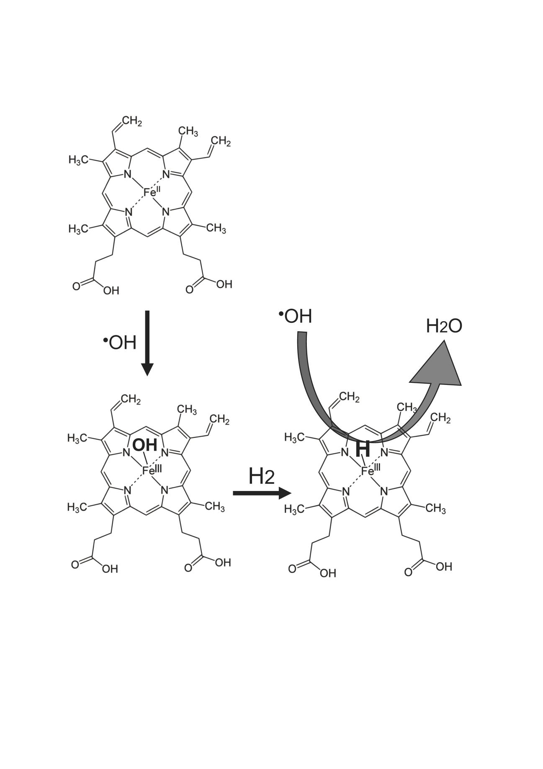
Figure 1. Fe-porphyrin catalyzes the reaction of H2 with the hydroxyl radical.
(Equation 1) PrP-Fe(II) + •OH → PrP-Fe(III)-OH
(Equation 2) PrP-Fe(III)-OH + H₂ → PrP-Fe(III)-H + H₂O
(Equation 3) PrP-Fe(III)-H + •OH → PrP-Fe(II) + H₂O
The formal name of Hematin PrP-Fe(III)-OH is ferriprotoporphyrin IX hydroxide.

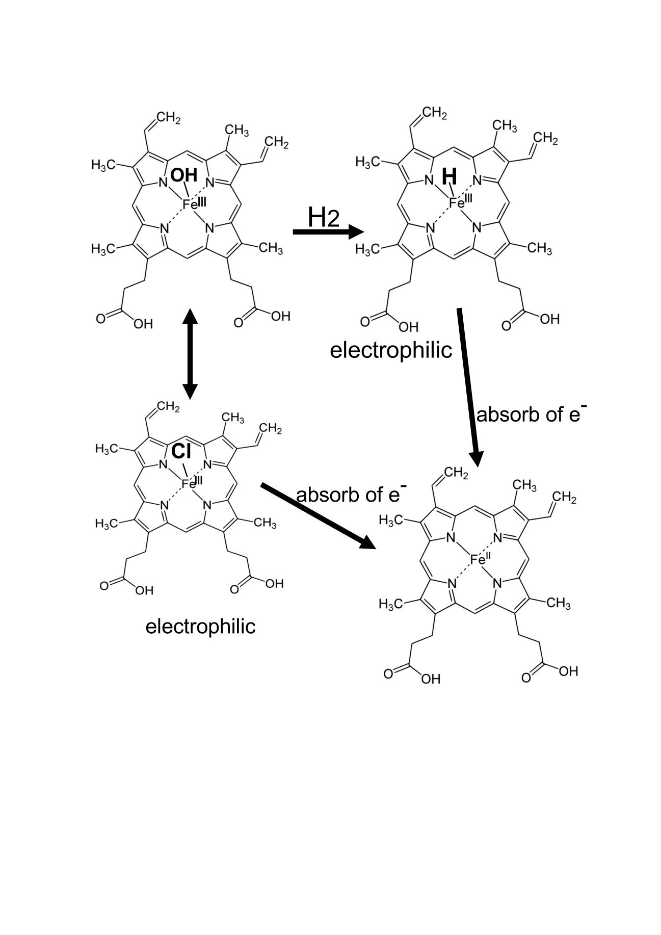
Figure 2. Fe(III) in hydride hematin can serve as an electrophile to oxidize the residues of Keap1.
Hematin and hemin can mutually be converted, and hemin is known to activate Nrf2 by oxidizing Keap1. Fe(III) of hemin is electrophilic to activate Nrf2. Fe(III)-H may be more electrophilic than Fe(III)-Cl to efficiently oxidize Keap1, resulting in activating Nrf2.
The formal name of Hemin PrP-Fe(III) is ferriprotoporphyrin IX chloride.

