Lichen planus

Running title: Lichen planus

Abstract:
Oral lichen planus is the chronic inflammatory lesion in oral mucous membrane that is under the attack by immune cells. The causes may include chronic medication, metal denture friction, stress and emotional disturbance. The condition manifests similarly to the swelling and irritation with slight desquamation of the membrane and when observed under dermoscopy, there is the Wickham striae. Another common benign condition of skin hyperplasia is lichenoid keratosis (LK), which involves erythematous rash in the trunk or upper limbs, where friction is the culprit in play. Although the two aforementioned conditions may occur separately, there are occasional reports of simultaneous sighting of two to three lesions in the skin.

Key-words: Lichen planus; Oral lichen planus (OLP); Precancerous lesions; Lichen planus-like keratosis.

Introduction:
Text

Lichen planus is a relatively rare skin disorder, affecting approximately 0.5 to 2% of the population. The estimated pooled prevalence of oral lichen planus (OLP) was 0.89% among the general population and 0.98% among clinical patients. It is a superficial, non-contagious and chronic inflammatory skin disease that usually involves with papules or scales and is commonly seen in oral mucosa or genital [1]. Oral lichen planus requires routine follow-up every 3 to 6 months to avoid progression to cancer. Oral lichen planus is a chronic inflammatory disease of unknown etiology with significant impact on patients' quality of life. Malignant transformation into oral squamous cell carcinoma is the most serious complications of the OLP [2]. The reported rate of OLP malignant transformation varied between 0 and 10%. Currently, the first-line treatment is the topical application of steroid ointment, or oral administration of immunosuppressants and antibiotics [3]. Generally, lichen planus is autoimmune, which implies an attack on autologous tissues by Th1 cells and females are more prone to the condition than males. Moreover, the disease is accompanied with other autoimmune conditions [3]. The possible inducing factors include infection, allergy, stress, etc. [3] Oral lichen planus, which occurs in oral cavity, will present reticular, dendritic, papular or plaque-like lesions, usually at more than two locations [4,5]. Also, other conditions that resemble lichen planus include Bowen's disease, inflammatory lentigo, and solar keratosis. Thus, in clinical practice, pathological evaluation is required for definitive diagnosis. The lesions of lichen planus are around 3 to 7 cm in diameter and have a variety of colors, but mostly pink or reddish brown. The lesions may be smooth, scaly or verrucous in appearance (figure 1 and figure 2). Although skin manifestations may recede, other symptoms may last for years and recur in places like mouth, buccal mucosa, tongue, gums, etc. [6] Despite the finding of correlation with immune disorders, infection, environmental factors and genetics, the etiology of lichen planus remains elusive.

Pathophysiology of Lichen Planus

The dermoscopic features of lichen planus vary by stages, dependent of its growth in progression. Lesions of lichen planus are typically reddish brown with either focal or diffuse brown-gray granular pattern. Since oral lichen planus affects the mucous membrane, patient will usually develop ulcers. Factors may include stress, postmenopausal imbalance in both men and women, chronic liver diseases, oral cancer, etc. [7]. OLP pathogenesis suggest the presence of Th17 cells and the up‐regulation of interleukin‐17 (IL‐17) expression are crucial events. An important role of IL‐17 in OLP by systematically investigating the overexpression of IL‐17 in the lesional tissue and blood from OLP patients and healthy controls [8]. The basic pathophysiology is the degeneration of pre-existing epidermal lesions, further aggravated by chronic inflammatory response to T-cell rejection of the overlying epidermal growth [8]. Although the trigger of the inflammatory response is not yet known, epidermal growth is recognized as the precursor lesion to lichenoid planus, including solar liver spots and seborrheic keratosis. Large cell acanthoma and viral wart are also in close resemblance of lichen planus, such that melanoma in situ with a lichenoid regression pattern may histologically resemble lichen planus [9,10]. In fact, any lichenoid patterns are thought to be mimic lichen planus and these will include lichenoid keratosis, dermatitis lupus, mycosis fungoides, and others [11]. Therefore, a thorough clinical history will be crucial, as histological evaluation alone cannot definitively differentiate keratinization from lichen planus, that sometimes may require skin biopsy. However, the diagnosis of lichen planus does not require serological tests, gene sequencing or imaging [12]. Lichenoid keratosis occurs in adults, usually starting at age 40 and climax at age 50 and 60. For unknown reason, lichen planus is three times more common in females than in males, and the incidence rate increases even more in Caucasian population [13].

Clinical Symptoms and Diagnosis of Lichen Planus

The typical manifestation of lichen planus is the purplish red rash on the skin, which may lead to pigmentation of skin after the rash recedes. The patient may experience itching and blisters, while sometimes, the condition may involve nails, which will become brittle and fragmented or even fall off [14]. When occurring in the scalp, it will destroy the hair follicles and cause hair loss. The histopathological examination reveals large amount of leukocyte infiltration, which is the similar event seen in lichen planus at other locations. There are also apoptotic keratinocytes, epidermal acanthosis, granule hyperplasia, and hyperkeratosis in the epidermis [15]. Some histological features that can be used to distinguish lichenoid keratosis from lichen planus include parakeratosis and infiltration of eosinophils and plasma cells [14]. All of these findings can be seen in conjunction with adjacent lentiginous epidermal lesions. To finalize clinical diagnosis, it is necessary to perform a skin biopsy, and once confirmed, it is crucial to advise the patient that it is benign. While biopsy may also remove the lesion at the same time, there are other methods to do so after the sampling [7,16]. The easiest method is cryotherapy using liquid nitrogen, along with curettage of tissues afterward. If multiple lesions are observed, the diagnosis of lichen planus must be reconsidered, especially if they are distributed in flexures, mucosa and nails, because lichen planus does not affect the nail bed or mucosa. It is likely that other lichenoid conditions are at the play, as they are also known to histologically mimic lichen planus. For example, cutaneous lupus is also known to be frequently misinterpreted as lichen planus. To help with the differentiation, lichen planus is reported by some literatures to have a mycosis fungoides-like pattern. And to diagnose more accurately, it is necessary to further incorporate clinical history with the pathological examination to distinguish other diseases, such as lichenoid keratosis, which is known: 1) to relate to epithelial changes; 2) to relate to changes in melanocytes; and 3) as the differential diagnosis to lichen planus, drug eruption, cutaneous lupus, and fungal granulation [17-20].

Classification of Oral Lichen Planus and Cutaneous Lichen Planus

1.Hypertrophic lichen planus: It is prone to occur in lower legs. The lesion surface is rough and causes strong itching. It is often referred to as lumpy or nodular prurigo. The course of the disease is extremely long and can last for years. It will also leave a distinct pigmentation on the skin [21].

2.Solar/Actinic lichen planus (a.k.a. lichen planus subtropicus): It is more likely to occur in young people in the Middle East and Asia and has similar symptom of dark spot at sun-exposed part of the skin [21].

3.Follicular lichen planus (lichen planopilaris): It often appears on the scalp and shows as pinhole-sized keratotic papules around the bald area. There may be some peripheral skin lesions or rash, too [21].

4.Pigmented lichen planus (lichen planus subtropicus): It is more common in the people of darker skin color but without itching [21].

5.Ulcerative lichen planus: This is the chronic occurrence of painful ulcers on the feet, which may lead to difficulty in walking and standing, as toenails may even fall off [21].

Treatment of Lichen Planus

Once confirmed of the clinical diagnosis, there are two main approaches to management and several methods to remove the lesions if the biopsy has not yet done so. Currently, the first-line treatment is the topical application of steroid ointment, or oral administration of immunosuppressants cyclosporine, antibiotics, antifungal drugs, vitamin A acid, or photochemotherapy. The other best and easiest method is cryotherapy using liquid nitrogen[14] and surgical curettage to remove tissues may also follow, if necessary, based on clinical and dermoscopic examination afterward. If the lesions persist, a biopsy must be performed in follow-up to further verify the diagnosis. The most common symptoms in patients with lichen planus are pruritus, and mild tenderness or irritation, which can be treated with topical corticosteroids, starting with 2.5% hydrocortisone butyrate ointment, twice a day, or 0.1% steroid ointment, twice a day [22]. Although the rash can be relieved by the ointment, drugs, such as antihistamine, must be added. However, antihistamine does not help with the symptom of mild tenderness. Oral lichen planus is currently incurable, but the main purpose of treatment is to control and relieve symptoms. The primary medication is steroid oral cream. Patient must be scheduled for routine dental follow-up [23-25].

Conclusion

Lichen planus has a variety of manifestations, including polygonal, pruritic, planar papules or plaques and may present heterogeneous papular-squamous eruptions with diverse morphological appearances but consistent histological phenotype. Oral lichen planus is the chronic inflammation of oral mucosa. It is thought to be related to the autoimmune response of T cells. It is more common in females (male:female ratio is 1:4). The incidence rate is about 0.5 to 2%. Oral lichen planus differs from lichenoid keratosis by the presence of lesions in mucosa, since patients with lichenoid keratosis, beside not having any mucosal lesions, experience no nail or hair follicle problem. Lichenoid keratosis is also rare in occurrence. Lichen planus almost always involves multiple areas, such as genital and oral cavity, as well as hair follicles and nails. The typical rash is polygonal, flat-topped, and shiny, with red and purplish papules [26,27]. Reticular leukoplakia can be observed in the oral cavity and other mucous membranes. The incidence rate is about 1% and common among population of 30 to 60-year-old. Women are prone to the condition more than men. There is a unique distinction, that is the presence of white melon-like stripes called Wickham striae on the glossy polygonal flat papules, making it easy to identify. The disease will usually recede within months or years and thus, its treatment primarily focuses on alleviating symptoms by using corticosteroids, immunosuppressants, and antihistamines. Also, light therapy may also help to relieve symptoms. About 30 to 70% cases of skin lichen planus have mucosal lesions and there are also those who have no rash but only mucosal changes. As for oral lichen planus, it occurs in the buccal mucosa and tongue. Reticular leukoplakia is also common, especially in the buccal mucosa. Most importantly, patient may develop erosions or ulcers, which are painful [28,29]. Currently, there is no effective treatment for lichen planus, as their focus is on symptoms. Topical corticosteroids are the most common medication, which is applied to local lesions and wrapped to keep the drug in place. For extensive lesions, oral medication may be required, including antifungal drugs, immunosuppressant cyclosporine, and vitamin A acid for 6 weeks. Photochemotherapy (PUVA) may also be used. These treatments vary by effect from person to person.

References:
1.Boyd AS, Neldner KH. Lichen planus. Journal of the American Academy of Dermatology 1991; 25: 593-619.
2.Giuliani M, Troiano G, Cordaro M, Corsalini M, Gioco G, Lo Muzio L, et al. Rate of malignant transformation of oral lichen planus: A systematic review. Oral diseases 2019, 25(3), 693-709.
3.Katta R. Lichen planus. American family physician 2000; 61: 3319-24.
4.Sugerman P, Savage NW, Walsh LJ, Zhao ZZ, Zhou XJ, Khan A, et al. The pathogenesis of oral lichen planus. Critical Reviews in Oral Biology & Medicine 2002; 13: 350-65.
5.Mollaoglu N. Oral lichen planus: a review. British Journal of oral and maxillofacial surgery 2000; 38: 370-7.
6.Sachdeva S, Sachdeva S, Kapoor P. Wickham striae: etiopathogenensis and clinical significance. Indian Journal of Dermatology 2011; 56(4): 442.
7.Usatine R, Tinitigan M. Diagnosis and treatment of lichen planus. American family physician 2011; 84: 53-60.
8.Husein‐ElAhmed H, Steinhoff M. Potential role of INTERLEUKIN‐17 in the pathogenesis of oral lichen planus: a systematic review with META‐analysis. Journal of the European Academy of Dermatology and Venereology 2022; 36(10): 1735-44.
9.Bhattacharya M, Kaur I, Kumar B. Lichen planus: a clinical and epidemiological study. The Journal of dermatology 2000; 27: 576-82.
10.Bugatti L, Filosa G. Dermoscopy of lichen planus‐like keratosis: a model of inflammatory regression. Journal of the European Academy of Dermatology and Venereology 2007; 21: 1392-7.
11.Miteva M, Ziemer M. Lichenoid keratosis-a clinicopathological entity with Lupus erythematosus-like features? Journal of Cutaneous Pathology 2007; 34: 209-10.
12.Sugerman P, Savage NW, Walsh LJ, Zhao ZZ, Zhou XJ, Khan A, et al. The pathogenesis of oral lichen planus. Critical Reviews in Oral Biology & Medicine 2002; 13: 350-65.
13.Eisen D, Carrozzo M, Bagan Sebastian JV, Thongprasom K. Number V Oral lichen planus: clinical features and management. Oral diseases 2005; 11: 338-49.
14.El‐Howati A, Thornhill MH, Colley HE, Murdoch C. Immune mechanisms in oral lichen planus. Oral Diseases 2022.
15.Sharma A, Białynicki-Birula R, Schwartz RA, Janniger CK. Lichen planus: an update and review. Cutis 2012; 90: 17-23.
16.Wagner G, Rose C, Sachse MM. Clinical variants of lichen planus. JDDG: Journal der Deutschen Dermatologischen Gesellschaft 2013; 11: 309-19.
17.Alrashdan MS, Cirillo N, McCullough M. Oral lichen planus: a literature review and update. Archives of dermatological research 2016; 308: 539-51.
18.Thongprasom K, Dhanuthai K. Steriods in the treatment of lichen planus: a review. Journal of oral science 2008; 50: 377-85.
19.Roopashree MR, Gondhalekar RV, Shashikanth MC, George J, Thippeswamy SH, Shukla A. Pathogenesis of oral lichen planus–a review. Journal of Oral Pathology & Medicine 2010; 39: 729-34.
20.Mai S, Mansouri S, Hassam B. Annular atrophic lichen planus. BMJ Case Reports 2019; 12: 1.
21.Olson MA, Rogers III RS, Bruce AJ. Oral lichen planus. Clinics in dermatology 2016; 34: 495-504.
22.Sugerman PB, Sabage NW. Oral lichen planus: causes, diagnosis and management. Australian dental journal 2002; 47: 290-7.
23.Edwards PC, Kelsch R. Oral lichen planus: clinical presentation and management. Journal de l’Association dentaire Canadienne 2002: 1-6.
24.Cai X, Zhang J, Zhang H, Li T. Overestimated risk of transformation in oral lichen planus. Oral Oncology 2022; 133: 106025.
25.Olson MA, Rogers III RS, Bruce AJ. Oral lichen planus. Clinics in dermatology 2016; 34: 495-504.
26.Carrozzo M, Thorpe R. Oral lichen planus: a review. Minerva stomatologica 2009; 58: 519-37.
27.Lavanya N, Jayanthi P, Rao UK, Ranganathan K. Oral lichen planus: An update on pathogenesis and treatment. Journal of oral and maxillofacial pathology: JOMFP 2011; 15: 127.
28.Husein‐ElAhmed H, Steinhoff M. Potential role of INTERLEUKIN‐17 in the pathogenesis of oral lichen planus: a systematic review with META‐analysis. Journal of the European Academy of Dermatology and Venereology 2022; 36(10): 1735-1744.
29.Usatine R, Tinitigan M. Diagnosis and treatment of lichen planus. American family physician 2011; 84(1): 53-60.

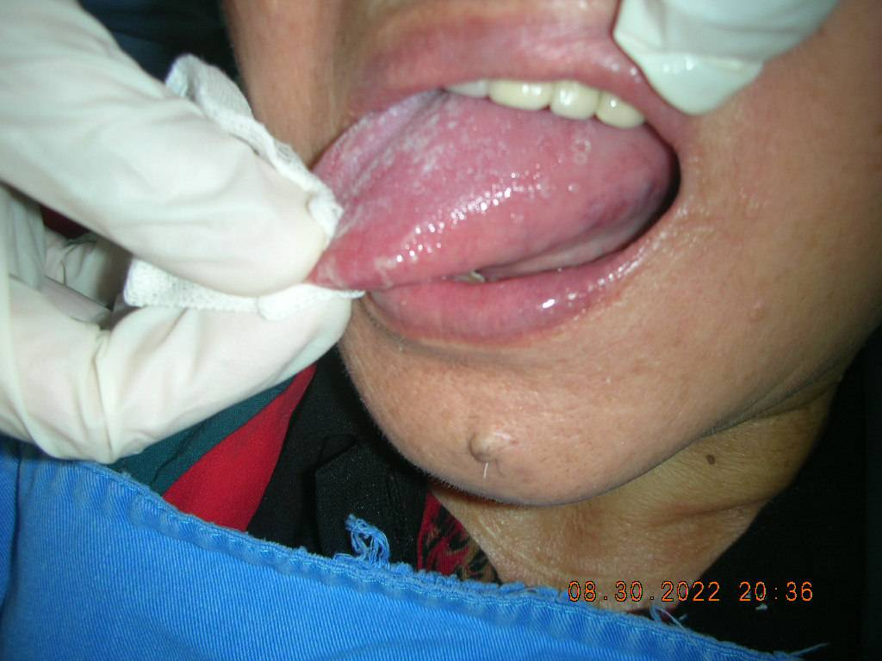
Figure 1. Lichen planus on the tongue. The lesions of lichen planus have a variety of colors, but mostly pink or reddish brown. The lesions may be smooth, scaly or verrucous in appearance.
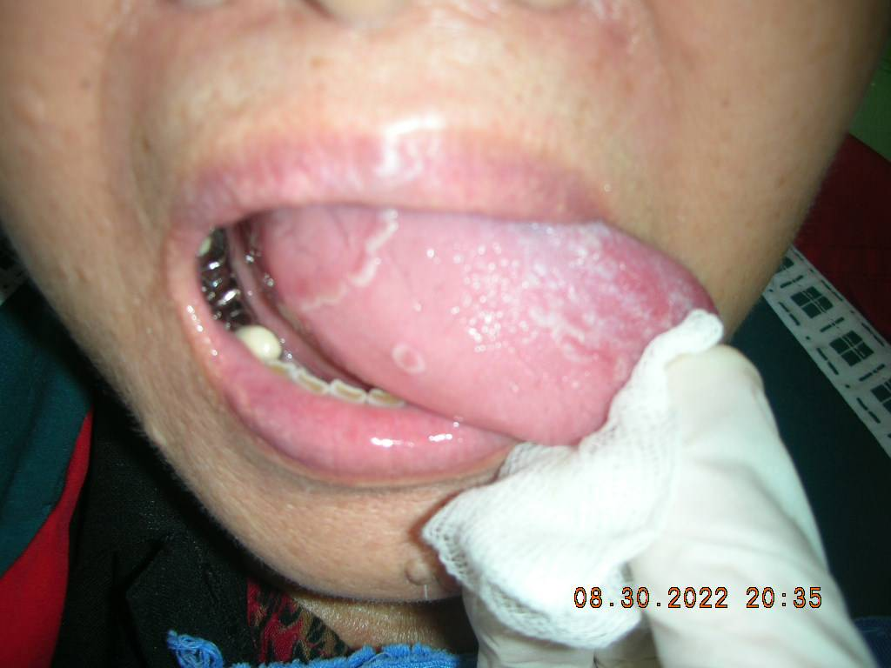
Figure 2. Lichen planus on the tongue. The lesions of lichen planus are around 3 to 7 cm in diameter and have a variety of colors, but mostly pink or reddish brown. The lesions may be smooth, scaly or verrucous in appearance.

Acknowledgement:

