Mini Review

Role of fibro-adipogenic progenitors in skeletal muscle aging
Renwen Wan¹, Hanli Zhang¹, Shan Liu², Chunmeng Jiao³, Hui Chen⁴, Zhiwen Luo^{1*}, Xiliang Shang^{1*}
¹ Department of Sports Medicine, Huashan Hospital, Fudan University, Shanghai 200040, China
² Department of Endocrinology, Huashan Hospital, Fudan University, Shanghai 200040, China
³ Guangdong Pharmaceutical University, Guangdong, China
⁴ Department of Integrative Medicine and Neurobiology, School of Basic Medical Sciences, Shanghai Medical College, Institute of Acupuncture Research, Institutes of Integrative Medicine, Fudan University, Shanghai 200040, China

* Corresponding author:
Xiliang Shang, Ph.D.,
Senior doctor, Department of Sports Medicine, Huashan Hospital, Fudan University, Shanghai 200040, China
Email: sxl00720@163.com
Zhiwen Luo, M.D.,
Department of Sports Medicine, Huashan Hospital, Fudan University, Shanghai 200040, China
Email: zhiwen.luo_fudan@hotmail.com

Abstract
Maintaining muscle mass is of paramount importance from a clinical perspective, as it supports the flexibility, strength, and essential everyday tasks that the body needs. Furthermore, muscle plays a role in regulating the body's metabolic system. Unfortunately, aging can lead to a decrease in muscle mass, which can reduce personal independence and quality of life, while increasing the risk of developing diseases. Fibro-adipogenic progenitor cells (FAPs) are a subset of muscle progenitor cells that are essential for the maintenance of skeletal muscle fiber size and muscle regeneration. These vital FAP functions are accomplished by a complex secretome that interacts in a paracrine manner to promote the division and differentiation of muscle satellite cells. Dysregulated differentiation of FAPs can cause fibrosis, fatty infiltration, muscle atrophy, and poor muscle regeneration. In this article, we review what is currently known about how FAPs work in aging muscles and how they can prevent the onset of muscular wasting and degeneration. Finally, we discuss how FAPs represent a population of cells that can be used as therapeutic targets to improve the health of skeletal and muscle tissues as they age.

Keywords aging, fibro-adipogenic progenitors, skeletal muscle, muscle regeneration

Introduction
Aging is now a major issue for the global population, and the rate of aging is accelerating(1). One of the hallmark characteristics of aging is a progressive decline in skeletal muscle mass and muscular strength which leads to increased incidence of injury, deconditioning and even loss of independence and quality of life(2). In addition, decreased muscle regeneration, increased fibrosis, and adipose infiltrations were also associated with age(3). Aging also leads to an imbalance in muscle homeostasis, and skeletal muscle homeostasis is maintained by a balance of physical and functional interactions of different cell types in the muscle ecotone(4-7). Due to these reasons, there is great interest in understanding the regulation and mechanisms of the degeneration of muscle so that effective therapeutic strategies can be developed.
Indeed, multiple cell types are involved in maintaining mass and homeostasis of skeletal muscle, including fibro-adipogenic progenitor cells (FAPs), tenocytes, endothelial cells, smooth muscle cells, immune cells (B cells, T cells, macrophages, neutrophils), neural or glial cells(8, 9). When skeletal muscle homeostasis is disrupted, the muscle environment also triggers dynamic changes in the composition of cell types and functional interactions between these cells(10, 11). Over the past decade, FAPs have been recognized as important regulators of muscle homeostasis and regeneration in healthy muscle, but also in acutely injured skeletal muscle and pathologically degenerated muscle. FAPs were first described in 2010, as a population of mesenchymal stem cells that exist in muscle and proliferate in response to muscle injury(12, 13). FAPs exhibit injury context-dependent pluripotent behavior and can differentiate into pro-fibrotic fibroblasts and white adipose tissue in the presence of prolonged inflammatory signals in injured muscle(11, 14). Furthermore, crosstalk between FAPs and other cells in the muscle stem cells (MuSCs) ecotone plays a critical role in restoring and maintaining muscle structure and function(15-18). Due to the importance of FAPs in the regenerative and degenerative muscle environment, balancing the activity of FAPs is essential to promote effective muscle regeneration without inducing chronic muscle degeneration.
Here, we provide an overview of current knowledge on the role of FAPs on muscle aging and the characterization of FAPs in aging muscle. We also discuss the plasticity and behavior of FAPs in the tissue microenvironment. Finally, we highlight the therapeutic opportunities of FAPs in regenerating aging muscle.

Contribution and mechanism of FAPs in aging
Aging is characterized by declining multiple physiological functions. The regenerative potential of muscle decreases with age and the progressive decrease in skeletal muscle mass is also known as sarcopenia(19). Age-related sarcopenia constitutes an important health problem, leading to impaired regeneration, impaired adaptive response to exercise training, and disrupted metabolic regulation(20). Meanwhile, degeneration and atrophy of aging muscles are associated with increased fibrosis, fatty infiltration, and low-grade chronic inflammation(21). In human and mouse muscles, FAPs are thought to be the cellular origin of fibrosis and adipogenesis leading to chronic inflammation and muscle loss(22, 23). Liu et al. found significant co-localization of FAPs with adipocyte markers using PDGFRα-GFP reporter mice(24). Jensen et al. also found similar co-localization when differentiating FAPs into adipocytes and fibroblasts in vitro(16). These studies are consistent in strongly suggesting that FAPs are an important mediator of the infiltration of adipose tissue and fibrosis in muscle. The exact mechanisms that allow FAPs to gravitate toward lipogenesis and fibrogenesis are currently unknown but may include alterations in local signaling, gene expression, and stem cell epigenetics, as well as the presence of baseline differences in subpopulations of FAPs. For example, Moratal et al. found that aging leads to changes in the ecological niche in which FAPs are exposed, creating a more favorable environment for FAPs fibrillation or adipogenic differentiation(5).
One of the characteristics of aging muscle is increased fibrotic tissue. Several studies have shown that as muscle ages, the activity of FAPs is impaired, and the number of FAPs and their ability to proliferate decreases, while the tendency for fibrotic differentiation increases(25, 26). Mueller et al. found that aging puts FAPs into a fibrotic state(27), Several intrinsic cellular defects have been shown to contribute to the perturbed activity of aging FAPs. A reduction in the truncated variant of the PDGFRα, which acts as a decoy receptor to inhibit the PDGF signaling pathway, has been observed in aged FAPs(26). In addition, the environment of aging stem cells is known to be more inflammatory than that of young cells(28). Inflammatory factors such as elevated levels of IL-6, IL-8, IL-1β, TNF-α, and NF-κβ are known to characterize the aging stem cell environment(29). These cytokines have been shown to have a significant effect on fibrosis in FAPs (Figure 1). For example, the presence of higher levels of the pro-fibrotic factor TGF-β during the aging process(30).And the TGFβ signaling pathway, a known stimulator of fibrosis in FAPs, is upregulated in injured muscle, with macrophages being identified as the main source of TGFβ(31-33). In the case of rotator cuff injuries, aging is associated with an increase in fibrosis(34). An increase in fibrosis is also due to an increase in the level of myostatin(35). Dong et al. have shown that myostatin causes increased proliferation and fibrotic differentiation of FAPs through the up-regulation of P-Smad2/Smad3(36).
As skeletal muscle atrophies, the amount of fat in the muscle increases, a process called myosteatosis. This process is another characteristic of muscle aging. Due to their adipogenic potential, FAPs play a central role in muscle steatosis. Adipogenic differentiation pathways in FAPs are stimulated by both injury and glucocorticoid treatment. For example, Itoigawa et al. found increased levels of the fatty markers PPARγ and CEBPα in a model of rotator cuff tear in rats(37). The correlation between increased number of FAPs and fatty infiltration with larger tear size suggests that different tear conditions may induce epigenetic changes in FAPs, thereby altering their proliferation and differentiation behavior(38). Furthermore, one study found that conditioned medium from myogenic cells isolated from young individuals increased FAPs proliferation and inhibited adipogenic differentiation, whereas conditioned medium from myogenic cells isolated from aged donors failed to improve FAPs proliferation and prevented adipogenic differentiation(5).
The effect of aging on FAPs is also associated with the presence of comorbidities. For example, the incidence of type 2 diabetes increases dramatically as people get older. The study by Mogi et al. showed that ectopic fatty deposition in regenerated muscle from diabetic mice was derived from FAPs(39). Insulin resistance in type 2 diabetes leads to overproduction of this hypoglycemic hormone, which is a known inducer of adipogenic differentiation of FAPs in vitro(17). A recent study found that enhanced conversion of a subset of FAPs to CD90⁺ FAPs is related to degenerative remodeling of the extracellular matrix in the skeletal muscles of type 2 diabetes patients. CD90⁺ FAPs exhibit a PDGF-mimetic phenotype with significant clonogenicity, proliferative activity, and extracellular matrix synthesis(22). Obesity is also common in the elderly. Obesity severely impairs muscle contractility and leads to progressive expansion of adipose tissue and collagen deposition during high fat intake, which may be due to increased number and proliferation of FAPs in chronically obese patients(40).
Lukjanenko et al. showed that aging impairs the function of mouse FAPs(26). Notably, they describe the inability of aging FAPs to support MuSCs due to reduced secretion of the stromal cell protein WNT1-inducible signaling pathway protein 1 (WISP1)(26). WISP1 plays an important role in the asymmetric division of muscle stem cells and the regeneration of muscle. Cellular transplantation of young FAPs into old mice restores the muscle stem cells' commitment to myogenesis, supporting the role of FAPs in the dysfunction of myogenesis during aging(26) (Figure 1). Meanwhile, lower levels of GDF10 are also expressed in aging FAPs. Uezumi et al. found that in vitro addition of conditioned medium from transgenic FAPs overexpressing GDF10 induced myotubular hypertrophy to a greater extent than conditioned medium from wildtype or GDF10 knockout FAPs, and that administration of GDF10 to aged mice reversed muscle mass loss and myofiber atrophy(25) (Figure 1). Muscle regeneration is also hampered by FAPs' ineffective production of paracrine substances. FAPs are the main source of IL-33, a cytokine linked to type 2 immunity, in monocytes; however, as we age, we produce less of this cytokine, which results in less Treg accumulation and subpar muscle regeneration(41) (Figure 1).
These findings strongly imply that aging-related alterations have an impact on FAPs' ability to provide homeostasis. In order to prevent muscle aging and sarcopenia, modulation of FAPs-derived cues has excellent therapeutic promise.
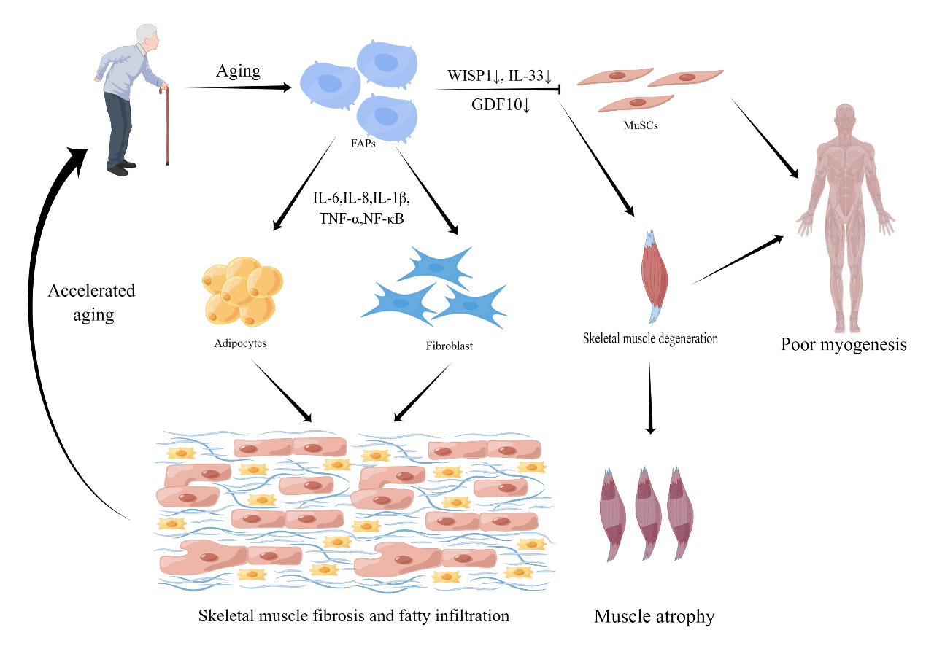
Figure 1. Contribution and mechanism of FAPs in aging

Potential therapeutic role of FAPs in aging
FAPs activity and number regulation may have an impact on how much fibrosis and adipose infiltration occur following muscle aging because FAPs have the ability to develop into fibroblasts and adipocytes. Numerous studies have actually examined this theory. Lemos et al. discovered that whereas the use of nilotinib, a tyrosine kinase inhibitor targeting the TGF signaling pathway, increased FAP apoptosis and consequently decreased fibrosis, blocking TNF signaling prevented the apoptosis of FAPs, resulting in a doubling of FAPs and a twofold increase in fibrosis after muscle injury(31). Imatinib, a related small molecule inhibitor that inhibits PDGFR alpha signaling and has been shown in studies to increase grip strength in mice with dystrophic limbs, significantly reduced muscle fibrosis(32). In the rotator cuff muscle, the small molecule inhibitor CWHM-12 has been demonstrated to drastically diminish FAPs-induced fibrosis in vitro tests(16). Even though it seems like lowering the overall amount and activity of FAPs may lessen their downstream pathologies, pharmacologically removing FAPs from muscle tissue runs the danger of muting whatever helpful impact they may have (Figure 2). The earliest benefits of FAPs in muscle regeneration have been demonstrated(13, 29). However, the detrimental impacts of its later development into fibroblasts and adipocytes may counteract these early advantageous benefits. This would indicate that a better strategy than just eliminating them would be to alter their behavior in order to get a more useful phenotype. This would preserve and enhance their original positive roles.
Lukjanenko et al. found that in vivo treatment with recombinant WISP1 improved muscle architecture and myofiber cross-sectional area, increased the proportion of newly formed myofibers, and increased the early proliferation of aged MuSCs and the commitment of Pax7+/MyoD+ MuSCs in aged muscles subjected to acute injury(26). As a result, systemic treatment of WISP1 improves the diminished ability of the aging muscle to regenerate, indicating that FAP-secreted molecules may be used as potential therapies to improve the endogenous ability of muscle regeneration (Figure 2). Mozzetta et al. demonstrated that aging inhibits the FAPs-stimulated production of MuSC-derived multinucleated myotubes by co-culture experiments between MuSCs and FAPs. The co-transplantation of FAPs increased the engraftment ability of MuSCs as well as muscle regeneration in aged mice, which the scientists also confirmed in vivo(42). The authors hypothesized that Follistatin from FAPs mediates their pro-myogenic actions on MuSCs, which are strengthened by histone deacetylase inhibitors (HDACi) therapy(42) (Figure 2). The production and transport of extracellular vesicles carrying miRNA by FAPs may be a mechanism by which HDACi-mediated pro-regenerative muscle actions enhance MuSCs regeneration(43).
The most recent research also focuses on FAPs' capacity to differentiate into a more advantageous adipose phenotype to investigate how to encourage muscle regeneration while reducing adipose infiltration and fibrosis. Through the production of uncoupled protein 1 (UCP-1), which prevents cellular respiration, brown fat can generate heat. In this respect, beige fat is comparable to brown fat and can also express UCP-1, but it comes from the same place as white adipose tissue(44, 45). There is growing evidence that, in addition to their fundamental thermogenic activity, the more metabolically active brown and beige adipose tissues also have a pro-myogenic role(29, 46, 47). Meyer et al. demonstrated that beige fat between rotator cuff muscles increased myotube formation in co-culture experiments with myogenic progenitor cells. Based on this, successful efforts have been made, such as those by Lee et al., to encourage the differentiation of FAPs to the beige adipose phenotype. The prevalence of fibrosis, fat infiltration, atrophy, and gait impairment in mice with deteriorated supraspinatus muscles was considerably reduced by transplanting beige adipose differentiated from FAPs obtained from UCP-1 reporter mice(48, 49). Additional in vitro studies have recently demonstrated that Amibegron-treated human rotator cuff FAPs tend to differentiate toward a beige fat phenotype(38). Future studies could focus on grafting methods and pharmaceutical strategies to boost the conversion of rotator cuff FAPs to a beige fat phenotype. These studies could clarify whether the approaches under this hypothesis lessen fat infiltration and fibrosis in the muscle and promote myokine secretion to aid in muscle regeneration (Figure 2).
Overall, aging-related intrinsic and extrinsic alterations have an impact on how FAPs are regulated, which in turn encourages the buildup of fibrotic tissue and hinders muscle regeneration. To assess the potential of therapeutic molecules that target FAPs to revive aged skeletal muscle, more research is required.
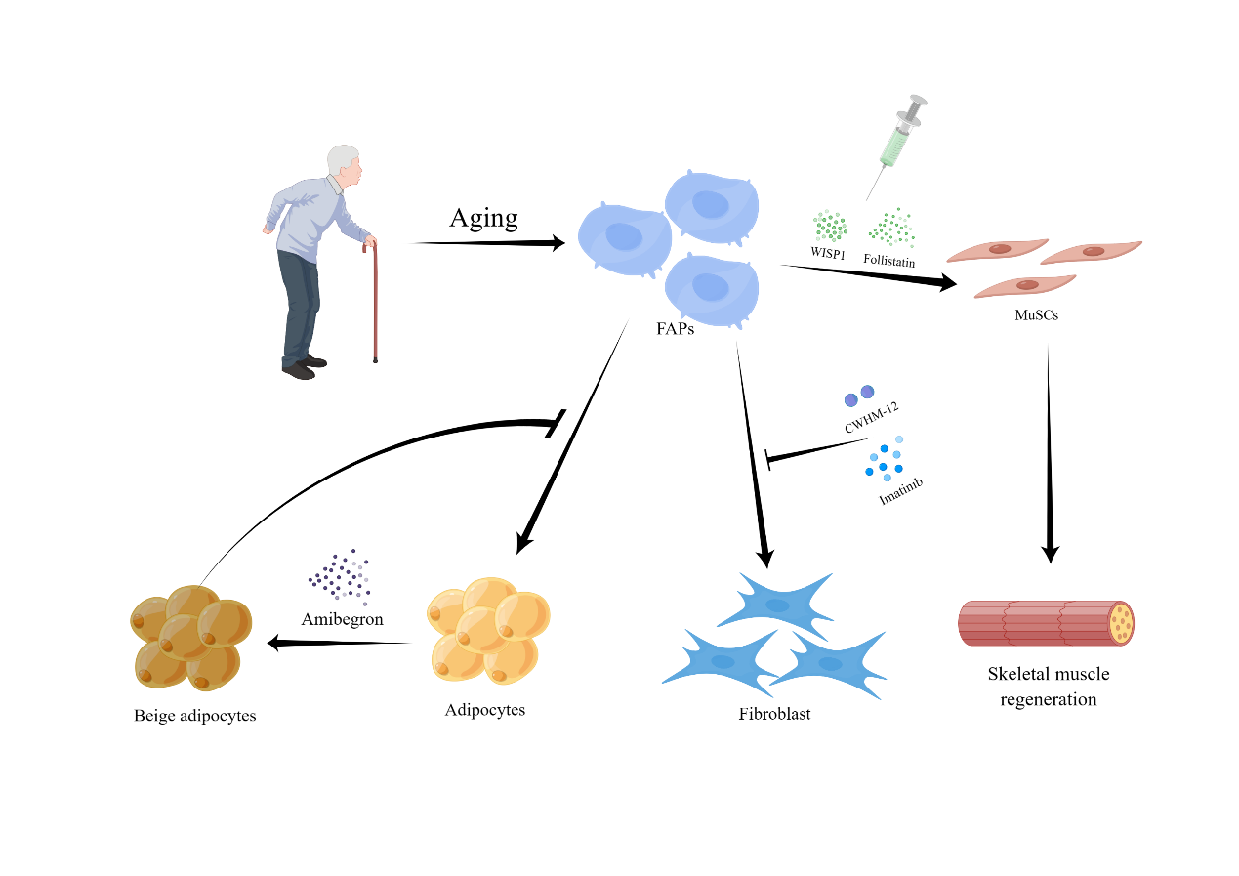
Figure 2. Potential therapeutic role of FAPs in aging

Conclusion and future directions
For skeletal muscle to remain healthy, it is crucial to comprehend the mechanisms underlying tissue regeneration and degeneration caused by cellular senescence. The numerous functions of skeletal muscle cell senescence in muscle regeneration and degeneration are being increasingly supported by research. In this review, we discuss the fundamental relationships between FAPs and aging as well as how FAPs affect the aging-related degeneration and regeneration of muscle. The regulatory function of FAPs in preserving muscle growth and function serves as an example of recent developments in our understanding of these proteins. The current data unambiguously shows that FAPs play a crucial role in skeletal muscle homeostasis regulation. Their capacity for differentiation directly determines whether or not impacts on muscle synthesis and regeneration are positive or unfavorable, and these effects are carefully controlled by signaling molecules in the ecotone of muscle stem cells.
Skeletal muscle research will develop with a better understanding of the connection between FAPs and the pathophysiology and physiology of muscle aging. However, there are still a few problems that need to be resolved. First, the phenotypes and functions of FAPs spatiotemporally controlled during the aging and degeneration of skeletal muscle still unknown; Second, what is the role of FAPs in controlling the initiation and development of muscle senescence degeneration; Third, the effect of FAPs and muscle stem cells interacting on muscle and tissue integrity; and how immune cells and FAPs interact to maintain homeostasis; To lessen or prevent fibrosis, fat infiltration, and the degenerative aging of muscles, it may be possible to use muscle-resident FAPs or their subpopulations as therapeutic targets. By addressing these problems, therapeutic strategies that target FAPs cells in aging skeletal muscle will be developed.
In conclusion, there is no question that anti-aging therapies, such as cell-based therapies, drug-based therapies, and combinations of these therapies, can help patients with chronic inflammatory muscle disorders and age-related muscle dysfunction. Moreover, while FAPs cells remain mostly unknown, a fuller knowledge of the intricate role of muscle aging with FAPs is essential for the creation of really effective targeted therapeutics for aging.

Funding
This work was supported by the National Natural Science Foundation of China (Grant No. 81972125 and 82172510).

Authors’ contributions
The authors contributed equally to the article.

Conflicts of Interest
The authors have declared that no conflicts interest exists.

Reference
1. Hsu W, Yang FC. Factors Associated with Home Health Aides' Turnover Intention and Organizational Citizenship Behavior in Long-Term Care Services. Healthcare (Basel). 2022;10(9). Epub 2022/09/24. doi: 10.3390/healthcare10091743. PubMed PMID: 36141356; PubMed Central PMCID: PMCPMC9498852.
2. Bao Z, Cui C, Chow SK, Qin L, Wong RMY, Cheung WH. AChRs Degeneration at NMJ in Aging-Associated Sarcopenia-A Systematic Review. Front Aging Neurosci. 2020;12:597811. Epub 2020/12/29. doi: 10.3389/fnagi.2020.597811. PubMed PMID: 33362532; PubMed Central PMCID: PMCPMC7759742.
3. Spehar K, Pan A, Beerman I. Restoring aged stem cell functionality: Current progress and future directions. Stem Cells. 2020;38(9):1060-77. Epub 2020/05/31. doi: 10.1002/stem.3234. PubMed PMID: 32473067; PubMed Central PMCID: PMCPMC7483369.
4. Cordani N, Pisa V, Pozzi L, Sciorati C, Clementi E. Nitric oxide controls fat deposition in dystrophic skeletal muscle by regulating fibro-adipogenic precursor differentiation. Stem Cells. 2014;32(4):874-85. Epub 2013/10/31. doi: 10.1002/stem.1587. PubMed PMID: 24170326.
5. Moratal C, Arrighi N, Dechesne CA, Dani C. Control of Muscle Fibro-Adipogenic Progenitors by Myogenic Lineage is Altered in Aging and Duchenne Muscular Dystrophy. Cell Physiol Biochem. 2019;53(6):1029-45. Epub 2019/12/23. doi: 10.33594/000000196. PubMed PMID: 31865646.
6. Wang Y, Yang Z, Yang L, Zou Q, Zhao S, Hu N, et al. Liuweidihuang Pill Alleviates Inflammation of the Testis via AMPK/SIRT1/NF-kappaB Pathway in Aging Rats. Evid Based Complement Alternat Med. 2020;2020:2792738. Epub 2020/06/23. doi: 10.1155/2020/2792738. PubMed PMID: 32565851; PubMed Central PMCID: PMCPMC7267858.
7. Cutler AA, Dammer EB, Doung DM, Seyfried NT, Corbett AH, Pavlath GK. Biochemical isolation of myonuclei employed to define changes to the myonuclear proteome that occur with aging. Aging Cell. 2017;16(4):738-49. Epub 2017/05/26. doi: 10.1111/acel.12604. PubMed PMID: 28544616; PubMed Central PMCID: PMCPMC5506426.
8. Mashinchian O, Pisconti A, Le Moal E, Bentzinger CF. The Muscle Stem Cell Niche in Health and Disease. Curr Top Dev Biol. 2018;126:23-65. Epub 2018/01/07. doi: 10.1016/bs.ctdb.2017.08.003. PubMed PMID: 29305000.
9. Wosczyna MN, Rando TA. A Muscle Stem Cell Support Group: Coordinated Cellular Responses in Muscle Regeneration. Dev Cell. 2018;46(2):135-43. Epub 2018/07/18. doi: 10.1016/j.devcel.2018.06.018. PubMed PMID: 30016618; PubMed Central PMCID: PMCPMC6075730.
10. Chung SW, Kim JY, Yoon JP, Suh DW, Yeo WJ, Lee YS. Atrogin1-induced loss of aquaporin 4 in myocytes leads to skeletal muscle atrophy. Sci Rep. 2020;10(1):14189. Epub 2020/08/28. doi: 10.1038/s41598-020-71167-8. PubMed PMID: 32843684; PubMed Central PMCID: PMCPMC7447774.
11. Farup J, Madaro L, Puri PL, Mikkelsen UR. Interactions between muscle stem cells, mesenchymal-derived cells and immune cells in muscle homeostasis, regeneration and disease. Cell Death Dis. 2015;6(7):e1830. Epub 2015/07/24. doi: 10.1038/cddis.2015.198. PubMed PMID: 26203859; PubMed Central PMCID: PMCPMC4650743.
12. Uezumi A, Fukada S, Yamamoto N, Ikemoto-Uezumi M, Nakatani M, Morita M, et al. Identification and characterization of PDGFRalpha+ mesenchymal progenitors in human skeletal muscle. Cell Death Dis. 2014;5(4):e1186. Epub 2014/04/20. doi: 10.1038/cddis.2014.161. PubMed PMID: 24743741; PubMed Central PMCID: PMCPMC4001314.
13. Uezumi A, Fukada S, Yamamoto N, Takeda S, Tsuchida K. Mesenchymal progenitors distinct from satellite cells contribute to ectopic fat cell formation in skeletal muscle. Nat Cell Biol. 2010;12(2):143-52. Epub 2010/01/19. doi: 10.1038/ncb2014. PubMed PMID: 20081842.
14. Heredia JE, Mukundan L, Chen FM, Mueller AA, Deo RC, Locksley RM, et al. Type 2 innate signals stimulate fibro/adipogenic progenitors to facilitate muscle regeneration. Cell. 2013;153(2):376-88. Epub 2013/04/16. doi: 10.1016/j.cell.2013.02.053. PubMed PMID: 23582327; PubMed Central PMCID: PMCPMC3663598.
15. Biferali B, Proietti D, Mozzetta C, Madaro L. Fibro-Adipogenic Progenitors Cross-Talk in Skeletal Muscle: The Social Network. Front Physiol. 2019;10:1074. Epub 2019/09/10. doi: 10.3389/fphys.2019.01074. PubMed PMID: 31496956; PubMed Central PMCID: PMCPMC6713247.
16. Jensen AR, Kelley BV, Mosich GM, Ariniello A, Eliasberg CD, Vu B, et al. Neer Award 2018: Platelet-derived growth factor receptor alpha co-expression typifies a subset of platelet-derived growth factor receptor beta-positive progenitor cells that contribute to fatty degeneration and fibrosis of the murine rotator cuff. J Shoulder Elbow Surg. 2018;27(7):1149-61. Epub 2018/04/15. doi: 10.1016/j.jse.2018.02.040. PubMed PMID: 29653843.
17. Uezumi A, Ito T, Morikawa D, Shimizu N, Yoneda T, Segawa M, et al. Fibrosis and adipogenesis originate from a common mesenchymal progenitor in skeletal muscle. J Cell Sci. 2011;124(Pt 21):3654-64. Epub 2011/11/03. doi: 10.1242/jcs.086629. PubMed PMID: 22045730.
18. Wang Z, Liu X, Davies MR, Horne D, Kim H, Feeley BT. A Mouse Model of Delayed Rotator Cuff Repair Results in Persistent Muscle Atrophy and Fatty Infiltration. Am J Sports Med. 2018;46(12):2981-9. Epub 2018/09/11. doi: 10.1177/0363546518793403. PubMed PMID: 30198747; PubMed Central PMCID: PMCPMC6730552.
19. Joanisse S, Nederveen JP, Snijders T, McKay BR, Parise G. Skeletal Muscle Regeneration, Repair and Remodelling in Aging: The Importance of Muscle Stem Cells and Vascularization. Gerontology. 2017;63(1):91-100. Epub 2016/10/21. doi: 10.1159/000450922. PubMed PMID: 27760421.
20. Burton LA, Sumukadas D. Optimal management of sarcopenia. Clin Interv Aging. 2010;5:217-28. Epub 2010/09/21. doi: 10.2147/cia.s11473. PubMed PMID: 20852669; PubMed Central PMCID: PMCPMC2938029.
21. Rahman FA, Angus SA, Stokes K, Karpowicz P, Krause MP. Impaired ECM Remodeling and Macrophage Activity Define Necrosis and Regeneration Following Damage in Aged Skeletal Muscle. Int J Mol Sci. 2020;21(13). Epub 2020/07/02. doi: 10.3390/ijms21134575. PubMed PMID: 32605082; PubMed Central PMCID: PMCPMC7369722.
22. Farup J, Just J, de Paoli F, Lin L, Jensen JB, Billeskov T, et al. Human skeletal muscle CD90(+) fibro-adipogenic progenitors are associated with muscle degeneration in type 2 diabetic patients. Cell Metab. 2021;33(11):2201-14 e11. Epub 2021/10/23. doi: 10.1016/j.cmet.2021.10.001. PubMed PMID: 34678202; PubMed Central PMCID: PMCPMC9165662.
23. Giuliani G, Vumbaca S, Fuoco C, Gargioli C, Giorda E, Massacci G, et al. SCA-1 micro-heterogeneity in the fate decision of dystrophic fibro/adipogenic progenitors. Cell Death Dis. 2021;12(1):122. Epub 2021/01/27. doi: 10.1038/s41419-021-03408-1. PubMed PMID: 33495447; PubMed Central PMCID: PMCPMC7835386.
24. Liu X, Ning AY, Chang NC, Kim H, Nissenson R, Wang L, et al. Investigating the cellular origin of rotator cuff muscle fatty infiltration and fibrosis after injury. Muscles Ligaments Tendons J. 2016;6(1):6-15. Epub 2016/06/23. doi: 10.11138/mltj/2016.6.1.006. PubMed PMID: 27331027; PubMed Central PMCID: PMCPMC4915463.
25. Uezumi A, Ikemoto-Uezumi M, Zhou H, Kurosawa T, Yoshimoto Y, Nakatani M, et al. Mesenchymal Bmp3b expression maintains skeletal muscle integrity and decreases in age-related sarcopenia. J Clin Invest. 2021;131(1). Epub 2020/11/11. doi: 10.1172/JCI139617. PubMed PMID: 33170806; PubMed Central PMCID: PMCPMC7773381.
26. Lukjanenko L, Karaz S, Stuelsatz P, Gurriaran-Rodriguez U, Michaud J, Dammone G, et al. Aging Disrupts Muscle Stem Cell Function by Impairing Matricellular WISP1 Secretion from Fibro-Adipogenic Progenitors. Cell Stem Cell. 2019;24(3):433-46.e7. Epub 2019/01/29. doi: 10.1016/j.stem.2018.12.014. PubMed PMID: 30686765; PubMed Central PMCID: PMCPMC6408230.
27. Mueller AA, van Velthoven CT, Fukumoto KD, Cheung TH, Rando TA. Intronic polyadenylation of PDGFRalpha in resident stem cells attenuates muscle fibrosis. Nature. 2016;540(7632):276-9. Epub 2016/11/29. doi: 10.1038/nature20160. PubMed PMID: 27894125; PubMed Central PMCID: PMCPMC5384334.
28. Nilsson MI, Bourgeois JM, Nederveen JP, Leite MR, Hettinga BP, Bujak AL, et al. Lifelong aerobic exercise protects against inflammaging and cancer. PLoS One. 2019;14(1):e0210863. Epub 2019/01/27. doi: 10.1371/journal.pone.0210863. PubMed PMID: 30682077; PubMed Central PMCID: PMCPMC6347267 therapies based on supplements, exercise-derived factors ('exerkines'), and extracellular vesicles to treat genetic disorders, chronic diseases, and aging. MAT is the founder, CEO, and CSO of Exerkine Corporation, which provided support in the form of salaries for MIN, ALB, BPH, and DR. MAT, MIN, ALB, BPH, and LM are also shareholders in the company. This does not alter our adherence to PLOS ONE policies on sharing data and materials.
29. Joe AW, Yi L, Natarajan A, Le Grand F, So L, Wang J, et al. Muscle injury activates resident fibro/adipogenic progenitors that facilitate myogenesis. Nat Cell Biol. 2010;12(2):153-63. Epub 2010/01/19. doi: 10.1038/ncb2015. PubMed PMID: 20081841; PubMed Central PMCID: PMCPMC4580288.
30. Forsey RJ, Thompson JM, Ernerudh J, Hurst TL, Strindhall J, Johansson B, et al. Plasma cytokine profiles in elderly humans. Mech Ageing Dev. 2003;124(4):487-93. Epub 2003/04/26. doi: 10.1016/s0047-6374(03)00025-3. PubMed PMID: 12714257.
31. Lemos DR, Babaeijandaghi F, Low M, Chang CK, Lee ST, Fiore D, et al. Nilotinib reduces muscle fibrosis in chronic muscle injury by promoting TNF-mediated apoptosis of fibro/adipogenic progenitors. Nat Med. 2015;21(7):786-94. Epub 2015/06/09. doi: 10.1038/nm.3869. PubMed PMID: 26053624.
32. Huang P, Zhao XS, Fields M, Ransohoff RM, Zhou L. Imatinib attenuates skeletal muscle dystrophy in mdx mice. FASEB J. 2009;23(8):2539-48. Epub 20090316. doi: 10.1096/fj.09-129833. PubMed PMID: 19289603; PubMed Central PMCID: PMCPMC2717779.
33. Davies MR, Lee L, Feeley BT, Kim HT, Liu X. Lysophosphatidic acid-induced RhoA signaling and prolonged macrophage infiltration worsens fibrosis and fatty infiltration following rotator cuff tears. J Orthop Res. 2017;35(7):1539-47. Epub 2016/08/10. doi: 10.1002/jor.23384. PubMed PMID: 27505847; PubMed Central PMCID: PMCPMC5502767.
34. Sharma AK, Levian B, Shah P, Mosich GM, Husman R, Ariniello A, et al. Aged Mice Demonstrate Greater Muscle Degeneration of Chronically Injured Rotator Cuff. J Orthop Res. 2020;38(2):320-8. Epub 2019/09/14. doi: 10.1002/jor.24468. PubMed PMID: 31517395.
35. Bo Li Z, Zhang J, Wagner KR. Inhibition of myostatin reverses muscle fibrosis through apoptosis. J Cell Sci. 2012;125(Pt 17):3957-65. Epub 2012/06/12. doi: 10.1242/jcs.090365. PubMed PMID: 22685331.
36. Dong J, Dong Y, Chen Z, Mitch WE, Zhang L. The pathway to muscle fibrosis depends on myostatin stimulating the differentiation of fibro/adipogenic progenitor cells in chronic kidney disease. Kidney Int. 2017;91(1):119-28. Epub 2016/09/23. doi: 10.1016/j.kint.2016.07.029. PubMed PMID: 27653838; PubMed Central PMCID: PMCPMC5179308.
37. Itoigawa Y, Kishimoto KN, Sano H, Kaneko K, Itoi E. Molecular mechanism of fatty degeneration in rotator cuff muscle with tendon rupture. J Orthop Res. 2011;29(6):861-6. Epub 2011/01/20. doi: 10.1002/jor.21317. PubMed PMID: 21246616.
38. Feeley BT, Liu M, Ma CB, Agha O, Aung M, Lee C, et al. Human Rotator Cuff Tears Have an Endogenous, Inducible Stem Cell Source Capable of Improving Muscle Quality and Function After Rotator Cuff Repair. Am J Sports Med. 2020;48(11):2660-8. Epub 20200730. doi: 10.1177/0363546520935855. PubMed PMID: 32730704; PubMed Central PMCID: PMCPMC9262007.
39. Mogi M, Kohara K, Nakaoka H, Kan-No H, Tsukuda K, Wang XL, et al. Diabetic mice exhibited a peculiar alteration in body composition with exaggerated ectopic fat deposition after muscle injury due to anomalous cell differentiation. J Cachexia Sarcopenia Muscle. 2016;7(2):213-24. Epub 2016/08/06. doi: 10.1002/jcsm.12044. PubMed PMID: 27493874; PubMed Central PMCID: PMCPMC4864245.
40. Buras ED, Converso-Baran K, Davis CS, Akama T, Hikage F, Michele DE, et al. Fibro-Adipogenic Remodeling of the Diaphragm in Obesity-Associated Respiratory Dysfunction. Diabetes. 2019;68(1):45-56. Epub 2018/10/27. doi: 10.2337/db18-0209. PubMed PMID: 30361289; PubMed Central PMCID: PMCPMC6302533.
41. Kuswanto W, Burzyn D, Panduro M, Wang KK, Jang YC, Wagers AJ, et al. Poor Repair of Skeletal Muscle in Aging Mice Reflects a Defect in Local, Interleukin-33-Dependent Accumulation of Regulatory T Cells. Immunity. 2016;44(2):355-67. Epub 2016/02/14. doi: 10.1016/j.immuni.2016.01.009. PubMed PMID: 26872699; PubMed Central PMCID: PMCPMC4764071.
42. Mozzetta C, Consalvi S, Saccone V, Tierney M, Diamantini A, Mitchell KJ, et al. Fibroadipogenic progenitors mediate the ability of HDAC inhibitors to promote regeneration in dystrophic muscles of young, but not old Mdx mice. EMBO Mol Med. 2013;5(4):626-39. Epub 2013/03/19. doi: 10.1002/emmm.201202096. PubMed PMID: 23505062; PubMed Central PMCID: PMCPMC3628105.
43. Sandonà M, Consalvi S, Tucciarone L, De Bardi M, Scimeca M, Angelini DF, et al. HDAC inhibitors tune miRNAs in extracellular vesicles of dystrophic muscle-resident mesenchymal cells. EMBO Rep. 2020;21(9):e50863. Epub 2020/08/06. doi: 10.15252/embr.202050863. PubMed PMID: 32754983; PubMed Central PMCID: PMCPMC7507515.
44. Bartesaghi S, Hallen S, Huang L, Svensson PA, Momo RA, Wallin S, et al. Thermogenic activity of UCP1 in human white fat-derived beige adipocytes. Mol Endocrinol. 2015;29(1):130-9. doi: 10.1210/me.2014-1295. PubMed PMID: 25389910; PubMed Central PMCID: PMCPMC5414770.
45. Sidossis L, Kajimura S. Brown and beige fat in humans: thermogenic adipocytes that control energy and glucose homeostasis. J Clin Invest. 2015;125(2):478-86. Epub 20150202. doi: 10.1172/JCI78362. PubMed PMID: 25642708; PubMed Central PMCID: PMCPMC4319444.
46. Wang Z, Feeley BT, Kim HT, Liu X. Reversal of Fatty Infiltration After Suprascapular Nerve Compression Release Is Dependent on UCP1 Expression in Mice. Clin Orthop Relat Res. 2018;476(8):1665-79. doi: 10.1097/CORR.0000000000000335. PubMed PMID: 30020151; PubMed Central PMCID: PMCPMC6259770.
47. Gorski T, Mathes S, Krutzfeldt J. Uncoupling protein 1 expression in adipocytes derived from skeletal muscle fibro/adipogenic progenitors is under genetic and hormonal control. J Cachexia Sarcopenia Muscle. 2018;9(2):384-99. Epub 20180205. doi: 10.1002/jcsm.12277. PubMed PMID: 29399988; PubMed Central PMCID: PMCPMC5879989.
48. Lee C, Liu M, Agha O, Kim HT, Feeley BT, Liu X. Beige FAPs Transplantation Improves Muscle Quality and Shoulder Function After Massive Rotator Cuff Tears. J Orthop Res. 2020;38(5):1159-66. Epub 20191219. doi: 10.1002/jor.24558. PubMed PMID: 31808573; PubMed Central PMCID: PMCPMC7162719.
49. Lee C, Liu M, Agha O, Kim HT, Liu X, Feeley BT. Beige fibro-adipogenic progenitor transplantation reduces muscle degeneration and improves function in a mouse model of delayed repair of rotator cuff tears. J Shoulder Elbow Surg. 2020;29(4):719-27. Epub 20191126. doi: 10.1016/j.jse.2019.09.021. PubMed PMID: 31784382; PubMed Central PMCID: PMCPMC7085983.

