Research article

Coordination of Regional Stroke Centers Improves the Clinical Efficacy of Intravenous Thrombolysis Treatment for Acute Ischemic Stroke
Yingjun Ouyang*, Chan Rong^{b}, Xin Xu^{b}, Jie Chenª, JuanAoª, Jiarong Wu^{b}
ª Department of Neurology, Guangzhou First People's Hospital, Guangzhou, Guangdong Province, 510000, China
^{b} Department of Geriatric Medicine, Guangzhou First People's Hospital, Guangzhou, Guangdong Province, 510000, China
*Correspondence to: Yingjun Ouyang, Department of Neurology, Guangzhou First People's Hospital, Guangzhou, Guangdong Province, 510000, China
Email: eyouyangyingjun@scut.edu.cn

Abstract
Background: Acute ischemic stroke (AIS) is a devastating disease, and intravenous thrombolysis is the gold-standard treatment. Shortening the pre-hospital delay and optimizing the in-hospital process are important for improving the stroke survival rate. This study aimed to investigate the influence of coordinated stroke centers and regional stroke networks on the clinical efficacy of intravenous thrombolysis for AIS patients.
Methods: This retrospective study enrolled 93 patients with AIS from January 2019 to December 2020. Patients referred by the coordinated system were included in group A(n=43) and patients admitted to the hospital on their own were included in group B(n=50). Patients’ information about duration from onset to needle time (ONT) and duration from door to needle time (DNT)were analyzed. The neurological functions were evaluated using the National Institute of Health stroke scale (NIHSS) and the modified Rankin Scale (mRS).
Results: There was no significant difference in gender, age, education level, or cerebrovascular disease-related risk factors between the two groups (all P>0.05). The ONT and DNT in group A were significantly lower than those in group B (P=0.026 for ONT; P=0.000 for DNT). A favorable prognosis was achieved in 34 patients (79.1%) and 21 patients (42.0%) in both group A and group B. The percentage of favorable prognosis in group A was significantly higher than that in group B (P=0.013). In group A, the NIHSS scores were significantly reduced after 30-day and 90-day intravenous thrombolysis (P=0.000). In group B, the NIHSS scores remained unchanged after 30-day intravenous thrombolysis (P=0.096), while they were significantly reduced after 90-day intravenous thrombolysis (P=0.000). After 30-day and 90-day intravenous thrombolysis, the NIHSS scores in group A were both lower than those in group B (P=0.001).
Conclusion: A coordinated stroke center and regional stroke network can significantly increase the efficacy of intravenous thrombolysis for AIS, shorten the pre-hospital delay time, and improve clinical prognosis.
Keywords: Regional Stroke Centers; Stroke network; Acute ischemic stroke; Intravenous thrombolysis; Clinical efficacy

Introduction
Stroke is a devastating disease, which is characterized by high mortality and disability as well as an increased risk of recurrence. Stroke is the second leading cause of death behind only cancer, and 75% of patients develop varying degrees of disability, which causes an enormous socio-economic burden[1]. According to a recent epidemiological investigation, more than 10 million Chinese are living with stroke, with 2.4 million new cases annually[2]. Acute ischemic stroke (AIS) is the most common type of stroke and accounts for approximately 70% of all strokes[1, 3]. Shortening the pre-hospital delay and optimizing the in-hospital process are key points for improving the stroke survival rate[4, 5]. Therefore, in recent years, China has made great efforts to establish regional stroke centers, on the basis that a coordinated system combining the pre-hospital first-aid scheduling system and the regional stroke network may effectively reduce the rate of disability and improve the patient’s quality of life[6-8].
Currently, intravenous thrombolysis is the mainstay of treatment for AIS. According to worldwide guidelines, recombinant tissue plasminogen activator (rt-PA) is the recommended first line of treatment[9]. Cumulative clinical evidence has shown that intravenous thrombolysis with rt-PA can improve the clinical prognosis of AIS and reduce disability and mortality[10, 11]. However, there is a strict time window for the administration of thrombolytic agents. Due to the underdeveloped stroke rescue system and primary care service in China, only about 20% of all patients with AIS arrive at an emergency room within 3 hours after onset, and only 2.4% receive thrombolytic therapy[12]. Therefore, shortening the pre-hospital delay is the most important issue for improving the prognosis of AIS.
We have established a coordinated stroke center (Nansha Central Hospital) and regional stroke network (including 11 neighboring hospitals and an emergency medical rescue command center) since December 2017, and this study aimed to investigate whether this combined system improved the clinical efficacy of intravenous thrombolysis for AIS.

Materials and Methods
Patients
This retrospective study enrolled 93 patients with AIS between January 2019 and December 2020. The patients were grouped by different ways of coming to the hospital: patients referred by a regional medical consortium (Group A; n=43) and patients admitted to the hospital on their own (Group B; n=50). All patients included in this study meet the international diagnostic criteria for acute ischemic stroke[13, 14], and all of the patients enrolled received intravenous thrombolysis treatment. The inclusion criteria are as follow: 1) a definitive diagnosis of AIS; 2) age ≥ 18 years; 3) duration of neurological deficits caused by AIS < 4.5 hours. The exclusion criteria include: 1) history of trauma or stroke within 3 months before admission; 2) head computed tomography (CT) showing any multi-lobe infarction, intracranial hemorrhage, intracranial tumor, vascular malformation or aneurysm; 3) a tendency of active hemorrhaging; or 4) blood glucose level > 2.7 mmol/L. Written informed consent was obtained from each patient or his/her relatives.
Coordinated Stroke Center and Regional Stroke Network
With the support of the district government and health administrative departments, the coordinated "Nansha Stroke Network Alliance" was established with Nansha Central Hospital as the core stroke center. This coordinated stroke system included an internet platform, an emergency medical rescue command center, a stroke telephone hotline, and 11 neighboring hospitals. The clinicians in this system provided 24h/7d inter-hospital consultation and offered remote medical evaluations for potential stroke patients who may have needed intravenous thrombolysis. For stroke patients who met the criteria for intravenous thrombolysis, an emergency referral to the Nansha Central Hospital Stroke Center was executed via a green channel. During this pre-hospital referral period, the specialist evaluation was performed, and head CT and laboratory tests were scheduled. Additionally, the Stroke Network Alliance also provided health education for stroke prevention and treatment for residents in the covered regions.

Intravenous thrombolysis
Intravenous thrombolysis was performed using an rt-PA agent (Actilyse; Boehringer Ingelheim, Biberach, Germany) with a dosage of 0.9 mg/kg (maximal dosage, 90 mg). Approximately 10% of the total dosage was injected intravenously within 1 minute, and the remaining 90% was continuously pumped intravenously for 1 hour[15].
Clinical characteristics and prognosis assessment
The duration from onset to needle time (ONT) and duration from door to needle time (DNT) were documented. A patient’s neurological functions were evaluated using the National Institute of Health stroke scale (NIHSS) and the modified Rankin Scale (mRS)[16]. The neurological evaluation was performed before intravenous thrombolysis, on discharge, 30 days after discharge, and 90 days after discharge. The 30-day and 90-day outcomes were defined as favorable prognosis when the mRS score < 3 points, and poor prognosis when the mRS score ≥ 3 points[17].

Statistical Analysis
SPSS 25.0 software (IBM Corp., Armonk, NY, USA) was used for statistical analyses. The continuous variables with a normal distribution are presented as mean ± standard deviation (SD) and were compared using an independent sample t-test. The continuous variables with a non-normal distribution are presented as median (P25, P75) and were compared using a Wilcoxon rank sum test. The categorical variables were compared using a Chi-square test. Probability (p) values ≤0.05 were considered significant. The study was approved by the Ethics Committee of Guangzhou First People’s Hospital. Written informed consent was obtained from each participant.

Results
Demographic and Clinical Characteristics
The detailed demographic and clinical profiles are summarized in Table 1. There was no significant difference in gender, age, education level, or cerebrovascular disease-related risk factors between the two groups (all P>0.05).
The ONT and DNT in the A group were significantly lower than those in the B group (P=0.026 for ONT; P=0.000 for DNT). Detailed data are presented in Table 2.
A favorable prognosis was achieved in 34 patients (79.1%) and 21 patients (42.0%) in the A and B groups, respectively. The percentage of favorable prognosis in the A group was significantly higher than that in the B group (P=0.013). Therefore, a shorter ONT might indicate a better prognosis. Detailed data are presented in Table 3.
On admission, there were no significant differences in the mRS (P=0.472) and NIHSS (P=0.535) scores between the A and B groups (Table 4). In the A group, the mRS and NIHSS scores were significantly reduced after 30-day and 90-day intravenous thrombolysis (all P=0.000). In the B group, the mRS and NIHSS scores remained unchanged after 30-day intravenous thrombolysis (P=0.145 for mRS; P=0.096 for NIHSS), while they were significantly reduced after 90-day intravenous thrombolysis (both P=0.000). After 30-day and 90-day intravenous thrombolysis, the mRS and NIHSS scores in the A group were all lower than those in the B group (all P<0.05).

Discussion
Nansha District has a resident population of about 820,000, with a total area of 783.86 square kilometers. Before August 2016, no hospital in the Nansha District could provide intravenous thrombolysis treatment for patients with AIS. Due to the remote geographical location of the Nansha District, referral to a higher-level hospital usually exceeded the required time window for intravenous thrombolysis, and the prognosis of AIS was extremely poor. The strict time window limit of AIS indicates that the first aid of stroke should follow the nearest-location principle and that patients with AIS should be sent to the closest hospital for thrombolysis or endovascular treatment as soon as possible[18]. The Nansha District has a wide area and uneven levels of stroke treatment. Therefore, building an efficient regional stroke rescue network and strengthening intra-regional cooperation is important for improving the AIS survival rate. Our findings showed that the coordinated system could significantly improve the efficacy of intravenous thrombolysis. During the 16 months before the establishment of the Stroke Network Alliance, only 13 cases underwent intravenous thrombolysis in this area; however, during the 15 months after the establishment of the Stroke Network Alliance, the number of intravenous thrombolysis treatments tripled. This is attributed to the early identification of hyperacute AIS by the coordinated network. Furthermore, the Stroke Network Alliance has made great efforts in the dissemination of information regarding early identification and treatment of stroke.
Shortening the pre-hospital delay is the most important issue for the treatment of AIS, as "time is the brain"[19, 20]. As estimated, approximately 2 million neurons may lose activity per minute before recanalization, and every 15 minutes of the pre-hospital delay may increase the mortality rate by 5 percent[21]. Additionally, shortening the pre-hospital delay can effectively lower the risk of hemorrhagic events after thrombolysis[4, 22]. After the establishment of the coordinated Stroke Network Alliance, the duration between onset and admission was significantly shortened. On the one hand, the cooperation among various departments has been improved, and the green channel in the hospital and the intravenous thrombolysis procedures have been optimized. On the other hand, the coordinated Stroke Network Alliance significantly strengthened inter-hospital cooperation[6, 23]. Moreover, this alliance also concentrated on improving the patients' and their families' understanding of stroke, which increases the acceptance of intravenous thrombolysis. During transportation to the hospital, dead time can be used for signing the consent form and the preparation time for head CT can be shortened as well.
Previous studies have shown that ONT is an important factor associated with the efficacy of intravenous thrombolysis, and a shorter ONT may indicate a more favorable prognosis [10, 11, 24]. In the current study, the patients in group A had a shorter ONT and DNT due to the high-efficiency scheduling of the Stroke Network Alliance. Additionally, the percentage of patients with favorable prognosis (mRS score <2) in group A was significantly higher than that group B, indicating that shorter ONT and DNT were protective factors of clinical prognosis in patients with AIS. The recurrence rate was 2% in the A group and 5% in group B. The patients in group A had better compliance, among which 85.2% followed the secondary prevention; nevertheless, the percentage in the B group was only 70.3%. Moreover, we interviewed the patients in the two groups regarding their clinical behaviors. In the A group, 84%, 76%, 51%, and 85% of patients were aware of stroke at onset, understood stroke symptoms, understood that thrombolytic therapy was available within the time window, and called the emergency service immediately after onset, respectively. However, in the B group, the percentages were 59%, 54%, 22%, and 73%, respectively. In summary, the construction of the Stroke Network Alliance is conducive to regional cooperation and emergency referrals. In addition, the pre-hospital popularization and education can improve the recognition rate of early stroke.
A large number of clinical trials have confirmed that early treatment with rt-PA thrombolytic therapy within 4.5h after the onset of AIS can significantly improve neurological symptoms and long-term prognosis compared with conventional treatment[25].In the past, only 20%-25% of patients in China were admitted to the hospital within the thrombolytic time window. Considering the possibility of intracranial hemorrhage and other complications after thrombolytic therapy, only 2% of patients agreed to receive thrombolytic therapy, and the thrombolytic rate was far lower than that in developed countries in Europe and America[12, 26]. Our study showed that the DNT of intravenous thrombolysis with the assistance of the Stroke Network Alliance in 2018 and 2019 was 65min and 59min, respectively. In 2018, more than 58% of all patients achieved a favorable prognosis; In 2019, this percentage had increased to 70%. Additionally, mRS and NIHSS scores at discharge were continually decreasing year by year. These data suggest that the stroke network in the Nansha area plays an irreplaceable role in reducing AIS morbidity and mortality as well as improving the regional healthcare service. The hospitals within the network cooperate and share the medical resources in clinical practice and social popularization, enabling more people to prevent the vascular risk factors of stroke as early as possible.
Although the Stroke Network Alliance significantly shortened the DNT and ONT of intravenous thrombolysis in the Nansha area, less than 50% of patients were able to arrive in the emergency room within 1 hour after the onset of AIS. Overall, there is still significant room for over-improvement of this system. Specifically, the operating efficiency of the green channel in hospitals and the general knowledge regarding identifying and treating AIS can be improved in the future.
Although intravenous thrombolysis with rt-PA remains the gold standard of treatment for AIS, it has some shortcomings, such as the narrow time window and low recanalization rate of macrovascular occlusion[27]. Recently, the efficacy and safety of endovascular therapy for macrovascular occlusive AIS have been proven and have had a profound impact on global AIS treatment[28]. However, most of the patients in the above studies received intravascular stent treatment following early intravenous rt-PA thrombolysis, and the guidelines also recommended active intravenous thrombolysis for patients with stent indications. Some guidelines recommend endovascular treatment for AIS caused by macrovascular occlusion in the anterior circulation. Intravascular stent therapy following intravenous thrombolysis should be administrated within 4.5 hours after onset[10, 11, 24]. Therefore, intravenous thrombolysis is the cornerstone of AIS treatment, and endovascular therapy provides a new opportunity for setting the trends of the future. Previous studies have reported that the stroke network can shorten the pre-hospital time and increase the recanalization rate[29, 30]. In our cohort, patients who received intravenous thrombolysis achieved a favorable prognosis. In the future, the Nansha Stroke Network will develop endovascular therapy, which may further improve the clinical prognosis of AIS.

Conclusions
The coordinated stroke center and regional stroke network can significantly increase the efficacy of intravenous thrombolysis for AIS, shorten the pre-hospital delay time and hospitalization days, and improve the clinical prognosis. This coordinated stroke system is also conducive to the rational allocation of medical resources, the reduction of medical costs, and the improvement of the quality of medical services. However, there are still some limitations to this approach, and further improvement is warranted.

DECLARATIONS
Authors’s contribution
Made substantial contributions to the conception and design of the study： Yingjun Ouyang； Data analysis and wrote the paper: Chan Rong and Xin Xu; Collecting data: Jie Chen, JuanAo, Jiarong Wu.
Availability of data
Data described in the manuscript will be available upon application and approval.
Financial support and sponsorship
This study was supported by the Guangzhou General Science and Technology Project of Health and Family Planning (NO. 20191A010001).
Conflicts of interest
The authors have no conflicts of interest to disclose.
Ethical approval and consent to participate
This research was performed by the Declaration of Helsinki and approved by the Institutional Ethics Review Board of The Guangzhou First People’s Hospital.
Consent for publication
Not applicable.

References
1. Capirossi, C., et al., Epidemiology, organization, diagnosis and treatment of acute ischemic stroke. Eur J Radiol Open, 2023. 11: p. 100527.
2. Wang, W., et al., Prevalence, Incidence, and Mortality of Stroke in China: Results from a Nationwide Population-Based Survey of 480 687 Adults. Circulation, 2017. 135(8): p. 759-771.
3. Shi, Y., et al., National Institute of Health Stroke Scale was associated with the immediate and long-term prognosis of patients with acute ischemic stroke treated with intravenous thrombolysis. Rev Assoc Med Bras (1992), 2023. 69(5): p. e20221630.
4. Man, S., et al., Shorter Door-to-Needle Times Are Associated With Better Outcomes After Intravenous Thrombolytic Therapy and Endovascular Thrombectomy for Acute Ischemic Stroke. Circulation, 2023. 148(1): p. 20-34.
5. Klu, M., et al., Improving door-to-reperfusion time in acute ischemic stroke during the COVID-19 pandemic: experience from a public comprehensive stroke center in Brazil. Front Neurol, 2023. 14: p. 1155931.
6. Li, H., et al., Impact of Medical Community Model on Intravenous Alteplase Door-to-Needle Times and Prognosis of Patients With Acute Ischemic Stroke. Front Surg, 2022. 9: p. 888015.
7. Liang, X., et al., Triage Nurse-Activated Emergency Evaluation Reduced Door-to-Needle Time in Acute Ischemic Stroke Patients Treated with Intravenous Thrombolysis. Evid Based Complement Alternat Med, 2022. 2022: p. 9199856.
8. Fu, Q., et al., Improving Thrombolysis for Acute Ischemic Stroke: The Implementation and Evaluation of a Theory-Based Resource Integration Project in China. Int J Integr Care, 2022. 22(1): p. 9.
9. Tsivgoulis, G., et al., Thrombolysis for acute ischaemic stroke: current status and future perspectives. Lancet Neurol, 2023. 22(5): p. 418-429.
10. Powers, W.J., et al., 2018 Guidelines for the Early Management of Patients With Acute Ischemic Stroke: A Guideline for Healthcare Professionals From the American Heart Association/American Stroke Association. Stroke, 2018. 49(3): p. e46-e110.
11. Chinese Society of Geriatrics Emergency Medicine Branch, S.G.O.C.M.A.E.M.B., Chinese Society of Stroke Emergency Medicine Branch, Chinese expert consensus on Emergency treatment of acute ischemic stroke (2018 Edition). Chinese Journal of Emergency Medicine, 2018. 27(7): p. 721-728.
12. Wang, Y., et al., Using recombinant tissue plasminogen activator to treat acute ischemic stroke in China: analysis of the results from the Chinese National Stroke Registry (CNSR). Stroke, 2011. 42(6): p. 1658-64.
13. Association, N.b.o.t.C.M., Clinical guidelines treatment of acute ischemic stroke in China (2014 Edition). Chin J Neurol, 2015. 4(48).
14. Kirkman, M.A., G. Citerio, and M. Smith, The intensive care management of acute ischemic stroke: an overview. Intensive Care Med, 2014. 40(5): p. 640-53.
15. Kamal, N., et al., Thrombolysis: Improving door-to-needle times for ischemic stroke treatment - A narrative review. Int J Stroke, 2018. 13(3): p. 268-276.
16. Josephson, S.A., N.K. Hills, and S.C. Johnston, NIH Stroke Scale reliability in ratings from a large sample of clinicians. Cerebrovasc Dis, 2006. 22(5-6): p. 389-95.
17. SulteG, S.C., De Keyser J, Use of the Barthel index and modified Rankin scale in acute stroke trials. Stroke, 1999. 30(8): p. 1538-1541.
18. Samavedam, S., If Time is Neuron, What Are We Waiting for? Indian J Crit Care Med, 2023. 27(2): p. 87-88.
19. Sapra, H., "No Time to Die" - Saving the Neurons. Indian J Crit Care Med, 2022. 26(5): p. 539-540.
20. Ganti, L., et al., Impact of emergency department arrival time on door-to-needle time in patients with acute stroke. Front Neurol, 2023. 14: p. 1126472.
21. Fonarow, G.C., et al., Timeliness of tissue-type plasminogen activator therapy in acute ischemic stroke: patient characteristics, hospital factors, and outcomes associated with door-to-needle times within 60 minutes. Circulation, 2011. 123(7): p. 750-8.
22. Yaghi, S., et al., Treatment and Outcome of Hemorrhagic Transformation After Intravenous Alteplase in Acute Ischemic Stroke: A Scientific Statement for Healthcare Professionals From the American Heart Association/American Stroke Association. Stroke, 2017. 48(12): p. e343-e361.
23. Altersberger, V.L., et al., Effect of admission time on provision of acute stroke treatment at stroke units and stroke centers-An analysis of the Swiss Stroke Registry. Eur Stroke J, 2022. 7(2): p. 117-125.
24. Demaerschalk, B.M., et al., Scientific Rationale for the Inclusion and Exclusion Criteria for Intravenous Alteplase in Acute Ischemic Stroke: A Statement for Healthcare Professionals From the American Heart Association/American Stroke Association. Stroke, 2016. 47(2): p. 581-641.
25. Berkhemer, O.A., et al., A randomized trial of intraarterial treatment for acute ischemic stroke. N Engl J Med, 2015. 372(1): p. 11-20.
26. Xu, J., et al., A comparison of rt-PA thrombolysis guidelines between China and the USA: are changes needed? Neurol Res, 2015. 37(1): p. 57-63.
27. Yuan, G., et al., Reducing intravenous thrombolysis delay in acute ischemic stroke through a quality improvement program in the emergency department. Front Neurol, 2022. 13: p. 931193.
28. Alhadid, K., L. Oliveira, and M.R. Etherton, Intravenous Thrombolytics in the Treatment of Acute Ischemic Stroke. Curr Treat Options Cardiovasc Med, 2023. 25(1): p. 15-28.
29. Y, L., Regional Stroke Rescue Network Improves Clinical Outcome of Endovascular Treated Patients with Acute Ischemic Stroke. Chin J Stroke, 2018. 2(13).
30. Li GJ, e.a., Construction and Optimization of In-hospital Stroke Fast Channel and Construction of Regional Stroke Rescue Network. Chin J Stroke, 2018. 2(13).

Table 1 Baseline characteristics of Acute ischemic stroke patients
 | Group A | Group B | p
Gender(male/female) | 25/18 | 29/21 | 0.846ª
Age(year) | 71.1±11.56 | 70.96±10.62 | 0.963 ª
Degree of education  (low/middle/high) | 8/16/19 | 9/18/23 | 0.933 ^{b}
Hypertension(%) | 68.97% | 56% | 0.325 ª
Diabetes(%) | 41.38% | 44% | 0.846 ª
CHD(%) | 24.14% | 20% | 0.715 ª
Alchohol(%) | 44.83% | 48% | 0.816 ª
Cigaret(%) | 41.38% | 32% | 0.477 ª
Dominant hemispherical infarction(%) | 58.62% | 64% | 0.686 ª
carotid plaque(%) | 75.86% | 80% | 0.715 ª
Hyperhomocysteinemia(%) | 58.62% | 64% | 0.686 ª
Glucose before IVT(mmol/l) | 9.2±5.37 | 9.47±5.95 | 0.715 ª
Carotid artery stenosis (%) | 15.77±23 | 21.61±25 | 0.357ª
Middle cerebral artery stenosis (%) | 32.16±19 | 32.44±23 | 1.000ª
Stenosis of the anterior cerebral artery (%) | 32.44±7 | 30.56±6 | 0.896ª
Vertebrobasilar artery stenosis (%) | 48.12±0.25 | 47.36±0.27 | 0.998ª
interventional therapy(%) | 8.33% | 5.26% | 0.999ª
EF(%) | 73.11±12 | 75.69±13 | 0.683ª
LDL-C(mmol/l) | 3.47±1.05 | 3.74±0.86 | 0.315 ª
HDL-C(mmol/l) | 0.91±0.33 | 0.97±0.43 | 0.551 ª
TC(mmol/l) | 6.54±1.11 | 6.67±1.38 | 0.715 ª
TG(mmol/l) | 2.51±0.82 | 2.55±0.87 | 0.876 ª
CRP (mg/l) | 9.81±3.24 | 10.12±3.12 | 0.726 ª
UA (umol/l) | 499.97±107.85 | 484.92±76.34 | 0.563 ª
HbA1c(%) | 7±0.01 | 7±0.02 | 0.898 ª
NIHSS score before admission  (0~5 vs. 5-15) | 21/22 | 24/26 | 0.967ª
NIHSS score in admission | 6.00(2.50,12.00) | 6.00(3.50,11.00) | 0.752 ª

Abbreviations: CHD: Coronary atherosclerotic heart disease；IVT: intravenous thrombolysis; EF: ejection fraction; LDL-C: Low-density lipoprotein cholesterol; HDL-C: high-density lipoproteincholesterol; TC: Total cholesterol ; TG: triglyceride; CRP: C-reactive protein; UA；Uric Acid；HbA1c: Glycosylated hemoglobin; NIHSS: The National Institutes of Health Stroke Scale

Table 2 Comparision of ONT and DNT between Groups.
 | Group A | Group B | t | p
DNT(min) | 54.08±5.05 | 61.33±2.32 | -4.090 | 0.026
ONT(min) | 110.21±5.09 | 119.21±4.11 | -4.950 | 0.000

Table 3 Evaluation of 90-day mRS between groups.
Groups | 90-day mRS |  | x2 | p
 | ≥ 3 points | < 3 points
Group A | 9(21.0) | 34(79.0) | 6.234 | 0.013
Group B | 29(58.0) | 21(42.0)

Table 4 Comparison of NIHSS score after IVT treatment between groups.
 | Groups | 7d | 30d | 90d | p1 | p2
NIHSS score | Group A | 3.0 (2.3,6.8) | 2.0 (2.0, 3.0) | 1.0 (0.3,2.0) | 0.000 | 0.000
 | Group B | 4.0 (2.0, 8.0) | 4.0 (2.0, 5.0) | 3.0 (1.0,6.0) | 0.096 | 0.000
 | Z | -0.719 | -3.177 | -2.528
 | p | 0.472 | 0.001 | 0.001

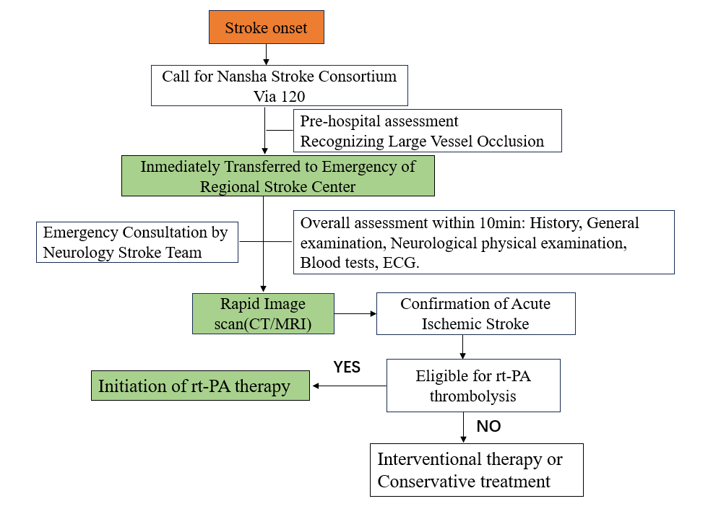
Figure1. The treatment process for acute stroke patients in a medical consortium with Nansha Central Hospital of Guangzhou as the network center.

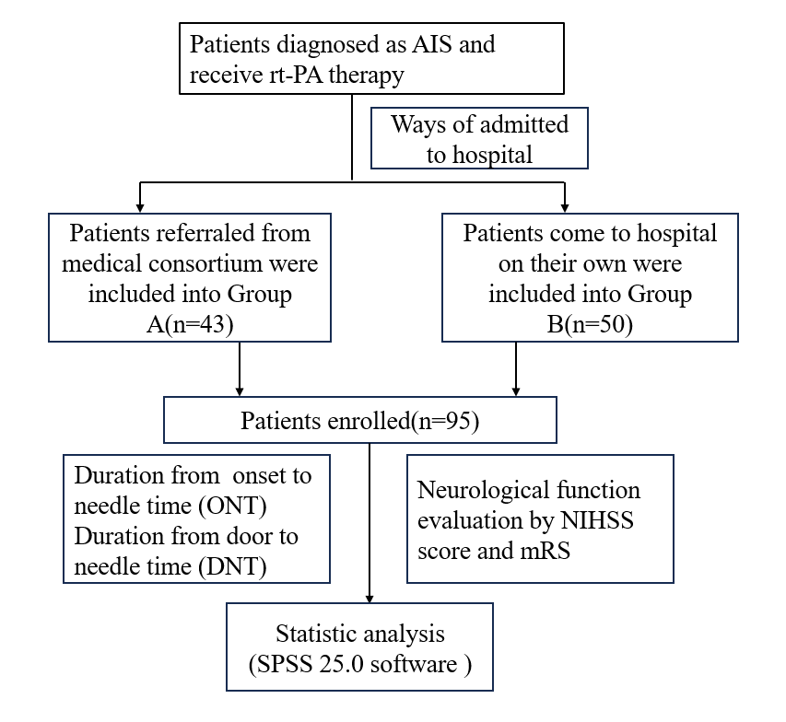

Figure2. Participant flow chart and research procedure.

