Mini Review

Modeling resilience to sleep disruption to study resistance to Alzheimer’s disease.

Jordan Mazzola¹, Joo Young Park¹, Warren Ladiges^{1*}

¹Department of Comparative Medicine, School of Medicine, University of Washington, Seattle, WA

Abstract
Alzheimer’s disease (AD) is a devastating neurodegenerative condition with unknown etiology and no cure. Therefore, it is imperative to learn more about underlying risk factors. Since AD is an age-related disease, one approach is to look at factors associated with aging. One example is sleep disruption (SD), which increases with age and accelerates progression of cognitive decline. However, some people with sleep loss experience little or no cognitive impairment and are considered resilient. The concept that resilience to sleep disruption increases resistance to AD can be modeled in aging mice with or without cognitive impairment to determine resistance or susceptibility to AD. Given that sleep disruption is a relevant and rising health concern, it is essential to gain a better understanding of resilience, and factors associated with resistance to AD, in order to develop successful intervention strategies.

Key words. Aging, Sleep disruption, Resilience, Cognitive impairment, Alzheimer’s disease, Neuropathology, Resistance

*Correspondence. Warren Ladiges, wladiges@uw.edu

Introduction

The prevalence of neurodegenerative diseases such as Alzheimer’s disease (AD) is expected to soar with the number of elderly individuals in both developed and developing countries rising dramatically. Efforts to find disease-modifying treatments have been largely unsuccessful in part due to the inability to assess early signs of disease, and lack of knowledge of risk factors associated with increasing age. One approach to investigating risk factors for AD is to look at attributes that oppose risk, ie, resilience and resistance. Physical resilience to aging is the ability of an organism to respond to physical stressors without causing long term adverse effects [1, 2]. Resistance to AD is defined as the failure to develop significant cognitive impairment and neuropathology associated with amyloid beta and phosphorylated tau [3, 4].

Sleep disturbances such as sleep fragmentation and sleep loss in humans occur with increasing age. It has recently been recognized as an important risk factor for AD [5, 6, 7]. There is growing evidence that poor sleep leads to acceleration in the progression of neurodegenerative disorders and may play a role in pathogenesis [8, 9, 10]. Research has shown that some individuals are resilient, and others are sensitive to sleep disruption [11, 12, 13]. A study by Dennis et al [14] suggested this phenotypic feature is maintained with increasing age. Approximately two thirds of healthy older adults showed performance deficits with moderate to severe sleep loss, while a third showed few or no performance deficits, even when sleep loss was severe. Therefore, sleep disruption is a universal issue that affects individuals in different ways. While some individuals experience a deficit in daily performance, others experience resiliency as they can maintain high levels of physical and mental function despite sleep loss. Although a loss of sleep causes cognitive dysfunction in areas such as learning and memory, it is not well understood how resilience to sleep disruption may be associated with a slowdown in aging, improved overall health, and decreased risk (resistance) for developing AD. The expectation is that those with enhanced resilience to sleep disruption would have an increased resilience to aging and the ability to adapt successfully without developing age-related diseases such as AD.

A mouse model of resilience to acute sleep disruption

Over the past decade, several studies have shown that people who are vulnerable versus resilient to the effects of sleep loss differ in their brain activation and behavioral performance when they are well rested [15, 16]. Observations in sleep deprived mice are similar, as evidenced by our recent publication showing that learning impairment is an adverse effect of acute sleep disruption [17]. In this study, we utilized a novel spatial navigation task designated as the Box Maze [18, 19] in sleep disrupted mice in order to identify resilience or sensitivity to learning impairment. The parameters consisted of keeping mice awake for a four-hour period of time each day for four days (Figure 1). Mice showed a consistent learning impairment pattern not seen in non-sleep deprived mice of the same age. Interestingly, the Box Maze task showed variable levels of performance within the sleep disrupted mice, indicating that certain mice were resilient (fast learners) and other mice were sensitive (slow learners) to the development of impaired learning.
A
B
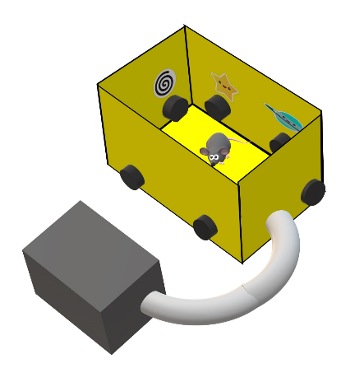

Figure 1. Protocol for identifying mice resilient to sleep disruption. A. Four hours after lights come on, mice are placed in a new cage and maintained in an awake state by gentle cage tapping and brush stroking for four hours daily for up to four days. B. Mice are then tested in a spatial navigation learning task (Box Maze) to identify those that rapidly find the escape hole (resilient and classified as fast learners) versus those that are slow in finding the escape hole (sensitive and classified as slow learners).

Are aging mice resilient to sleep disruption also resistant to Alzheimer’s disease?

In a preliminary experiment, we identified 23-month-old male and female C57BL/6J mice as fast learners (resilient) or slow learners (sensitive) after short term sleep disruption. Since AD is an age-related disease, it was imperative to use an aging mouse model of AD instead of a transgenic model that expresses neuropathology at a young age [20]. We therefore elected to use an AAV PHP.eB vector [21] containing sequences to Aβ₁₋₄₂ and P301L tau [22] to induce AD in our resilient and sensitive aging cohorts. Three months later, when mice were 26 months of age, brains were examined for neuropathology using immunohistochemistry and Qu-Path digital imaging as previously described [23]. As can be seen in Figure 2, sleep disrupted resilient mice had significantly less evidence of the presence of Aβ₁₋₄₂ /P301L tau, less inflammation and better synaptic integrity compared to sleep disrupted sensitive mice.

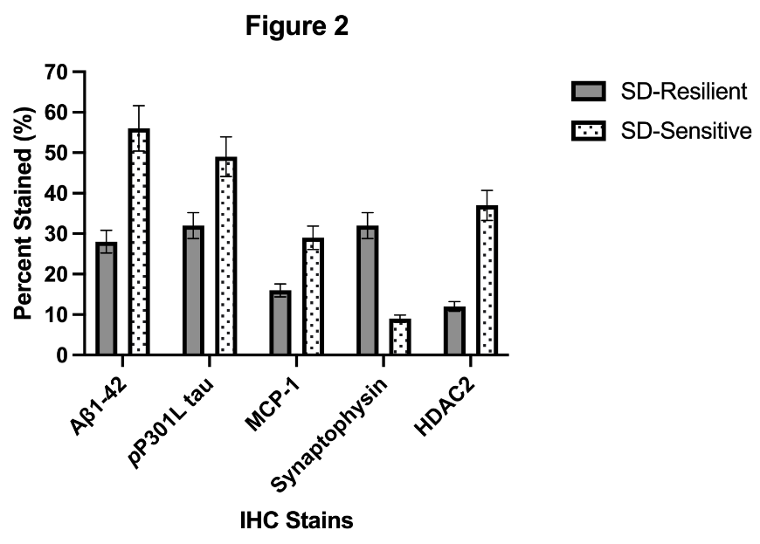

Figure 2. Sleep disrupted resilient C57BL/6 mice (SD-Resilient), 26 months of age, developed less neuropathology than sleep-disrupted sensitive mice following intravenous injection of AAV Aβ₁₋₄₂/P301L tau at 23 months of age. Data are presented as percent superpixel staining using immunohistochemistry and Qu-Path digital imaging. p≤0.05 for all stains. N = 8-10/cohort. Similar results were seen in males and females. Antibodies were obtained from Abcam, Inc.

While these observations are very preliminary, they do provide increased interest in the concept of resilience to sleep disruption as a way to investigate resistance to age-related neurodegenerative diseases such as AD. Given that sleep disruption is a relevant and rising health concern, the novel mouse model we describe could be useful in helping gain a better understanding of resilience to aging and factors associated with resistance to AD.

Acknowledgments
Supported by National Institutes of Health grants R01 AG057381 and R01 AG067193 (Ladiges PI).

References
1. Kirkland JL, Stout MB, Sierra F. Resilience in Aging Mice. J Gerontol A Biol Sci Med Sci. 2016 Nov;71(11):1407-1414
2. Schorr A, Carter C, Ladiges W. The potential use of physical resilience to predict healthy aging. Pathobiol Aging Age Relat Dis. 2017;8(1):1403844. Published 2017 Nov 21. doi:10.1080/20010001.2017.1403844
3. Latimer CS, Keene CD, Flanagan ME, et al. Resistance to Alzheimer Disease Neuropathologic Changes and Apparent Cognitive Resilience in the Nun and Honolulu-Asia Aging Studies. J Neuropathol Exp Neurol. 2017;76(6):458–466. doi:10.1093/jnen/nlx030
4. Arenaza-Urquijo EM, Vemuri P. Resistance vs resilience to Alzheimer disease: Clarifying terminology for preclinical studies. Neurology. 2018 Apr 10;90(15):695-703. doi: 10.1212/WNL.0000000000005303. Epub 2018 Mar 28. PMID: 29592885; PMCID: PMC5894932
5. Kang DW, Lee CU, Lim HK. Role of Sleep Disturbance in the Trajectory of Alzheimer's Disease. Clin Psychopharmacol Neurosci. 2017 May 31;15(2):89-99. doi: 10.9758/cpn.2017.15.2.89. PMID: 28449556; PMCID: PMC5426492.
6. Spira AP, Gottesman RF. Sleep disturbance: an emerging opportunity for Alzheimer's disease prevention? Int Psychogeriatr. 2017 Apr;29(4):529-531. doi: 10.1017/S1041610216002131. Epub 2016 Dec 12. PMID: 27938445; PMCID: PMC5493989.
7. Shi L, Chen SJ, Ma MY, Bao YP, Han Y, Wang YM, Shi J, Vitiello MV, Lu L. Sleep disturbances increase the risk of dementia: A systematic review and meta-analysis. Sleep Med Rev. 2017 Jul 6. pii: S1087-0792(17)30011-4. doi: 10.1016/j.smrv.2017.06.010.
8. Malhotra RK. Neurodegenerative Disorders and Sleep. Sleep Med Clin. 2018 Mar;13(1):63-70. doi: 10.1016/j.jsmc.2017.09.006. Epub 2017 Nov 10. Review.
9. Zdanys KF, Steffens DC. Sleep Disturbances in the Elderly. Psychiatr Clin North Am. 2015 Dec;38(4):723-41. doi: 10.1016/j.psc.2015.07.010. Epub 2015 Aug 28
10. Frau R, Traccis F, Bortolato M. Neurobehavioural complications of sleep deprivation: Shedding light on the emerging role of neuroactive steroids. Journal of Neuroendocrinology, 2020, 32(1): e12792. [PubMed: 31505075].
11. Van Dongen H, Maislin G, Dinges DF. Dealing with interindividual differences in the temporal dynamics of fatigue and performance: importance and techniques. Aviation, space, and environmental medicine, 2004, 75(3): A147–A154. 15.
12. Goel N, Dinges DF. Behavioral and genetic markers of sleepiness. Journal of Clinical Sleep Medicine, 2011, 7(5 Suppl): S19–S21. [PubMed: 22003324] 14.
13. Goel N, Dinges DF. Predicting risk in space: genetic markers for differential vulnerability to sleep restriction. Acta astronautica, 2012, 77: 207–213. [PubMed: 23524958]
14. Dennis LE, Wohl RJ, Selame LA, et al. Healthy adults display long-term trait-like neurobehavioral resilience and vulnerability to sleep loss. Scientific Reports, 2017, 7(1): 1–10. [PubMed: 28127051]
15. Chuah YM, Venkatraman V, Dinges DF, Chee MW. The neural basis of interindividual variability in inhibitory efficiency after sleep deprivation. J Neurosci. 2006 Jul 5;26(27):7156-62. doi: 10.1523/JNEUROSCI.0906-06.2006. PMID: 16822972; PMCID: PMC6673955.
16. Patanaik A, Kwoh CK, Chua EC, Gooley JJ, Chee MW. Classifying vulnerability to sleep deprivation using baseline measures of psychomotor vigilance. Sleep. 2015 May 1;38(5):723-34. doi: 10.5665/sleep.4664. PMID: 25325482; PMCID: PMC4402656.
17. Lee A, Lei H, Zhu L, Jiang Z, Ladiges W. Resilience to acute sleep deprivation is associated with attenuation of hippocampal mediated learning impairment. Aging Pathobiol Ther. 2020;2(4):195-202. doi: 10.31491/apt.2020.12.040. PMID: 35083449; PMCID: PMC8789029.
18. Mukherjee, K., Lee, A., Zhu, L., Darvas, M., & Ladiges, W. (2019). Sleep-deprived cognitive impairment in aging mice is alleviated by rapamycin. Aging Pathobiology and Therapeutics, 1(1), 05-09.
19. Darvas, M., Mukherjee, K., Lee, A., & Ladiges, W. (2020). A Novel One‐Day Learning Procedure for Mice. Current Protocols In Mouse Biology, 10(1). doi: 10.1002/cpmo.68
20. Qiu H, Zhong R, Liu H, Zhang F, Li S, Le W. Chronic Sleep Deprivation Exacerbates Learning-Memory Disability and Alzheimer's Disease-Like Pathologies in AβPP(swe)/PS1(ΔE9) Mice. J Alzheimers Dis. 2016;50(3):669-85. doi: 10.3233/JAD-150774.
21. Kawabata H, Konno A, Matsuzaki Y, Hirai H. A blood-brain barrier-penetrating AAV2 mutant created by a brain microvasculature endothelial cell-targeted AAV2 variant. Mol Ther Methods Clin Dev. 2023 Mar 2;29:81-92. doi: 10.1016/j.omtm.2023.02.016. PMID: 36970652; PMCID: PMC10036519.
22. Darvas M, Keene D, Ladiges W. A geroscience mouse model for Alzheimer's disease. Pathobiol Aging Age Relat Dis. 2019;9(1):1616994. Published 2019 May 14. doi:10.1080/20010001.2019.1616994
23. Lee A, Jiang Z, Zhu L, et al. QuPath. A new digital imaging tool for geropathology. Aging Pathobiology and Therapeutics, 2020, 2(2): 114–116. [PubMed: 35083445]

