Voluntary wheel running is a non-invasive test to measure physical performance in aging mice

Addison Keely¹, Christina Pettan-Brewer¹, Warren Ladiges¹
¹Department of Comparative Medicine, School of Medicine, University of Washington, Seattle, WA, USA

Abstract

Physical and cognitive abilities are important elements of healthy aging with many complexities for which tests have been established to quantitatively measure age-related declines. Mouse studies can effectively model human phenotypic traits and parameters that accompany aging by addressing questions not realistic in human clinical trials. The shortened timeline in aging mouse models provides researchers the ability to investigate intervention approaches in a shorter time period. A number of tests have been developed over the years to measure physical and cognitive abilities in mice that have a wide range of stress and invasiveness. Voluntary wheel running (VWR) is a non-invasive representation of natural behavior in a mouse as it measures the voluntary limit of physical capacity in a non-stressful scenario. Archived data from a mouse healthspan study were used to determine if there was an independent relationship between VWR and grip strength force, maze learning and memory retention, and physical coordination on a rotating rod, in male mice from age groups of 4 months, 12 months, 20 months and 28 months. Wheel running distance over three days was not associated with performance data from any of the three physical tests, suggesting VWR can be used independently as a stand alone or in concert with other performance tests to help determine anti-aging effects of a drug or other intervention approaches.

Keywords. Voluntary wheel running; Aging; Noninvasive performance test; Resilience to aging; Aging mouse model; Self-motivated exercise.

Corresponding author. Warren Ladiges, wladiges@uw.edu
Introduction

Aging affects cognitive and physical functions in animals and humans. Memory retention, learning ability, coordination, and physical strength are impaired with aging. Such deterioration causes stress and limits independence which is additionally harmful to quality of life [1]. Mouse models are practical for studying aging because mice undergo similar functional declines as humans. Mouse studies can effectively model human phenotypic traits and parameters that accompany aging by answering questions that cannot feasibly be investigated in a clinical trial with humans. The short lifespan of a mouse proves advantageous for aging studies since the full impact of an anti-aging treatment can be observed in a matter of months, whereas in humans the outcomes remain unknown for years. The shortened timeline in aging mouse models allows for an accelerated treatment protocol and provides researchers the ability to investigate more intervention approaches in a much shorter time period.

In this regard, it is imperative to have meaningful and non-stressful tests to measure any changes in aging parameters as the result of a specific treatment regimen. Many tests have been developed to measure physical and cognitive abilities in mice with a wide range of invasiveness. Some physical and cognitive tests include shocking mice or putting mice in gallons of water and requiring them to perform. The Morris water maze [2, 3] is invasive and stressful because it forces mice to swim, while the radial water tread maze measures similar cognitive parameters but is less stressful and noninvasive [4]. Other tests are relatively noninvasive such as grip strength and a rotating rod (Rotarod), but these are generally performed during the sleep cycle so there is still some degree of stress. On the other hand, voluntary wheel running (VWR) is noninvasive since performance measurements are fully self-motivated, and mice are tested during their active cycle and as such are not disturbed [5]. Additionally, VWR has been well characterized in literature [6-9]

This brief report provides evidence that distance ran over three days in a running wheel is not dependent on any of several standard performance tests used to measure the degree of physical aging in mice. Therefore, it can be used as an independent performance test as a stand alone or in concert with other tests to help determine anti-aging effects of a drug or other intervention approaches. Researchers must continue to develop less invasive assays to accomplish the same testing requirements to be more relevant for comparative medicine. Less invasive tests are better translated for use in human aging studies in addition to the importance of mouse health and well-being.

Materials and Methods

Data were collected from archived records of a study performed at the University of Washington as part of a project to define mouse health span [10]. For this study, 22 C57BL/6 and 24 CB6F1 (C57BL/6×BALB/c) male mice from each of four age groups at 4 months, 12 months, 20 months, and 28 months were obtained from the NIA aged mouse colony (Charles River, Inc). The archived data used for this study were from cross-sectional cohorts from four different age groups, so mice were not followed throughout their lifetimes.

Voluntary wheel running (VWR) was performed as described [5]. Briefly, mice were individually housed in cages with a slanted running wheel (from Med Associates, Inc) with additional nestlets as enrichment. There was a one-day acclimation period with locked wheels before the start of data collection. The wheels transmitted data in the form of distance run per minute wirelessly to a nearby hub connected to a computer. Distance was exported to a spreadsheet in kilometers run every minute for the following 72 hours.

The radial water tread (RWT) maze tested cognitive ability of the mice by looking at memory retention and learning abilities as described [4]. Briefly, the maze was composed of a circular enclosure filled with one inch of water and had nine escape holes all closed except one, which led out of the enclosure to a darkened standard cage. During the four training days, each mouse had three trials. On day 5 and day 12, the location of the escape hole was changed. This allowed testing for learning as well as short- and long-term memory retention.

A mouse’s ability to walk on a rotating rod (Rotarod) at increasing speeds was used to test for physical coordination and agility [11]. The mice were placed on a rod with four lanes, and rotation speed of the rod increased until all mice fell to a soft cushion below. A sensor determined when each mouse had fallen and the time was noted in seconds. The median time of three trials per mouse was recorded.

Physical strength was tested by measuring the maximum grip strength force [12]. Each mouse was placed on a horizontal metal bar with their front paws pulled backwards by an operator until they released their grip. The sensor connected to the bar recorded the peak force. There were five trials per mouse and the highest force reading was kept. Mice were also weighed on the trial date and the force was normalized by dividing the reading by body weight.

Numerical data were analyzed using student's t-tests and the calculation of p-values. Differences between types of runners were analyzed using a two factor Analysis of Variance. Linear regression and best fit curves were determined using GraphPad Prism analysis and Microsoft Excel data analysis.

Results and Discussion

The range and variation of total running distance decreased with advancing age in age groups of 4 months, 12 months, 20 months, and 28 months (Figure 1). There was a decrease in the maximum distance from young ages to old ages with regular fluctuation within each age group. The variation within each group also decreased with increasing age. This observation suggests that VWR performance can be used to test physical aging declines.

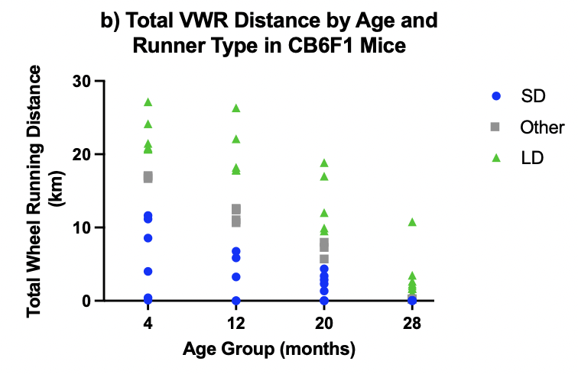
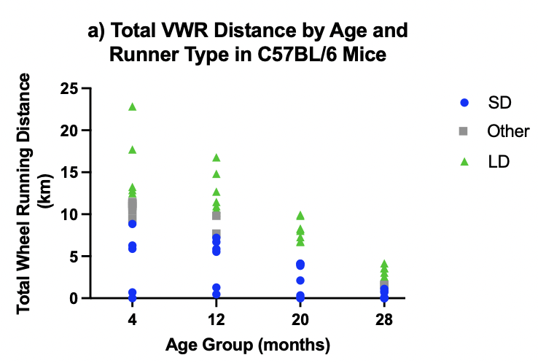
Figure 1: VWR distance declined with age in A. C57BL/6 mice. N= 15-16 per age group; and B. CB6F1 mice. N=15-24 per age group. Differences in distance between ages were analyzed using two-tailed t-tests and found significant in both strains between the 4-month age group and both 20 month and 28 month age groups. p<0.05.

The average running distance and standard deviation were calculated at each age group and mice that ran 0.25 standard deviations further than average were classified as long distance (LD) runners, and mice that ran 0.25 standard deviations less than average were short distance (SD) runners. Mouse numbers for each SD and LD cohort are shown in Figure 2.

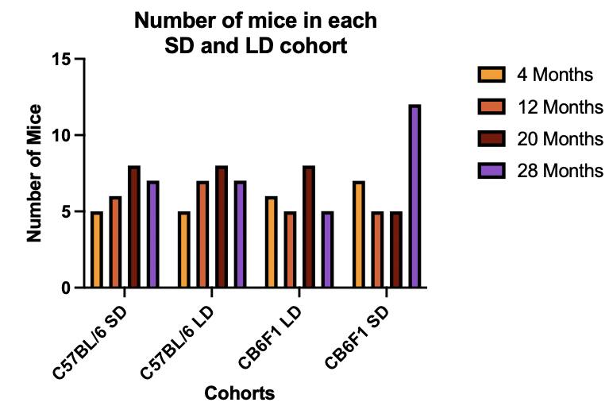
Figure 2: Number of mice in each cohort of long distance (LD) runners and short distance (SD) runners, by strain.

LD or SD distance runners did not have either strong or weak performances in grip strength, RWT maze, or rotarod assays (Figure 3). T-tests showed there were no significant differences in test data between LD and SD runners. The lack of direct association between VWR and these tests suggest that VWR assesses independent aspects of physical and possibly cognitive age-related impairment.

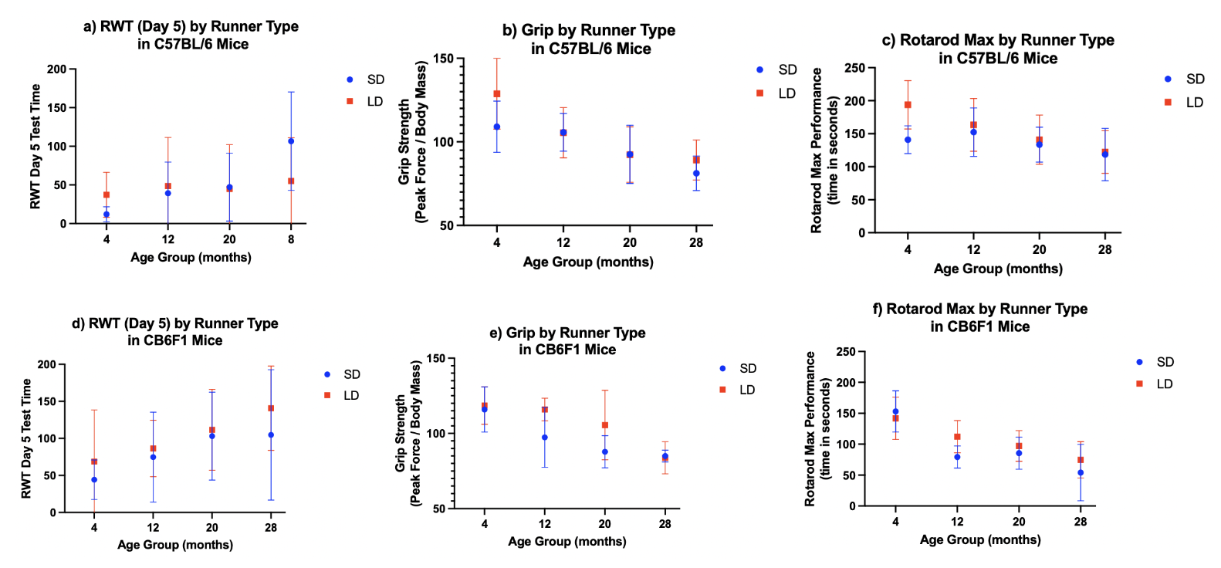
Figure 3. There was no association between distance ran by either short distance runners or long-distance runners and results from other assays. A. RWT performance by runner type in B6 mice. B. Grip strength by runner type in B6 mice. C. Rotarod performance by runner type in B6 mice. D. RWT performance by runner type in F1 mice. E. Grip strength by runner type in F1 mice. F. Rotarod performance by runner type in F1 mice. Differences between SD and LD runners were analyzed by t-test and found not significant (p>0.05). N=5-12 mice per cohort for each age group.

It is worth noting that only males were used in this study. CB6F1 and C57BL/6 male mice run further than female mice (Keely and Ladiges, unpublished observations), so female mice of these strains would be expected to show lower numbers and less variation in the results. Therefore, VWR should be informative in both sexes, though repeating this project with female mice for more cross examination of differences between the sexes would be informative.

Observations from this study suggest that VWR performance declines with age and can provide additional insights into aging that can be used as an independent assay either in a stand-alone manner or included in a test panel to assess aging decline. Running wheels can be expensive and this addition has a cost consideration. Another consideration is that mice must be individually housed for four days and additional enrichment added to cages.

A long-term study that followed the same mice from young to older ages would be informative as this was a cross-sectional study that used different mice at these age points and did not follow mice as they aged. Because the current study investigated the association of voluntary wheel running with other assays over the span of a few weeks, the question of whether VWR can be predictive of aging resilience could be addressed by a longer-term study.

References

- Fried LP, Tangen CM, Walston J, Newman AB, Hirsch C, Gottdiener J, Seeman T, Tracy R, Kop WJ, Burke G, McBurnie MA; Cardiovascular Health Study Collaborative Research Group. Frailty in older adults: evidence for a phenotype. J Gerontol A Biol Sci Med Sci. 2001 Mar;56(3):M146-56. doi: 10.1093/gerona/56.3.m146. PMID: 11253156.

- Morris R. Developments of a water-maze procedure for studying spatial learning in the rat. J Neurosci Methods. 1984 May;11(1):47-60. doi: 10.1016/0165-0270(84)90007-4. PMID: 6471907.

- Hölscher C. Stress impairs performance in spatial water maze learning tasks. Behav Brain Res. 1999 Apr;100(1-2):225-35. doi: 10.1016/s0166-4328(98)00134-x. PMID: 10212070.

- Pettan-Brewer C, Touch DV, Wiley JC, Hopkins HC, Rabinovitch PS, Ladiges WC. A novel radial water tread maze tracks age-related cognitive decline in mice. Pathobiol Aging Age Relat Dis. 2013 Oct 4;3. doi: 10.3402/pba.v3i0.20679. PMID: 24106580; PMCID: PMC3791354.

- Goh J, Ladiges W. Voluntary Wheel Running in Mice. Curr Protoc Mouse Biol. 2015 Dec 2;5(4):283-290. doi: 10.1002/9780470942390.mo140295. PMID: 26629772; PMCID: PMC4686373.

- Zhu L, Wang J, Pettan-Brewer C, Ladiges W, Goh J. Wheel running predicts resilience to tumors in old mice. Pathobiol Aging Age Relat Dis. 2019 Oct 10;9(1):1676104. doi: 10.1080/20010001.2019.1676104. PMID: 31681467; PMCID: PMC6807863.

- Manzanares G, Brito-da-Silva G, Gandra PG. Voluntary wheel running: patterns and physiological effects in mice. Braz J Med Biol Res. 2018 Dec 10;52(1):e7830. doi: 10.1590/1414-431X20187830. PMID: 30539969; PMCID: PMC6301263

- McMullan RC, Kelly SA, Hua K, Buckley BK, Faber JE, Pardo-Manuel de Villena F, Pomp D. Long-term exercise in mice has sex-dependent benefits on body composition and metabolism during aging. Physiol Rep. 2016 Nov;4(21):e13011. doi: 10.14814/phy2.13011. Epub 2016 Nov 14. PMID: 27905293; PMCID: PMC5112492.

- Garrett, L., Lie, D.C., Hrabé de Angelis, M. et al. Voluntary wheel running in mice increases the rate of neurogenesis without affecting anxiety-related behaviour in single tests. BMC Neurosci 13, 61 (2012). https://doi.org/10.1186/1471-2202-13-61

- Richardson A, Fischer KE, Speakman JR, de Cabo R, Mitchell SJ, Peterson CA, Rabinovitch P, Chiao YA, Taffet G, Miller RA, Rentería RC, Bower J, Ingram DK, Ladiges WC, Ikeno Y, Sierra F, Austad SN. Measures of Healthspan as Indices of Aging in Mice-A Recommendation. J Gerontol A Biol Sci Med Sci. 2016 Apr;71(4):427-30. doi: 10.1093/gerona/glv080. Epub 2015 Aug 22. PMID: 26297941; PMCID: PMC4834833.

- Ge X, Ciol MA, Pettan-Brewer C, Goh J, Rabinovitch P, Ladiges W. Self-motivated and stress-response performance assays in mice are age-dependent. Exp Gerontol. 2017 May;91:1-4. doi: 10.1016/j.exger.2017.02.001. Epub 2017 Feb 8. PMID: 28189701; PMCID: PMC6118215.

- Ge X, Cho A, Ciol MA, Pettan-Brewer C, Snyder J, Rabinovitch P, Ladiges W. Grip strength is potentially an early indicator of age-related decline in mice. Pathobiol Aging Age Relat Dis. 2016 Sep 8;6:32981. doi: 10.3402/pba.v6.32981. Erratum in: Pathobiol Aging Age Relat Dis. 2016 Oct 24;6:33718. PMID: 27613499; PMCID: PMC5018066.

