Research article

Carvacrol induces osteogenic differentiation of BMSCs and alleviates osteolysis in aged mice by upregulating lncRNA NEAT1 to promote SIRT1 expression
Running title: Carvacrol regulates SIRT1 in osteolysis

Zefeng Xu¹, Zeyu Wang¹, Wenming Ma¹, Zhihui Huang^{1,*}

1 Department of Traumatic Orthopedics, The First People’s Hospital of Changzhou, the Third Affiliated Hospital of Soochow University, Changzhou, Jiangsu Province, China.

*Corresponding author: Zhihui Huang
Mailing address: No. 185 Juqian Street, Department of Traumatic Orthopedics, The First People’s Hospital of Changzhou, Changzhou, Jiangsu Province, 213000, China.
Email: 15618106624@163.com
Tel: 0519-68870000

Abstract
Background: Wear particle-induced periprosthetic osteolysis is a major contributor to joint replacement failure and revision surgery in the elderly. Osteogenic differentiation of bone marrow-derived mesenchymal stem cells (BMSCs) is a promising approach for bone regeneration. Carvacrol may have bone-protective potential. This study investigated whether carvacrol alleviates osteolysis and promotes osteogenic differentiation of BMSCs by regulating SIRT1 expression.
Materials and Methods: An osteolysis model in aged mice was established by titanium (Ti) particle induction. BMSCs were isolated from femur and tibia of 18-month-old mice and cultured in osteogenic differentiation medium. RIP and RNA pull-down were used to evaluate the binding of SIRT1 and lncRNA NEAT1. Ubiquitination analysis was performed to investigate NEAT1-mediated regulation of SIRT1 ubiquitination modification levels.
Results: Carvacrol treatment improved Ti particle-induced calvarial erosion and attenuated osteolysis. Carvacrol increased SIRT1 both in the mouse model of Ti-induced osteolysis and in BMSCs under osteogenic differentiation. Carvacrol treatment promoted ALP activity, bone mineralization capacity, and expression of osteogenic differentiation-related factors, whereas SIRT1 knockdown reversed this effect. LncRNA NEAT1 interacted with SIRT1, and overexpression of NEAT1 stabilized SIRT1 by inhibiting its ubiquitination modification. NEAT1 knockdown altered the promoting effect of carvacrol on osteogenic differentiation of BMSCs, while overexpression of SIRT1 reversed the effects of NEAT1 knockdown. Similarly, NEAT1 knockdown altered the inhibitory effect of carvacrol on osteolysis in vivo.
Conclusion: Our research results demonstrate that carvacrol showed potential in treating osteolysis in aged mice by regulating NEAT1 to promote the expression of SIRT1 and can facilitate the osteogenic differentiation of BMSCs.
Keywords: Osteolysis; carvacrol; bone marrow-derived mesenchymal stem cells; NEAT1; SIRT1

List of abbreviations
Titanium (Ti)
Bone marrow-derived mesenchymal stem cells (BMSCs)
Silent information regulator type 1 (SIRT1)
Long non-coding RNAs (lncRNAs)
Osteocalcin (OCN)
Osteopontin (OPN)
Bone volume/total volume (BV/TV)
Micro-computed tomography (Micro-CT)
Cycloheximide (CHX)
Immunoprecipitation (IP)
Immunoblotting (IB)
Alkaline phosphatase (ALP)
Alizarin red S (ARS)
Reverse transcription-quantitative PCR (RT-qPCR)
Standard deviation (SD)
Tris-HCl buffer saline and Tween (TBST)
RNA immunoprecipitation (RIP)
phenylmethanesulfonyl fluoride (PMSF)
polyvinylidene fluoride membrane (PVDF)
Ubiquitin (Ub)
Total hip arthroplasty (THA)
Total knee arthroplasty (TKA)
Total joint arthroplasty (TJA)
Phosphate buffer saline (PBS)
Analysis of variance (ANOVA)

Introduction
Total hip arthroplasty (THA), total knee arthroplasty (TKA), and total joint arthroplasty (TJA) are some of the most common surgeries in orthopedics used to treat severe joint injuries, rheumatoid arthritis, osteoarthritis, and other end-stage joint diseases [1]. TKA surgery is typically performed on elderly patients with conditions such as rheumatoid arthritis [2], while TJA is a common and effective surgery for older patients (>65 years old) with late-stage osteoarthritis [3, 4]. Despite the maturity of these surgeries, some patients still require further surgical renovation mainly due to aseptic loosening [5]. The main cause of aseptic loosening is the accumulation of wear particles around the implant, such as titanium (Ti) particles [6]. According to reports, wear particles induce osteolysis by disrupting the differentiation, survival, and function of osteoblasts and osteoclasts, leading to an imbalance between bone formation and resorption [7-10]. Bone marrow-derived mesenchymal stem cells (BMSCs) are important for bone regeneration due to their multipotent differentiation ability, as they can differentiate into various cell types, including osteoblasts, chondrocytes, and adipocytes, thereby aiding in bone tissue regeneration and repair [11-14]. Additionally, BMSCs secrete growth factors and extracellular matrix molecules that promote angiogenesis, cell proliferation, and differentiation [15]. Therefore, it is important to study the differentiation mechanism of BMSCs to promote osteoblast differentiation and alleviate osteolysis around prostheses.
Carvacrol (2-methyl-5-[1-methylethyl] phenol) is a volatile oil component primarily found in herbaceous plants such as oregano, peppermint, and thyme [16]. It has anti-inflammatory, antioxidant, and antimicrobial properties [17, 18]. Research indicates that carvacrol can effectively reduce tissue damage and bone loss associated with ligature-induced periodontitis [19, 20]. Deepak et al. discovered that carvacrol inhibits osteoclastogenesis and negatively regulates the survival of mature osteoclasts [18]. Additionally, carvacrol has a bacteriostatic effect on osteoblast proliferation without any cytotoxic effects [21]. Based on the existing literatures, we speculate that carvacrol may have therapeutic effect in osteolysis. There is evidence suggesting that carvacrol participates in mesenchymal stem cell differentiation. Specifically, it has been observed that carvacrol can reduce the differentiation of mesenchymal stem cells derived from umbilical cord tissue into adipocytes [22]. Furthermore, carvacrol can promote paracrine potential and endothelial differentiation of bone marrow mesenchymal stem cells in angiogenesis at low concentrations [23]. Therefore, we speculate that carvacrol induces osteogenic differentiation of BMSCs to alleviate osteolysis.
Numerous studies have demonstrated that silent information regulator type 1 (SIRT1) has a therapeutic effect on osteolysis [24-27]. Studies have shown that promoting osteogenic potential in BMSCs through SIRT1 can improve osteolysis [24]. Upregulating SIRT1 has been found to promote osteogenic differentiation in BMSCs [28, 29]. Runx2 and Osterix, which are the primary transcription factors involved in osteogenesis [30], are positively regulated by SIRT1. Additionally, the expression of osteogenesis-related factors, including osteocalcin (OCN), osteopontin (OPN), and sialoprotein, is reduced in SIRT1 knockout cells [31-33]. Although research has found that carvacrol upregulates SIRT1 levels [34], the specific regulatory mechanism is not yet understood.
Long non-coding RNAs (lncRNAs), as a type of non-coding RNA, have been recognized as key regulatory molecules involved in gene expression, epigenetic modifications, and protein activity [35]. Recently, it has been discovered that lncRNAs are involved in the process of osteolysis. For instance, lncRNA TSIX has been shown to promote osteoblast apoptosis in particle-induced osteolysis [36]. LncRNA DANCR contributes to osteolysis by inhibiting osteoblast differentiation [37]. Similarly, LncRNA KCNQ1OT1 improves particle-induced osteolysis by inducing macrophage polarization [38]. NEAT1 and XIST promote osteogenic differentiation of human bone marrow mesenchymal stem cells [39, 40], but there is no clear literature reporting their involvement in osteolysis.
Therefore, this study proposes to use a mouse model of osteolysis and Ti particle-induced BMSCs to investigate the potential therapeutic effects of carvacrol on osteolysis in aged mice. Additionally, this study will investigate whether carvacrol induces the expression of SIRT1 by mediating NEAT1 to promote osteogenic differentiation of BMSCs. The results of this study hold promise for providing new ideas and methods for the treatment of osteolysis.

Materials and Methods
Ti particle-induced osteolysis model
As previously described, a mouse model of osteolysis was established to determine the protective effect of carvacrol on osteolysis in elderly mice [41]. C57BL/6 mice of SPF grade (18 months old) were purchased from Changzhou Cavens Laboratory Animal Co., Ltd. The living conditions of the mice are as described above [42].The mice were housed in a controlled environment with a temperature of 22-24℃ and a humidity of 50%. Prior to the start of the experiment, the mice underwent a one-week period of ad libitum feeding and acclimatization. The mice were subjected to intraperitoneal injection of ketamine and xylazine for anesthesia. Following anesthesia, the skin on the calvarial area was gently scraped and disinfected with a 10% povidone-iodine solution, and then cut along the center line with a sharp scalpel. Subsequently, 30 mg titanium particles (30 μL) were evenly distributed on the surface of the bilateral parietal bones, followed by closure of the surgical skin incision. In the sham+PBS group, an equivalent volume of PBS (30 μL) was used instead of the titanium particle suspension. After the establishment of the model, Carvacrol (5 or 10 mg/kg) was administered intragastrically daily for two weeks, while PBS was administered daily to the mice in the sham+PBS and Ti+PBS groups. For the Ti+Carvacrol+LV-shRNA and Ti+Carvacrol+LV-sh-NEAT1 groups, following the completion of the surgical procedure, a local injection of 70 µL LV-sh-NEAT1 or LV-shRNA (titer: 8×10⁸ TU/mL) was immediately administered onto the calvarial. The injection site was determined to be 2 mm from the midline and on the right lateral side of the surgical incision. After the completion of the injection, the mice were administered carvacrol at a dose of 10 mg/kg. In order to euthanize the mice, intraperitoneal injection of 480 mg/kg avertin was administered. The calvarial bones were dissected and fixed in 4% paraformaldehyde for 2 days. After fixation, the calvarial samples were washed three times with PBS and then stored in 75% ethanol at 4°C until further analysis. The animal experiment was approved by The First People’s Hospital of Changzhou.
Micro-computed Tomography (Micro-CT) scanning
Carefully extract Ti particles from each calvarial to avoid metal artifacts in the scanning results. Subsequently, fix the harvested mouse calvarial and employ a micro-CT scanner (Skyscan 1272, Bruker, Germany). Set the scanning resolution to 9 μm, X-ray energy to 50 kV, and 500 μA. Initiate the scanning process by rotating the scanning stage and exposing the specimens to the X-ray beam, capturing a series of projection images of the calvarial. Use the software provided by the manufacturer to perform three-dimensional image reconstruction. Following the established methodologies in previous studies [43], employ the micro-CT analysis software (Skyscan) to evaluate various tissue morphometric measurements: bone density (g/cm³) and bone volume/total volume (BV/TV, %).
Cell culture of BMSCs and Osteogenic differentiation
The culture and differentiation of BMSCs were performed as described previously [44]. BMSCs were isolated from the femurs and tibias of 18-month-old C57BL/6 mice. The cells were cultured in MEM Alpha Medium (α-MEM, 11900024, Gibco, USA) supplemented with 2 mM glutamine, 20% fetal bovine serum (FBS, 12483020, Gibco, USA), 100 U/mL penicillin, and 100 μg/mL streptomycin (15140122, Invitrogen, USA). The cells were maintained in a cell culture incubator at 37℃ with 5% carbon dioxide. BMSCs were seeded in 12-well plates at a density of 1 × 10⁵ cells per well. When the cell density reached approximately 70-80%, osteogenic induction differentiation was initiated. For osteogenic differentiation, the cells were incubated in Dulbecco modified Eagle medium (DMEM) supplemented with 10% FBS, 10% horse serum, 12 mM L-glutamine, 20 mM β-glycerol phosphate, 100 μg/mL streptomycin, 50 ng/mL thyroxine, 1 nM dexamethasone, 100 U/mL penicillin, and 0.5 μM ascorbate 2-phosphate. For Ti and carvacrol treatments, Ti (1.0 mg/mL) or carvacrol (12.5, 25, and 50 μM) was added simultaneously at the initiation of osteogenic induction.
Lentivirus infection
NEAT1 overexpression lentiviruses (LV-NEAT1), SIRT1 overexpression lentiviruses (LV- SIRT1), negative control (LV-NC), NEAT1 RNA interference lentiviruses (LV-sh-NEAT1), and negative control (LV-shRNA) were purchased from GenePharma (China). The lentiviral suspensions containing polybrene (5 mg/mL) were added to the cell proliferation medium. After 48 hours of incubation, cells were selected using puromycin (1 µg/mL).
Alkaline phosphatase (ALP) activity
After 7 days of cultivation in osteogenic differentiation medium, BMSCs were subjected to ALP activity assessment using an ALP detection kit (P0321S, Beyotime, China). The cells were lysed using RIPA lysis buffer (P0013B, Beyotime, China), and the appropriate reagents were added as per the manufacturer's instructions. The mixture was incubated at 37℃ for 10 minutes. Following termination of the reaction, the absorbance was measured at 405nm to quantify the ALP activity in the samples.
Alizarin red S (ARS) staining
The mineralization ability of the cells was assessed using an ARS staining kit (C0148S, Beyotime, China). After 21 days of induction and differentiation, the culture medium was removed, and the cells were washed once with PBS. The cells were then fixed with a fixing solution for 20 minutes, followed by three washes with PBS. Next, 0.5% ARS working solution was added to detect calcium deposition according to the instructions provided with the kit. The samples were observed using an optical microscope (Leica, Germany).
Western blotting analysis
The experimental procedure for extracting proteins from low-temperature frozen calvarial tissue samples is as follows: the samples were washed 2-3 times with pre-chilled PBS. Then, a mixture of 2% protease phosphatase inhibitor and 200 μL RIPA protein lysis buffer was added to the samples, followed by thorough grinding. After sufficient grinding, 300 μL protein lysis buffer was added and mixed evenly. For BMSCs, the lysis was performed on ice using RIPA protein lysis buffer containing phenylmethanesulfonyl fluoride (PMSF, 100 mM). After completing the lysis, the supernatant is collected by centrifugation. Then, 2 μL of the protein solution is taken for protein concentration measurement using a BCA assay kit (P0012, Beyotime, China). Next, the protein samples can be separated using SDS-polyacrylamide gel electrophoresis. The separated proteins were then transferred onto a polyvinylidene fluoride membrane (PVDF, 88518, ThermoFisher Scientific, USA). The membrane was blocked with 5% skim milk at room temperature for one hour. Specific primary antibodies were added and incubated with the PVDF membrane overnight at 4℃: anti-SIRT1 (ab263965, abcam, USA), anti-RUNX2 (ab114133, abcam, USA), anti-Osterix (ab209484, abcam, USA), anti-OCN (ab93876, abcam, USA), anti-OPN (ab8448, abcam, USA), and anti-β-actin (ab8227, abcam, USA). After washing three times with Tris-HCl buffer saline and Tween (TBST), the membrane was incubated with the corresponding secondary antibody (HRP-conjugated anti-mouse IgG or anti-rabbit IgG) for 1 hour. Specific protein signals were detected using a chemiluminescence assay (PE0010, Solarbio, China). Images were captured using the Amersham Imager 600 system (GE Healthcare, USA).
Reverse transcription-quantitative PCR (RT-qPCR)
After culturing BMSCs in osteogenic induction medium for seven days, Trizol reagent (15596026, ThermoFisher Scientific, USA) was added to fully lyse the cells for RNA extraction. After the RNA concentration was detected by spectrophotometer, the total RNA extracted was used as a template, and the reverse transcription reaction was performed according to the instructions provided in the M-MLV Reverse Transcription Kit manual (M1701, Promega, USA). The PCR reaction system was constructed according to the Fast SYBR Mixture reaction kit (CW0955M, CWBIO, China). Finally, qPCR was performed using the ABI 7000 real-time fluorescence quantitative PCR system (Applied Biosystems, USA). Relative gene expression levels were calculated using the 2^{-ΔΔCt} formula.
RNA pull-down
The RNA probes were synthesized by GenePharma and labeled with biotin (Bio-NEAT1 or Bio-NC). The experiment was performed following the instructions of the RNA-Protein Pull-Down Assay Kit (20164, Thermo Fisher Scientific, USA). Briefly, BMSCs were lysed with lysis buffer, and then the synthesized RNA probes were incubated with lysate at room temperature for 30 minutes. The biotinylated RNA probe specifically binds to streptavidin-coated magnetic beads to form an RNA probe-beads complex. Wash buffer is used several times to remove non-specifically bound proteins and RNA molecules. The specific binding proteins are eluted from the RNA probe-beads complex, and finally the RNA-protein complex is detected by western blotting.
RNA immunoprecipitation (RIP)
The RIP experiments were performed using the EZ-Magna RIP Kit (17-701, Millipore, USA) to verify the binding between SIRT1 and NEAT1. The cross-linked cells were fully lysed using RIPA lysis buffer. Subsequently, SIRT1 antibody and magnetic beads were added to the lysed samples for immunoprecipitation. Non-specifically bound proteins and impurities were removed through multiple washing steps. Finally, RNA was extracted from the immunoprecipitated samples, and the RNA samples were analyzed by RT-PCR.
Ubiquitination assay
BMSCs were transfected with HA-ubiquitin (Ub) and LV-NEAT1 (or LV-NC). After 24 hours of transfection, MG132 (10 μM) was added to the medium, and the cells were incubated for 4 hours. The cells were washed twice with PBS and lysed with RIPA lysis buffer. After centrifugation, the supernatant was transferred to a new EP tube and 50μL of beads were added to the supernatant. The cell lysate was incubated with anti-SIRT1 antibody at 4℃ overnight for immunoprecipitation. The washing solution (500μL sterile PBS buffer +50μL protease inhibitor) was prepared. Centrifuge at 7500rpm for 5 minutes and discard the supernatant. The washing solution is added to the tube, quickly mixed and centrifuged. Discard the supernatant, leaving the beads behind in each tube. 50 μL of 6× loading buffer was added to each tube, vortexed to mix thoroughly and boiled in a 100℃ metal bath for 10 minutes. Subsequently, immunoblotting was performed to detect binding proteins using anti-HA (ab137838, abcam, USA) and anti-SIRT1.
Immunoprecipitation (IP) and immunoblotting (IB) assay
BMSCs were transfected with LV-NEAT1 (or LV-NC). After transfection 24 hours, MG132 (10 μM) was added to the medium, and the cells were incubated for 4 hours. Cells were lysed using RIPA lysis buffer containing PMSF. The supernatant of the lysed cells was mixed with protein A/G agarose, and the centrifuge tube was gently shaken at 4℃. Anti-SMURF2 (ab313470, abcam, USA) was then added and incubated overnight at 4℃. Finally, the target protein and its interacting proteins were eluted with elution buffer. Immunoblotting and detection of eluted proteins were performed using anti-SIRT1 and anti-SMURF2.
Statistical analysis
All data analysis was performed using GraphPad Prism 6.0. All numerical values are presented as mean ± standard deviation (SD). Two-tailed unpaired Student's t-test was used to compare the mean differences between two independent samples. Comparison between the different groups was performed using One-way ANOVA followed by Tukey's multiple comparisons test or Two-way ANOVA followed by Bonferroni's multiple comparisons test. P value <0.05 was considered statistically significant.

Results
Carvacrol alleviates osteolysis in elderly mice in vivo.
To investigate the role of carvacrol in osteolysis, we studied the calvarial of elderly mice in a mouse model of osteolysis induced by Ti particles treated with different doses of carvacrol. We evaluated the calvarial conditions of different groups using Micro-CT scanning. Three-dimensional reconstructed images showed that compared with the sham+PBS group, the calvarial bone of the Ti+PBS group was extensively eroded, and the calvarial thickness was reduced. However, carvacrol treatment significantly improved calvarial erosion (Figure 1A). Further analysis revealed that the Ti+PBS group exhibited a significant reduction in bone density and BV/TV compared to the sham+PBS group (Figure 1B-C). Interestingly, treatment with 5 or 10 mg/kg of carvacrol significantly increased the bone density reduction induced by Ti particles (Figure 1B), and only 10 mg/kg carvacrol treatment significantly upregulated the BV/TV level (Figure 1C). Overall, these results indicate that carvacrol has a protective effect against Ti particle-induced osteolysis.
To further elucidate the role of carvacrol in osteoblast differentiation, we examined the expression levels of SIRT1 and osteoblast differentiation-related factors (RUNX2, Osterix, OCN, and OPN) in the calvaria of elderly mice. Western blot analysis revealed that the expression of SIRT1, RUNX2, Osterix, OCN, and OPN was significantly decreased after Ti treatment, while carvacrol treatment effectively reversed this phenomenon (Figure 1D). These findings indicate that carvacrol has the potential to promote osteoblast differentiation.
Carvacrol alleviates osteogenic differentiation of Ti-inhibited BMSCs in vitro.
In order to determine the appropriate concentration of carvacrol to promote the differentiation of BMSCs into osteoblasts, we conducted ARS staining and ALP activity analysis on different concentrations of carvacrol-treated groups and control groups. The results showed that the mineralization ability of BMSCs was significantly enhanced when the concentration of carvacrol exceeded 25 μM (Figure S1A). When the concentration of carvacrol exceeded 12.5 μM, the ALP activity of BMSCs was observed to be promoted (Figure S1B). At the same time, we assessed the expression of osteogenic differentiation-related factors and found that the expression of RUNX2 and OCN in BMSCs was promoted when the concentration of carvacrol exceeded 25 μM (Figure S1C, E). In addition, the expression of Osterix and OPN in BMSCs was also promoted when the concentration of carvacrol exceeded 12.5 μM (Figure S1D, F). Based on these findings, we concluded that carvacrol at a concentration of 25 μM significantly promotes osteogenic differentiation. Therefore, we selected this concentration for subsequent experiments.
To further investigate whether the protective effect of carvacrol against osteolysis occurs through promoting osteogenic differentiation of BMSCs, we first measured the expression of osteogenic differentiation-related factors. The results showed that carvacrol treatment significantly promoted the expression of RUNX2, Osterix, OCN, and OPN in Ti-inhibited mouse BMSCs (Figure 2A-D). To further elucidate the role of carvacrol in BMSCs function, we next examined ALP activity. Ti inhibited the ALP activity of BMSCs, whereas carvacrol treatment reversed this result (Figure 2E). To evaluate whether carvacrol promotes the mineralization ability of BMSCs, we performed ARS staining. Ti significantly reduced the osteogenic capacity of BMSCs, whereas carvacrol reversed these effects (Figure 2F). Overall, these observations suggest that carvacrol effectively alleviates the Ti-inhibited osteogenic differentiation of BMSCs. Furthermore, compared to the control group, the expression of SIRT1 was significantly decreased in the Ti group, while the addition of carvacrol treatment significantly upregulated the expression level of SIRT1, which is consistent with the results in mice (Figure 2G). Therefore, we speculate that carvacrol may induce osteogenic differentiation of BMSCs and alleviate osteolysis by upregulating the expression of osteogenic differentiation-related factors and SIRT1. However, further validation is required to confirm this hypothesis.
Carvacrol alleviates osteogenic differentiation of Ti-inhibited BMSCs by upregulating SIRT1.
To further confirm the regulatory role of carvacrol on SIRT1 during osteogenic differentiation of BMSCs, we transfected BMSCs with LV-sh-SIRT1 or LV-shRNA (negative control). Compared with the Ti+Carvacrol+LV-shRNA group, the significant decrease in SIRT1 expression in BMSCs transfected with LV-sh-SIRT1 indicates the effectiveness of transfection (Figure 3A). Carvacrol treatment significantly up-regulated the expression of osteoblast differentiation-related factors (RUNX2, Osterix, OCN, OPN), and LV-sh-SIRT1 partially reversed the effect of carvacrol (Figure 3B-E). Further analysis of the osteogenic potential of BMSCs revealed that carvacrol promoted ALP activity and mineralization ability, which was partially reversed by LV-sh-SIRT1 (Figure 3F-G). Overall, these findings suggest that carvacrol alleviates titanium inhibition of osteogenic differentiation in BMSCs by upregulating SIRT1.
Carvacrol promotes SIRT1 expression through NEAT1.
To further investigate the promoting effect of carvacrol on SIRT1 expression, we have employed software prediction and combined with existing literature to identify potential lncRNAs that may interact with SIRT1 and play a role in osteolysis or osteoblast differentiation processes. The selected lncRNAs are as follows: TSIX [36], DANCR [37], KCNQ1OT1 [38], NEAT1 [39], and XIST [40]. Therefore, we cultured BMSCs under the treatment of carvacrol at a concentration of 25μM and evaluated lncRNAs expression levels using RT-qPCR after 48 hours after incubation. The results showed a significant upregulation of NEAT1 expression in response to carvacrol (Figure 4A). Thus, we hypothesize that carvacrol may influence SIRT1 by regulating NEAT1.
To determine the interaction between NEAT1 and SIRT1, we performed an RNA pull-down assay using biotin-labeled lncRNA-NEAT1 (Bio-NEAT1) and detected SIRT1 in the pulled-down complexes by western blot. The results demonstrated that SIRT1 was enriched in the Bio-NEAT1 pulled-down complexes compared to the Bio-NC (Figure 4B). In addition, we performed RIP assay using specific antibodies to precipitate SIRT1, followed by RT-qPCR to determine the levels of NEAT1 in the precipitated material. The results revealed a significant enrichment of NEAT1 in the immunoprecipitated complex of SIRT1 (Figure 4C). Furthermore, we employed LV-sh-NEAT1 plasmids to transfect BMSCs. Remarkably, the downregulation of NEAT1 resulted in a significant decrease in the expression level of SIRT1 (Figure 4D), proving further evidence for the interaction between NEAT1 and SIRT1.
Subsequently, we investigated whether carvacrol affects SIRT1 expression through NEAT1. BMSCs were divided into the following groups: control, Ti, Ti+carvacrol, Ti+carvacrol+ LV-shRNA, and Ti+carvacrol+LV-sh-NEAT1. Western blot analysis revealed that carvacrol significantly promoted the expression of SIRT1 protein, but this promotion was altered in the presence of LV-sh-NEAT1 (Figure 4E). Additionally, RT-qPCR analysis of the calvarial samples in Figure 1 revealed that NEAT1 expression was significantly downregulated in the Ti+PBS group compared to the sham+PBS group. However, the introduction of carvacrol resulted in the upregulation of NEAT1 levels (Figure 4F). The data presented strongly support the notion that NEAT1 plays a crucial role in facilitating the upregulation of SIRT1 expression induced by carvacrol.
NEAT1 stabilizes the expression of SIRT1 by inhibiting its ubiquitination levels.
Previous studies have revealed that lncRNAs can regulate the expression of SIRT1 through ubiquitination pathways [45-47]. Based on this evidence, we hypothesized that NEAT1 may modulate SIRT1 expression via ubiquitination. To investigate this hypothesis, we employed cycloheximide (CHX) treatment to evaluate the impact of NEAT1 on the stability of SIRT1 protein. BMSCs were transfected with LV-NEAT1 plasmid, followed by treatment with 10μg/mL CHX for 0, 3, 6, and 9 hours. Our results revealed that the overexpression of NEAT1 significantly inhibited the time-dependent degradation of SIRT1 protein in BMSCs under CHX treatment (Figure 5A). Subsequently, BMSCs were treated with (or without) 10μM proteasome inhibitor MG132 for 4 hours. Western blot analysis demonstrated that MG132 significantly increased the protein levels of SIRT1, confirming the successful blockade of proteasome-mediated protein degradation (Figure 5B). In the absence of MG132 treatment, the overexpression of NEAT1 resulted led to a significant increase in SIRT1 protein levels. However, when BMSCs were pre-treated with MG132, the impact of LV-NEAT1 on SIRT1 protein levels was relatively modest. This observation supports the notion that NEAT1's effect on SIRT1 is dependent on proteasome-mediated degradation (Figure 5B). The ubiquitination assay further confirmed that the overexpression of NEAT1 inhibits the ubiquitination modification of SIRT1 (Figure 5C). According to relevant literature, the E3 ubiquitin ligase SMURF2 interacts with SIRT1 and facilitates its ubiquitination and degradation [48]. We hypothesized that NEAT1 regulates the ubiquitination levels of SIRT1 by modulating the interaction between SIRT1 and SMURF2. The IP and IB assay revealed a significant decrease in the enrichment of SIRT1 within the SMURF2 immunoprecipitation complex in BMSCs transfected with LV-NEAT1 (Figure 5D). Overall, these findings suggest that NEAT1 plays a pivotal role in stabilizing SIRT1 and effectively inhibiting its ubiquitination modification levels.
Carvacrol promotes SIRT1 expression by upregulating NEAT1 and alleviates titanium-inhibited osteoblast differentiation.
We initially investigated the expression levels of NEAT1, SIRT1, and osteogenic differentiation-related factors in BMSCs following different treatments. The findings revealed that knockdown of NEAT1 significantly inhibited the carvacrol-induced increase in NEAT1 expression, providing compelling evidence for the effectiveness of the transfection (Figure 6A). Moreover, LV-sh-NEAT1 suppressed the expression of SIRT1, RUNX2, Osterix, OCN, and OPN promoted by carvacrol, while LV-SIRT1 reversed the effects of LV-sh-NEAT1 (Figure 6B-F). Subsequently, we performed osteogenic differentiation of BMSCs in different treatment groups. The ALP activity significantly increased in the Ti+Carvacrol group, while the Ti+Carvacrol+LV-sh-NEAT1 group showed a notable decrease. As expected, the ALP activity increased again in the Ti+Carvacrol+LV-sh-NEAT1+LV-SIRT1 group (Figure 6G). The ARS staining results showed enhanced mineralization ability in BMSCs of the Ti+Carvacrol group, while decreased mineralization ability was observed in the Ti+Carvacrol+LV-sh-NEAT1 group. After transfection with LV-SIRT1, mineralization ability was restored (Figure 6H). These results demonstrate that silencing NEAT1 can inhibit the osteogenic effect of carvacrol, but this inhibition can be reversed by overexpression of SIRT1.
Carvacrol alleviates osteolysis in elderly mice by upregulating NEAT1.
We randomly divided 18-month-old mice into four groups: Ti+PBS, Ti+Carvacrol, Ti+Carvacrol+LV-shRNA, and Ti+Carvacrol+LV-sh-NEAT1 groups. After two weeks of surgery, we collected calvarial tissue from the mice and performed Micro-CT scanning, quantitative Micro-CT analysis, and western blot. Analysis of the three-dimensional reconstructed images revealed extensive erosion and reduced thickness of the calvarial bone in the Ti+PBS group. However, the application of carvacrol ameliorated calvarial erosion, and the injection of LV-sh-NEAT1 partially reversed the effects of carvacrol (Figure 7A). Furthermore, carvacrol also upregulated bone density and BV/TV levels, which were partially counteracted by LV-sh-NEAT1 injection (Figure 7B-C). This suggests that NEAT1 may play a crucial role in mediating the protective effects of carvacrol on calvarial bone erosion. Additionally, LV-sh-NEAT1 attenuated the carvacrol-induced increase in the protein levels of SIRT1, RUNX2, Osterix, OCN, and OPN (Figure 7D). These findings highlight that carvacrol alleviates osteolysis in older mice by upregulating NEAT1.

Discussion
This study demonstrated the potential bone-protective effects of carvacrol. Carvacrol enhances SIRT1 expression by upregulating NEAT1, thereby alleviating the inhibitory effect of titanium particles on osteoblast differentiation. In summary, carvacrol may have potential therapeutic effects on osteolysis in elderly mice by promoting osteogenic differentiation of BMSCs. This finding provides a promising direction for the development of new treatment strategies and drugs (Figure 8).
Osteolysis refers to a pathological condition characterized by increased bone resorption and decreased bone formation in the bone tissue, resulting in the destruction and loss of bone mass [49]. This pathological process is typically triggered by wear particles following joint replacement surgery [6]. The probability of wear particle-induced osteolysis is significantly higher in elderly patients [50]. Therefore, triggering osteogenesis promotion may be one of the most promising therapeutic approaches to treat osteolysis. BMSCs have the potential for osteogenic differentiation, which can promote the formation and repair of bone tissue by differentiating into osteoblasts and osteocytes [51, 52]. Therefore, the development of drugs that enhance the osteogenic differentiation ability of BMSCs offers a new therapeutic approach for the treatment of osteolysis.
Previous studies have revealed the potential regulatory effects of carvacrol on osteoblasts and osteoclasts [18, 21]. Additionally, carvacrol has been suggested to reduce tissue damage and bone loss caused by ligature-induced periodontitis [19, 53]. However, the potential of carvacrol in regulating osteogenic differentiation for the treatment of particle-induced osteolysis has not been explored until now.
In this study, we have demonstrated for the first time that carvacrol alleviates particle-induced osteolysis in an osteolysis model of elderly mice. It is worth noting that the accumulation of wear particles (Ti particles) around implants can lead to local bone resorption and ultimately calvarial erosion [54, 55]. As expected, micro-CT imaging, bone density and BV/TV statistical analysis revealed that carvacrol exhibited a protective effect against Ti-induced bone destruction. Furthermore, a recent study by Spalletta et al. reported the involvement of carvacrol in the differentiation of umbilical cord mesenchymal stem cells [22]. Therefore, in this study, we also evaluated the impact of carvacrol on the osteogenic differentiation and osteogenesis of titanium-inhibited BMSCs. The results demonstrated that titanium treatment suppressed cell mineralization, the activity of the osteogenic differentiation marker ALP, and the expression of osteogenic differentiation-related factors (RUNX2, Osterix, OCN, and OPN). However, carvacrol was able to reverse these effects induced by titanium.
The reduction in SIRT1 levels and activity is associated with the progression of osteolysis [25, 27, 56, 57]. Furthermore, SIRT1 is involved in the differentiation of BMSCs in aged mice and promotes bone formation [58, 59]. SIRT1 effectively improves osteolysis by enhancing the osteogenic potential of BMSCs [24]. Our research revealed that carvacrol upregulates SIRT1 levels, which is consistent with previous findings [34]. Previous study has shown that melatonin promotes the osteogenic potential of BMSCs by regulating SIRT1-mediated antioxidant properties [29]. Eldecalcitol inhibits BMSC aging by modulating the SIRT1-Nrf2 signaling pathway [60]. Based on these findings, we further investigate whether carvacrol regulates SIRT1 to influence the osteogenic differentiation of BMSCs. The inhibitory effect of sh-SIRT1 on carvacrol-induced osteogenic differentiation of BMSCs was confirmed by ALP activity assay, ARS staining, and RT-qPCR analysis.
Many studies have emphasized the crucial impact of lncRNAs on various processes. Increasing evidence suggests that lncRNAs are involved in BMSC osteogenic differentiation [61], bone formation [62], and osteoblasts matrix mineralization [63]. In order to gain a deeper understanding of the molecular mechanism by which carvacrol regulates osteolysis, we screened several lncRNAs potentially involved in SIRT1 interaction and osteolysis. Surprisingly, only NEAT1 expression was regulated upon the addition of carvacrol to the culture medium. It has been discovered that lncRNA NEAT1 activates BTK and regulates the NF-κB pathway, thereby participating in the process of wear particle-induced osteolysis [64]. Our results also show that the inhibition of NEAT1 weakened the protective effect of carvacrol on calvarial and participates in osteolysis. LncRNAs can participate in the regulation of gene expression through various mechanisms [65, 66], including the regulation of SIRT1 through ubiquitination [46, 47, 67]. To explore the correlation between NEAT1 and SIRT1 further, we conducted RNA pull-down and RIP experiments. Subsequently, we discovered that NEAT1 stabilizes SIRT1 expression by inhibiting its ubiquitination modification. Additionally, NEAT1 has been shown to promote the osteogenic differentiation of human bone marrow mesenchymal stem cells [39]. The findings of our study indicate that in Ti-induced in vitro BMSCs, LV-sh-NEAT1 inhibits the osteogenic differentiation promoted by carvacrol, while LV-SIRT1 reverses the effect of sh-NEAT1.

Conclusions
In conclusion, carvacrol promotes SIRT1 expression by up-regulating NEAT1 and induces the expression of transcription factors related to osteogenesis. This mechanism may contribute to the promotion of osteogenic differentiation of BMSCs and the alleviation of osteolysis. However, this study was only discussed in animal models, and there is a lack of further clinical research evidence.

Competing interests
All authors declare that they have no conflict of interest.

Funding
None.

References
1. Ryu, K.J., CORR Insights®: What Host Factors Affect Aseptic Loosening After THA and TKA? Clin Orthop Relat Res, 2015. 473(8): p. 2710-1.
2. Heyse, T.J., et al., Total knee arthroplasty in patients with juvenile idiopathic arthritis. Clin Orthop Relat Res, 2014. 472(1): p. 147-54.
3. Sculco, T.P., The role of constraint in total knee arthoplasty. J Arthroplasty, 2006. 21(4 Suppl 1): p. 54-6.
4. Oussedik, S., et al., Alignment and fixation in total knee arthroplasty: changing paradigms. Bone Joint J, 2015. 97-b(10 Suppl A): p. 16-9.
5. Dong, J., et al., NRF2 is a critical regulator and therapeutic target of metal implant particle-incurred bone damage. Biomaterials, 2022. 288: p. 121742.
6. Goodman, S.B., Wear particles, periprosthetic osteolysis and the immune system. Biomaterials, 2007. 28(34): p. 5044-8.
7. Zhang, Y., et al., The effects of icariine concentration on osteoclasts bone resorption induced by titanium particles in vitro. Regen Biomater, 2015. 2(3): p. 197-202.
8. Yao, J., et al., Suppression of osteoblast function by titanium particles. J Bone Joint Surg Am, 1997. 79(1): p. 107-12.
9. Pioletti, D.P., et al., The cytotoxic effect of titanium particles phagocytosed by osteoblasts. J Biomed Mater Res, 1999. 46(3): p. 399-407.
10. Liu, G., et al., Endoplasmic reticulum stress-mediated inflammatory signaling pathways within the osteolytic periosteum and interface membrane in particle-induced osteolysis. Cell Tissue Res, 2016. 363(2): p. 427-47.
11. Al-Ahmari, F., et al., Efficacy of Mesenchymal Stem Cells as Adjunct to Guided Bone Regeneration in Standardized Calvarial Defects in Rats: An In Vivo Microcomputed Tomographic and Histologic Analysis. Int J Periodontics Restorative Dent, 2016. 36 Suppl: p. s23-37.
12. Namli, H., et al., Vertical Bone Augmentation Using Bone Marrow-Derived Stem Cells: An In Vivo Study in the Rabbit Calvaria. Implant Dent, 2016. 25(1): p. 54-62.
13. Zaher, W., et al., An update of human mesenchymal stem cell biology and their clinical uses. Arch Toxicol, 2014. 88(5): p. 1069-82.
14. Su, P., et al., Mesenchymal Stem Cell Migration during Bone Formation and Bone Diseases Therapy. Int J Mol Sci, 2018. 19(8).
15. Choudhery, M.S., et al., Bone marrow derived mesenchymal stem cells from aged mice have reduced wound healing, angiogenesis, proliferation and anti-apoptosis capabilities. Cell Biol Int, 2012. 36(8): p. 747-53.
16. De Vincenzi, M., et al., Constituents of aromatic plants: carvacrol. Fitoterapia, 2004. 75(7-8): p. 801-4.
17. Baser, K.H., Biological and pharmacological activities of carvacrol and carvacrol bearing essential oils. Curr Pharm Des, 2008. 14(29): p. 3106-19.
18. Deepak, V., et al., Carvacrol Inhibits Osteoclastogenesis and Negatively Regulates the Survival of Mature Osteoclasts. Biol Pharm Bull, 2016. 39(7): p. 1150-8.
19. Kuo, P.J., et al., Carvacrol Ameliorates Ligation-Induced Periodontitis in Rats. J Periodontol, 2017. 88(7): p. e120-e128.
20. Botelho, M.A., et al., Protective effect of locally applied carvacrol gel on ligature-induced periodontitis in rats: a tapping mode AFM study. Phytother Res, 2009. 23(10): p. 1439-48.
21. Vu, A.A. and S. Bose, Natural Antibiotic Oregano in Hydroxyapatite-Coated Titanium Reduces Osteoclastic Bone Resorption for Orthopedic and Dental Applications. ACS Appl Mater Interfaces, 2020. 12(47): p. 52383-52392.
22. Spalletta, S., et al., Carvacrol reduces adipogenic differentiation by modulating autophagy and ChREBP expression. PLoS One, 2018. 13(11): p. e0206894.
23. Matluobi, D., et al., Carvacrol promotes angiogenic paracrine potential and endothelial differentiation of human mesenchymal stem cells at low concentrations. Microvasc Res, 2018. 115: p. 20-27.
24. Zhang, Y., et al., Melatonin Rescues the Ti Particle-Impaired Osteogenic Potential of Bone Marrow Mesenchymal Stem Cells via the SIRT1/SOD2 Signaling Pathway. Calcif Tissue Int, 2020. 107(5): p. 474-488.
25. Deng, Z., et al., SIRT1 protects osteoblasts against particle-induced inflammatory responses and apoptosis in aseptic prosthesis loosening. Acta Biomater, 2017. 49: p. 541-554.
26. Liu, L., et al., Hydrogen sulfide protects against particle-induced inflammatory response and osteolysis via SIRT1 pathway in prosthesis loosening. Faseb j, 2020. 34(3): p. 3743-3754.
27. Deng, Z., et al., The metal nanoparticle-induced inflammatory response is regulated by SIRT1 through NF-κB deacetylation in aseptic loosening. Int J Nanomedicine, 2017. 12: p. 3617-3636.
28. Wang, Y., et al., Upregulation of SIRT1 by Kartogenin Enhances Antioxidant Functions and Promotes Osteogenesis in Human Mesenchymal Stem Cells. Oxid Med Cell Longev, 2018. 2018: p. 1368142.
29. Chen, W., et al., Melatonin restores the osteoporosis-impaired osteogenic potential of bone marrow mesenchymal stem cells by preserving SIRT1-mediated intracellular antioxidant properties. Free Radic Biol Med, 2020. 146: p. 92-106.
30. Satija, N.K., et al., Mesenchymal stem cells: molecular targets for tissue engineering. Stem Cells Dev, 2007. 16(1): p. 7-23.
31. Tseng, P.C., et al., Resveratrol promotes osteogenesis of human mesenchymal stem cells by upregulating RUNX2 gene expression via the SIRT1/FOXO3A axis. J Bone Miner Res, 2011. 26(10): p. 2552-63.
32. Terauchi, K., et al., The NAD-Dependent Deacetylase Sirtuin-1 Regulates the Expression of Osteogenic Transcriptional Activator Runt-Related Transcription Factor 2 (Runx2) and Production of Matrix Metalloproteinase (MMP)-13 in Chondrocytes in Osteoarthritis. Int J Mol Sci, 2016. 17(7).
33. Zainabadi, K., C.J. Liu, and L. Guarente, SIRT1 is a positive regulator of the master osteoblast transcription factor, RUNX2. PLoS One, 2017. 12(5): p. e0178520.
34. Kim, E., et al., Carvacrol Protects against Hepatic Steatosis in Mice Fed a High-Fat Diet by Enhancing SIRT1-AMPK Signaling. Evid Based Complement Alternat Med, 2013. 2013: p. 290104.
35. Fatica, A. and I. Bozzoni, Long non-coding RNAs: new players in cell differentiation and development. Nat Rev Genet, 2014. 15(1): p. 7-21.
36. Bu, Y., et al., LncRNA TSIX promotes osteoblast apoptosis in particle-induced osteolysis by down-regulating miR-30a-5p. Connect Tissue Res, 2018. 59(6): p. 534-541.
37. Tang, Z., Z. Gong, and X. Sun, LncRNA DANCR involved osteolysis after total hip arthroplasty by regulating FOXO1 expression to inhibit osteoblast differentiation. J Biomed Sci, 2018. 25(1): p. 4.
38. Gao, X., et al., LncRNA KCNQ1OT1 ameliorates particle-induced osteolysis through inducing macrophage polarization by inhibiting miR-21a-5p. Biol Chem, 2018. 399(4): p. 375-386.
39. Zhang, Y., et al., LncRNA NEAT1/miR-29b-3p/BMP1 axis promotes osteogenic differentiation in human bone marrow-derived mesenchymal stem cells. Pathol Res Pract, 2019. 215(3): p. 525-531.
40. Zheng, C., et al., Long noncoding RNA XIST regulates osteogenic differentiation of human bone marrow mesenchymal stem cells by targeting miR-9-5p. Mech Dev, 2020. 162: p. 103612.
41. Kaar, S.G., et al., Rapid repair of titanium particle-induced osteolysis is dramatically reduced in aged mice. J Orthop Res, 2001. 19(2): p. 171-8.
42. Johnson, C., et al., Older-aged C57BL/6 mice fed a diet high in saturated fat and sucrose for ten months show decreased resilience to aging. Aging Pathobiology and Therapeutics, 2023. 5(3).
43. Gu, M., et al., SPHK Inhibitors and Zoledronic Acid Suppress Osteoclastogenesis and Wear Particle-Induced Osteolysis. Front Pharmacol, 2021. 12: p. 794429.
44. Li, X., et al., Dysfunction of metabolic activity of bone marrow mesenchymal stem cells in aged mice. Cell Prolif, 2022. 55(3): p. e13191.
45. Tang, Y., et al., Downregulated long non-coding RNA LINC01093 in liver fibrosis promotes hepatocyte apoptosis via increasing ubiquitination of SIRT1. J Biochem, 2020. 168(3): p. 315.
46. Shi, C., W. Zheng, and J. Wang, lncRNA-CRNDE regulates BMSC chondrogenic differentiation and promotes cartilage repair in osteoarthritis through SIRT1/SOX9. Mol Cell Biochem, 2021. 476(4): p. 1881-1890.
47. Zhang, J., et al., LncRNA XIST restrains the activation of Müller cells and inflammation in diabetic retinopathy via stabilizing SIRT1. Autoimmunity, 2021. 54(8): p. 504-513.
48. Yu, L., et al., Ubiquitination-mediated degradation of SIRT1 by SMURF2 suppresses CRC cell proliferation and tumorigenesis. Oncogene, 2020. 39(22): p. 4450-4464.
49. Alhasan, H., et al., Inhibitory role of Annexin A1 in pathological bone resorption and therapeutic implications in periprosthetic osteolysis. Nat Commun, 2022. 13(1): p. 3919.
50. Yamada, C., et al., Glycyrrhizin mitigates inflammatory bone loss and promotes expression of senescence-protective sirtuins in an aging mouse model of periprosthetic osteolysis. Biomed Pharmacother, 2021. 138: p. 111503.
51. He, Z., et al., Irisin inhibits osteocyte apoptosis by activating the Erk signaling pathway in vitro and attenuates ALCT-induced osteoarthritis in mice. Bone, 2020. 141: p. 115573.
52. Wu, S., et al., Rat bone marrow mesenchymal stem cells induced by rrPDGF-BB promotes bone regeneration during distraction osteogenesis. Front Bioeng Biotechnol, 2023. 11: p. 1110703.
53. Botelho, M.A., et al., Effects of a herbal gel containing carvacrol and chalcones on alveolar bone resorption in rats on experimental periodontitis. Phytother Res, 2008. 22(4): p. 442-9.
54. Jiao, Z., et al., SOST gene suppression stimulates osteocyte Wnt/β-catenin signaling to prevent bone resorption and attenuates particle-induced osteolysis. J Mol Med (Berl), 2023. 101(5): p. 607-620.
55. Shi, J., et al., Inhibitory effect of acetyl-11-keto-β-boswellic acid on titanium particle-induced bone loss by abrogating osteoclast formation and downregulating the ERK signaling pathway. Int Immunopharmacol, 2021. 94: p. 107459.
56. Zhang, L., et al., miR-9-5p promotes wear-particle-induced osteoclastogenesis through activation of the SIRT1/NF-κB pathway. 3 Biotech, 2021. 11(6): p. 258.
57. Zhang, L., et al., Particle-induced SIRT1 downregulation promotes osteoclastogenesis and osteolysis through ER stress regulation. Biomed Pharmacother, 2018. 104: p. 300-306.
58. Hong, W., et al., Sirt1 is involved in decreased bone formation in aged apolipoprotein E-deficient mice. Acta Pharmacol Sin, 2015. 36(12): p. 1487-96.
59. Zhu, C., et al., Exercise improved bone health in aging mice: a role of SIRT1 in regulating autophagy and osteogenic differentiation of BMSCs. Front Endocrinol (Lausanne), 2023. 14: p. 1156637.
60. Kou, Y., et al., Eldecalcitol prevented OVX-induced osteoporosis through inhibiting BMSCs senescence by regulating the SIRT1-Nrf2 signal. Front Pharmacol, 2023. 14: p. 1067085.
61. Li, Y., et al., HuR-mediated nucleocytoplasmic translocation of HOTAIR relieves its inhibition of osteogenic differentiation and promotes bone formation. Bone Res, 2023. 11(1): p. 53.
62. Arai, M., et al., A Novel Long Noncoding RNA in Osteocytes Regulates Bone Formation through the Wnt/β-Catenin Signaling Pathway. Int J Mol Sci, 2023. 24(17).
63. Freitas, J., et al., Long non-coding RNA CASC2 regulates osteoblasts matrix mineralization. Front Bioeng Biotechnol, 2023. 11: p. 1155596.
64. Lin, S., et al., LncRNA Neat1 promotes the macrophage inflammatory response and acts as a therapeutic target in titanium particle-induced osteolysis. Acta Biomater, 2022. 142: p. 345-360.
65. Wang, Y.W., et al., PIN1P1 is activated by CREB1 and promotes gastric cancer progression via interacting with YBX1 and upregulating PIN1. J Cell Mol Med, 2023.
66. Fan, Y., et al., LncRNA ASB16-AS1 accelerates cellular process and chemoresistance of ovarian cancer cells by regulating GOLM1 expression via targeting miR-3918. Biochem Biophys Res Commun, 2023. 675: p. 1-9.
67. Tang, Y., et al., Downregulated long non-coding RNA LINC01093 in liver fibrosis promotes hepatocyte apoptosis via increasing ubiquitination of SIRT1. J Biochem, 2020. 167(5): p. 525-534.

Figure legends
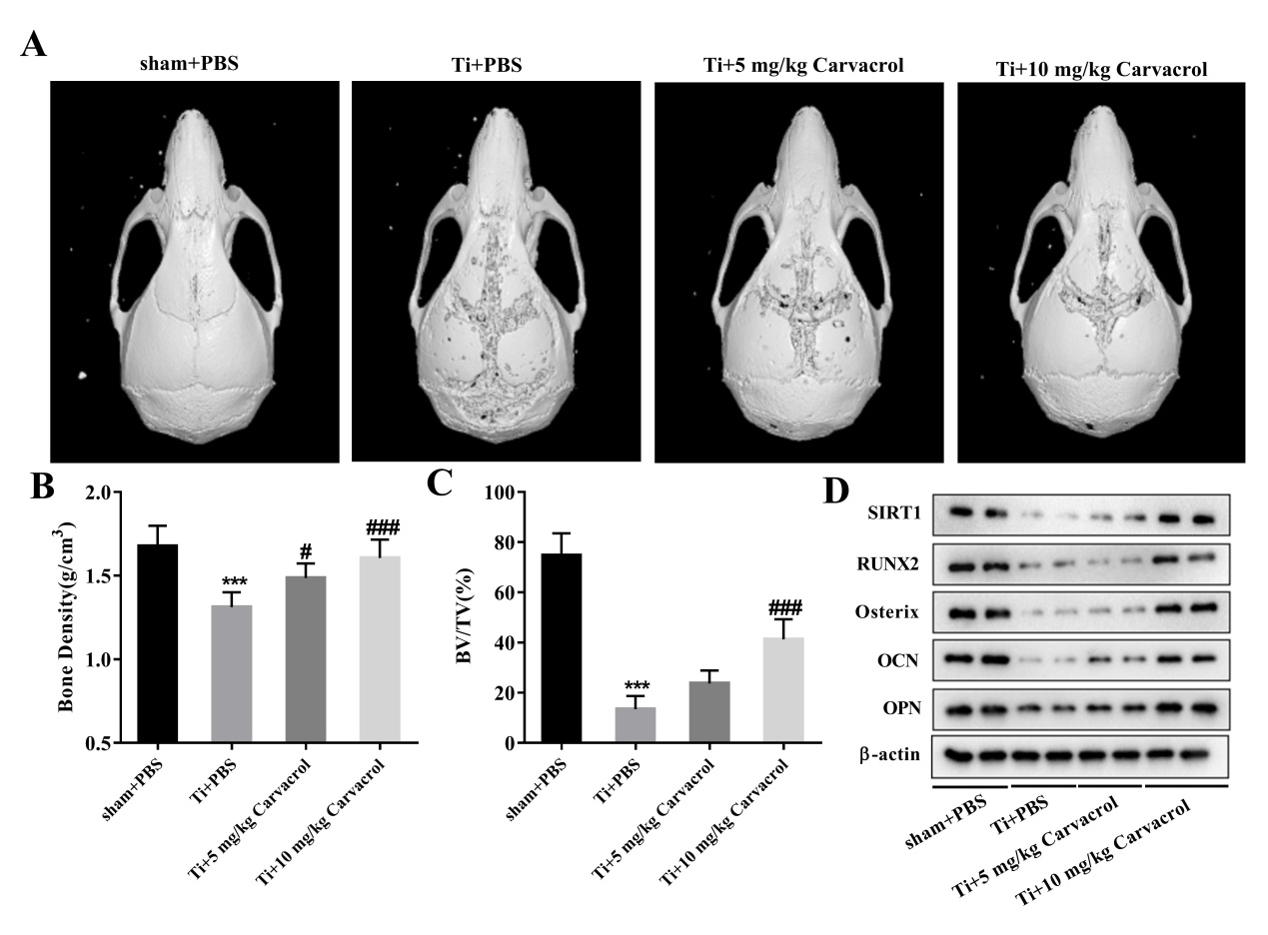
Fig. 1 Carvacrol alleviates osteolysis in elderly mice in vivo. After creating the osteolysis model using Ti particles, carvacrol (5 mg/kg or 10 mg/kg) was administered daily for two weeks. The sham+PBS and Ti+PBS groups received the same amount of PBS. (A) Representative micro-CT three-dimensional reconstructed images of the mouse calvaria in each group. (B-C) Bone density (g/cm³) and BV/TV (%) of each group were measured. All values are presented as mean ± SD. One-way ANOVA was performed by Tukey's multiple comparisons test and statistically significant differences were indicated by: ***p<0.001 vs. the Sham+PBS group; #p<0.05, ###p<0.001 vs. the Ti+PBS group. (D) The expressions of PSIRT1, RUNX2, Osterix, OCN, OPN, and β-actin in each group were detected by western blot. β-actin was used as an internal control for equal amounts of protein applied.

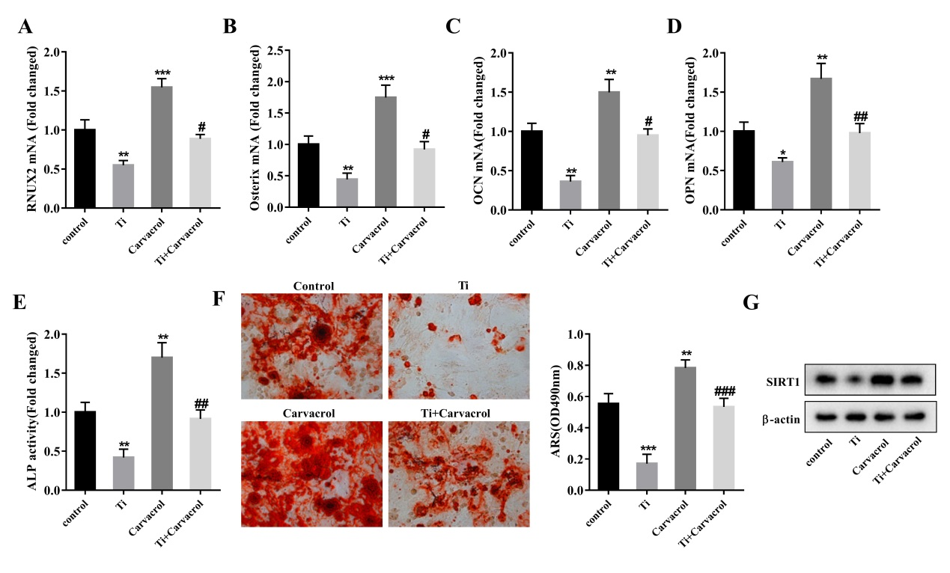
Fig. 2 Carvacrol alleviates osteogenic differentiation of Ti-inhibited BMSCs in vitro. BMSCs were stimulated by Ti particles and treated with carvacrol at concentrations of 25 μM. RT-qPCR analysis of relative mRNA levels of osteoblast differentiation-related factors, including RUNX2 (A), Osterix (B), OCN (C), and OPN (D) in BMSCs supernatant of each group. (E) Quantitative analysis of ALP activity of BMSCs. (F) After carvacrol treatment, BMSCs were cultured in an osteogenic induction medium and stained with ARS on days 21. Representative photographs of ARS staining. Mineralized nodules were quantified by calculating the ratio of mineralized area to total area after staining. One-way ANOVA was performed by Tukey's multiple comparisons test and statistically significant differences were indicated by: *p<0.05, **p<0.01, ***p<0.001 vs. the control group; #p<0.05, ##p<0.01, ###p<0.001 vs. the Ti group. (G) The relative protein expression levels of SIRT1 in each group of BMSCs were evaluated.
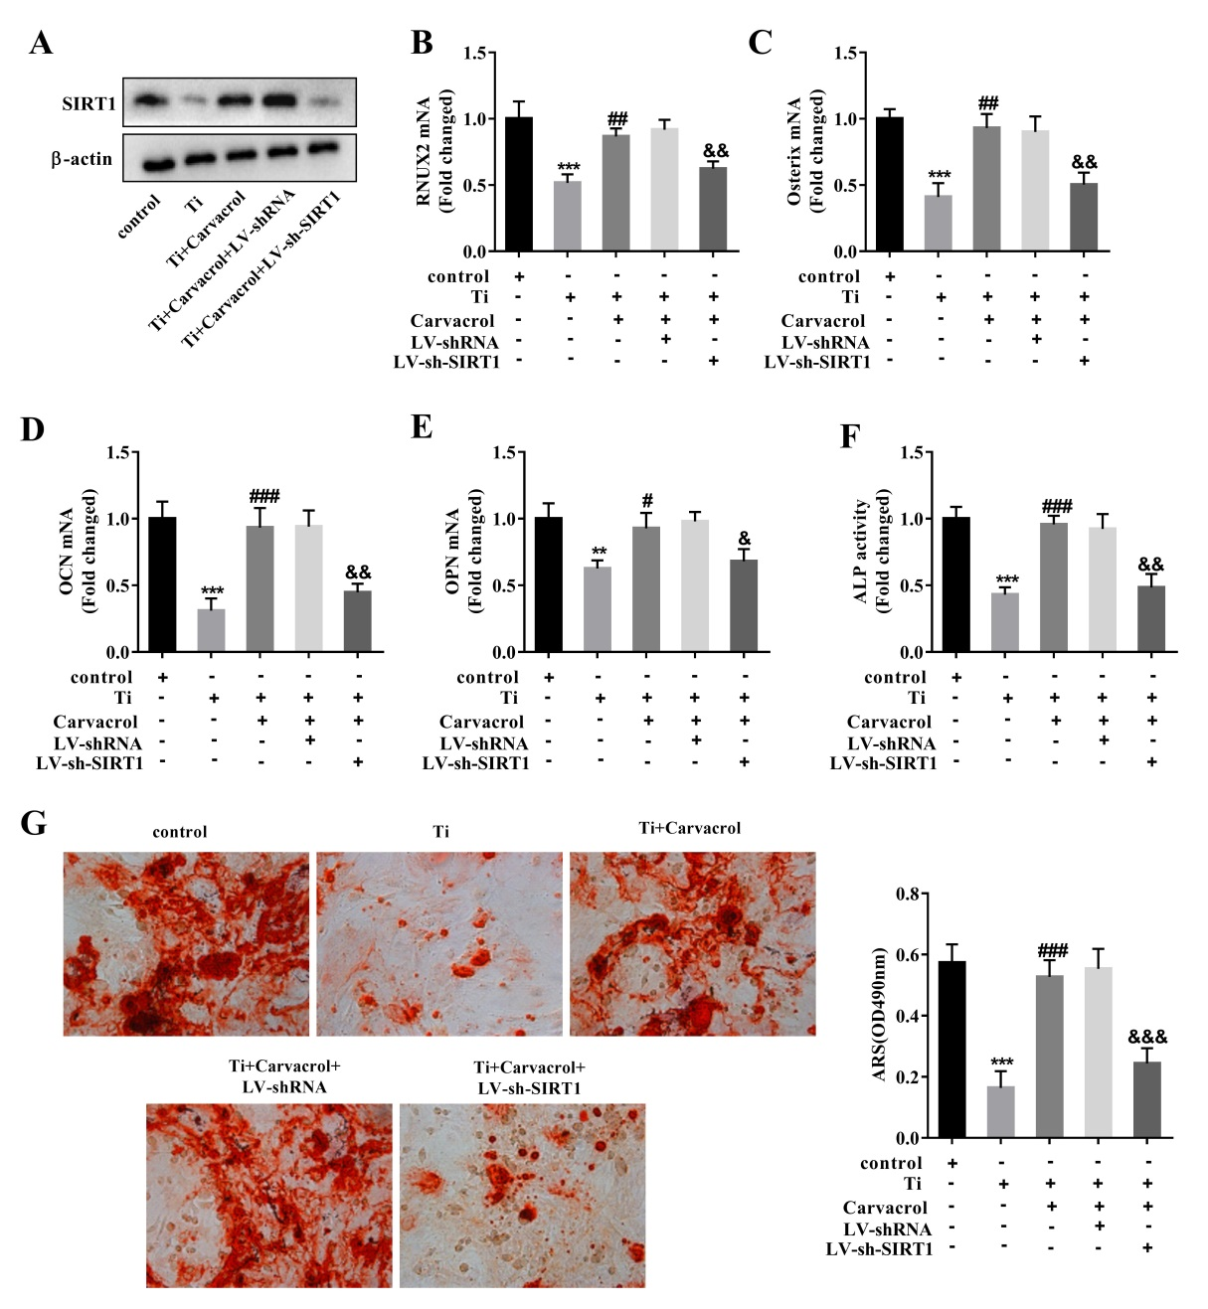
Fig. 3 Carvacrol alleviates osteogenic differentiation of Ti-inhibited BMSCs by upregulating SIRT1. BMSCs were transfected with LV-sh-SIRT1 or LV-shRNA (negative control), then cultured for osteogenic differentiation after transfection, and treated with carvacrol (25 μM). (A) Expression levels of SIRT1 were analyzed by western blotting. (B-E) RUNX2, Osterix, OCN, and OPN mRNA expression in mouse BMSCs was measured by RT-qPCR. (F) Quantitative analysis of ALP activity of BMSCs. (G) ARS staining measured mineralized nodules. Mineralized nodules were quantified by calculating the ratio of mineralized area to total area after staining. One-way ANOVA was performed by Tukey's multiple comparisons test and statistically significant differences were indicated by: **p<0.01, ***p<0.001 vs. the control group; #p<0.05, ##p<0.01, ###p<0.001 vs. the Ti group; &p<0.05, &&p<0.01, &&&p<0.001 vs. the Ti+Carvacrol+ LV-shRNA group.
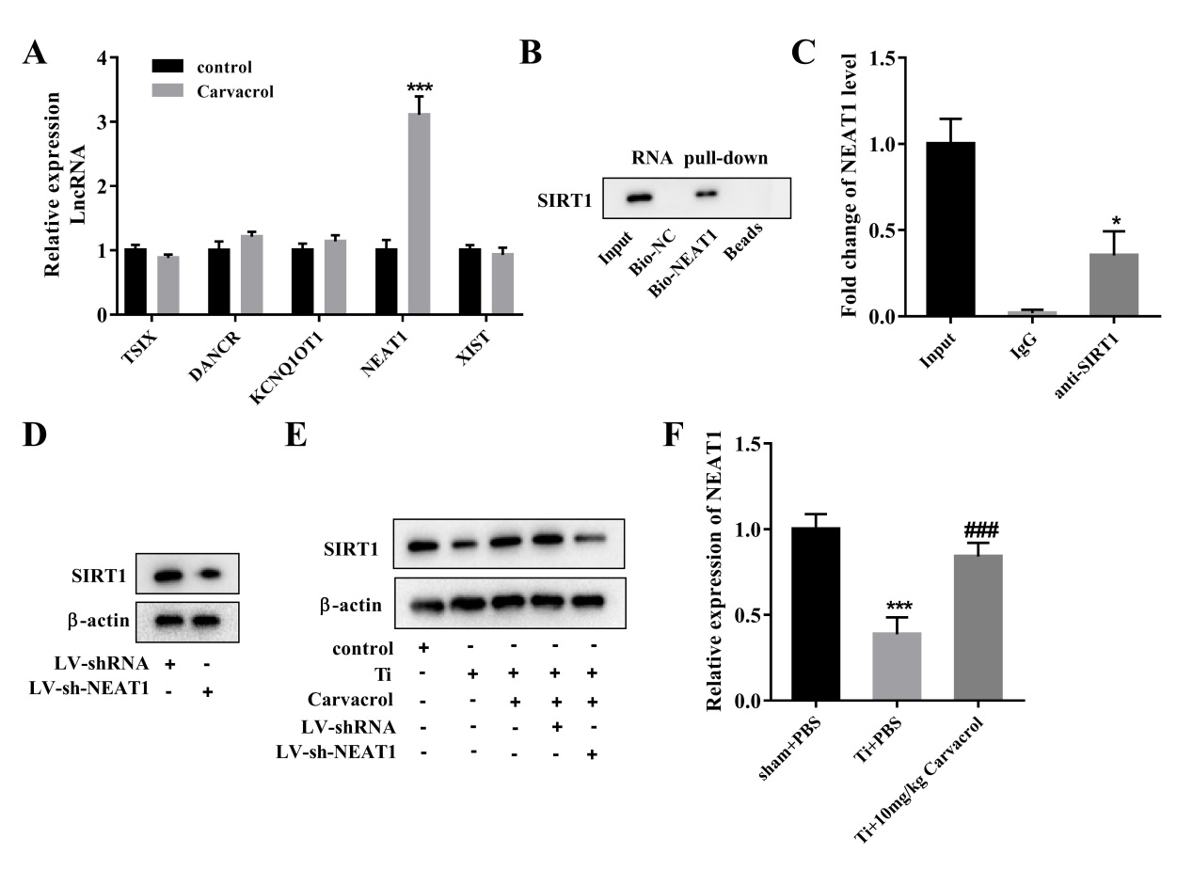
Fig. 4 Carvacrol promotes SIRT1 expression through NEAT1. (A) The mRNA levels of lncRNAs, including TSIX, DANCR, KCNQ1OT1, NEAT1, and XIST in carvacrol-treated cells were measured using RT-PCR. ***p<0.001 vs. control. Statistical analyses were performed using a two-tailed unpaired Student's T-test. (B) RNA pull-down assay was performed to verify the interaction between NEAT1 and SIRT1. (C) The binding between NEAT1 and SIRT1 was measured using RIP assay. *P<0.05 vs. IgG. (D) The protein levels of SIRT1 in BMSCs transfected with LV-sh-SIRT1 or LV-shRNA were determined using western blot assays. (E) BMSCs were divided into control, Ti, Ti+carvacrol, Ti+carvacrol+LV-shRNA, and Ti+carvacrol+LV-sh-NEAT1 groups. SIRT1 protein levels were detected by western blot. (F) NEAT1 mRNA expression levels in the calvarial samples in Figure 1 were detected by RT-qPCR. One-way ANOVA was performed by Tukey's multiple comparisons test and statistically significant differences were indicated by: ***p<0.001 vs. the sham+PBS group; ###p<0.001 vs. the Ti+PBS group.

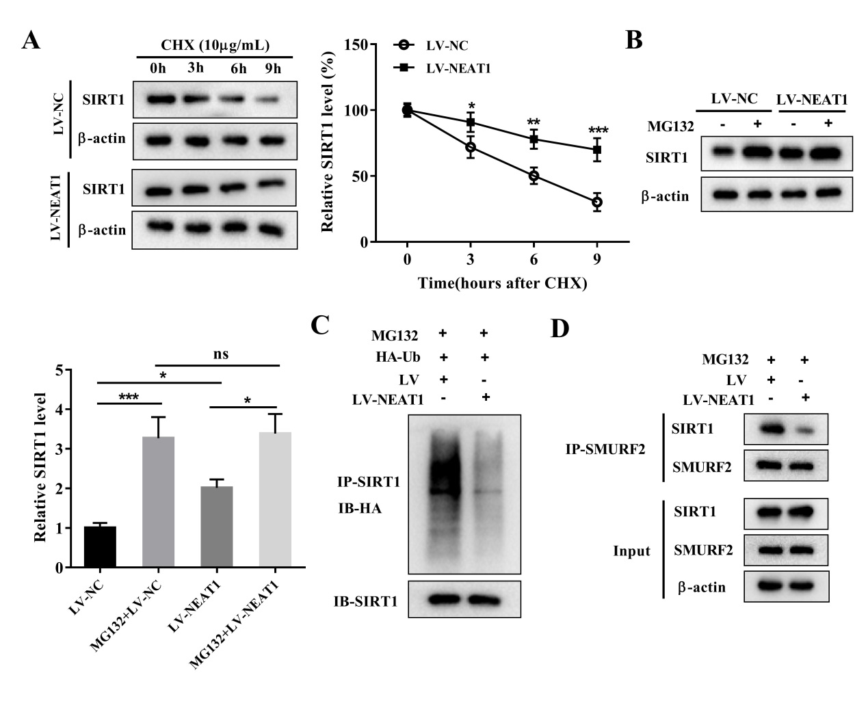
Fig. 5 NEAT1 stabilizes the expression of SIRT1 by inhibiting its ubiquitination levels. BMSCs were transfected with LV-NEAT1 or LV-NC. (A) BMSCs treated with CHX for 0 h, 3 h, 6 h, and 9 h were analyzed by western blotting for SIRT1 expression. *P<0.05, **P<0.01, ***P<0.001 vs. control. Two-way ANOVA was performed by Bonferroni's multiple comparisons test. (B) BMSCs were treated with (or without) 10μM proteasome inhibitor MG132 for 4 hours. The cells were collected and SIRT1 protein expression was detected by western blot. One-way ANOVA was performed by Tukey's multiple comparisons test and statistically significant differences were indicated by: ^{ns} P>0.05, *P<0.05, ***P<0.001. One-way analysis of variance with Tukey's multiple comparisons post hoc test. (C) After MG132 (10 μM) treatment for 4 h, IP assays were performed with anti-SIRT1 in BMSCs transfected with LV-NEAT1 or LV-NC. IB analysis of total-Ub and SIRT1 in SIRT1-immunoprecipitated products was performed. (D) The interaction between SIRT1 and SMURF2 regulated by NEAT1 was analyzed by IP and IB assay.

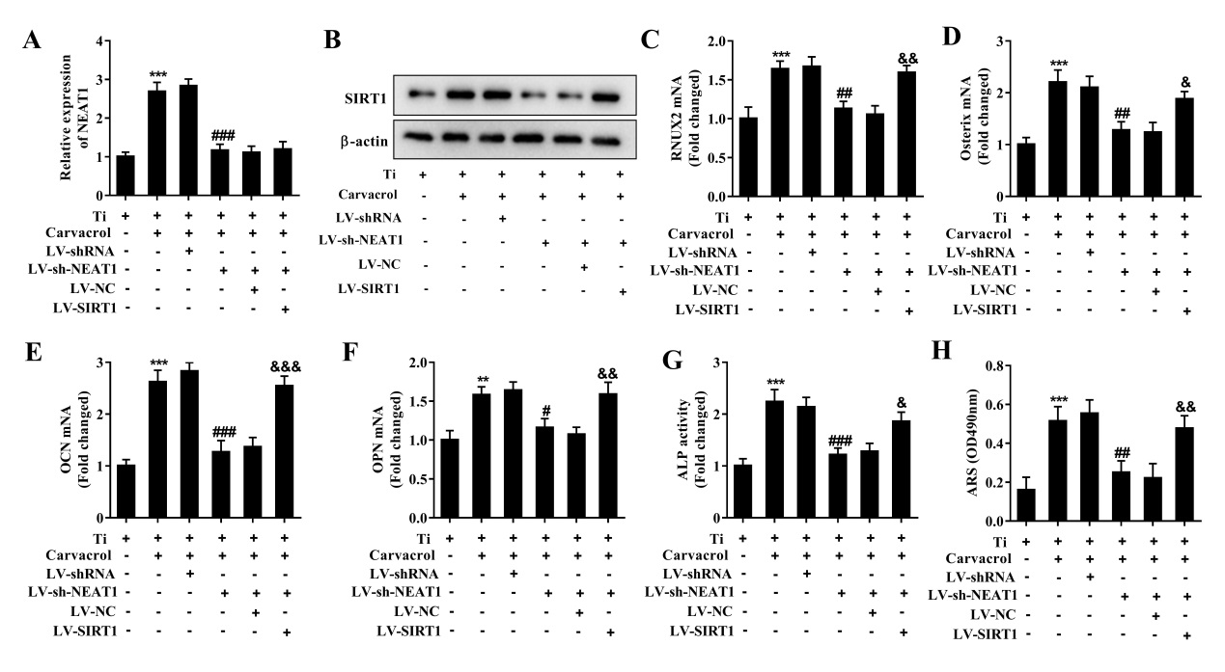
Fig. 6 Carvacrol promotes SIRT1 expression by upregulating NEAT1 and alleviates titanium inhibited osteoblast differentiation. BMSCs were transfected with LV-shRNA, LV-sh-NEAT1, LV-sh-NEAT1+LV-NC or LV-sh-NEAT1+LV-SIRT1, then cultured for osteogenic differentiation after transfection, and treated with carvacrol (25 μM). (A) Reverse transcription-quantitative PCR was performed to analyze the expression of NEAT1. (B) The protein expression of SIRT1 was examined using western blotting. β-actin was used as an internal control for equal amounts of protein applied. (C-F) Reverse transcription-quantitative PCR was performed to analyze the expression of RUNX2, Osterix, OCN, and OPN. (G) Quantitative analysis of ALP activity of BMSCs. (H) ARS staining measured mineralized nodules. Mineralized nodules were quantified by calculating the ratio of mineralized area to total area after staining. One-way ANOVA was performed by Tukey's multiple comparisons test and statistically significant differences were indicated by: **P<0.01, ***P<0.001 vs. the Ti group; #p<0.05, ##p<0.01, ###p<0.001 vs. the Ti+Carvacrol+LV-shRNA group; &p<0.05, &&p<0.01, &&&p<0.001 vs. the Ti+Carvacrol+ LV-sh-NEAT1+LV-NC group.

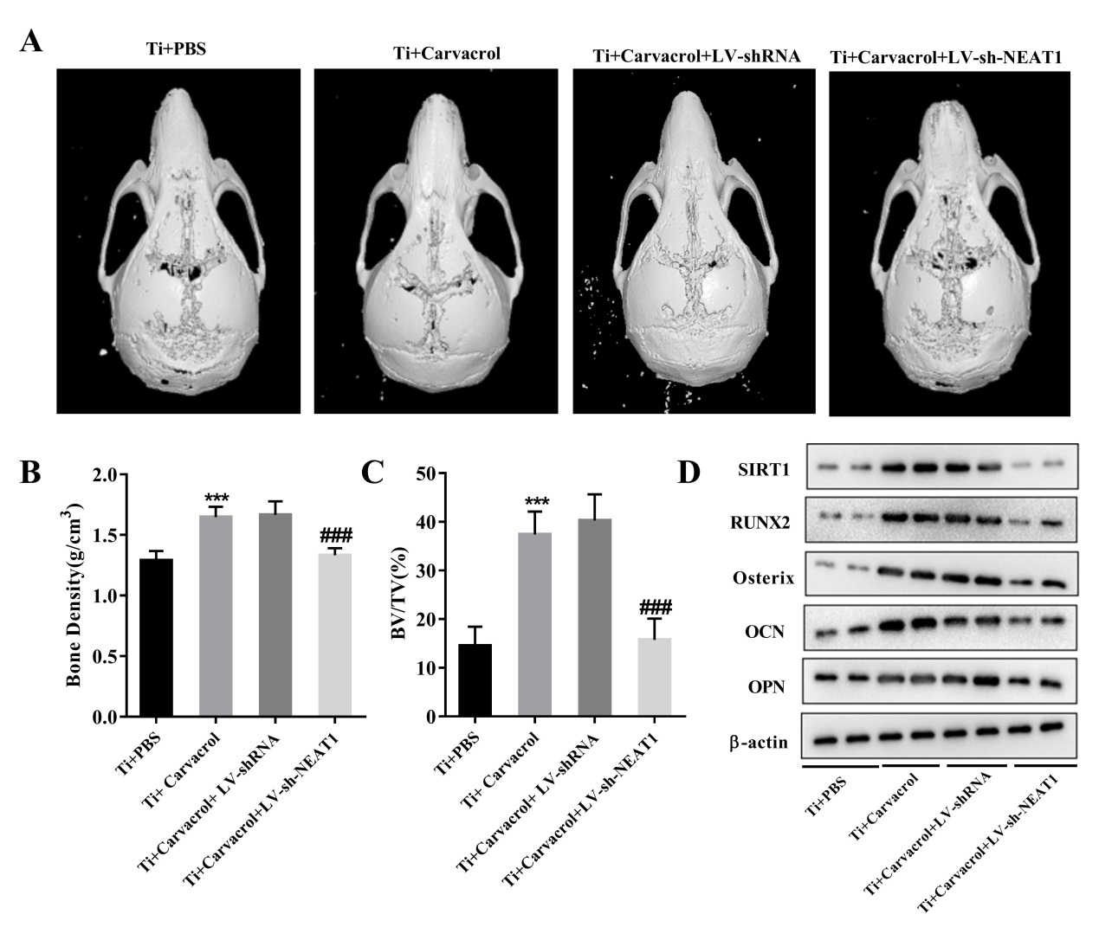
Fig. 7 Carvacrol alleviates osteolysis in elderly mice by upregulating NEAT1. We randomly divided 18-month-old mice into four groups: Ti+PBS, Ti+Carvacrol, Ti+Carvacrol+LV-shRNA, and Ti+Carvacrol+LV-sh-NEAT1 groups. Two weeks after surgery, we collected calvarial tissue from the mice and performed Micro-CT scanning, quantitative Micro-CT analysis, and western blot. (A) Representative micro-CT three-dimensional reconstructed images of the mouse calvaria in each group. (B-C) Bone density (g/cm³) and BV/TV (%) of each group were measured. One-way ANOVA was performed by Tukey's multiple comparisons test and statistically significant differences were indicated by: ***P<0.001 vs. the Ti+PBS group; ###p<0.001 vs. the Ti+ Carvacrol+LV-shRNA group. (D) The protein expression of SIRT1, RUNX2, Osterix, OCN, and OPN was examined using western blotting. β-actin was used as an internal control for equal amounts of protein applied.
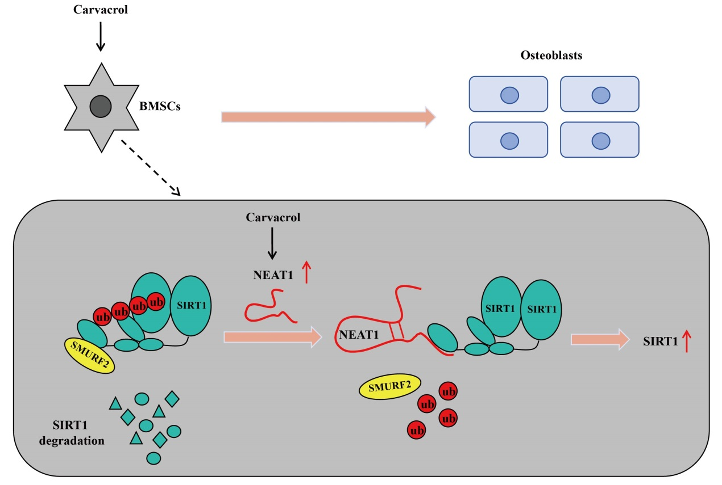
Fig. 8 A working model has been proposed for carvacrol induces osteogenic differentiation of BMSCs and alleviates osteolysis in aged mice. Carvacrol promotes SIRT1 expression by upregulating NEAT1 and induces the expression transcription factors, ultimately leading to the promotion of osteogenic differentiation of bone marrow mesenchymal stem cells and the alleviation of osteolysis in aged mice.

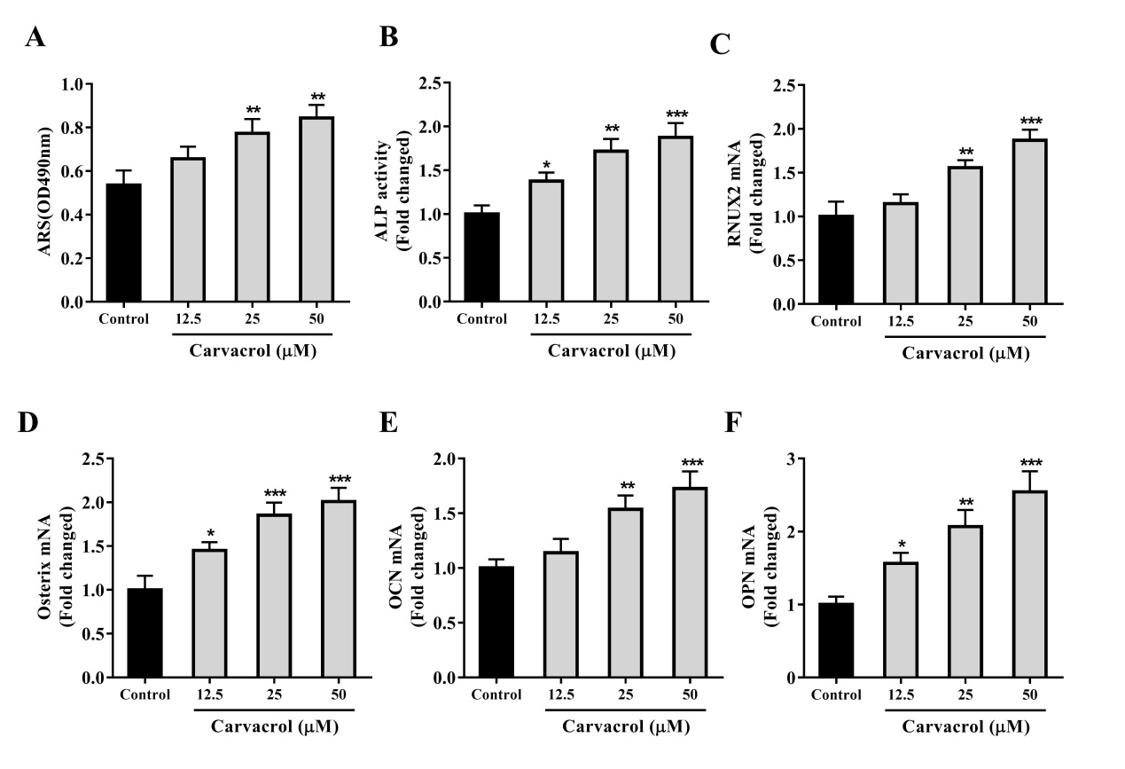
Fig. S1 Determining the concentration of carvacrol for promoting the differentiation of BMSCs into osteoblasts. BMSCs were pretreated with different concentrations of carvacrol (12.5, 25, and 50 μM). (A) ALP activity detection. (B) Ratio of area of purple nodules of calcium phosphate to total area after staining. (C-F) BMSCs were harvested after treatment with carvacrol for 7 d, and RUNX2, Osterix, OCN and OPN expression levels were measured by RT-qPCR. Data are presented as the mean ± SD. One-way ANOVA was performed by Tukey's multiple comparisons test. *p<0.05, **p<0.01, ***p<0.001 vs. the control group.

