Dear reviewer:
Thank you for your decision and constructive comments on my manuscript. We have carefully considered the suggestion of the reviewer and made some changes. We have tried our best to improve. The revised sections are marked in red. Revision notes, point-to-point, are given as follows:

Reviewer 1#
In this article, Xu et al. investigated whether carvacrol alleviates osteolysis and promotes osteogenic differentiation of BMSCs by regulating SIRT1 expression. I think this paper is acceptable after some minor revisions.
1. Line 88: Please add 2-3 sentences to specify why BMSCs are important for bone regeneration rather than just listing several references.
Response: Thank you for the suggestion. We have added the information required as explained above: Bone marrow-derived mesenchymal stem cells (BMSCs) are important for bone regeneration due to their multipotent differentiation ability, as they can differentiate into various cell types, including osteoblasts, chondrocytes, and adipocytes, thereby aiding in bone tissue regeneration and repair [1-4]. Additionally, BMSCs secrete growth factors and extracellular matrix molecules that promote angiogenesis, cell proliferation, and differentiation [5]. Please see the revised manuscript of line 88-93.

2. It is better to add a graphical abstract of the mechanism of the paper.
Response: We have added a graphical abstract in the revised manuscript. Please see the revised manuscript of page 32. The revised text is as follows: Fig. 8 A working model has been proposed for carvacrol induces osteogenic differentiation of BMSCs and alleviates osteolysis in aged mice. Carvacrol promotes SIRT1 expression by upregulating NEAT1 and induces the expression transcription factors, ultimately leading to the promotion of osteogenic differentiation of bone marrow mesenchymal stem cells and the alleviation of osteolysis in aged mice.
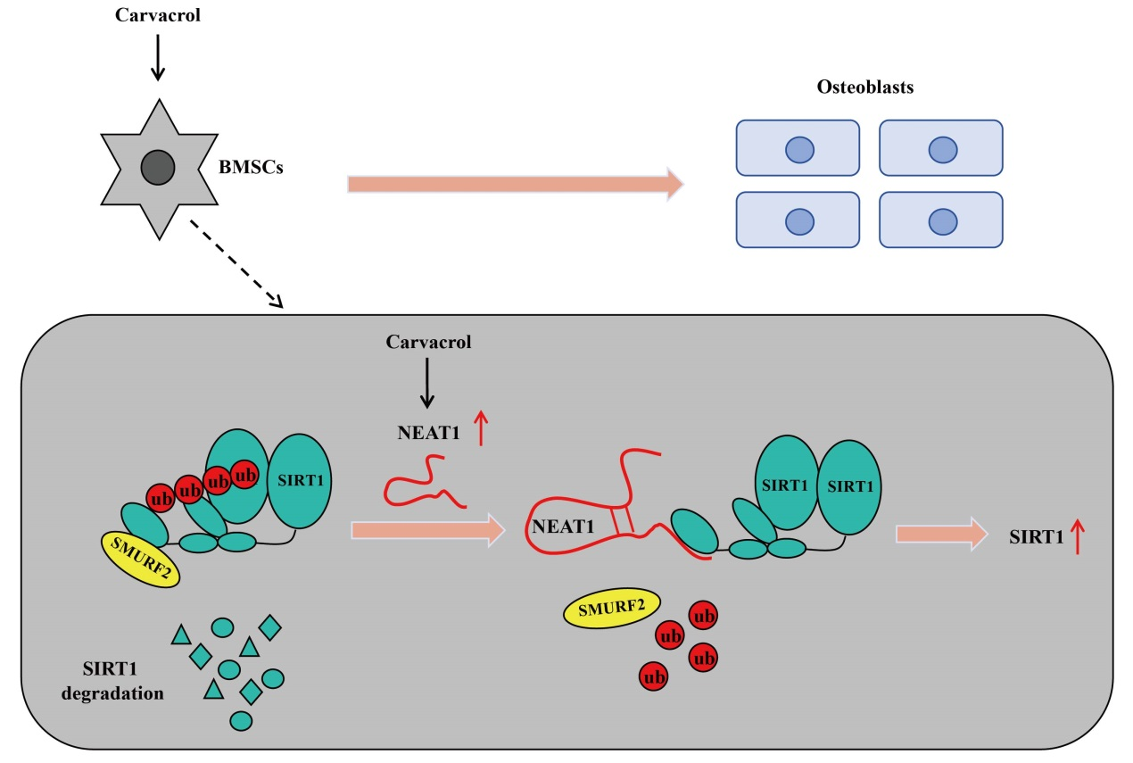

3. Line 460: "upregating" should be "upregulating".
Response: Thank you for pointing this out. We were really sorry for our careless mistakes. Thank you for your reminder. We have made corrections as “upregulating”. Please see the revised manuscript of line 463.

Reviewer 2#
This manuscript showing that carvacrol induces osteogenic differentiation of BMSCs and alleviates osteolysis in aged mice by upregulating lncRNA NEAT1 to promote SIRT1 expression is well written and scientifically solid. It is well suited for publication in Aging Pathobiology and Therapeutics.
Response: Thank you for your decision and constructive comments on my manuscript.

Reference
1. Al-Ahmari, F., et al., Efficacy of Mesenchymal Stem Cells as Adjunct to Guided Bone Regeneration in Standardized Calvarial Defects in Rats: An In Vivo Microcomputed Tomographic and Histologic Analysis. Int J Periodontics Restorative Dent, 2016. 36 Suppl: p. s23-37.
2. Namli, H., et al., Vertical Bone Augmentation Using Bone Marrow-Derived Stem Cells: An In Vivo Study in the Rabbit Calvaria. Implant Dent, 2016. 25(1): p. 54-62.
3. Zaher, W., et al., An update of human mesenchymal stem cell biology and their clinical uses. Arch Toxicol, 2014. 88(5): p. 1069-82.
4. Su, P., et al., Mesenchymal Stem Cell Migration during Bone Formation and Bone Diseases Therapy. Int J Mol Sci, 2018. 19(8).
5. Choudhery, M.S., et al., Bone marrow derived mesenchymal stem cells from aged mice have reduced wound healing, angiogenesis, proliferation and anti-apoptosis capabilities. Cell Biol Int, 2012. 36(8): p. 747-53.

