Exploring the complex interplay between anxiety, aging, and behavior in CB6F1 and C57BL/6 mice: Implications for cognitive function

¹Kunyuan Li, Gerald Yu Liao¹, Addison Keely¹, Shuliang Yu², Christina Pettan-Brewer¹, Warren Ladiges^{1*}

¹Department of Comparative Medicine, School of Medicine, University of Washington, Seattle, WA
²State University of Buffalo, Buffalo, NY.

Abstract
Anxiety is a pervasive emotional response that can profoundly impact well-being and cognitive function in both humans and animals. The relationship between anxiety and aging remains complex and multifaceted. In order to study this relationship in more detail, an open-field photobeam system was used to quantify anxiety-related behaviors in aging CB6F1 and C57BL/6 male mice and determine associations with aging phenotypes including short- and long-term memory, grip strength, rotarod performance, and self-motivated wheel running. The findings indicated a heightened anxiety in novel environments with increasing age as evidenced by preference for peripheral areas during the open-field test. Elevated anxiety levels were associated with decreased cognitive performance, suggesting a link between anxiety and cognitive impairment. A negative correlation was observed between anxiety level and distance ran in the voluntary wheel running assessment, while no associations were seen with grip strength or rotarod performance. These observations contribute to an increased understanding of anxiety and its consequences in aging mice, providing insights into potential therapeutic interventions aimed at delaying aging through anxiety management.

Key words. Anxiety, Aging, Behavioral assessment, Cognition, CB6F1 mice, C57BL/6 mice.

*Correspondence. Warren Ladiges, wladiges@uw.edu

Introduction
Anxiety is a pervasive emotion that can manifest as an unpleasant state of internal confusion and a sense of fear toward impending events [1-3]. While anxiety is a common physiological response to a stressful situation, the constant presence is a sign of a clinical diagnosis of an anxiety disorder [4-7]. The numerous types of anxiety disorders have common risk factors but distinct symptoms, with generalized anxiety disorder (GAD) and obsessive-compulsive disorder (OCD) being the most common [8-9]. There is published evidence of an association between anxiety and memory, with the presence of anxiety serving as a strong predictor of future cognitive deterioration [10-13]. Symptoms of memory impairment often emerge along with those of anxiety [14-17].
Anxiety in mice parallels the physiological responses observed in humans, which include increased alertness, avoidance of certain environments or stimuli, changes in motor activity, changes in social interactions, and physiological changes such as increased heart rate or blood pressure [18]. Several behavioral tests have been designed to measure anxiety in mice based on the introduction to novel environments that may elicit anxiety secondary to an intrinsic fear response. The open-field test (OFT) is a popular paradigm that employs a floor grid and video tracking system to record movements within predefined grid zones over various time intervals [19]. The photobeam-based variant of this test allows for increased tracking frequencies, enabling more precise observations of anxiety-related behaviors [20]. Anxious tendencies in mice are often characterized by an aversion to open and exposed spaces, leading to increased time spent in the peripheral areas of the testing area while avoiding exploration of the central region [21-22].
This study examines the relationship between anxiety and established aging parameters in mice to help understand the associations and mechanisms underlying the aging process and its effect on various physiological and behavioral aspects. The findings develop further insight on age-related disorders and contribute to the development of novel therapeutic approaches and interventions to promote healthy aging.

Methods

Animals. CB6F1 (C57BL/6 X Balb/c F1 cross) and C57BL/6 male mice in age groups of 4, 12, 20, 28 months were obtained from the National Institute on Aging Aged Rodent Colony, contracted by Charles River, Inc. Mice were housed in a specific pathogen free mouse facility at the University of Washington (UW) main campus in Seattle, WA. The status of the room was monitored under the guidance of the Rodent Health Monitoring Program within the purview of the UW Department of Comparative Medicine. Mice were group housed, up to five per cage, and given nestlets (Ancare Corp, Bellmore, NY) for environmental enrichment. Mice were acclimated for two weeks before starting test procedures. All procedures were approved by the University of Washington IACUC (Animal Care and Use Committee).

Anxiety Assessment. An open-field photobeam testing system (Columbus Instruments, Inc) was employed to evaluate anxiety-related behaviors of mice in a novel environment as previously described [23]. The apparatus simulates a standard mouse cage, featuring a clear rectangular container and infrared beams arranged in a grid pattern, three horizontally and four vertically. The open-field photobeam system was configured with two sets of infrared beams to measure both lateral and vertical activity. Beam breaks, which occurred when mice crossed an infrared beam, were counted for each activity. The data collected were subsequently categorized into two distinct zones: the central and peripheral areas of the container. This categorization allowed for the assessment of anxiety levels based on preference for exploring specific regions. Increased time spent in the central area suggested reduced anxiety, whereas a preference for peripheral regions suggested heightened anxiety. Each mouse was placed inside the testing container for a period of five minutes. This standard duration ensured consistent evaluation of anxiety-related behaviors and minimized potential habituation effects or stress-related responses.

Memory Assessment. A radial water tread maze was used to assess short-term and long-term memory [24]. The maze consisted of a circular basin with nine holes, eight decoys leading to dead ends, and one escape hole leading to a dark safety box equipped with a heating pad to simulate a standard mouse cage. The basin contained approximately one inch of water and an overhead light placed above the cage as an escape incentive. Mice had three trials in the maze for four consecutive days of training, followed by testing on the fifth day and retesting on the twelfth day.

Grip Strength Assessment. Forelimb paw strength was measured using a grip strength meter [25]. Each mouse was positioned horizontally with forepaws on a metal grip bar (Columbus Instruments, Inc), and the mouse was pulled back at a uniform rate until releasing the bar. The machine recorded the maximum force exerted by the mouse for a total of five trials. Mice were weighed on the test day and peak force was expressed relative to body weight to normalize grip strength measurements.

Agility Assessment. Agility was assessed using a Rotamax 4/8 rotating bar machine (Columbus Instruments, Inc) [25]. The machine tested the ability of mice to maintain walking speed on a rotating bar. The initial speed was set to 0 RPM and gradually increased by 0.1 RPM/s over a 5-minute duration until all mice fell off and were detected by a sensor. The time in seconds was recorded for each mouse over three trials.

Voluntary Wheel Running Assessment. Total distance ran over three days was measured with a running wheel added to a standard mouse cage [26]. Mice were individually housed in standard cages with a slanted running wheel wirelessly connected to a computer (Med Associates, Inc). There was a two-day acclimation period with the wheels locked and on the third day the wheel was unlocked, and data collection began. Running distances were continuously monitored over a 72-hour period with total distances ran every minute recorded in kilometers.

Data Analysis. All data were grouped according to strain and age. A Shapiro-Wilk test was used to assess data under each group when normally distributed. For normally distributed data, statistical comparisons were performed using parametric tests. Data that were not normally distributed were analyzed using non-parametric tests. The Wilcoxon rank sum test was used to determine significant differences between two groups when the data were not normally distributed. The Kruskal-Wallis H test was used to determine significant differences between multiple groups. In cases where there was no interaction between factors, but a factor was found to be statistically significant, a post-hoc analysis of means was conducted using the Bonferroni adjustment method. Spearman’s rank test was used to measure the strength of association between aging and each parameter while the point-biserial correlation coefficient was used for assessing the association between a continuous variable and a binary variable. All statistical analyses were performed using R Statistical Software (version 4.2.1).

Results

Age-related differences in movement were detected in both CB6F1 and C57BL/6 mice.
Mice 20 to 28 months of age exhibited prolonged periods of movement compared to younger mice at 4 to 12 months of age in both CB6F1 and C57BL/6 (B6) strains (Figure 1). Inter-strain comparison of the older mice displayed more extensive movement in the CB6F1 strain compared to their B6 cohorts. Statistical analysis using ANOVA reinforced the significance of age as a determining factor of movement type.
A. CB6F1 Total Movement Time in OFT B. C57BL/6 Total Movement Time in OFT
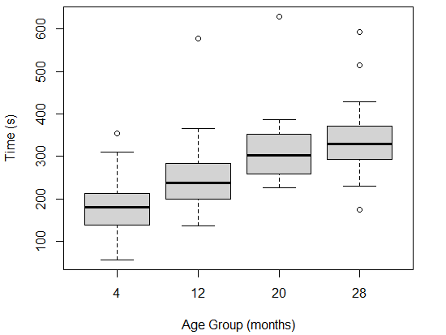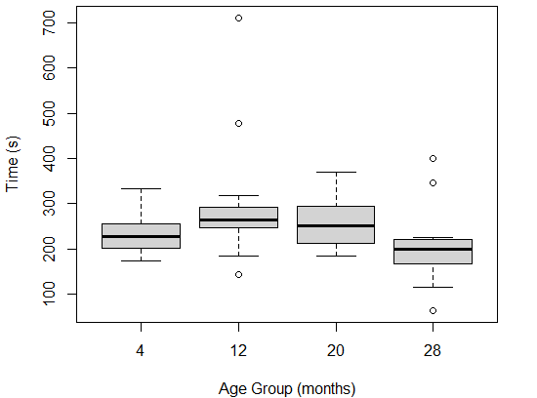

Figure 1. Total movement time in open field. A. CB6F1 mice at 20 and 28 months of age exhibited significant differences when compared to 4 and 12-month-old cohorts, and showed a positive association between movement and age. B. B6 mice at the same age groups showed the same significant differences, but the age-related increase in movement seen in CB6F1 mice was absent (p<0.05, N = 20/cohort, OFT = open-field photobeam testing system).

CB6F1 mice showed age-dependent area region preferences.
Older CB6F1 mice exhibited significantly more time in both central and peripheral areas than their younger counterparts (Figure 2). Older B6 mice did not display such distinctions. A comparative analysis of time recorded within each area for both strains yielded significant differences between time spent in each type of area.
CB6F1 mice at 28 months of age allocated significantly more time to peripheral areas than 28-month-old B6 mice (Figure 2). A specific analysis of time spent in the peripheral area was conducted considering age and strain as differentiating factors. These observations collectively suggest that with increasing age CB6F1 mice have a higher likelihood than B6 mice for prolonged occupancy in peripheral areas.

A. CB6F1 Central Movement in OFT B. C57BL/6 Central Movement Time in OFT
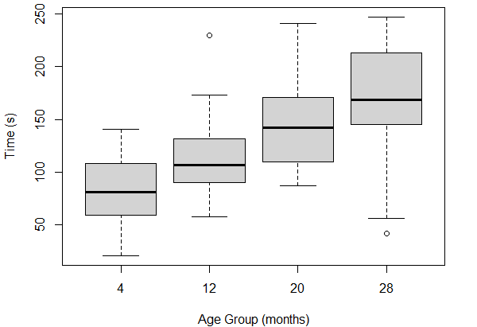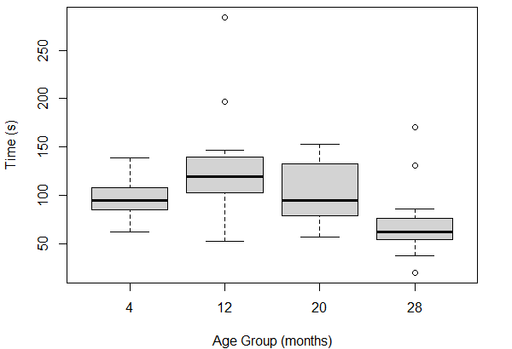
C. CB6F1 Peripheral Movement Time in OFT D. C57BL/6 Peripheral Movement Time in OFT
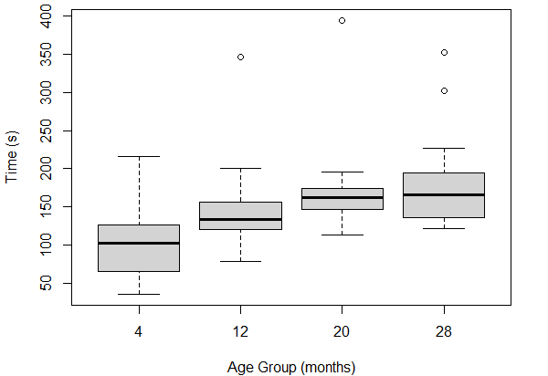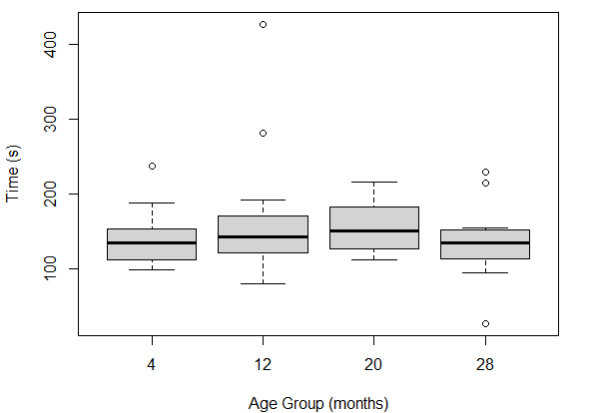

Figure 2. Total time spent in central and peripheral areas. CB6F1 mice at 28-months of age spent significantly more time in both central (Figure 2A) and peripheral (Figure 2C) areas compared to B6 mice (Figures 2B and 2D, respectively) (p<0.05, N = 20/cohort, OFT = open-field photobeam testing system).

Time spent rearing was age dependent in CB6F1 mice.
Older CB6F1 mice spent significantly more time rearing than their younger counterparts, as demonstrated by a focused analysis (Figure 3). Time spent rearing was not area dependent as there was no statistically significant difference between time rearing in peripheral areas and central areas in any analysis group. Overall, both CB6F1 and B6 mice spent significantly less time rearing than moving laterally.

A. CB6F1 Central Lateral Movement Time in OFT B. CB6F1 Central Vertical Movement Time in OFT
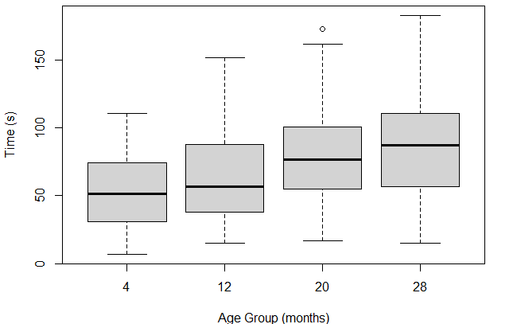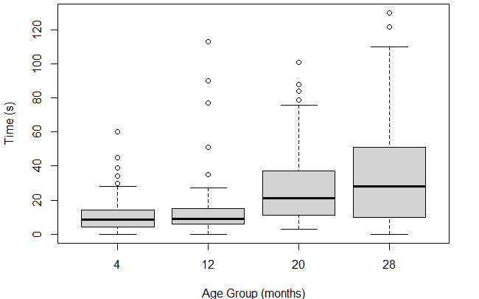
C. CB6F1 Peripheral Lateral Movement Time in OFT D. CB6F1 Peripheral Vertical Movement Time in OFT
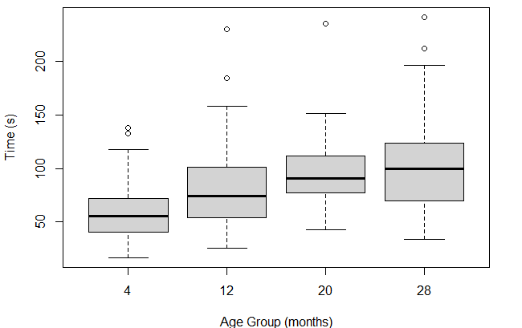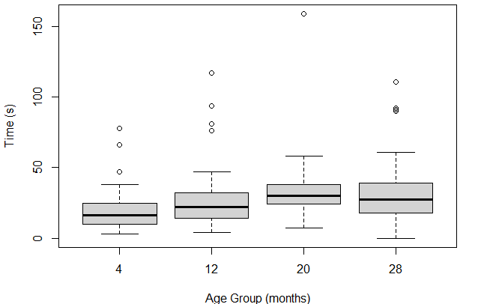
E. C57BL/6 Central Lateral Movement Time in OFT F. C57BL/6 Peripheral Vertical Movement Time in OFT
G. C57BL/6 Peripheral Lateral Movement Time in OFT H. C57BL/6 Peripheral Vertical Movement Time in OFT

Figures 3. Time spent in each area analyzed according to age and strain. Both 20- and 28-month-old CB6F1 mice showed statistical significance in each type of area (Figures 3A, 3B, 3C, 3D) compared to B6 mice (Figures 3E, 3F, 3G, 3H) (p < 0.05, N = 20/cohort, OFT = open-field photobeam testing system).

Long-term memory function was associated with peripheral area preference in aging CB6F1 mice.
Significantly worse long-term memory was observed in older CB6F1 mice that preferred the periphery compared to older CB6F1 mice that spent more time in the central area of the cage (Figure 4). The Open Field Ratio (OFR) was calculated as the time spent in peripheral areas divided by the total time recorded. Long-term memory was quantified by the difference in time to find the escape between day 5 and day 12. There was no discernible association between short term memory and peripheral area preference. Short-term memory was measured by the difference in time to find the escape between day 1 and day 5. There were no statistically significant correlations between memory performance and peripheral area preference in C57BL/6 mice.
A. CB6F1 4-Month Short-Term Memory Correlation B. CB6F1 12-Month Short-Term Memory Correlation
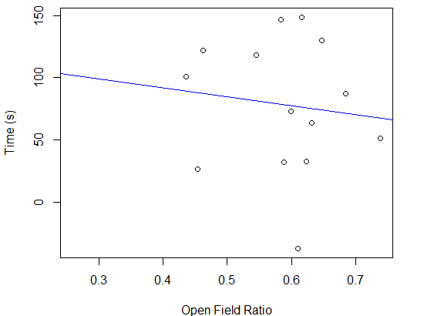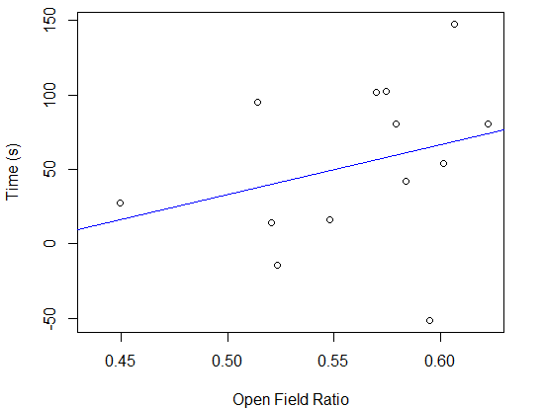
C. CB6F1 20-Month Short-Term Memory Correlation D. CB6F1 28-Month Short-Term Memory Correlation
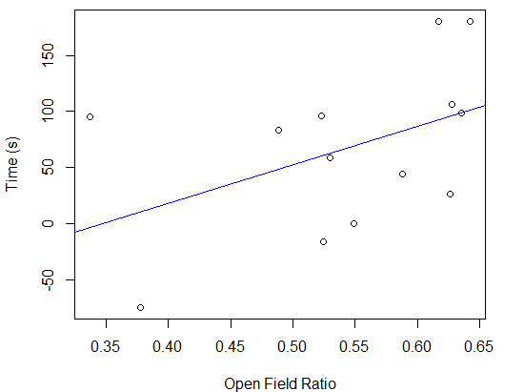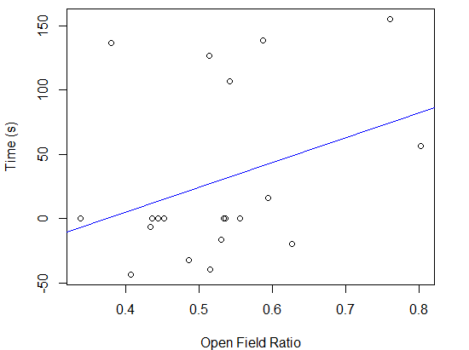
E. CB6F1 4-Month Long-Term Memory Correlation. F. CB6F1 12-Month Long-Term Memory Correlation
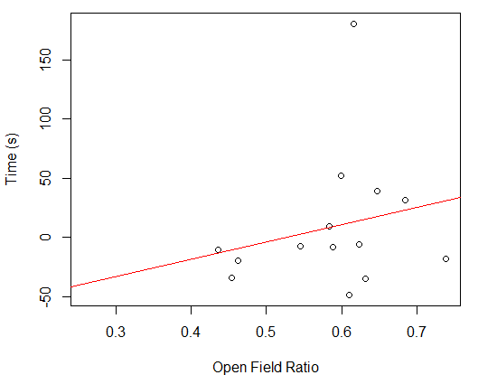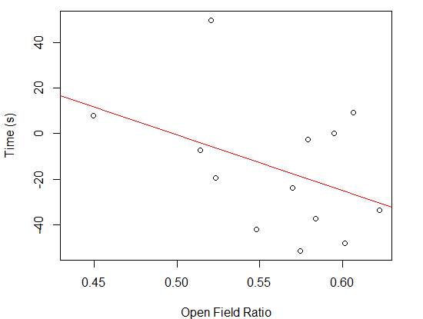
G. CB6F1 20-Month Long-Term Memory Correlation H. CB6F1 28-Month Long-Term Memory Correlation
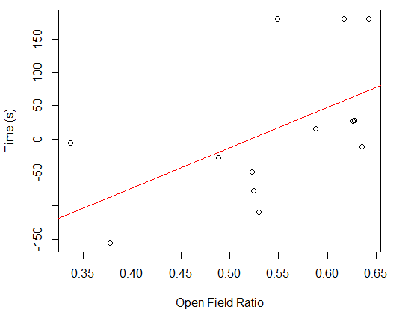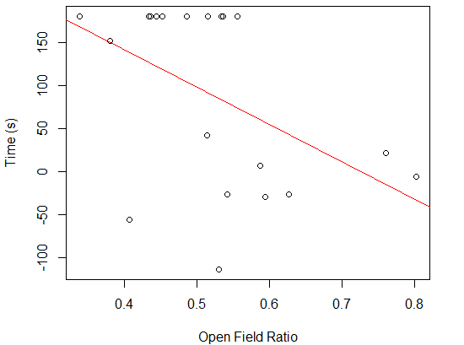

Figure 4. Relationship between memory and Open Field Ratio (OFR). No significant correlation within the younger CB6F1 age groups (Figures 4A, 4B, 4C, 4E, 4F, 4G) (p > 0.05). There was a statistically significant correlation in 28-month-old CB6F1 mice (Figures 4D, 4H) (p < 0.001, N = 20/cohort).

Peripheral area preference was associated with reduced running distance, but not with grip strength or rotarod performance in CB6F1 mice.
28-month-old CB6F1 mice that preferred peripheral areas exhibited a significant reduction in self-motivated running distances (Figure 5). There were no discernible correlations observed between peripheral area preference and grip strength or rotarod performance for either CB6F1 or C57BL/6 mice.
A. CB6F1 4-month running distance correlation B. CB6F1 12-month running distance correlation
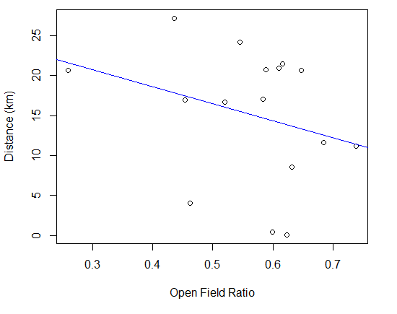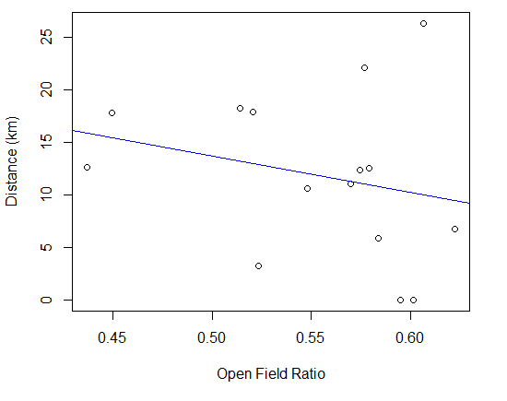
C. CB6F1 20-month running distance correlation D. CB6F1 28-month running distance correlation
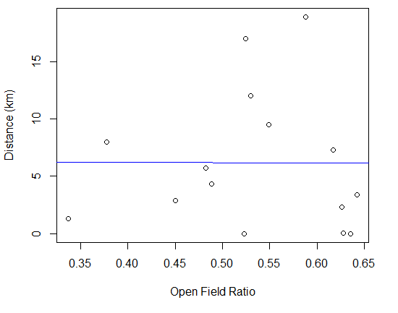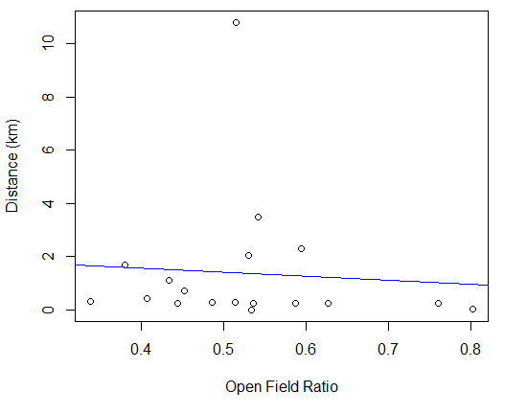

Figure 5. Relationship between OFR and voluntary wheel running distance. There was a significant correlation among 28-month-old CB6F1 mice between time spent in peripheral areas and total running distance (Figure 5D) that was not observed among other age groups (Figures 5A, 5B, 5C) (p < 0.05, N = 20/cohort).

Discussion
Analysis of anxiety-related behaviors in the open-field photobeam testing system (OFT) in relation to cognitive and performance functions revealed insights into the relationships between anxiety, aging, and behavior in mice. Total movement in the test, region preference, rearing time, and the correlation of the open field ration (OFR) and long-term memory were all age dependent. The OFT is useful to measure anxiety in mice based on natural instincts to avoid open spaces and especially with high intensity light due to their vulnerability to predation. This well-documented behavioral manifestation of anxiety is rooted in evolutionary survival mechanisms and is associated with difficulty in emotional and spatial learning [27]. The amount of time spent in peripheral regions emerged as a critical parameter of anxiety. Older mice across strains exhibited heightened anxiety when exposed to a novel environment, as shown by increased time spent in peripheral areas and time spent rearing. Furthermore, mice that displayed elevated anxiety levels demonstrated worse performance in cognitive tasks, suggesting a link between anxiety and cognitive impairment. A negative correlation was also revealed between anxiety level and distance traveled on the voluntary wheel running assessment.
The impact of anxiety on learning and memory is shown in this study by the association of peripheral region preference and decreased long-term memory. Previous research has emphasized the role of neuronal circuits and neurotransmitter systems in anxiety-related cognitive impairment [28-29]. Stress hormones such as cortisol and corticosterone are released during anxiety states and are known to impact the functioning of brain regions involved in memory processing, such as the hippocampus and prefrontal cortex [30-35]. These were not investigated in this study but would be highly relevant for future studies.
Interestingly, there was a statistically significant association between memory performance and peripheral area preference in CB6F1 mice but not in C57BL/6 mice. Since the OFT system tracked movement by registering the number of beams broken when mice departed from their initial position in the middle of the cage, those that remained stationary failed to trigger beam breaks. As C57BL/6 mice are often considered to have a lower baseline level of anxiety without clearly understood reasons [36], this observation suggests that C57BL/6 mice may not be the first choice of a mouse model for studies related to anxiety.
The reduction in running distance observed in the voluntary wheel-running assessment among mice with increased anxiety can be attributed to reduced exploratory behavior and a diminished willingness to engage in physical activity [37]. Such cautiousness, reluctance to take risks, and decreased engagement in high-energy activities align with anxiety-induced behaviors. The absence of a significant correlation between anxiety and motor function, as assessed by the rotarod and grip strength tests, may be attributed to several factors. Performance on these tests primarily reflects motor coordination and physical strength, while anxiety primarily affects emotional and cognitive domains. These tests may not directly elicit anxiety-specific responses in mice. Individual variability in mouse responses to anxiety and motor function capabilities could also contribute to the observed absence of a significant correlation. Further investigations employing more specific anxiety-related assays, or a broader array of behavioral tests may provide a more comprehensive understanding of the relationship between anxiety and motor function in aging mice.
The results of this study highlight the influence of age and strain on anxiety responses in male mice, emphasizing the need for careful consideration of these factors when interpreting open-field test results. The observed preference for peripheral areas in novel environments suggests that physiological anxiety plays a role in mouse behavior and its implications for cognitive function. This study contributes to future research aimed at a better understanding of how anxiety and aging interact in male mice. It is inherent to conduct similar studies in female mice to determine and identify any sex-dependent differences, and thus help provide the rationale to develop new strategies to delay aging through anxiety management.

Acknowledgements
This project was supported by NIH grant R01 AG057381 (Ladiges, PI).

References
- Miceli, M, and Cristiano Castelfranchl. “Expectancy and emotion.” OUP Oxford (2014)
- Rosen, J B, and J Schulkin. “From normal fear to pathological anxiety.” Psychological review vol. 105,2 (1998): 325-50. doi:10.1037/0033-295x.105.2.325
- Rosen, J B et al. “Hyperexcitability: exaggerated fear-potentiated startle produced by partial amygdala kindling.” Behavioral neuroscience vol. 110,1 (1996): 43-50. doi:10.1037//0735-7044.110.1.43
- Robinson, Oliver J et al. “The translational neural circuitry of anxiety.” Journal of neurology, neurosurgery, and psychiatry vol. 90,12 (2019): 1353-1360. doi:10.1136/jnnp-2019-321400
- Julian, Laura J. “Measures of anxiety: State-Trait Anxiety Inventory (STAI), Beck Anxiety Inventory (BAI), and Hospital Anxiety and Depression Scale-Anxiety (HADS-A).” Arthritis care & research vol. 63 Suppl 11,0 11 (2011): S467-72. doi:10.1002/acr.20561
- Shankman, Stewart A et al. “A psychophysiological investigation of threat and reward sensitivity in individuals with panic disorder and/or major depressive disorder.” Journal of abnormal psychologyvol. 122,2 (2013): 322-38. doi:10.1037/a0030747
- Mohlman, Jan, and Jack M Gorman. “The role of executive functioning in CBT: a pilot study with anxious older adults.” Behaviour research and therapy vol. 43,4 (2005): 447-65. doi:10.1016/j.brat.2004.03.007
- Hovenkamp-Hermelink, Johanna H M et al. “Predictors of persistence of anxiety disorders across the lifespan: a systematic review.” The lancet. Psychiatry vol. 8,5 (2021): 428-443. doi:10.1016/S2215-0366(20)30433-8
- Evans, Dwight L et al., “Treating and preventing adolescent mental health disorders: what we know and what we don't know. A research agenda for improving the mental health of our youth.” Oxford University Press (2005) doi:10.1093/9780195173642.001.0001
- Sinoff, Gary, and Perla Werner. “Anxiety disorder and accompanying subjective memory loss in the elderly as a predictor of future cognitive decline.” International journal of geriatric psychiatry vol. 18,10 (2003): 951-9. doi:10.1002/gps.1004
- Kassem, Ahmed M et al. “Anxiety symptoms and risk of cognitive decline in older community-dwelling men.” International psychogeriatrics vol. 29,7 (2017): 1137-1145. doi:10.1017/S104161021700045X
- Shackman, Alexander J et al. “Anxiety selectively disrupts visuospatial working memory.” Emotion (Washington, D.C.) vol. 6,1 (2006): 40-61. doi:10.1037/1528-3542.6.1.40
- Tan, Xin-jie et al. “Anxiety in liver X receptor β knockout female mice with loss of glutamic acid decarboxylase in ventromedial prefrontal cortex.” Proceedings of the National Academy of Sciences of the United States of America vol. 109,19 (2012): 7493-8. doi:10.1073/pnas.1205189109
- Becker, Eva et al. “Anxiety as a risk factor of Alzheimer's disease and vascular dementia.” The British journal of psychiatry: the journal of mental science vol. 213,5 (2018): 654-660. doi:10.1192/bjp.2018.173
- Roberts, Rosebud, and David S Knopman. “Classification and epidemiology of MCI.” Clinics in geriatric medicine vol. 29,4 (2013): 753-72. doi:10.1016/j.cger.2013.07.003
- Beaudreau, Sherry A, and Ruth O'Hara. “Late-life anxiety and cognitive impairment: a review.” The American journal of geriatric psychiatry : official journal of the American Association for Geriatric Psychiatry vol. 16,10 (2008): 790-803. doi:10.1097/JGP.0b013e31817945c3
- Lyketsos, C G et al. “Behavioral disturbances in dementia Reichel’s Care of the Elderly: Clinical Aspects of Aging (5th ed.).” Williams and Wilkins (1999): 214-228
- Steimer, Thierry. “The biology of fear- and anxiety-related behaviors.” Dialogues in clinical neuroscience vol. 4,3 (2002): 231-49. doi:10.31887/DCNS.2002.4.3/tsteimer
- Kraeuter, Ann-Katrin et al. “The Open Field Test for Measuring Locomotor Activity and Anxiety-Like Behavior.” Methods in molecular biology (Clifton, N.J.) vol. 1916 (2019): 99-103. doi:10.1007/978-1-4939-8994-2_9
- Ge, Xuan et al. “Self-motivated and stress-response performance assays in mice are age-dependent.” Experimental gerontology vol. 91 (2017): 1-4. doi:10.1016/j.exger.2017.02.001
- Lee, Wei-Ju et al. “Plasma MCP-1 and Cognitive Decline in Patients with Alzheimer's Disease and Mild Cognitive Impairment: A Two-year Follow-up Study.” Scientific reports vol. 8,1 1280. 19 Jan. 2018, doi:10.1038/s41598-018-19807-y
- Lezak, Kimberly R et al. “Behavioral methods to study anxiety in rodents.” Dialogues in clinical neuroscience vol. 19,2 (2017): 181-191. doi:10.31887/DCNS.2017.19.2/wcarlezon
- Daneshjoo, Sara et al. “A mouse model of naturally occurring age-related cognitive impairment.” Aging pathobiology and therapeutics vol. 4,3 (2022): 87-89. doi:10.31491/apt.2022.09.090
- Pettan-Brewer, Christina et al. “A novel radial water tread maze tracks age-related cognitive decline in mice.” Pathobiology of aging & age related diseases vol. 3 10.3402/pba.v3i0.20679. 4 Oct. 2013, doi:10.3402/pba.v3i0.20679
- Ge, Xuan et al. “Grip strength is potentially an early indicator of age-related decline in mice.” Pathobiology of aging & age related diseases vol. 6 32981. 8 Sep. 2016, doi:10.3402/pba.v6.32981
- Goh, Jorming, and Warren Ladiges. “Voluntary Wheel Running in Mice.” Current protocols in mouse biology vol. 5,4 283-290. 2 Dec. 2015, doi:10.1002/9780470942390.mo140295
- Küçük, Ayşegül et al. “Effects of age and anxiety on learning and memory.” Behavioural brain research vol. 195,1 (2008): 147-52. doi:10.1016/j.bbr.2008.05.023
- Chen, Gui-Hai et al. “Age-related changes in anxiety are task-specific in the senescence-accelerated prone mouse 8.” Physiology & behavior vol. 91,5 (2007): 644-51. doi:10.1016/j.physbeh.2007.03.023
- Abel, T et al. “Memory suppressor genes: inhibitory constraints on the storage of long-term memory.” Science (New York, N.Y.) vol. 279,5349 (1998): 338-41. doi:10.1126/science.279.5349.338
- Kellett, J, and L Kokkinidis. “Extinction deficit and fear reinstatement after electrical stimulation of the amygdala: implications for kindling-associated fear and anxiety.” Neuroscience vol. 127,2 (2004): 277-87. doi:10.1016/j.neuroscience.2004.05.011
- Merz, Christian J, and Oliver T Wolf. “How stress hormones shape memories of fear and anxiety in humans.” Neuroscience and biobehavioral reviews vol. 142 (2022): 104901. doi:10.1016/j.neubiorev.2022.104901
- Anwar, M J et al. “Effect of escitalopram on cardiomyopathy-induced anxiety in mice.” Human & experimental toxicology vol. 32,6 (2013): 632-9. doi:10.1177/0960327112462728
- Joung, Jin-Yong et al. “A literature review for the mechanisms of stress-induced liver injury.” Brain and behavior vol. 9,3 (2019): e01235. doi:10.1002/brb3.1235
- Oakley, Robert H et al. “Essential role of stress hormone signaling in cardiomyocytes for the prevention of heart disease.” Proceedings of the National Academy of Sciences of the United States of America vol. 110,42 (2013): 17035-40. doi:10.1073/pnas.1302546110
- Zhang, David Y, and Allen S Anderson. “The sympathetic nervous system and heart failure.” Cardiology clinics vol. 32,1 (2014): 33-45, vii. doi:10.1016/j.ccl.2013.09.010
- An, Xiao-Lei et al. “Strain and sex differences in anxiety-like and social behaviors in C57BL/6J and BALB/cJ mice.” Experimental animals vol. 60,2 (2011): 111-23. doi:10.1538/expanim.60.111
- McCartan, Claire J et al. “Factors that influence participation in physical activity for anxiety or depression: a synthesis of qualitative evidence.” The Cochrane Database of Systematic Reviews vol. 2020,3 CD013547. 4 Mar. 2020, doi:10.1002/14651858.CD013547

