**Urotheliectomy**

**Autores:** Diego Barreiro[1], Lázaro Deinys Rodríguez Borrego[2], Castro Montiel Francisco1, Colicigno Mauricio1, Lafos Norberto1.

**Introduction**

Renal carcinoma ofthe Bellini (CRDC) is a very rare histologicalvariantof renal tumor, it was first described in 1949 and recognized withits own identity in 1986. It is and aggressive form of renal neoplasia that accounts for 1% of malignant epithelial lesions of the kidney.1

**Casepresentation**

76-year-old malepatient, with a historyofbeingfunctionalmonorenalduetohydronephrosisofunclear cause, withchronic renal failure (usual creatininebetween 1.5 - 1.7 mg/dl), with a clinical diagnosis ofUpperurinarytract carcinoma in October 2020 performedbyureterorenoscopy, butwithoutbiopsy in another center, and a historyofurinarytractinfectionsduetomultiresistantgerms.

He entersonguard (in themiddleoftherequestof covid19) presenting hematuria withthepresenceofclotsassociatedwithintermittentdysuria and leftlow back pain, subsequentlyevolvingwithasthenia, hyporexia and decreaseddiureticrhythm. Presentingdeteriorationof renal function (Urea 192 mg/dI, creatinine 6.98 mg/dl) withhyponatremia (120 mEq/I) and elevated LDH and CPK (235 and 224 U/l respectively). Inflammatoryurinarysediment. Swabfor SARS-CoV2 negative. Computed axial tomography (CT) wasperformed. (Figure 1-2)

Emergency hemodialysis performed after correctionofhyponatremia.

Giventhepossibility of a urothelium tumor in left renal pelvis, withgross hematuria, with a non-functioning contralateral kidney (patientondialysis) and multipleurinary tract infectionsbymultidrug-resistantgerms, itwasdecided in a hospital athenaeumtoperformuroteliectomy.

Thesurgicalpiece shows theatrophic and uronephroticrightkidney, thebladderwithchronicinflammation and theleftkidneywith a large Bellini tumor. (Figures 3-4-5-6-7)

Thepatientevolved*anephros*, performingtriweeklydialysis, had a post-surgical control tomography at 3 monthswithoutevidenceof local ordistantrelapses (Figure 8-9).

Thepatient died 7 months after surgery withoutevidenceof recurrence, and without systemic treatment, after suffering a Bleeding vascular brainaccident.





**Figure: 1 Figure: 2**

Atrophic right kidney, Dilated left Kidney with heterogeneous pelvic content (Without contrast).



**Figura 3:** Urotheliectomy



**Figure 4:** Bladder and prostate with conic infection.



**Figure 5:** Right anthropicuronephrotic kidney



**Figure 6:** Left Kidney Bellinitumor

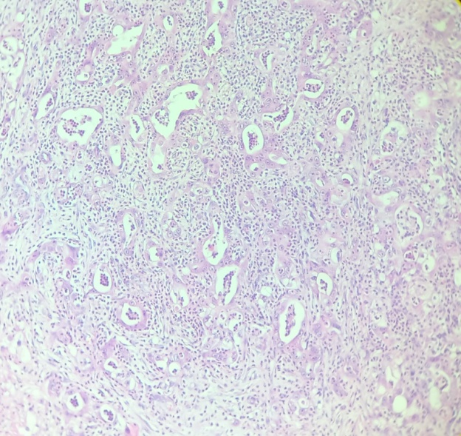

**Figure 7:** Microscopic aspect of Bellini tumor



**Figure: 8 Figure: 9**

After 3 months of urotheliectomy no evidence of disease.

**Discussion**

Bellini tumorsusuallymimicupperurotheliumtumors4see Figures 3 and 6, so they are usually a diagnosticchallenge.

Renal carcinoma of Bellini collectingductstreatedby surgery systemictherapy or both; theyhadanaveragesurvival time of 11 months and only 1 patientsurvived more than 5 years after diagnosis; 5something similar toourpatientwhomanagedtoachieve a shortersurvivalof 7 months after uroteliectomy, whichdiesfrom other cause without recurrence.

Thebesttreatmentavailabletodayisbasedonsurgicalresectionwheneverpossible, usuallyaccompaniedbysystemicchemotherapywiththesameregimen as urotheliumtumors in cases ofdistantdisease. However, in most cases, the prognosis isusuallyinfamousdespitethetreatment instituted,6 so weagreeonthesurgical performance and subsequentfollow-up ofthe case presented in ourstudy, performinguroteliectomy.

Authorsofthisstudyreportanother case of uroteliectomy in 2014, whereitisdemonstrated once againthaturotelietomy7is a usefulresource in thistypeofpatientor in multicenterurotheliumtumors. 8

**Conclusions**

Urothelietomyis a recentlydescribedtherapeuticresource, rarelyused and withfewpublications.

Ifweassumed that thelesionwas a Bellini tumor, wewouldhave done thesamewaysinceleavingthepatientondialysis and withrepeatedinfectionscould lead tobladderempyemaorrepeatedurosepsis.

**Conflicts de interest**

Theauthors declare thattheyhave no competinginterests.

**References**

1. Gutiérrez-Domingo A, Gutiérrez-Domingo I, Gallardo-Rodríguez K, Rodríguez-Caulo A.Carcinoma ofthecollectingductsof Bellini: a rareentitywith a poor prognosis. Rev Mex Urol. 2017 May 26;77(3).
2. P.P. Genov, N.H. Kolev, V.R. Dunev. Oncology. A rare case of Bellini duct carcinoma. Elsevier. Urology Case Reports25 (2019) 100899.
3. Qian X, Wang Z, Zhang J, Wang Q, Zhou P, Wang S, et al. ClinicalFeatures and PrognosticOutcomeof Renal CollectingDuct Carcinoma:12 Cases from a Single Institution. CancerManag Res. 2020;12:3589–95.
4. Gutiérrez-Zurimendi G., García de Casasola-Rodríguez G., Urrestizala-Peña I., Aizcorbe-Gómez M., Maldonado-De Sasia A., Urresola-Olabarrieta A. Renal carcinoma ofBellini'scollectingducts: presentationoftwo cases and reviewoftheliterature. Rev Mex Urol.2022;82(1): pp 1-10
5. Diego Barreiro, Victoria García Fernández, Francisco Castro Montiel, Norberto Lafos.Uroteliectomia .Rev. Arg. OfUrol. 2014. Vol. 79 (1) 2014 (38-39) (1):38-39
6. Mebust WK, Valk WL, Foret JD, Haskins R.[The pathophysiology and therapy of empyema in the isolated bladder.](https://pubmed.ncbi.nlm.nih.gov/4703846/)J Surg Oncol. 1973;5(2):89-95.

1. Instituto de Investigaciones Medicas Alfredo Lanari, University of Buenos Aires, Argentina
2. Hospital General Docente Iván Portuondo, Artemisa, Cuba.