Case Report

Percutaneous nephrolithotomy in a patient with a ureterosigmoidostomy diversion
Irache Abáigar Pedrazaª, Santiago Moreno Pérez de la Cruz^{b}, Andrés López de Alda^{c}
ª Hospital Don Benito Villanueva. Carretera Don Benito Villanueva s/n km 3,5 06400 Don Benito, Badajoz, Spain.
Corresponding author: Irache Abáigar Pedraza
Mailing address: Hospital Don Benito Villanueva, Carretera Don Benito Villanueva s/n km 3,5 06400 Don Benito, Badajoz, Spain.
Email: irache.abaigar@salud-juntaex.es

Abstract:

Ureterosigmoidostomy has been used as a form of urinary diversion in patients with bladder cancer and urinary lithiasis has been reported as a complication of that. We report a case of a patient with a large bilateral kidney stone and ureterosigmoidostomy diversion. 61 years old man submitted to cystectomy in 2012 due to bladder cancer. The patient was lost to follow up and he presented to the emergency department in 2016 with right flank pain and fever. Computed tomography (CT): bilateral staghorn calculus. Percutaneous nephrostomy bilateral was performed. The patient was planned for bilateral percutaneous nephrolithotomy (PCNL). He refused it, so we offered External Shock Wave Lithotripsy (ESWL). The right kidney stone was removed, but after 7 ESWL sessions, the left kidney stone did not change so we planned PCNL. In Valdivia's modified position, under fluoroscopic guidance throw the nephrostomy the middle calyx was punctured. Two 0.035'' hydrophilic guides wire was passed down in the renal pelvis and the ureter till the ureterosigmoidostomy union. Dilation was carried out with Nephromax. An Amplatz 30 Ch was placed. The holed stone was then fragmented with Laser Holmium. PCNL tubeless was performed. He was discharged two days after surgery. PCNL tubeless was performed. The hospital stay was two days. CT control two months later: Lower pole 5 cm hematoma, the residual stone of 4 mm in the upper calyx. After resolving the renal hematoma, the residual stone will be dealt with ESWL.
Keywords: Ureterosigmoidostomy, renal stone, percutaneous nephrolithotomy

Introduction

Ureterosigmoidostomy has been used as a form of urinary diversion in patients with bladder cancer. Urinary lithiasis has been reported as a ureterosigmoidostomy complication in 3-40% of the cases in recent series. The main causes are bacterial colonization and metabolic derangements due to urinary diversion [1].
Ureterosigmoidostomy was probably first used in about 1852 by Simon for exstrophy of the urinary bladder [2]. This technique has been criticized for the postoperative complications, perhaps the most important is that most patients develop pyelonephritis at some time, struvite renal lithiasis, because they are strongly associated with urinary tract infections (UTIs) with urea-splitting organisms, hyperchloremic metabolic acidosis and they always have some anal leakage of a malodorous mixture of feces and urine [3].
The principal issue with the use of the bowel in the urinary diversion is that the bowel continues to produce mucus and continues to perform its main physiological function of secretion and re-absorption [4].
Patients that have ureterosigmoidostomy must be watched closely. They need a low sodium chloride diet to reduce their chloride intake to avoid acidosis. They must be given sodium potassium citrate once or twice per day and an alkalinizing therapy with oral sodium bicarbonate 1–2 g three times a day [3].

Case presentation
We report the case of a 61 years old man who submitted to cystectomy and ureterosigmoidostomy in 2012 due to bladder cancer. After the surgery, he was lost to follow up and in 2016 he presented to the emergency department with right flank pain and fever. The main laboratory findings were anemia, leukocytosis, hyperchloremic metabolic acidosis, and increased serum creatinine.
A computed tomography scan showed bilateral staghorn stones.
Two bilateral ultrasound-guided percutaneous nephrostomies were performed to relieve obstruction and fever. Once the patient recovered from his acute pathology, bilateral PCNL access was offered to him, but he denied it. So bilateral ESWL was performed. The right staghorn lithiasis was completely disintegrated after 5 sessions (for each session: 3,000 shocks were delivered at a frequency of 100/min approximately) and the homolateral nephrostomy was removed but, after 7 ESWL sessions over the left kidney lithiasis, any changes were evidence on X-Ray (each session: 3,000 shocks were delivered at a frequency of 100/min approximately, but no expulsive fragments were evidenced) A new computed tomography scan was performed showing a staghorn stone that filled the renal pelvis (32x20 mm, 975 Hounsfield units (HU), superior (35x18 mm, 1000 UH) and inferior renal calyces (24x23 mm (903 HU) (Figure 1-3).

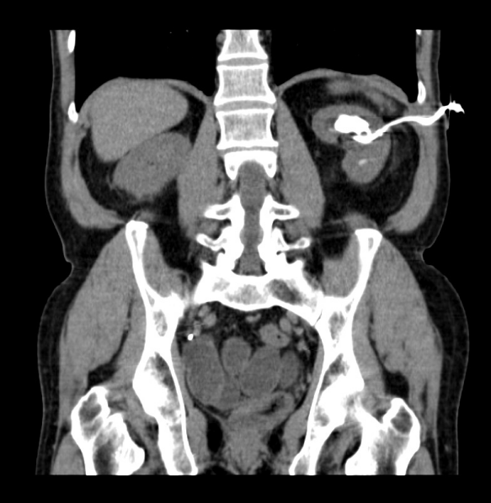
Figure 1. CT coronal plane. Upper calyx lithiasis.
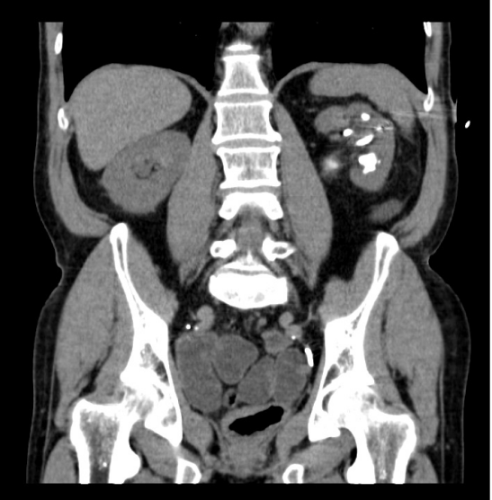
Figure 2. CT coronal plane. Lower calyx lithiasis.

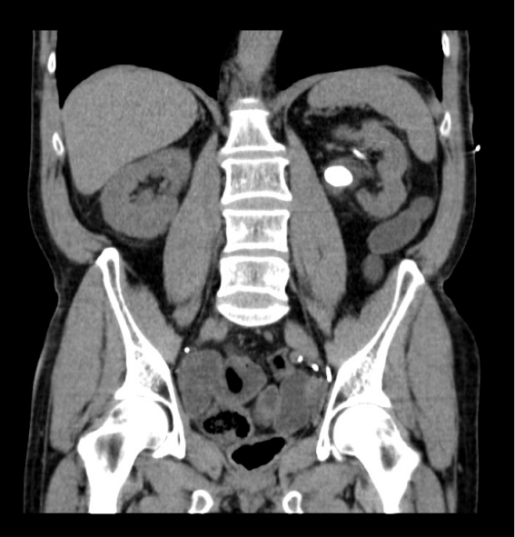
Figure 3. CT coronal plane. Renal pelvis lithiasis.

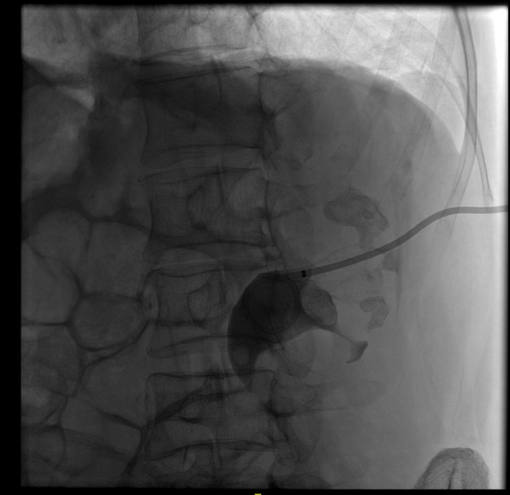

Figure 4. Neprhostomy tube was placed in the renal kidney and upper calyx, lower calyx, and renal pelvis lithiasis.

Once at that point, we advised the patient to reconsider PCNL and he accepted.
Two weeks previous urine culture revealed multi-drug resistant Klebsiella pneumonia and the antibiotic was started then according to the results (Meropenem 1 g iv/12h x 7 d, according to renal function). Five days after having finished the antibiotic, the urine culture control did not evidence of any germs.
On the day of the surgery, in the Galdakao-modified Valdivia position, we performed an antegrade pyelography through the left nephrostomy tube showing the hydronephrotic changes, the lithiasis, and filling of the rectal ampulla (Figure 4). Because of the location and magnitude of lithiasis, the lower calyx was chosen to puncture using the “bull’s eye” technique, but the hydrophilic guidewire did not progress probably because it was an excluded calyx, not despite using the ultrasound. So we decided to insert two ZIP wire™ Hydrophilic Guide Wire (®) through the nephrostomy tube one guided up to the upper pole (for tract dilation) and the other guided down to the ureter (for safety). After that, the nephrostomy was replaced and we introduce a Nefromax (®) for a "single-step" dilation technique till 30 F, an Amplatz sheath was then placed.
The calculus in the renal pelvis and upper calyx was identified by a rigid nephroscope, and fragmentation was performed by Holmium laser (Auriga 30 W. 2500 MJ, 12 Hz). Significant fragments were retrieved by a grasper. The lower and the residual upper calyx stones were removed using the flexible cystoscope, Holmium laser (Auriga 30 W. 2000-2500 MJ, 10 Hz), and a grasper. After complete stone removal, an inspection of the calyces and ureter was performed by anterograde pyelography. Once we evidenced no residual stone, we removed the Amplatz sheath performing an NPLC tubeless. The postoperative course was successful. No active bleeding (preoperative hemoglobin of 13 g/dl and postoperative of 11.4 g/dl) and no fever. He was discharged two days after surgery.
Stone analysis was performed showing a mixture of magnesium and ammonium phosphate (struvite) 34%, calcium carbonate apatite 47%, and calcium oxalate (19%), this last component is rarely developed in corals [5].
Two weeks later post-surgery CT scan control showed a 5cm hematoma in the lower pole and a 5 mm residual lithiasis in the upper calyx (Figure 5). The hemoglobin was 12 g/dl. Conservative management of the hematoma with ultrasound and a blood test in the second and seventh month after surgery was decided. Once it was reabsorbed, the residual lithiasis was resolved with extracorporeal shock wave lithotripsy.
Stone analysis revealed a mixed type stone, composed of struvite and apatite.

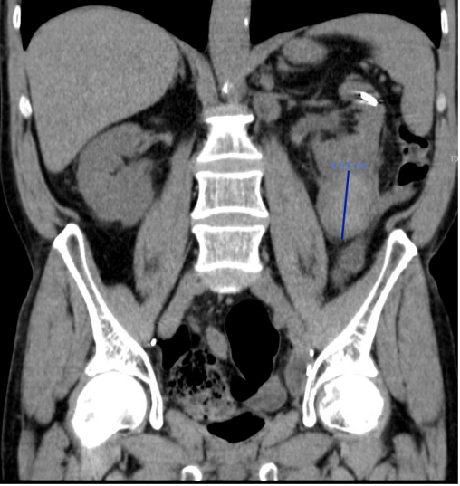
Figure 5. Hematoma at de lower pole.

Discussion
It is well-established that patients undergoing urinary diversion are at amplified risk of calculi formation. Reported prevalence varies between 3% and 43% [1-4, 6].
When urine is in contact with the bowel wall, ammonia, hydrogen, and chloride are also reabsorbed. Chronic Acidosis develops from excess reabsorption of ammonium chloride across the colonic mucosa.
Besides, patients undergoing urinary intestinal diversion are at increased risk for upper tract stones formation as well as calculi within the diversion segment for many reasons such as chronic bacteriuria (colonization rates range from 14 to 96%), urinary reflux, and the possibility of the presence of foreign bodies such as staples or sutures that can act as a nidus for stone formation; apart from the hyperchloremic metabolic acidosis patient status [6].
The colon has an abundant luminal anion exchanger that absorbs chloride and secretes bicarbonate. Thus, when chloride-rich urine enters the colon, the chloride is absorbed in exchange for bicarbonate, resulting in bicarbonate loss, and chloride retention [7]. The prolonged contact of urine with the intestinal surface encourages the exchange of chloride with bicarbonate. The resulting systemic acidosis causes impaired calcium reabsorption from the proximal tubules and decreased renal production of citrate. There exists also an increase in citrate absorption by the bowel segments. All of this results in hypercalciuria, hypocitraturia, alkaline urine, and abundant ammonium and phosphate ions, each of which promotes stone formation. Besides, the loss of bicarbonate results in acidosis and hypercalciuria, resulting in calcium stones [1-4, 6].
There are several treatment options for managing urinary stones. Percutaneous nephrolithotomy is the preferred option for treating complex kidney stones, large volume stones, or after the failure of other less invasive therapeutic alternatives [8, 9].
Besides is the best option for treating renal stones in patients with urinary diversion. Although PCNL is an efficient and safe technique, it may be a demanding procedure in case of urinary diversion.
Despite these newer management techniques, the reconstructed urinary tract poses a variety of challenges, and gaining percutaneous access is one of them, it is a difficult step. A detailed study of the anatomy previous to the surgery, cross-sectional imaging with CT and other techniques, if it is possible, and a thorough study of the pyelography during the surgery is essential in surgical planning.
The appropriate management of calculi in patients with urinary diversions must be individualized. With a priority on minimally invasive procedures. Little is available in published reports regarding the outcomes of PCNL in this specific patient population. Most of the literature is case reports, there is no large series of patients that allows us to follow during the procedure.
As we say, there is not exist step-by-step guideline in these cases. Identifying the neo-ureteral orifices is not mandatory, in our case we decided not to perform a retrograde pyelography to avoid the risk of bacteriemia [10]. Puncture of the collecting system is necessary to obtain primary access and to perform a pyelography that allows surgery. There is no standard position, prone or supine (Galdakao modified) when performing PCNL. We are used to the second one, and so we proceeded with this patient.
In normal PCNL we are used to operating with a safety guide that threads the patient (usually, from de kidney to the urethra) but in that case, due to the risk of bacteriemia, we decided not to thread the patient and instead of that, two guides, one for safety and the other for work, were used. At that time, we did not have the Miniperc set, so we used a single dilatation step technique (Nefromax ®) till 30 F.
We are used to and feel safe performing tubeless PNL, so, as such, we proceeded in the same way, once performing an anterograde pyelography after having finished the surgery. The patient was discharged two days after surgery.
The post-surgery CT showed a lower pole 5 cm hematoma and a residual stone of 5 mm in the upper calyx. After resolving the renal hematoma (ultrasound follow), the residual stone will be dealt with ESWL. Intraoperative bleeding may result from trauma renal parenchyma or injury to the perinephric vessels [11]. It has been reported that the size of stones and stone complexity are important factors for severe vessel injury besides, the number of calyceal punctures is one of the predictive factors of intraoperative bleeding in PCNL [12]. Moreover, the use of a rigid nephroscope may injure the renal parenchyma, resulting in increased bleeding [13]. In our patient, probably, the big size stone, the unsuccessful attempt to puncture the lower calyx, and the use of a rigid nephroscope to reach the calyces occupied by the stone favored the renal hematoma.
Given that there was no clinical or analytical repercussion, with a decrease in hemoglobin, conservative management with ultrasound follow-up was done.

Conclusions

Surgical management of renal stone disease in patients with urinary diversion requires detailed evaluation and individualized consideration depending on stone location and burden, diversion type, and surgeon's experience.

Declarations

Authors' contributions
All of the authors have participated in the article.
Irache Abáigar Pedraza: Research and writing.
Santiago Moreno Pérez de la Cruz: Review.
Andrés López de Alda: Review.

Availability of data and materials
Not applicable.

Financial support and sponsorship
None.

Conflicts of interest
All authors declared that there are no conflicts of interest.
Ethical approval and informed consent
Not applicable.

Consent for publication
Written informed consent for publication was obtained.

References

1. Abreu LA, Lara C, Dionísio MA, Pelosi AD, & Figueiredo FA. Endoscopic management of ureteral calculus in a patient with ureterosigmoidostomy diversion. Int Braz J Urol, 2013, 39(4): 593-596. https://doi.org/10.1590/s1677-5538.Ibju.2013.04.19
2. Simon J. Operation for directing the orifices of ureters into the rectum; temporary success, subsequent failure; autopsy. Lancet 1852: 568-570.
3. Goodwin WE, & Scardino PT. Ureterosigmoidostomy. J Urol, 1977, 118(1 Pt 2): 169-174. https://doi.org/10.1016/s0022-5347(17)57938-0
4. Vasdev N, Moon A, & Thorpe AC. Metabolic complications of urinary intestinal diversion. Indian J Urol, 2013, 29(4): 310-315. https://doi.org/10.4103/0970-1591.120112
5. Nemoy NJ, & Staney TA. Surgical, bacteriological, and biochemical management of "infection stones". JAMA, 1971, 215(9): 1470-1476.
6. Okhunov Z, Duty B, Smith AD, & Okeke Z. Management of urolithiasis in patients after urinary diversions. BJU Int, 2011, 108(3): 330-336. https://doi.org/10.1111/j.1464-410X.2011.10194.x
7. Palmer BF, Emmett M. Renal and metabolic complications following urinary diversion. UpToDate. 2022 Jan [cited 2022 Jan 19]. Available from: https://www.uptodate.com/contents/renal-and-metabolic-complications-following-urinary-diversion Subscription required.
8. Pérez-Fentes D. [Techniques for percutaneous access during percutaneous nephrolithotomy.]. Arch Esp Urol, 2017, 70(1): 155-172.
9. Sfoungaristos S, Mykoniatis I, Poulios E, Paikos D, & Hatzichristou D. Percutaneous Nephrolithotomy in a Patient with Mainz Pouch II Urinary Diversion: A Case Report. Prague Med Rep, 2016, 117(4): 198-203. https://doi.org/10.14712/23362936.2016.20
10. Poudyal S. Current insights on haemorrhagic complications in percutaneous nephrolithotomy. Asian J Urol, 2022, 9(1): 81-93. https://doi.org/10.1016/j.ajur.2021.05.007
11. Palka J, Farooq Z, & Anderson BG. Safety of retrograde pyelography for infected ureteral stones. Can J Urol, 2020, 27(1): 10130-10134.
12. Turna B, Nazli O, Demiryoguran S, Mammadov R, & Cal C. Percutaneous nephrolithotomy: variables that influence hemorrhage. Urology, 2007, 69(4): 603-607. https://doi.org/10.1016/j.urology.2006.12.021
13. Gadzhiev N, Malkhasyan V, Akopyan G, Petrov S, Jefferson F, & Okhunov Z. Percutaneous nephrolithotomy for staghorn calculi: Troubleshooting and managing complications. Asian J Urol, 2020, 7(2): 139-148. https://doi.org/10.1016/j.ajur.2019.10.004

