Surgical Technique

Percutaneous nephrolithotomy in a patient with an ureterosigmoidostomy diversion
Irache Abáigar Pedraza ^{a,*}, Santiago Moreno Pérez de la Cruz ª, Andrés López de Alda ª
ª Hospital Don Benito Villanueva. Carretera Don Benito Villanueva s/n km 3,5 06400 Don Benito. Badajoz.
Corresponding author: Irache Abáigar Pedraza
Mailing address: Hospital Don Benito Villanueva. Carretera Don Benito Villanueva s/n km 3,5 06400 Don Benito. Badajoz.
Email: irache.abaigar@salud-juntaex.es
Running title: PCNL in an ureterosigmoidostomy diversion: quite a challenge.

Abstract:
Introduction: Ureterosigmoidostomy has been used as a form of urinary diversion in patients with bladder cancer. Urinary lithiasis has been reported as ureterosigmoidostomy complication in 3-40% of the cases in recent series because of bacterial colonization and metabolic derangements due to the urinary diversion (1)
Materials and Methods: 61 years old man submitted to cystectomy in 2012 due to bladder cancer. The patient was lost to follow up and he presented to the emergency department in 2016 with right flank pain and fever. TC: bilateral staghorn calculus. Percutaneous nephrostomy bilateral was performed. Patient was planned for bilateral PCNL. He denaied it, so we offered ESWL (External Shock Wave Lithotripsy). The right kidney stone was totally removed, but after 7 ESWL sessions the left kidney stone did not change so we planned PCNL. In Valdivia modified position, under fluoroscopic guidance throw the nephrostomy the middle calyx was punctured. Two 0.035’’ hydrophilic guides wire was passed down in the renal pelvis and in the ureter till the ureterosigmoidostomy union. Dilation was carried out with Nephromax. An Amplatz 30 Ch was placed. The hole stone was then fragmented with Laser Holmium. PNL tubeless was performed. He was discharged two days after surgery.
Results: PCNL tubeless was performed. Hospital stay was two days. TC control two months later: Lower pole 5 cm hematoma, residual stone of 4 mm in upper calix After resolving the renal hematoma, residual stone will be deal with ESWL.

Key words: ureterosigmoidostomy, renal stone, percutaneous nephrolithotomy

Introduction:
Ureterosigmoidostomy was probably first used about 1852 by Simon for exstrophy of the urinary bladder (2). This technique has been criticized for the postoperative complications, perhaps the most important is that most patients develop
pyelonephritis at some time, struvite renal lithiasis, because they are strongly associated with urinary tract infections (UTIs) with urea-splitting organisms, hyperchloremic metabolic acidosis and they always have some anal leakage of a malodorous mixture of feces and urine (3).
The principal issue with the use of bowel in urinary diversion is due to the fact that the bowel continues to produce mucus and continues to perform its main physiological function of secretion and re-absorption (4).
Patients that have ureterosigmoidostomy must be watched closely. They need a low sodium chloride diet to reduce their chloride intake to avoid acidosis They must be given sodium potassium citrate one or twice per day and an alkalinizing therapy with oral sodium bicarbonate 1–2 g three times a day) (3)

Surgical technique:
We report the case of a 61 years old man submitted to cystectomy and ureterosigmoidostomy in 2012 due to a bladder cancer. After the surgery he was lost to follow up and in 2016 he presented to the emergency department with right flack pain and fever. The main laboratory findings were anemia, leukocytosis, hyperchloremic metabolic acidosis and increased serum creatinine.
A computed tomography scan showed bilateral staghorn stones.
Two bilateral ultrasound-guided percutaneous nephrostomies were performed to relieve obstruction and fever. Once the patients recovered from his acute pathology, a bilateral NLP access was offered to him, but he denied it. So bilateral ESWL was performed. The right staghorn lithiasis was completely solved and the homolateral nephrostomy was removed, but not the left kidney lithiasis which, after 7 ESWL sessions, any changes were evidence on X-Ray. A new computed tomography scan was performed showing a staghorn stone that filled the renal pelvis, superior and inferior renal calyces (Fig 1-3).
Once at that point, we advised the patient to reconsider NLP and he accepted.

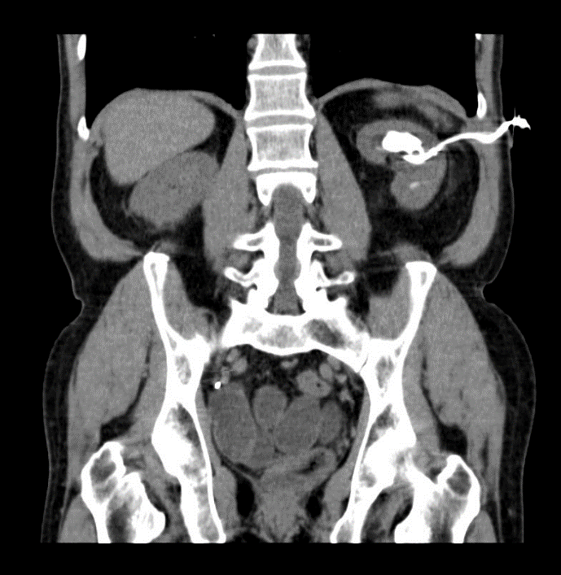

Figure 1.
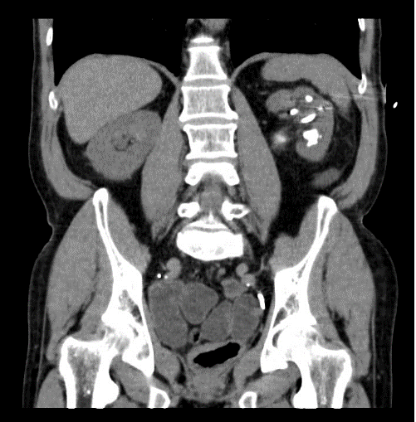
Figure 2.

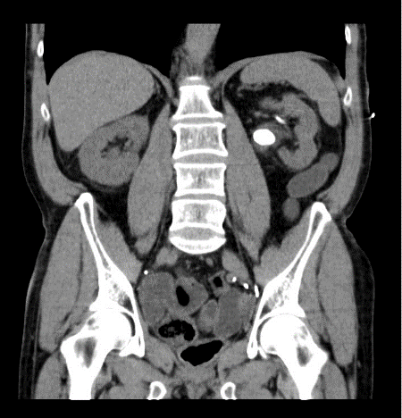
Figure 3.

Two weeks previous urine culture revealed multi-drug resistant Klebsiella pneumoniae and antibiotic was started then according to the results.
The day of the surgery, in Galdakao-modified Valdivia position, we performed an antegrade pyelography through the left nephrostomy tube showing the hydronephrotic changes, the lithiasis and filling the rectal ampulla (Fig 4) Because of the location and magnitude of lithiasis, the lower calyx was chosen to puncture using the “bull’s eye” technique, but the hydrophilic guidewire did not progress probably because it was an excluded calyx, not despite using the ultrasound. So we decided to inserted two ZIPwire™ Hydrophilic Guide Wire (®) through the nephrostomy tube one guided up to the upper pole (for tract dilation) and the other guided down to the ureter (for safety). After that the nephrostomy was replaced and we introduce a Nefromax (®) for a “single-step” dilation technique till 30 F, an Amplatz sheath was then placed.
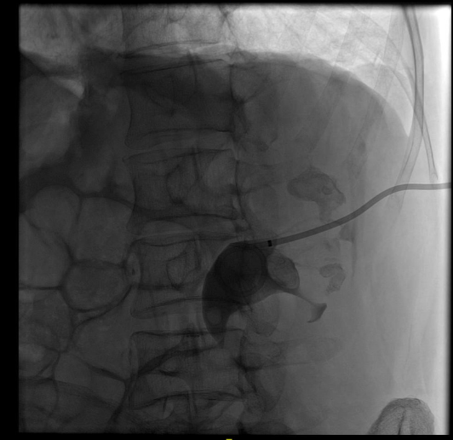
Figure 4.

The calculus in the renal pelvis and upper calyx was identified by rigid nephroscope, and fragmentation performed by Holmium laser. Significant fragments were retrieved by a grasper. The lower and the residual upper calyx stones were remove using the flexible cystoscope, Holmium laser and a grasper. After completely stone removal, inspection of the calyces and ureter was performed by anterograde pyelography. Once we evidenced no residual stone, we removed the Amplatz sheath performing a NPLC tubeless. Postoperative course was successful. No active bleedings (preoperative hemoglobin of 13g/dl and postoperative of 11.4g/dl) and no fever. He was discharged two days after surgery.
Two weeks later post-surgery CT scan control showed a 5cm hematoma in the lower pole and a 5mm residual lithiasis in the upper calyx (Fig 5). The hemoglobin was 12g/dl. Conservative management of the hematoma with ultrasound control was decided. Once it was reabsorbed, the residual lithiasis was resolved with extracorporeal shock wave lithotripsy.
Stone analysis revealed a mixed type stone, composed by struvite and apatite.

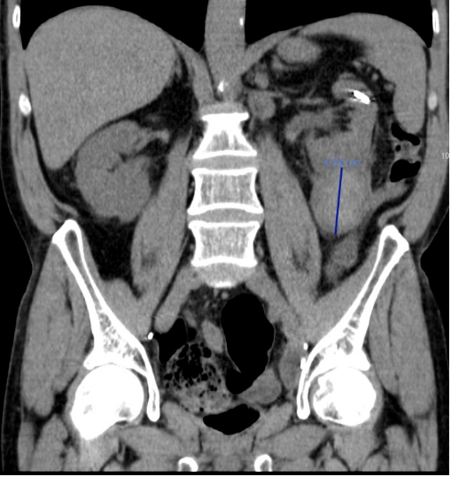
Figure 5.

Comments
It is well-established that patients undergoing urinary diversion are at amplified
risk of calculi formation. Reported prevalence varies between 3% and 43% (1,5)
When urine is in contact with the bowel wall, ammonia, hydrogen and chloride are also reabsorbed. Chronic Acidosis develops from an excess reabsorption of ammonium chloride across the colonic mucosa.
Besides, patients undergoing urinary intestinal diversion are at increased risk for upper tract stones formation as well as calculi within the diversion segment for many reasons such chronic bacteriuria (colonization rates range from 14 to 96%), urinary reflux and the possibility of presence of foreign bodies such as staples or sutures that can act as a nidus for stone formation; apart from the hypercloremic metabolic acidosis patient status (5).
The colon has an abundant luminal anion exchanger (SLC26A3) that absorbs chloride and secretes bicarbonate. Thus, when chloride-rich urine enters the colon, the chloride is absorbed in exchange for bicarbonate, resulting in bicarbonate loss, and chloride retention (6). The prolonged contact of urine with the intestinal surface encourages the exchange of chloride with bicarbonate. The resulting systemic acidosis causes impaired calcium reabsorption from the proximal tubules and decreased renal production of citrate. There exists also an increase in citrate absorption by the bowel segments. Al of this results in hypercalciuria, hypocitraturia, alkaline urine and abundant ammonium and phosphate ions, each of which promotes stone formation. Besides, the loss of bicarbonate results in acidosis and hypercalciuria, resulting in calcium stones (1-5)
There are several treatment options for managing the urinary stones. Percutaneous nephrolithotomy is the preferred option for treating complex kidney stones, large volume stones or after the failure of other less invasive therapeutic alternatives (7,8)
Besides is the best option for treating renal stones in patients with urinary diversion. Although PCNL is an efficient and safe technique, it may be a demanding procedure in case of urinary diversion.
Despite these newer management techniques, the reconstructed urinary tract poses a variety of challenges and gaining percutaneous access is a one of them, it is a difficult step. A detailed study of the anatomy previous to the surgery, a cross-sectional imaging with CT and other techniques, if it is possible, and thorough study of the pyelography during the surgery are essential in surgical planning.
The appropriate management of calculi in patients with urinary diversions must be individualized. With priority of minimally invasive procedures. Little is available in published reports regarding the outcomes of PNL in this specific patient population. Most of the literature are case reports, there is no a large series of patients that allows us to follow during the procedure.
As we say, there is not exist a step-by-step guideline in these cases. Identified the neo-ureteral orifices is not mandatory, in our case we decided not to performed a retrograde pyelography in order to avoid the risk of bacteriemia. Puncture of the collecting system is necessary to obtain a primary access and to perform a pyelography that allows the surgery. In normal PCNL we are used to operating with a safety guide that threads the patient (usually, from de kidney to the urethra) but in that case, due to the risk of bacteriemia, we decided not to thread the patient and instead of that, two guides, one for safety and the other for work, were used. At that time, we did not have the Miniperc set, so we used a single dilatation step technique (Nefromax ®) till 30 F.
We are used to and feel safe performing tubeless PNL, so, as such, we proceeded in the same way, once performing an anterograde pyelography after having finished the surgery. Two days after the intervention, the patient was discharged.
The post-surgery CT showed a lower pole 5 cm hematoma and a residual stone of 5 mm in upper calyx. After resolving the renal hematoma (ultrasound follow), residual stone will be deal with ESWL. Intraoperative bleeding may result from traumatised renal parenchyma or injury to the perinephric vessels (9). It has reported that the size of stones and stone complexity are important factors for severe vessel injury besides, the number of calyceal punctures is one of the predictive factors of intraoperative bleeding in PCNL (10). Moreover, the use of rigid nephroscope may injure the renal parenchyma, resulting in increased bleeding (11). In our patient, probably, the big size stone, the unsuccessful attempt to puncture the lower calyx, and the used of rigid nephroscope to reach the calyces occupied by the stone favored the renal hematoma.
Given that there was no clinical or analytical repercussion, with a decrease in hemoglobin, conservative management with ultrasound follow up was done.

Conclusions:

Surgical management of renal stone disease in patients with urinary diversion
requires detailed evaluation and individualized consideration depending on stone
location and burden, diversion type and surgeon’s experience.
Declarations:
Authors' Contributions
All of the authors have participated in the article.
Irache Abáigar Pedraza: Research and writing.
Santiago Moreno Pérez de la Cruz: Review
Andrés López de Alda: Review
Availability of Data and Materials
Not applicable.
Financial Support and Sponsorship
None.
Conflicts of Interest
“All authors declared that there are no conflicts of interest."
Ethical Approval and Informed consent
"Not applicable."
Consent for Publication
A written informed consent for publication was obtained.

References:
- Abreu LA, Lara C, Dionísio MA, Pelosi AD, Figueiredo FA. Endoscopic management of ureteral calculus in a patient with ureterosigmoidostomy diversion. Int Braz J Urol. 2013 Jul-Aug;39(4):593-6
- Simon, J.: Ectopia vesicae (absence of the anterior walls of the bladder and pu-
bic abdominal parietes); operation for directing the orifices of ureters into the
rectum: temporary success: subsequent death: autopsy. Lancet 2:568, 1852.
- Goodwin, W.E. and Scardino, P.T.: Ureterosigmoidostomy. J. Urol. 118:169,
1977.
- Vasdev N, Moon A, Thorpe AC. Metabolic complications of urinary intestinal diversion. Indian Journal of Urology : IJU : Journal of the Urological Society of India. 2013 Oct;29(4):310-315.
- Okhunov, Z., Duty, B., Smith, A. D., Okeke, Z. (2011) Management of urolithiasis in patients after urinary diversions. BJU Int. 108, 330–336.
- Biff F Palmer, MDMichael Emmett, MDSection Editor:Richard H Sterns, MDDeputy Editor:John P Forman, MD, : Renal and metabolic complications following urinary diversión UpToDate Jan 19, 2022. https://www.uptodate.com/contents/renal-and-metabolic-complications-following-urinary-diversion
- Pérez-Fentes D. Técnicas para el acceso percutáneo durante la nefrolitotomía percutánea [Techniques for percutaneous access during percutaneous nephrolithotomy.]. Arch Esp Urol. 2017 Jan;70(1):155-172
- Sfoungaristos S.; Mykoniatis I.; Poulios E.; Paikos D.; Hatzichristou D. Percutaneous Nephrolithotomy in a Patient with Mainz Pouch II Urinary Diversion: A Case Report. Prague Medical Report / Vol. 117 (2016) No. 4, p. 198–203.
- Poudyal S. Current insights on haemorrhagic complications in percutaneous nephrolithotomy. Asian J Urol. 2022 Jan;9(1):81-93.
- Turna B., Nazli O., Demiryoguran S., Mammadov R., Cal C. Percutaneous nephrolithotomy: Variables that influence hemorrhage. Urology. 2007;69:603–607
- Gadzhiev N, Malkhasyan V, Akopyan G, Petrov S, Jefferson F, Okhunov Z. Percutaneous nephrolithotomy for staghorn calculi: Troubleshooting and managing complications. Asian J Urol. 2020 Apr;7(2):139-148.

