Case Report
Preoperative 3D models guidance for robotic-partial nephrectomy:
a case report of intraoperative vascular injury and its management

¹Gabriele Volpi, ²Daniele Amparore, Giovanni Busacca, ²Alberto Piana, ²Federico Piramide,
² Sabrina De Cillis, ²Cristian Fiori, ²Francesco Porpiglia, ^{3*}Michele Di Dio, ^{1*}Enrico Checcucci

¹Department of Surgery, Candiolo Cancer Institute, FPO-IRCCS, Candiolo, Turin, Italy
²Division of Urology, Dept. Of Oncology, School of Medicine, University of Turin, San Luigi Hospital, Orbassano (Turin), Italy
³Division of Urology, Dept. of Surgery, Annunziata Hospital, Cosenza, Italy
* These two authors equally contributed to the senior authorship

Corresponding author:
Gabriele Volpi, MD

Department of Surgery, Candiolo Cancer Institute, FPO-IRCCS
Strada Provinciale 142, km 3,95 10060 Candiolo, Turin – Italy
Email address: gabriele.volpi@ircc.it
Word Count: 2122

Key words: robotic partial nephrectomy, 3D models, nightmares, kidney cancer

ABSTRACT
Background: Partial nephrectomy (PN) is being ever more adopted for the treatment of renal cell carcinoma and is today considered the “gold standard” treatment for T1 lesions. However, it is still considered a challenging procedure. Multiple imaging tools have been tested in order to improve PN outcomes. Among them, one of the most fascinating is represented by 3D reconstructions, that can be used for both the preoperative planning and the intraoperative decision-making process. In the case discussed below, we describe an intraoperative vascular injury that occurred during robot assisted PN (RAPN), notwithstanding an accurate preoperative 3D-guided planning, and its management.
Case description: The patient submitted to PN was 57 and had an incidental diagnosis of a 17 mm left-sided renal lesion, located on the posterior face of the kidney, at the lower pole. Based on the CT scan, a 3D virtual reconstruction was obtained, highlighting the presence of a saccular dilation of the main artery. A selective clamping of a segmental artery feeding the posterior face of kidney’s lower pole was planned. The RENAL nephrometry and PADUA score were calculated, with a value of 4p and 6, respectively. Notwithstanding a thorough preoperative planning, a lesion of the main artery’s dilation was determined with copious bleeding that was managed by global clamping of the kidney and subsequent selective suture.
Conclusions: PN still represents a demanding procedure, even for experienced and skilled surgeons. The occurrence of intraoperative complications isn’t anecdotical. The introduction of the robotic console and new intraoperative tools such as 3D models has been able to mitigate the risk of adverse events, but their complete elimination is still utopic due to the extreme complexity of the procedure.

1. INTRODUCTION
Nephron-sparing surgery (NSS) is being ever more adopted for the treatment of renal cell carcinoma and is today considered the “gold standard” treatment for T1 lesions [1]. However, this procedure has historically been considered as a challenging one, reserved to skilled and experienced surgeons, due to both oncological and safety aspects. Over the last years, the progressively increasing use of the robotic platform has allowed to improve the perioperative outcomes of partial nephrectomy (PN) [2]. Nevertheless, despite technical and technological developments, the approach to complex tumours remains an open issue. The complexity of the procedure can be increased by multiple factors such as the presence of endophytic lesions that are difficult to visualize on organ’s surface, by the location on the posterior face of the kidney which require a medialisation and rotation of the organ before starting the resection phase and, finally, by the complexity of the renal pedicle. Over the last years, multiple imaging tools have been tested in order to improve PN outcomes [3-6]. Among them, one of the most fascinating is certainly represented by 3D reconstructions, that can be used for both the preoperative planning and the intraoperative decision-making process [7].
Herein we present a case report of intraoperative vascular injury that occurred during robot assisted PN (RAPN), notwithstanding an accurate preoperative 3D-guided planning, and its management.

2. CASE PRESENTATION

2.1 3D Model Creation
Specifically for this clinical case, we created a 3D reconstruction of the kidney following a rigorous approach [8].
The first step is represented by the upload of contrast enhanced computed tomography (C.E. CT) DICOM images on a dedicated and authorized cloud platform (www.mymedics3d.com). Using the visualization software, it is then possible to select a specific organ and analyze it, to extrapolate the most useful images (e.g., arterial, or late phase images of a CT scan) and to modify and adjust specific parameters (e.g., image contrast and brightness). This represents the "preprocessing phase." Subsequently, a rendering of the organ is created and the ''segmentation'' is carried out semi-automatically by a dedicated software. Finally, the obtained 3D model is carefully analyzed and refined by a biomedical engineer under the supervision of the urologist. The aim is to obtain an hyperaccurate 3D model, reproducing the organ, the lesion, the vessels and the intraparenchymal structures. The final steps in the process are the creation of a transcription code for visualizing the reconstruction in an interactive 3D-PDF format.
Then, on the same cloud platform, virtual reconstructions can be downloaded and displayed, using them for both preoperative planning or intraoperative decision-making.

2.2 Case description
Herein we present the case of a non-smoking 57-year-old woman with a past medical history of hypertension who referred to our urology department for recurrent cystitis and a single episode of hematuria. For the diagnostic assessment, she was submitted to a cystoscopy, which didn’t highlight any bladder suspicious lesion, and a C.E. CT which showed a 17 mm inhomogeneous lesion on the posterior face of the lower pole of the left kidney, worthy of a deeper investigation. The patient was then submitted to a Magnetic Resonance Imaging (MRI) which confirmed the presence of a suspicious lesion deserving a surgical treatment. The patient was then scheduled for left Robot-Assisted Partial Nephrectomy (RAPN). The patient had a BMI of 33.1 and a Charlson’s Comorbidity Index of 3.
Preoperatively, the CT scan (Figure 1) was thoroughly evaluated and a 3D virtual reconstruction of the case was obtained (Figure 2), with the technique described above. The 3D model showed the presence of two renal arteries: the main one directed to the hilum and a second collateral artery directed to the anterior face of the lower pole the kidney, both originating from the aorta. The main artery was characterized by a saccular dilatation just proximally to a bifurcation for the segmental arteries. Based on the 3D model obtained, a selective clamping of the lower branch of the main artery ramification was preoperatively planned in order to minimize the impact of ischemia damage on postoperative renal function. The RENAL nephrometry and PADUA score were calculated, with a value of 4p and 6, respectively. In the light of these results, we opted to use the 3D model just for the preoperative planning.
Moving to the surgical procedure, the patient was placed in a 45° flank position and four 8 mm trocar were placed in the classic configuration for transperitoneal RAPN. Two further ports for the assistant, one of 5 and one of 12 mm, were placed. The daVinci Xi surgical system was then docked and the surgical procedure was started. The Toldt fascia was incised allowing the medialization of the descending colon and the identification and isolation of the renal lodge. The left ureter was recognized and, following it, so was the renal pedicle. The isolation of the kidney was then pursued cranially and posteriorly, identifying the lesion on the posterior face, with a predominantly exophytic aspect. We then carried on the procedure with the dissection of the renal hilum, a crucial step of the procedure (Figure 3a). During the dissection of the arterial vessel directed toward the lower pole of the kidney, a focal lesion of the saccular dilatation of the main artery was determined (figure 3b). A consistent bleeding was subsequently observed (figure 4a). A Weck clip was timely placed proximally to the bleeding site, stopping the copious hemorrhage. The surgeon then applied a vascular clamp on the healthy renal artery, upstream of the vascular violation, therefore performing a global vascular clamping of the kidney (figure 4b). The enucleation of the lesion was then carried out and the renal cortex was sutured with a 0-monofilament stitch anchored with Weck Clips. The lesion was placed in endobag. Subsequently, a thorough suture of the vascular defect was performed with a prolene 4-0 stitch, anchored with absorbable suture clips (Lapra-Ty^{R}) (figure 4c). The vascular clamp was removed, verifying the watertight closure of arterial’s defect. Finally, indocyanine green was injected in order to verify the kidney’s complete re-vascularization (figure 4d). The warm ischemia time was 21 minutes. An independent drain was placed through the most caudal robotic port. Estimated blood losses (EBL) were 400 mL.
During the hospitalization the patient did not require any blood transfusion. On blood tests a substantial stability of hemoglobin’s values was recorded. The patient was mobilized on the second post-operative day (POD). On the third POD the patient underwent a C.E. CT which did not highlight any contrast leakage at the level of left renal’s pedicle. Finally, the patient was discharged on the fourth POD. No late postoperative complications were recorded.
At final pathological examination, the lesion was characterized as a pT1a type 1 papillary renal cell carcinoma.
The patient underwent a C.E. CT at 6 and 12 months from the procedure, no signs of local or distant recurrence was observed. Serum creatinine was stable, with a value of 0.95 mg/dL.

3. DISCUSSION
Partial Nephrectomy (PN) has historically been considered a challenging procedure, however, in recent years, with the introduction of the robotic console and the refinement of surgical techniques, the organ sparing approach has been widely adopted and is today considered the first indication for cT1 renal tumours [1].
Nevertheless, the occurrence of intraoperative complications during PN is not an anecdotical event. As reported in the RECORd1 project, which gathered data regarding partial nephrectomies carried out in Italy between 2009 and 2012 with different surgical approaches (laparoscopic, open and robot-assisted), the rate of intraoperative complication was 5% [9]. On the other hand, RAPN allows to reduce this risk to 2.6% of the procedures [10]. Focusing on vascular injuries, this unwanted event occurred in approximately 1% of the procedures, and it was usually managed with direct suture of the bleeding vessel, while conversion to radical nephrectomy was rarely performed [9].
RAPN’s rate of complications is influenced by multiple factors such as surgeons’ skills and tumour’s aspect. Surgical experience is certainly related to a progressive decrease of complications, as already widely demonstrated. In fact, Mottrie et al. showed that increasing surgeon experience was correlated to a progressive decrease of warm ischemia time, total operative time, and EBL [11]. These findings were validated by both Mathieu et al. and Ficarra et al. who highlighted that the relative risk for perioperative complications’ occurrence was 2.14 and 2.99 for the first 20 and 30 cases, respectively [12, 13]. Moreover, also some non-modifiable factors such as lesion’s characteristics are associated with the occurrence of surgical complications. In fact, two scores have been validated in order to define tumor’s complexity: the RENAL nephrometry score and the PADUA classification. These scores showed a correlation with the occurrence of surgical complications during PN, with a four times greater risk of adverse events in case of RENAL score > 9 or PADUA > 10 [14]. Specifically concerning the robotic approach, RENAL score appears to be associated with greater overall complication rates and major complication rates. In fact, Tanagho et al., demonstrated that in patients undergoing RAPN, increasing RENAL scores of 4-6, 7-9, and 10-12 were associated to progressively increasing complication rates of 11, 18, and 23%, respectively [10]. These results were confirmed by Simhan et al. who highlighted that, in patients submitted to PN, of which almost 50% underwent RAPN, RENAL scores of 4-6, 7-9, and 10-12 resulted in progressively increasing major complication rates of 6, 11, and 22 %, respectively. Finally, also tumor’s size has been found as an independent predictor of complications, with a small but statistically significant correlation to perioperative complications after RAPN [15].
Over the last years, the introduction of the use of 3D virtual models has furtherly improved the accuracy of complications’ prediction of the above-mentioned classifications. In fact, our group demonstrated that, in a cohort of 101 patients, the preoperative assessment of PADUA and RENAL nephrometry scores with the 3D reconstructions demonstrated a downgrading compared to the ones defined based on bidimensional imaging in 48.5% and 52.4% of the cases, respectively. Similar results were obtained regarding the nephrometry categories. It is important to underline that 3D-based nephrometry scores and categories demonstrated a higher accuracy in postoperative complications’ prediction compared to the ones based on bidimensional imaging [16].
Moreover, 3D virtual models’ use has also refined the possibility to apprehend the surgical anatomy before and during PN, aiming to improve both oncological and functional outcomes of the surgical procedure. 3D models can be exploited both during the preoperative planning or during the intraoperative decision-making process. Throughout the intraoperative phase, 3D models can be used in a cognitive fashion, consulting in real-time the 3D model on a digital support placed next to the robotic console, or for augmented reality procedures (AR), overlapping the 3D reconstruction over patient’s real anatomy. Our group has already published multiple experiences with these technologies, demonstrating promising results. In fact, we highlighted that preoperative planning with 3D reconstructions determines a better apprehension of vascular anatomy, decreasing the rate of global clamping. In a previously published study comparing RAPN performed with and without 3D reconstructions, we demonstrated that in the no 3D group, a significantly higher rate of patients was submitted to global ischemia (80.6% vs 23.8%) [17]. Moreover, in the 3D group 90.5% of the procedures were carried out with an intraoperative approach to the renal pedicle in accordance with what preoperatively planned. In these cases, the tumor resection bed was almost completely bloodless, indicating an effective selection of the clamped arterial branch. A further evidence of the successful clamping was obtained with near-infrared fluorescence, corroborating our findings.
Considering 3D models’ use in AR procedures, we demonstrated their usefulness in the identification of complex tumours, in particular endophytic or posteriorly located lesions during transperitoneal PN, which resulted easier and faster [18]. Moreover, 3D models allowed the identification of “hidden” intraparenchymal structures such as vessels and calyces, allowing to perform a selective management during the resection phase of the procedure. Moreover, such structures were also identified at the end of the excision phase, at the level of the resection bed, allowing the execution of dedicated sutures of both vessels and calyces in case of violation.
Notwithstanding the low clinical evidence of our work, these experiences demonstrate how nephrometry scores and 3D model’s use might help to improve the management of renal cell carcinoma candidate to NSS. However, PN is still a demanding procedure and the risk of surgical complications is just around the corner.

CONCLUSIONS
PN still represents a challenging procedure, even for experienced and skilled surgeons and the occurrence of intraoperative complications isn’t uncommon. The introduction of the robotic console and the use of 3D virtual models has been able to mitigate the risk of adverse events, however they will never be eliminated due to the intrinsic complexity of certain renal lesions and to the heterogeneity of the vascular anatomy.

REFERENCES
- Ljungberg B, Albiges L, Bedke J, et al. EAU guidelines on renal cell carcinoma 2022. Arnhem, The Netherlands: European Association of Urology; 2022.
- Leow JJ, Heah NH, Chang SL, Chong YL, Png KS. Outcomes of Robotic versus Laparoscopic Partial Nephrectomy: an Updated Meta-Analysis of 4,919 Patients. J Urol. 2016 Nov;196(5):1371-1377. doi: 10.1016/j.juro.2016.06.011. Epub 2016 Jun 10. PMID: 27291654.
- Secil M, Elibol C, Aslan G, et al. Role of intraoperative US in the decision for radical or partial nephrectomy. Radiology 2011;258:283–90. https://doi.org/10.1148/radiol.10100859.
- Qin B, Hu H, Lu Y, et al. Intraoperative ultrasonography in laparoscopic partial nephrectomy for intrarenal tumors. PLoS One 2018;13:e0195911.
- Krane LS, Manny TB, Hemal AK. Is near infrared fluorescence imaging using indocyanine green dye useful in robotic partial nephrectomy: a prospective comparative study of 94 patients. Urology 2012;80:110–8. https://doi.org/10.1016/j.urology.2012.01.076.
- Veccia A, Antonelli A, Hampton LJ, et al. Near-infrared fluorescence imaging with indocyanine green in robot-assisted partial nephrectomy: pooled analysis of comparative studies. Eur Urol Focus 2020;6:505–12. https://doi.org/10.1016/j.euf.2019.03.005.
- Porpiglia F, Amparore D, Checcucci E, et al. Current use of three- dimensional model technology in urology: a road map for personalised surgical planning. Eur Urol Focus 2018;4:652–6. https://doi.org/10.1016/j.euf.2018.09.012.
- Checcucci E, Amparore D, Pecoraro A, et al. 3D mixed reality holograms for preoperative surgical planning of nephron-sparing surgery: evaluation of surgeons' perception. Minerva Urol Nefrol. 2019 Sep 5. doi: 10.23736/S0393-2249.19.03610-5.
- Minervini A, Mari A, Borghesi M, Antonelli A, Bertolo R, Bianchi G, Brunocilla E, Ficarra V, Fiori C, Longo N, Mirone V, Morgia G, Porpiglia F, Rocco B, Serni S, Simeone C, Tellini R, Volpe A, Carini M, Schiavina R. The occurrence of intraoperative complications during partial nephrectomy and their impact on postoperative outcome: results from the RECORd1 project. Minerva Urol Nefrol. 2019 Feb;71(1):47-54. doi: 10.23736/S0393-2249.18.03202-2. Epub 2018 Sep 10. PMID: 30203939.
- Tanagho YS, Kaouk JH, Allaf ME, Rogers CG, Stifelman MD, Kaczmarek BF, Hillyer SP, Mullins JK, Chiu Y, Bhayani SB. Perioperative complications of robot-assisted partial nephrectomy: analysis of 886 patients at 5 United States centers. Urology. 2013 Mar;81(3):573-9. doi: 10.1016/j.urology.2012.10.067. PMID: 23452807.
- Larcher A, Muttin F, Peyronnet B, De Naeyer G, Khene ZE, Dell'Oglio P, Ferreiro C, Schatteman P, Capitanio U, D'Hondt F, Montorsi F, Bensalah K, Mottrie A. The Learning Curve for Robot-assisted Partial Nephrectomy: Impact of Surgical Experience on Perioperative Outcomes. Eur Urol. 2019 Feb;75(2):253-256. doi: 10.1016/j.eururo.2018.08.042. Epub 2018 Sep 19. PMID: 30243798.
- Mathieu R, Verhoest G, Droupy S, et al. Predictive factors of complications after robot-assisted laparoscopic partial nephrectomy: a retrospective multicentre study. BJU Int. 2013;112:283–9.
- Ficarra V, Bhayani S, Porter J, et al. Predictors of warm ischemia time and perioperative complications in a multicenter, international series of robot-assisted partial nephrectomy. Eur Urol. 2012;61:395–402.
- Hew MN, Baseskioglu B, Barwari K, et al. Critical appraisal of the PADUA classification and assessment of the RENAL nephrometry score in patients undergoing partial nephrectomy. J Urol. 2011;186:42–6.
- Simhan J, SmaldoneMC, Tsai KJ, et al.Objectivemeasures of renal mass anatomic complexity predict rates of major complications following partial nephrectomy. Eur Urol. 2011;60:724–30.
- Porpiglia F, Amparore D, Checcucci E, Manfredi M, Stura I, Migliaretti G, Autorino R, Ficarra V, Fiori C. Three-dimensional virtual imaging of renal tumours: a new tool to improve the accuracy of nephrometry scores. BJU Int. 2019 Dec;124(6):945-954. doi: 10.1111/bju.14894. Epub 2019 Sep 27. PMID: 31390140.
- Porpiglia F, Fiori C, Checcucci E, Amparore D, Bertolo R. Hyperaccuracy Three-dimensional Reconstruction Is Able to Maximize the Efficacy of Selective Clamping During Robot-assisted Partial Nephrectomy for Complex Renal Masses. Eur Urol. 2018 Nov;74(5):651-660. doi: 10.1016/j.eururo.2017.12.027. Epub 2018 Jan 6. PMID: 29317081.
- Porpiglia F, Checcucci E, Amparore D, Piramide F, Volpi G, Granato S, Verri P, Manfredi M, Bellin A, Piazzolla P, Autorino R, Morra I, Fiori C, Mottrie A. Three-dimensional Augmented Reality Robot-assisted Partial Nephrectomy in Case of Complex Tumours (PADUA ≥10): A New Intraoperative Tool Overcoming the Ultrasound Guidance. Eur Urol. 2020 Aug;78(2):229-238. doi: 10.1016/j.eururo.2019.11.024. Epub 2019 Dec 30. PMID: 31898992.
FIGURES LEGEND
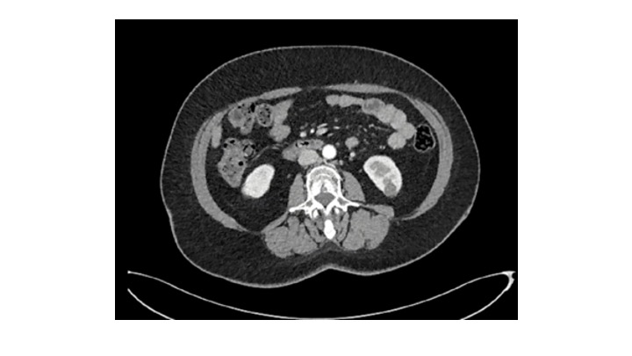
Figure 1. C.E. CT highlighting the presence of an inhomogeneous lesion on the posterior face of the lower pole of the left kidney
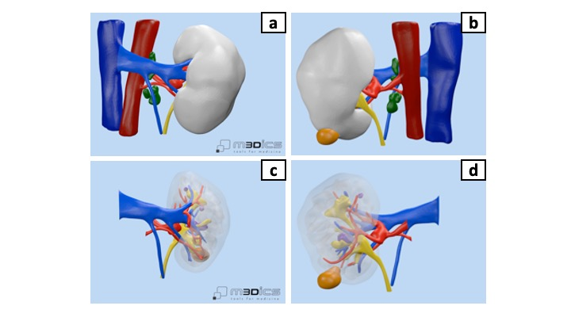
Figure 2. The 3D model obtained from the preoperative CT: (a) anterior face of the kidney; (b) posterior face of the kidney; (c) anterior view of the kidney with parenchymal transparency; (d) posterior view of the kidney and its vessels, saccular dilation of the main artery.

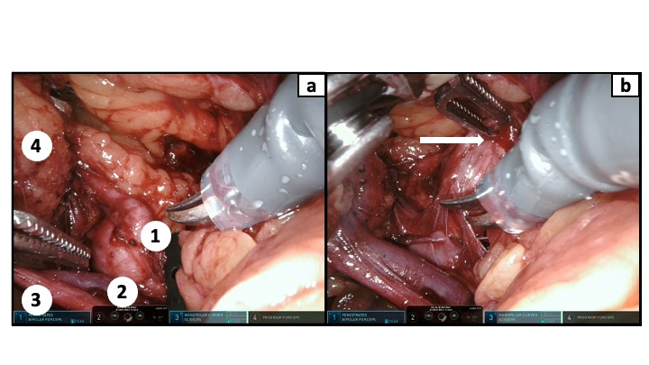
Figure 3. Intraoperative vision of kidney’s pedicle: (a) Dissection of the different structures: 1) main artery’s dilation; 2) Renal vein; 3) Ureter; 4) Kidney; (b) Main artery’s dilation is accidentally violated by the robotic grasp

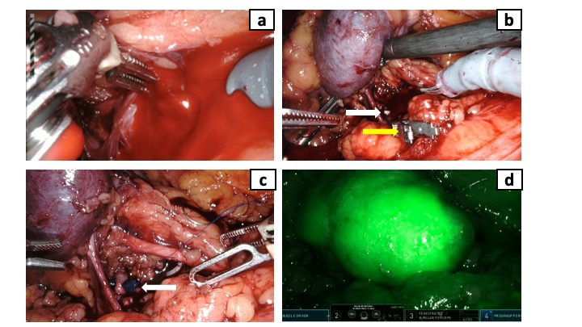

Figure 4. (a) Artery’s violation caused an immediate massive hemorrhage; (b) a Weck clip (white arrow) is quickly placed upstream of the bleeding site, stopping the hemorrhage. Then, a vascular clamp (yellow arrow) is applied on the healthy renal artery allowing the surgeon to perform the subsequent vascular suture; (c) a single monofilament running suture is realized over the injured segment of the artery. At the end of the procedure, the suture is secured with an absorbable clip (white arrow); (d) indocyanine green is injected in order to verify the complete re-vascularization of the kidney.

