Case Report

Title: Robotic-assisted partial nephrectomy nightmare: poor clamping and tumor rupture

Artur de Oliveira Paludo MD, MSc 1,2,3 - arturpaludo@gmail.com
Pedro Glusman Knijnik MD 2,3 - knijnik.pedro@gmail.com
Dorival Manrique Duarte Jr MD, 1,2 - dorimdjr@hotmail.com
Elio Mazzone MD 4 - eliomazzone@gmail.com
Stefano Puliatti MD 5 - stefanopuliatti@gmail.com
André Kives Berger MD, PhD 1,2,3 - andrekberger@hotmail.com
Brasil Silva Neto MD, PhD 1,2,3 - bsneto.uro@gmail.com
Milton Berger MD, PhD 1,2,3 - mbergerurologia@gmail.com

1. Hospital Moinhos de Vento - Rua Ramiro Barcelos, 910 - Moinhos de Vento, Porto Alegre - RS, 90035-000
2. Universidade Federal do Rio Grande do Sul - Av. Paulo Gama, 110; Porto Alegre,
Rio Grande do Sul, Brazil
3. Hospital de Clínicas de Porto Alegre - Rua Ramiro Barcelos, 2350; Porto Alegre, Rio
Grande do Sul, Brazil
4. Department of Urology, San Raffaele Hospital. - Milan, Italy
5. Department of Urology, University of Modena and Reggio Emilia - Modena, Italy

Corresponding Author:
Dr. Artur de Oliveira Paludo
Hospital Moinhos de Vento
Rua Tiradentes 333, 12° andar
Porto Alegre, Rio Grande do Sul, Brazil
E-mail: arturpaludo@gmail.com

ABSTRACT

A 82-year-old Caucasian male patient was referred to our center due to incidental detection of a nodule in the middle third of the right kidney at an abdominal ultrasonography imaging performed for screening. When first evaluated, no local or systemic symptom could be associated with the renal mass. Patient underwent an abdominal contrast-enhanced CT scan that revealed a mass in the outer middle third of the right kidney measuring 4,5 × 3,5 cm, predominantly exophytic, demonstrating contact with the collecting system and showing enhancement pattern, suspicious for primary renal malignancy. Tumor complexity was classified as PADUA score of 9 and Renal Score 9x. Clinical stage was cT1b N0M0. Overall procedure time was 130 min. Estimated blood loss was 800 ml and warm ischemia time was 24 min. Intraoperative complications were tumor rupture and increased bleeding (as described in the video above). The post operative course underwent without any complications. A meticulous preoperative planning including a contrast-enhanced CT with 1mm thick slices and a 3D reconstruction imaging is pivotal. A comprehensive dissection of renal hilum must be done to access the exact number of vessels vascularizing the kidney and to provide an adequate ischemia to the renal parenchyma for clean visualization during tumor resection avoiding nightmares as positive margins and tumor rupture.
Key Words: partial nephrectomy; robotic surgery; complications

BACKGROUND

Partial nephrectomy represents the optimal surgical strategy in T1a renal tumors [1]. In recent years, thanks to the evolution of the technique and the progressive implementation of robotic surgery, it has been possible to safely expand indications for partial nephrectomy to patients with larger tumors, namely T1b and/or T2 [2].

However, to achieve good postoperative and oncological results, meticulous preoperative planning is necessary. A triphasic, contrast-enhanced computed tomography (CT) with 1mm thick slices is fundamental for understanding the vascular anatomy and for performing a reliably 3D reconstruction which, when available, represents a key tool to support surgical planning. This type of reconstruction allows us to accurately study the anatomical nuances of different cases that will be encountered intraoperatively in each different surgery.
Also, a magnetic resonance image can add valid information about the involvement of structures adjacent to the tumor and venous thrombus[3].

Despite all this accurate preoperative planning, technical and surgical difficulties may be encountered during a robotic-assisted partial nephrectomy (RAPN) and some of them may represent a nightmare if not properly managed. One of the most undesired intraoperative complications is bleeding, which can occur due to inadequate arterial or venous preparation and clamping. Tumor rupture is another complication that should be always avoided due to the risk of contamination and consequently tumor recurrence [4].

CASE DESCRIPTION

In this case report, a 82-year-old Caucasian male patient was referred to our center due to incidental detection of a nodule in the middle third of the right kidney at an abdominal ultrasonography imaging performed for screening. When first evaluated, no local or systemic symptom could be associated with the renal mass. Patient’s medical history included a surgical procedure for aortic valve replacement and myocardial revascularization with posterior need for percutaneous angioplasty of the right coronary artery. Comorbidities included chronic heart failure with low impact at daily activities (NYHA class II), hypertension and dyslipidemia (both controlled with medical therapy). Physical examination was unremarkable for palpable flank masses or other findings. Body mass index was 24,5 kg/m2. Patient presented stage IIIb chronic kidney disease prior to surgery (eGFR): 43. ml/min/1.73m2 estimated by 2021 CKD-EPI creatinine equation [5]. Urinalysis presented no hematuria, proteinuria nor other alterations. All other biochemical studies were normal.

Tumor Nephrometric Characterization
Patient underwent an abdominal contrast-enhanced CT scan for better definition of the lesion that revealed a mass in the outer middle third of right kidney measuring 4,5 × 3,5 cm, predominantly exophytic, demonstrating contact with the collecting system and showing enhancement pattern, suspicious for primary renal malignancy. Tumor complexity was classified as PADUA score of 9 (2 points for “tumor size”; 1 point for “exophytic” rate; 2 points for “collecting system” involvement; 1 point for “sinus” involvement; 1 point for “renal rim”; 2 points for polar location) and Renal Score 9x
Clinical stage was cT1b N0M0.

Pre operative evaluation
The images from Contrast-enhanced CT scan were retrieved in DICOM format and edited in a software under development in our institution to obtain a virtual 3D reconstruction of the renal mass and its correlation to major vessels and other structures of importance. (Figure 1).

Surgical Technique and set up
(a) use of the da Vinci Si robotic platform with a four arm configurations plus two assistant ports [both 12-mm ports, (in this specific case, we used two 12-mm ports for the assistant to allow him hem-o-lok clips from both ports, maximizing patient safety and coordination with the primary surgeon) [6]; (Figure 2)
(b) transperitoneal approach;
(c) mobilizing right colon and duodenum
(d) psoas identification
(e) hilum dissection and isolation
(d) main renal artery and vein clamping with bulldogs
(e) enucleation / enucleoresection strategy,
(f) double-layer renorrhaphy for renal reconstruction (Declamp after medular layer reconstruction)
(g) Gerota's closure

Intra- and Post-operative Outcomes
The overall procedure time was 130 min. Estimated blood loss was 800 ml and warm ischemia time was 24 min. Intraoperative complications were tumor rupture and increased bleeding (as described in the video above).
The post operative course underwent without any complications. The urinary catheter was removed 1 day after surgery. On day 2, surgical drain was removed and the patient was discharged from the hospital in good condition, although he presented a decrease in renal function from eGFR 43 ml/min/1.73m2 to eGFR: 26 ml/min/1.73m2.

Histopathological Analysis
Specimen processing and histopathological examination were undertaken by uropathologists according to our institution's standard protocols. Tumor staging was classified in accordance with the most recent TNM criteria and the histopathological classification followed the latest guidelines from International Society of Urological Pathology [7,8]. The histopathological analysis demonstrated a renal mass measuring 35 x 30 x 30 mm, G2, renal cell carcinoma, papillary type, with the presence of necrosis in 20% of the neoplasia. The analysis demonstrated no signs of sarcomatoid/rhabdoid pattern, angiolymphatic invasion, renal capsule infiltration or perirenal adipose tissue infiltration. The surgical parenchymal and radial margins were free of neoplastic involvement (pT1aNxMx). (Figure 3)

Follow-Up
At the 6-month follow-up, the patient was assymptomatic and did not present any postoperative complication. Renal function has returned to baseline levels (eGFR 43 ml/min/1.73m2) and the contrast-enhanced CT scan 6 months after surgery showed no evidence of local or systemic recurrence.

DISCUSSION
During the last decade, the prevalence of kidney tumors is rising, and, of note, more challenging cases are being performed, thus potentially increasing the risk of perioperative complications [9]. In this context, several retrospective series demonstrated that RAPN offers a lower rate of perioperative complications, less estimated blood loss, and shorter length of stay than open partial nephrectomy (OPN), suggesting that RAPN can be an effective alternative to OPN. [10].
In order to further reduce risks and complications of a surgical technique, it is important to standardize the outcomes collection. In this regard, Sri et al described the concept of "trifecta" and "pentafecta" with the goal of identifying the key outcomes of a surgical procedure. "Pentafecta" was defined as achievement of "Trifecta" (namely, negative surgical margin, no postoperative complications and WIT of < 25 min) plus over 90% estimated GFR preservation and no CKD stage upgrading at 1 year [11]. These concepts have been demonstrated to be easily applicable to PN patients, and offer an internationally comparable PN outcome as a quality measure.
Despite this premise, complications nightmares can still occur; therefore, regarding intra-operative bleeding, there are some maneuvers that can be useful for its prevention or management. For instance, the "clamp test" consists in clamping the renal artery for 1 to 3 min during renal artery test ischemia prior to the actual ischemia and tumor resection. The disappearance of blood flow around the renal tumor using color Doppler ultrasonography must be confirmed to proceed with actual ischemia and tumor resection. This practice has been proven to prevent massive bleeding during tumor resection and to omit dissection of non-feeding arteries around the tumor [12]. Furthermore, Nepple et al, described a comprehensive checklist for intraoperative hemorrhage control while clamped in RAPN[13] . Concerning the arterial bleeding, the authors suggested a controlled reduction in the blood pressure may improve visualization in patients with notable hypertension. Furthermore, another temporizing option is to unclamp the renal vein to allow venous outflow, hence improving visualization of the partial nephrectomy bed.
Another feared complication is tumor rupture, mainly when there is a cystic component, that is a relatively common situation but with limited oncologic implications [14]. Pradere et al evaluated a retrospective cohort of patients who had presented tumoral cystic rupture and reported that, at a median follow-up of 32 months, 5 patients (2.5%) had local recurrence, while progression to metastasis was observed in only 2% of patients. No peritoneal carcinomatosis nor port site metastasis was described. Also, no local or metastatic recurrence in the subgroup with intraoperative cyst rupture was recorded. Estimated recurrence-free survival did not differ significantly between patients with vs without intraoperative cyst rupture at 100% vs 92.7% at 5 years (p = 0.2). However, when tumor rupture occurs, it is necessary to avoid extensive contamination of the cavity, thus aspirating and carefully removing any residual tumor fragments. An irrigation of the area with at least 1 L of saline solution is also indicated.
A trained and experienced team is essential to avoid and resolve these complications. Two aspirators must be available and extra wires for renorrhaphy as well. Key points when such complications occur are: keeping calm, but being effective and quick in tumor resection and renal suturing to avoid extensive bleeding.

CONCLUSIONS
A meticulous preoperative planning including a contrast-enhanced CT with 1mm thick slices and a 3D reconstruction imaging is pivotal. During surgery, a comprehensive dissection of renal hilum must be attempted to access the exact number of vessels vascularizing the kidney and its branching point to properly evaluate whether clamp of the artery would be sufficient to provide an adequate ischemia to the renal parenchyma for clean visualization during tumor resection avoiding nightmares as positive margins and tumor rupture.

COMPLIANCE WITH ETHICAL STANDARDS:

Funding: None.
Conflict of Interest: The authors report no conflicts of interest.
Ethical approval: All procedures performed in studies involving human participants were in accordance with the ethical standards of the institutional and/or national research committee and with the 1964 Helsinki declaration and its later amendments or comparable ethical standards.
Informed consent: Informed consent was obtained from the patient
Availability of data and materials: Not applicable

Contribution of Authors:
Study concept and design: Paludo
Acquisition of data: Paludo, Knijnik, Duarte Jr.
Analysis and interpretation of data: Paludo, Berger M, Brasil
Drafting of the manuscript: Paludo, Knijnik
Critical revision of the manuscript for important intellectual content: Paludo, Mazzone, Puliatti, Berger M., Berger A. Brasil.
Statistical analysis: Paludo
Administrative, technical, or material support: None.
Supervision: Berger A.; Brasil; Berger M.
Other: None.

[1] van Poppel H, da Pozzo L, Albrecht W, Matveev V, Bono A, Borkowski A, et al. A Prospective, Randomised EORTC Intergroup Phase 3 Study Comparing the Oncologic Outcome of Elective Nephron-Sparing Surgery and Radical Nephrectomy for Low-Stage Renal Cell Carcinoma. Eur Urol 2011;59:543–52. https://doi.org/10.1016/J.EURURO.2010.12.013.
[2] Mir MC, Derweesh I, Porpiglia F, Zargar H, Mottrie A, Autorino R. Partial Nephrectomy Versus Radical Nephrectomy for Clinical T1b and T2 Renal Tumors: A Systematic Review and Meta-analysis of Comparative Studies. Eur Urol 2017;71:606–17. https://doi.org/10.1016/J.EURURO.2016.08.060.
[3] Abou Elkassem AM, Lo SS, Gunn AJ, Shuch BM, Dewitt-Foy ME, Abouassaly R, et al. Role of imaging in renal cell carcinoma: A multidisciplinary perspective. Radiographics 2021;41:1387–407. https://doi.org/10.1148/RG.2021200202/ASSET/IMAGES/LARGE/RG.2021200202.FIG13D.JPEG.
[4] Tanagho YS, Kaouk JH, Allaf ME, Rogers CG, Stifelman MD, Kaczmarek BF, et al. Perioperative Complications of Robot-assisted Partial Nephrectomy: Analysis of 886 Patients at 5 United States Centers. Urology 2013;81:573–80. https://doi.org/10.1016/J.UROLOGY.2012.10.067.
[5] Inker LA, Eneanya ND, Coresh J, Tighiouart H, Wang D, Sang Y, et al. New Creatinine- and Cystatin C–Based Equations to Estimate GFR without Race. New England Journal of Medicine 2021;385:1737–49. https://doi.org/10.1056/NEJMoa2102953.
[6] Gettman MT, Blute ML, Chow GK, Neururer R, Bartsch G, Peschel R. Robotic-assisted laparoscopic partial nephrectomy: Technique and initial clinical experience with daVinci robotic system. Urology 2004;64:914–8. https://doi.org/10.1016/j.urology.2004.06.049.
[7] Srigley JR, Delahunt B, Eble JN, Egevad L, Epstein JI, Grignon D, et al. The International Society of Urological Pathology (ISUP) Vancouver classification of renal neoplasia. American Journal of Surgical Pathology 2013;37:1469–89. https://doi.org/10.1097/PAS.0B013E318299F2D1.
[8] Delahunt B, Cheville JC, Martignoni G, Humphrey PA, Magi-Galluzzi C, McKenney J, et al. The International Society of Urological Pathology (ISUP) grading system for renal cell carcinoma and other prognostic parameters. American Journal of Surgical Pathology 2013;37:1490–504. https://doi.org/10.1097/PAS.0B013E318299F0FB.
[9] Padala SA, Padala SA, Barsouk A, Thandra KC, Saginala K, Mohammed A, et al. Epidemiology of Renal Cell Carcinoma. World J Oncol 2020;11:79–87. https://doi.org/10.4021/wjon.v11i3.1279.
[10] Bravi CA, Rosiello G, Mazzone E, Minervini A, Mari A, di Maida F, et al. The IRON Study: Investigation of Robot-assisted Versus Open Nephron-sparing Surgery. Eur Urol Open Sci 2023;49:71–7. https://doi.org/10.1016/J.EUROS.2022.12.017.
[11] Sri D, Thakkar R, Patel HRH, Lazarus J, Berger F, McArthur R, et al. Robotic-assisted partial nephrectomy (RAPN) and standardization of outcome reporting: a prospective, observational study on reaching the “Trifecta and Pentafecta.” J Robot Surg 2021;15:571–7. https://doi.org/10.1007/S11701-020-01141-Z.
[12] Nohara T, Kadomoto S, Iwamoto H, Yaegashi H, Iijima M, Kawaguchi S, et al. Test clamp procedure in robot-assisted partial nephrectomy: is it a safe procedure? J Robot Surg 2022;16:633–9. https://doi.org/10.1007/S11701-021-01288-3.
[13] Nepple KG, Sandhu GS, Rogers CG, Allaf ME, Kaouk JH, Figenshau RS, et al. Description of a multicenter safety checklist for intraoperative hemorrhage control while clamped during robotic partial nephrectomy. Patient Saf Surg 2012;6:1–6. https://doi.org/10.1186/1754-9493-6-8/FIGURES/2.
[14] Pradere B, Peyronnet B, Delporte G, Manach Q, Khene ZE, Moulin M, et al. Intraoperative Cyst Rupture during Partial Nephrectomy for Cystic Renal Masses-Does it Increase the Risk of Recurrence? J Urol 2018;200:1200–6. https://doi.org/10.1016/J.JURO.2018.06.025.

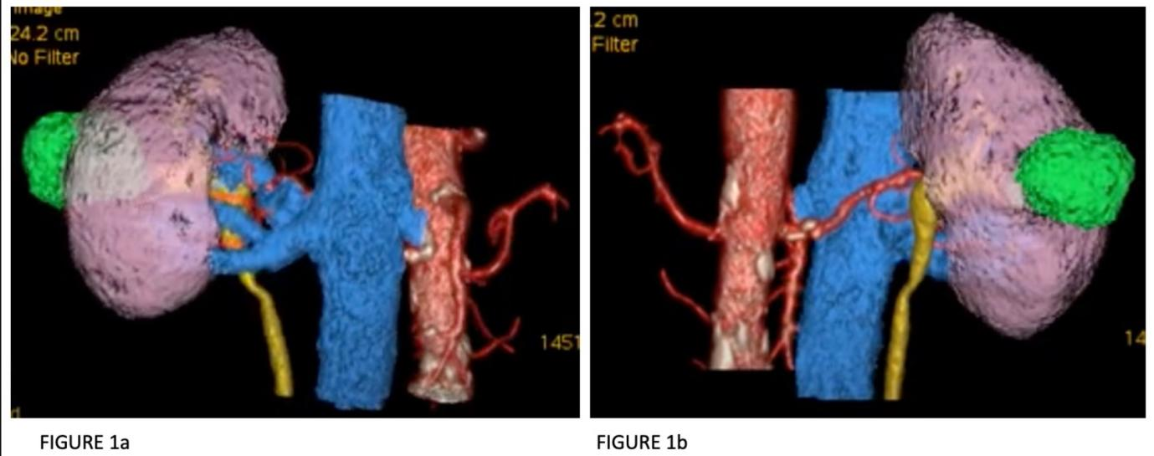
Figure 1
Depicts the anterior (figure 1a) and posterior (figure 1b)aspect of 3D reconstruction of the tumor and its relation to kidney and other key structures

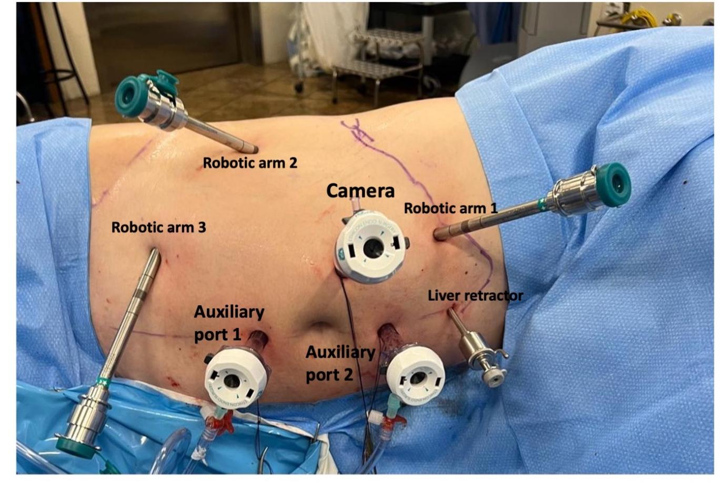
Figure 2
Depicts the port placement in our case of robotic-assisted partial nephrectomy (RAPN). The da Vinci Si robotic platform with a 30º lens, a four-arm configuration plus two assistants ports (both 12-mm ports with 2 gas insufflators) was adopted

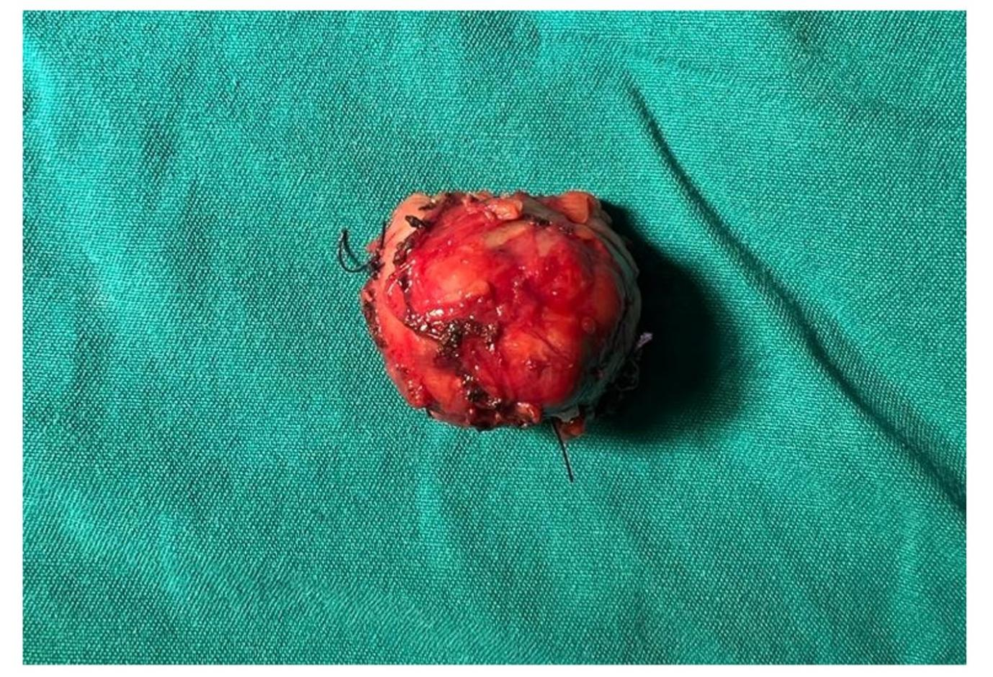
Figure 3
Depicts the resected renal lesion suspicious for renal malignancy. Histopathological analysis demonstrated a renal mass measuring 35 x 30 x 30 mm, G2, renal cell carcinoma, papillary type, with the presence of necrosis in 20% of the neoplasia. Margins were free of neoplastic involvement (pT1aNxMx).

