A case of duodenal perforation and pancreatic bleeding after flexible ureteroscopy for right renal pelvis UTUC.

Key words: UTUC; laser ablation; bleeding; duodenum.

Background

Upper tract urothelial carcinoma (UTUC) is an uncommon neoplasm and accounts for only 5-10% of all urothelial carcinomas [1]. Kidney-sparing endoscopic management of UTUC is a feasible option in patients with solitary kidney and/or impaired renal function, as well as in cases of bilateral or low-risk tumours [2]. Flexible ureteroscopy (f-URS) can be used to perform diagnostic biopsies as well as ablate the tumour in the ureter or renal pelvis using laser technology. Potential risks of this procedure range from minor complications such as UTI and haematuria to serious complications including life-threatening sepsis, ureteral strictures and ureteral and renal pelvis injuries. [3][4]. Here we present the first described case of duodenal perforation and pancreatic bleeding due to flexible ureteroscopy and laser ablation of right renal pelvis urothelial carcinoma.

Case description

A 53year-old man, with significant medical history of peptic ulcer disease on treatment with proton-pump inhibitor (PPI), was referred to our Urology Department for a high-risk upper tract urothelial cancer (UTUC) involving right renal pelvis and ureter. He was first treated in 2017 for right renal pelvis tumour and histology showed pTa G3 urothelial carcinoma. He refused right nephroureterectomy. During a follow-up period of 2 years, he underwent at least six endourological procedures (ureteroscopy and biopsies and endoluminal instillation of Mitomicin C through MJ stent) to treat recurrent UTUC. He has also undergone multiple endoscopic bladder resections (TURB) for concurrent high grade bladder cancer followed by intravesical immunotherapy with BCG. Considering the extent of the disease, multiple recurrences and the limitation of the endoscopic treatment, he was repeatedly offered right radical nephroureterectomy (RNU) but patient declined radical treatment.
In February 2019, he underwent right f-URS. Wireless and sheathless “no-touch” technique was performed using an 8.5 F flexible digital ureteroscope (Flex-XC, Karl Storz, Tuttlingen, Germany) [5]. Multiple papillary lesions were found in all the major calyces and the renal pelvis. Biopsy was performed with a tipless 1.9 F nitinol basket, followed by tumor ablation with a 200µm fiber for Thulium: YAG (Tm:Yag) laser (Cyber-TM, Quanta System, Samarate, Italy). The laser was set at 10 watts for the procedure. After an initial bloodless ablation, endoscopic vision deteriorated due to development of significant bleeding. Laser power was increased up to 30 watts in the effort of controlling the ongoing bleeding, but unsuccessfully. Decision was then made to terminate the procedure and a single J ureteral stent was placed.
On post-operative day (POD) 1, the patient presented with acute hematemesis and haematuria. CT scan showed a large clot in the right renal pelvis clot. Duodenoscopy was also carried out in emergency and the patient was found to have a 1cm perforation at the second part of the duodenum. This was treated endoscopically with the application of 4 metallic clips (Fig 1).

Unfortunately, the next day, patient developed hemodynamic instability and a drop of haemoglobin from 13 to 9g/dL. An emergency exploratory laparotomy was performed with intraoperative findings of massive hemoperitoneum due to active bleeding from a 1cm perforation of the anterior duodenum wall and from the pancreatic head (Fig 2).

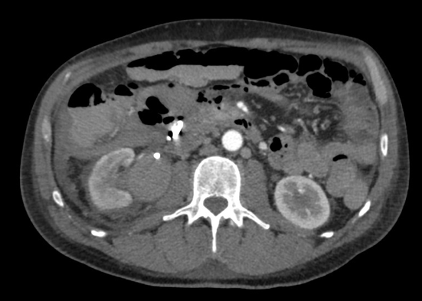

After the abdomen was washed out, the pancreatic head bleeding was controlled with haemostatic sutures and the duodenal perforation repaired. Right radical nephroureterectomy was also performed at the same setting. The patient received 4 pints of packed cells transfusion during surgery. Post-operatively, the patient was clinically stable but admitted to the Intensive Care Unit for monitoring. On POD 8th, drain output was suspicious for enteric content, hence a CT scan and gastrograffin swallow was performed. The scans demonstrated duodenal fistula. The patient was then brought back into the operating room for repair of the duodenal fistula (Fig 3).

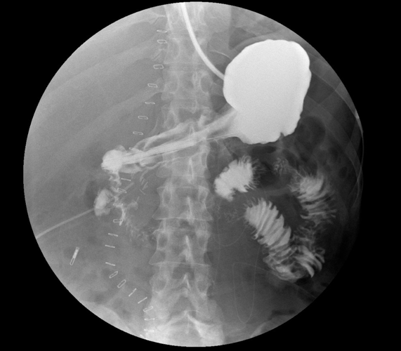

Patient recovered gradually following the second duodenal repair surgery. However, after 1 weeks the patient presented with recurrent hematemesis and haemorrhagic shock. CT angiogram documented recurrent active bleeding near the previous metallic clips used in the repair of the duodenal perforation. Patient underwent selective embolization of the duodenal branch of superior mesenteric artery and as well as branches of gastroduodenal artery successfully (Fig 4, Fig 5).

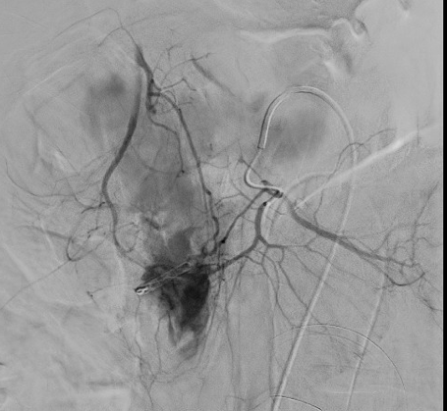

Subsequently, patient recovered without further hematemesis and haemoglobin levels remained stable. He was discharged from hospital on the 30th post-operative day since first surgery.
Final histological examination of the right radical nephroureterectomy specimen was reported to be pTis urothelial carcinoma of the right renal pelvis. He is now still on follow up, with the last bladder recurrence in May 2022.

Discussion and Conclusions
According to the current European Association of Urology (EAU) Guidelines, RNU remains the gold standard for high-risk UTUC[2]. Nevertheless, conservative treatment should be considered as an option in patients with imperative indications for kidney-sparing surgery, such as in solitary kidney, bilateral UTUC or chronic renal failure, as well as for clinically low risk UTUC [6]. In some cases where the patient chooses to avoid radical surgery, it is important to ensure that the patient is aware of the possible risks of disease progression and the necessity of close endoscopic follow-up. To date, f-URS is useful for both endoscopic tumour ablation and a close postoperative surveillance of UTUC after kidney-sparing treatment [7]. Endoscopic procedures in the upper urinary tract are associated with the risk of trauma to the ureter and pyelocaliceal system[8]. These injuries are classified as a major complication of f-URS and usually reported to be due to the use of a ureteral access sheath (UAS) [4]. In our case, we did not use a UAS, and therefore, the pelvic wall perforation must have been due to tumor ablation with Thulium: YAG laser in the setting of poor visibility due to significant bleeding during the tumour ablation.
In a review of URS complications by Linehan et al. [3], the authors found a rate of bleeding ranging from 1.6% to 27.3% but only a few were serious enough to require hospitalization and/or blood transfusion. Bleeding during URS treatment for UTUC was more frequently associated with patients who had previously received adjuvant instillations [3]. Renal pelvis wall perforation is an even rarer event, with rates varying from 1.3% to 7.4% of cases. There are also some disease-related factors to consider, such as tumor location and invasiveness. In our case, the patient presented with a large tumour involving the entire anterior wall of renal pelvis and all the calyces and the diseased urothelium is more prone to injury and perforation.
The choice of laser in the ablation of the tumour also contributes to the risk of injury to the collecting system and hence the characteristics of the laser must be considered. Proietti et al evaluated the effects of both Tm:YAG and Holmium:YAG (Ho:YAG) lasers on upper urinary tract urothelium, with a focus on incision depth and coagulation area[9]. This study showed a lower penetrative power for Tm:YAG (due to lower peak-power, better water absorption and continuous mode) compared to Ho:YAG, with a higher coagulation effect without excessive carbonization of tissue. Despite these advantages in choosing Tm: YAG laser, we encountered major bleeding in our case, resulting in poor vision that led to the inadvertent perforation of the renal pelvis with the involvement of the duodenum and the pancreas.
In addition, our patient had a history of peptic ulcer disease, and this underlying pathology may have contributed to the fragility of the duodenal wall. The second segment of duodenal “C” lies over the right renal hilum, hence its proximity resulted in the injury with the renal pelvis perforation (Fig 6).

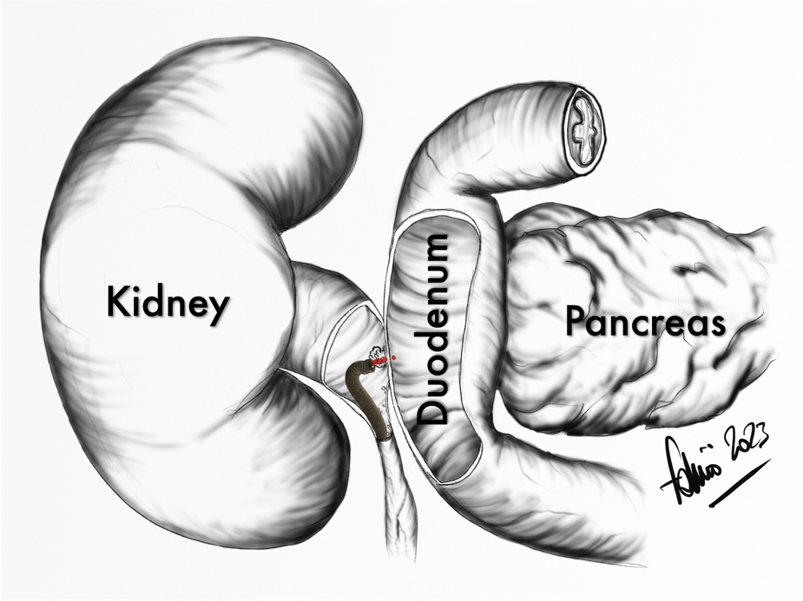

Duodenal perforation is a rare condition but is associated with high morbidity and mortality, ranging from 8% to 25% [10]. Isolated duodenal injuries after trauma are rare and pancreas is frequently injured concomitantly due to their close anatomical relationship. The second segment of the duodenum is the most commonly injured part (36%). When isolated minor CT findings are discovered the clinical case can be managed conservatively with close monitoring, otherwise patients usually require surgical intervention. Endoscopic management with supportive medical therapies is first line therapy and is highly effective. However, approximately 10% of all patients will either continue to bleed or experience re-bleeding within 48 h of the endoscopic treatment. While surgical therapy has historically been considered the next line of treatment for upper GI refractory bleeding, angioembolization has now become the next line of therapy[11]. Given the dual supply to the duodenum from the celiac trunk (GDA), as well as the superior mesenteric artery (through the inferior pancreaticoduodenal arcades), embolization that is distal to the site, and proximal to the bleeding is needed for effective embolization[11] The main complication after trans-arterial embolization is bowel ischemia. Although the upper gastrointestinal tract has a rich collateral blood supply, ischemic complications can still occur in 7 to 16% of cases [12] in which unfavourable evolution is very likely.
In the literature we find only very limited number of cases of iatrogenic injury of the duodenum during endourological surgery: one in a patient with indwelling right ureteral DJ stent [13] and 4 cases of duodenal perforation during percutaneous nephrolithotomy [14].
Here, we describe the first case of duodenal injury occurring during operative ureteroscopy for UTUC. The injury was due to laser ablation of the tumour in poor visibility condition on background of tissue fragility. Urologists should pay special attention when using laser in endourology, especially during soft tissue treatment: the last generation high power lasers are very effective but also able to deliver an energy that may clearly exceed the amount needed becoming dangerous and counterproductive especially in case of severe bleeding. In this scenario, when controlling of the bleeding in the upper urinary tract is not achievable, always consider stopping the procedure in order to avoid life-threatening complication like this and involving interventional radiologists.
Early recognition, diagnosis and timely intervention are crucial in the management of these rare but serious complications.

REFERENCES

[1] R. L. Siegel, K. D. Miller, and A. Jemal, “Cancer statistics, 2019,” CA Cancer J Clin, vol. 69, no. 1, pp. 7–34, Jan. 2019, doi: 10.3322/caac.21551.
[2] M. Rouprêt et al., “European Association of Urology Guidelines on Upper Urinary Tract Urothelial Carcinoma: 2020 Update,” European Urology, vol. 79, no. 1. Elsevier B.V., pp. 62–79, Jan. 01, 2021. doi: 10.1016/j.eururo.2020.05.042.
[3] J. Linehan, M. Schoenberg, E. Seltzer, K. Thacker, and A. B. Smith, “Complications Associated With Ureteroscopic Management of Upper Tract Urothelial Carcinoma,” Urology, vol. 147, pp. 87–95, Jan. 2021, doi: 10.1016/j.urology.2020.09.036.
[4] V. De Coninck et al., “Complications of ureteroscopy: a complete overview,” World Journal of Urology, vol. 38, no. 9. Springer, pp. 2147–2166, Sep. 01, 2020. doi: 10.1007/s00345-019-03012-1.
[5] G. B. Johnson, D. Portela, and M. Grasso, “Advanced Ureteroscopy: Wireless and Sheathless,” 2006. [Online]. Available: www.liebertpub.com
[6] S. Proietti et al., “Conservative treatment of UTUC in patients with imperative indications,” 2020, doi: 10.23736/S0393-2249.20.03710-8.
[7] S. Y. Cho, “Current status of flexible ureteroscopy in urology,” Korean Journal of Urology, vol. 56, no. 10. Korean Urological Association, pp. 680–688, Oct. 01, 2015. doi: 10.4111/kju.2015.56.10.680.
[8] H. Abboudi, K. Ahmed, J. Royle, M. S. Khan, P. Dasgupta, and J. N’Dow, “Ureteric injury: A challenging condition to diagnose and manage,” Nature Reviews Urology, vol. 10, no. 2. pp. 108–115, 2013. doi: 10.1038/nrurol.2012.254.
[9] S. Proietti et al., “Thulium:Yag versus holmium:Yag laser effect on upper urinary tract soft tissue: Evidence from an ex vivo experimental study,” J Endourol, vol. 35, no. 4, pp. 544–551, Apr. 2021, doi: 10.1089/end.2020.0222.
[10] D. Ansari, W. Torén, S. Lindberg, H. S. Pyrhönen, and R. Andersson, “Diagnosis and management of duodenal perforations: a narrative review,” Scandinavian Journal of Gastroenterology, vol. 54, no. 8. Taylor and Francis Ltd, pp. 939–944, Aug. 03, 2019. doi: 10.1080/00365521.2019.1647456.
[11] G. Kuyumcu, I. Latich, R. L. Hardman, G. C. Fine, R. Oklu, and K. B. Quencer, “Gastrodoudenal embolization: Indications, technical pearls, and outcomes,” Journal of Clinical Medicine, vol. 7, no. 5. MDPI, May 01, 2018. doi: 10.3390/jcm7050101.
[12] A. N. Barkun et al., “International Consensus Recommendations on the Management of Patients With Nonvariceal Upper Gastrointestinal Bleeding,” 2010. [Online]. Available: https://annals.org
[13] Scott Tenner and Ian Wall, “Spontaneous perforation of the duodenum by a migrated ureteral stent,” Gastrointest Endosc, vol. 68, no. no 6, pp. 1236–1238, Dec. 2008.
[14] Dahril, H. Oetama, and A. Mustafa, “Duodenal perforation and a broken guidewire fragment inside the duodenum during supine percutaneous nephrolithotomy (PCNL) without adequate prior imaging: A case report,” Urol Case Rep, vol. 22, pp. 25–27, Jan. 2019, doi: 10.1016/j.eucr.2018.10.007.

