Cover letter
Dear Editor/s
I am sending you our case report entitled "Robotic assisted transvesical excision of recurrent bladder leiomyoma with intraoperative ultrasound guidance" for a consideration of publication in your respectful journal, Uro-Technology Journal.
We have submitted our work in the Uro-Technology Journal where we hope to be accepted and published because our current case study, to the best of the authors' knowledge, is the only documented case on the use of robotic assisted bladder leiomyoma excision and the first to describe the additional benefits of combining robotics with intracorporeal USS guidance. The manuscript includes 4 figures.
We confirm that this case study has not been published in part or whole ant any journal and not under consideration for publication elsewhere.
We confirm that all authors have reviewed, approved, and consented to the submission in the Uro-Technology Journal.
We confirm that there are no any potential competing interests.

Best regards,
The authors

Corresponding author: Ayman Ali; senior clinical fellow in robotic urology at Portsmouth hospitals University NHS trust, Portsmouth, United Kingdom.
E-mail: Ayman.Ali3@nhs.net.

Title page
Robotic assisted transvesical excision of recurrent bladder leiomyoma with intraoperative ultrasound guidance
Running Head: A case of robotic assisted bladder leiomyoma excision with the beneficial guidance of intraoperative ultrasound.
Authors:
Ayman Ali ª*, Daniel Wilbyª, Joni Dossantosª, Richard Robinsonª
Affiliations:
ª Urology Department, Portsmouth Hospitals NHS Trust, Portsmouth, United Kingdom.
*Corresponding Author details:
Name: Ayman Ali
E-mail: Ayman.Ali3@nhs.net
Address: Portsmouth Hospitals NHS Trust, Portsmouth, United Kingdom; PO6 3LY.

Robotic assisted transvesical excision of recurrent bladder leiomyoma with intraoperative ultrasound guidance
Abstract
Background: Leiomyoma of the urinary bladder is uncommon benign tumour with a wide range clinical presentation. Surgical excision remains the definitive treatment of leiomyoma with excellent outcomes. Seldom literatures reported the use of robotic assisted surgical techniques for its excision. Case description: A 51 years old woman presented with frequent episodes of visible haematuria in consistence with lower urinary tract symptoms. The initial diagnosis was urinary tract infection however, symptoms did not resolve even with the proper antibiotics. After further investigations a soft tissue density mass measuring 20×23×20 mm within the left posterior wall of the urinary bladder extending towards the bladder neck was found. The histological finding of the transurethral resected biopsy of the mass revealed a benign submucosal leiomyoma of the bladder with no evidence of any malignancy. Using the Intuitive Da Vinci X system the tumor was excised using the ultrasound guidance to define the tumour margins, sparing the left ureteric orifice and ureter. The patient was discharged home on the day of surgery, with a urethral catheter in place. The catheter was successfully removed after 10 days, with cystogram prior confirming no leakage. The ureteric stent was removed by flexible cystoscopy two weeks later. The final histology was reported as a bladder leiomyoma with no evidence of malignant features and negative circumferential resection margins. Conclusion: Herein, in the current case we present a safe and effective technique for the excision of recurrent bladder leiomyoma using the robotic assisted transvesical approach with intraoperative ultrasound guidance.
Keywords: Bladder, Leiomyoma, Robotic, partial cystectomy.

Introduction
Bladder leiomyoma, a benign smooth muscle tumour, represents 0.43% of all bladder neoplasms. Clinical presentation is variable, depending on location and size of the tumour ^{[1]}. Patients may present with haematuria or storage urinary symptoms, however, others may be asymptomatic discovering the lesion incidentally. The management of leiomyomas is mainly surgical, with different approaches from transurethral resection to open segmental resection or partial cystectomy described ^{[2].} Bladder leiomyoma were exceptionally resected in certain female cases through trans-vaginal approach ^{[3]}. laparoscopic partial cystectomy was also suitable ^{[4]} However, there is a very limited data on the robotic excision of bladder leiomyoma ^{[5].}
Over the past 20 years, the application of robotic assisted technology in urological oncology has totally transformed the urologists' manner for approaching tumours. Being a feasible and safe technique with comparable oncologic outcomes and increased surgeon comfort, convince urologists to make the robotic assisted surgeries their top choice in urological cancers ^{[6]}.
The use of robotic assisted surgical techniques in urology offered many benefits over the established open surgery and laparoscopy. As, in addition to the benefit of 3D visualisation of the surgical field, robotics allow good motion scaling, thus large movements at the console are translated into a very small motions at the operative site. Furthermore, robots terminated the fulcrum effect of laparoscopic surgery, in which the movement of the instrument tips went in an opposite direction to the surgeon's hand however with robotic instruments the movement of instrument tips in the body goes in the same direction as the surgeon's hands in the console so that the degree of freedom during the operation is enhanced ^{[7]}. In addition, robotics assisted surgeries, eliminates tremors, reduced surgeon fatigue with more ergonomic positioning so that allowing precise and smooth surgery. Accordingly, robotic assisted technique offers a higher dexterity and accuracy with less surgical complications ^{[8]}.
There is an expanding use of the intraoperative ultrasound to handle and guide different intraoperative interventions. The main goal is the better visualization and location of lesions in order to provide interactive and precise information during surgery, thus, helping surgeons for a precise guidance during operation and in turn a potentially improving of the outcomes ^{[9]}.
In our case, we introduce robotic assisted intravesical approach to excise bladder leiomyoma, using intraoperative ultrasound guidance for accurate demarcation of lesion margins.
Case presentation
Our patient was 51 years old lady who presented with recurrent episodes of visible haematuria. She had no history of smoking, no occupational risk factors and no family history of urological cancer. Her performance status was zero and she was on no medications. She was initially treated with antibiotics due to co-existing lower urinary tract symptoms thought to be due to UTI, but subsequently referred to the urology clinic due to non-resolution of these symptoms and ongoing haematuria.
Initial flexible cystoscopy was inconclusive, due to poor views with a bladder full of debris. CT urography (CTU) demonstrated two relatively large distal ureteric stones measuring 15mm and 10 mm in the longest diameter with proximal hydroureteronephrosis and non-obstructing renal stones in the contralateral kidney. The scan also identified a soft tissue density mass measuring 20×23×20 mm within the left posterior wall of the urinary bladder extending towards the bladder neck (Fig. 1).
She subsequently proceeded to rigid cystoscopy with transurethral resection biopsies and ureteroscopic LASER fragmentation of the right ureteric stones. Cystoscopy revealed normal bladder urothelium. The area of concern on the CTU appeared as a bulge with, normal urothelial, adjacent to the left ureteric orifice. Loop resection biopsies were taken from the bulging area and sent for histological analysis. The tissue was relatively avascular on cutting.
Histology demonstrated a benign submucosal leiomyoma of the bladder with no evidence of any malignancy. Due to the anatomical position of the leiomyoma (adjacent to ureteric orifice and bladder neck) and the absence of malignant features, a conservative management approach was adopted, with plan for surveillance cystoscopic assessment.
Her first check flexible cystoscopy revealed a calcified deposit in the region of her previous resection area with progression in its size. She underwent further transurethral resection which again reported benign leiomyoma on histology. She continued on conservative follow up, with 6 monthly imaging with CTU and MRI demonstrating stable appearance of her bladder leiomyoma for almost 14 months. Despite this she experienced increasing storage urinary symptoms and haematuria. Subsequent CTU showed an increase in both the intravesical and extravesical components and calcification. (Fig.2). In view of her increasingly bothersome symptoms and radiological progression, she was counselled regarding surgical excision. It was felt that continued conservative management risked further increase in size with resultant surgery being more complex with a higher risk of functional complications. The patient agreed to undergo robotic assisted transvesical bladder leiomyoma excision.
Using the Intuitive Da Vinci X system the patient was docked with the robot in 20° Trendelenburg using a standard cystectomy port placement, with a urinary catheter in place. The left side of bladder was mobilised down to endo-pelvic fascia, with no division of the vascular pedicles. The bladder was then released anteriorly and dropped obliquely, leaving right side undisturbed. The bladder was filled with saline and the tumour characterised using intracorporeal USS. The bladder was opened with a cranio-caudal oblique incision down to the anterior border of the tumour at the bladder neck, again with USS guidance. Due to the proximity of the tumour to the left ureteric orifice a 6/24 JJ stent was inserted. The tumour was then excised using USS guidance to define the tumour margins, sparing the left ureteric orifice and ureter. The bladder closed using a single layer 3/0 V-Loc, with bladder neck reconstruction. The patient was discharged home on the day of surgery, with a urethral catheter in place. (Fig.3A, 3B, 3C, 3D, 3E).
The catheter was successfully removed after 10 days, with cystogram prior confirming no leakage (Fig. 4). The ureteric stent was removed by flexible cystoscopy two weeks later.
The final histology was reported as a bladder leiomyoma with no evidence of malignant features and negative circumferential resection margins.
The patient was reviewed 6 weeks post operatively and reported she was fully continent with no ongoing lower urinary tract symptoms, and was discharged from follow up.

Discussion
Despite being a rare neoplasm, bladder leiomyoma is the most common soft tissue benign non-epithelial tumour of the urinary bladder with variable clinical presentations ^{[10]}.
Our patient had submucosal baldder leiomyoma that was adjacent to ureteric orifice and bladder neck. Nearly 80% of the affected patients suffered from symptoms ranged from irritative to obstructive symptoms with associated hematuria which comes in line with the clinical presentation of our case ^{[11]}. On the other hand, rarely other patients were asymptomatic ^{[12]}.
Although bladder leiomyoma has benign nature, it may behave as malignant tumors, thus surgical removal, using different surgical approaches, is often preferred ^{[11]}. surgical excision remains the definitive treatment of leiomyoma with excellent outcomes ^{[1, 12]} however laparoscopy, transurethral resection and transvagainal resection using hysteroscope are also other options.
Robotic assisted excision of bladder leiomyomas provides the opportunity for this definitive treatment to be delivered in a minimally invasive way, providing all of the well described advantages to patients of minimally invasive surgery (MIS) ^{[5]}. Literature on the excision of bladder leiomyoma using robotic approaches is limited. However, the use of the transvesical approach for leiomyoma excision was reported ^{[13]}. Interestingly, the use of intra operative ultrasonic guidance is a valuable tool that helps urologists to implement different complex robotic procedures with improved surgical outcomes ^{[14].} Our procedure utilized the addition of intracorporeal USS guidance that gives the additional benefit of precise tumour identification, limiting the degree of bladder mobilisation required, providing clear margin delineation, which should lead to a reduced risk of functional bladder sequalae and incomplete resection. Given the availability of robotics in modern urology, early use of robotic resection and reconstruction should be considered over other techniques and conservative management.
Our case sheds lights into two clinical finding; first the feasibility of robotic bladder leiomyoma excision using the transvesical approach; second, utilizing intra operative ultrasonic guidance during the procedure assisted us in performing a precise and safer excision of the leiomyoma. Hence, to the authors' knowledge, there are very few documented cases on the use of robotic assisted bladder leiomyoma excision in the literature, however our case is the first to describe the additional benefits of combining robotics with intracorporeal USS guidance.
Conclusion
Leiomyomas are rare benign neoplasms of the bladder, which present with variable symptoms and may even be asymptomatic. Excision via a robotic transvesical approach offers a minimally invasive option for complete resection with minimal functional impact.

Declarations
Acknowledgements
NO grant or funding has been received to support this research from any funding agency.
Author contributions:
Substantial contributions to the conception, design, methodology, drafting, writing, editing, reviewing and final revision of the study: Ali A; Supervision, reviewing and final revision of the work: Wilby D; Substantial contribution to the methodology of the work: Dossantos J; Supervision, methodology, reviewing, editing and final revision of the work: Robinson R.
Financial Support and Sponsorship
None

Conflict of interest statement
No conflict of interest.

Ethical Approval and Informed consent
According to institutional regulations, the patient has provided an informed consent for publication of images and information in this study. Any procedure performed was in accordance with the ethical standards of the institutional and national research committee and with the 1964 Helsinki Declaration and its later amendments or comparable ethical standards.

References
[1] Caliskan S, Sungur M. Bladder Leiomyoma. J Coll Physicians Surg Pak. 2017;27(3):189-190. PMID: 28406781. https://pubmed.ncbi.nlm.nih.gov/28406781/
[2] Zachariou A, Filiponi M, Dimitriadis F, Kaltsas A, Sofikitis N. Transurethral resection of a bladder trigone leiomyoma: a rare case report. BMC Urol. 2020 Oct 7;20(1):152. doi: 10.1186/s12894-020-00722-2. PMID: 33028269; PMCID: PMC7542762. https://www.ncbi.nlm.nih.gov/pmc/articles/PMC7542762/
[3] Nagai N, Katayama Y, Iguchi M, Esa A. A case of urinary retention due to a female paraurethral leiomyoma. Hinyokika Kiyo 1988 Apr;34(4):696-700. https://pubmed.ncbi.nlm.nih.gov/3041781/
[4] Murota T, Komai Y, Danno S, Fujita I, Kawakita M, Matsuda T. Endoscopic partial cystectomy for bladder leiomyoma using retroperitoneoscopic and transurethral procedures. Int J Urol. 2002 Mar;9(3):190-2. doi: 10.1046/j.1442-2042.2002.00447.x. PMID: 12010334. https://pubmed.ncbi.nlm.nih.gov/12010334/
[5] Baird BA, Ericson CA, Augustus A, Geldmaker L Wajswol E, Young P R , Robotic transvesical bladder leiomyoma excision. Urology Case Reports, 2022; (43),102054. doi.org/10.1016/j.eucr.2022.102054 https://www.ncbi.nlm.nih.gov/pmc/articles/PMC8956799/
[6] Skolarus TA, Zhang Y, Hollenbeck BK. Robotic surgery in urologic oncology: gathering the evidence. Expert Rev Pharmacoecon Outcomes Res. 2010 Aug;10(4):421-32. doi: 10.1586/erp.10.46. PMID: 20715919; PMCID: PMC3004124. https://www.ncbi.nlm.nih.gov/pmc/articles/PMC3004124/

[7] Kim V B, Chapman W H, Albrecht R J. Early experience with telemanipulative robot assisted laparoscopic cholecystectomy using da Vinci. Surg Laparosc Endosc Percutan Tech 20021234–40. https://pubmed.ncbi.nlm.nih.gov/12008760/

[8] Murphy D, Challacombe B, Khan MS, Dasgupta P. Robotic technology in urology. Postgrad Med J. 2006 Nov;82(973):743-7. doi: 10.1136/pgmj.2006.048140. PMID: 17099094; PMCID: PMC2660512. https://pubmed.ncbi.nlm.nih.gov/17099094/

[9] Porpiglia F, Checcucci E, Amparore D, Piramide F, Volpi G, Granato S, Verri P, Manfredi M, Bellin A, Piazzolla P, Autorino R, Morra I, Fiori C, Mottrie A. Three-dimensional Augmented Reality Robot-assisted Partial Nephrectomy in Case of Complex Tumours (PADUA ≥10): A New Intraoperative Tool Overcoming the Ultrasound Guidance. Eur Urol. 2020 Aug;78(2):229-238. doi: 10.1016/j.eururo.2019.11.024. Epub 2019 Dec 30. PMID: 31898992.
https://pubmed.ncbi.nlm.nih.gov/30979636/

[10] Park J W., Jeong B C., Seo SI., Jeon SS., Kwon GY., Lee HM. Leiomyoma of the Urinary Bladder: A Series of Nine Cases and Review of the Literature. Urology, 2010; 76(6), 1425-1429. doi:10.1016/j.urology.2010.02.046 https://pubmed.ncbi.nlm.nih.gov/20947147/

[11] Yoshioka Y, Kawakita M, Kameoka H. Cystoscope-Assisted laparoscopic enucleation of a large progressive bladder leiomyoma. J Endourol Case Rep, 2019; 5 (3), pp. 120-123. https://pubmed.ncbi.nlm.nih.gov/32775643/
[12] Marcos Tobias-Machado, Cristiano Linck Pazeto , Rafael Castilho Borges. Robot-assisted transvesical partial cystectomy for leiomyoma of bladder trigone. Int Braz J Urol Mar-Apr 2020;46(2):300. Doi: 10.1590/S1677-5538.IBJU.2018.0801. https://pubmed.ncbi.nlm.nih.gov/32022531/
[13] Gok A. Transurethral Resection of a Large Urinary Bladder Leiomyoma: A Rare Case Report. Urol J. 2017 Jul 2;14(4):4052-4054. PMID: 28670675. https://pubmed.ncbi.nlm.nih.gov/28670675/
[14] Ukimura O, Okihara K, Kamoi K, Naya Y, Ochiai A, Miki T. Intraoperative ultrasonography in an era of minimally invasive urology. International journal of urology, 2008; 15(8); pp 673-680 https://doi.org/10.1111/j.1442-2042.2008.02090.x. https://pubmed.ncbi.nlm.nih.gov/18564203/

Figures

Figure (1) CTU showed the soft tissue density mass within the left posterior wall of the urinary bladder extending towards the bladder neck.
Figure (2): CTU showed an increase in both the intravesical and extravesical components and calcification.
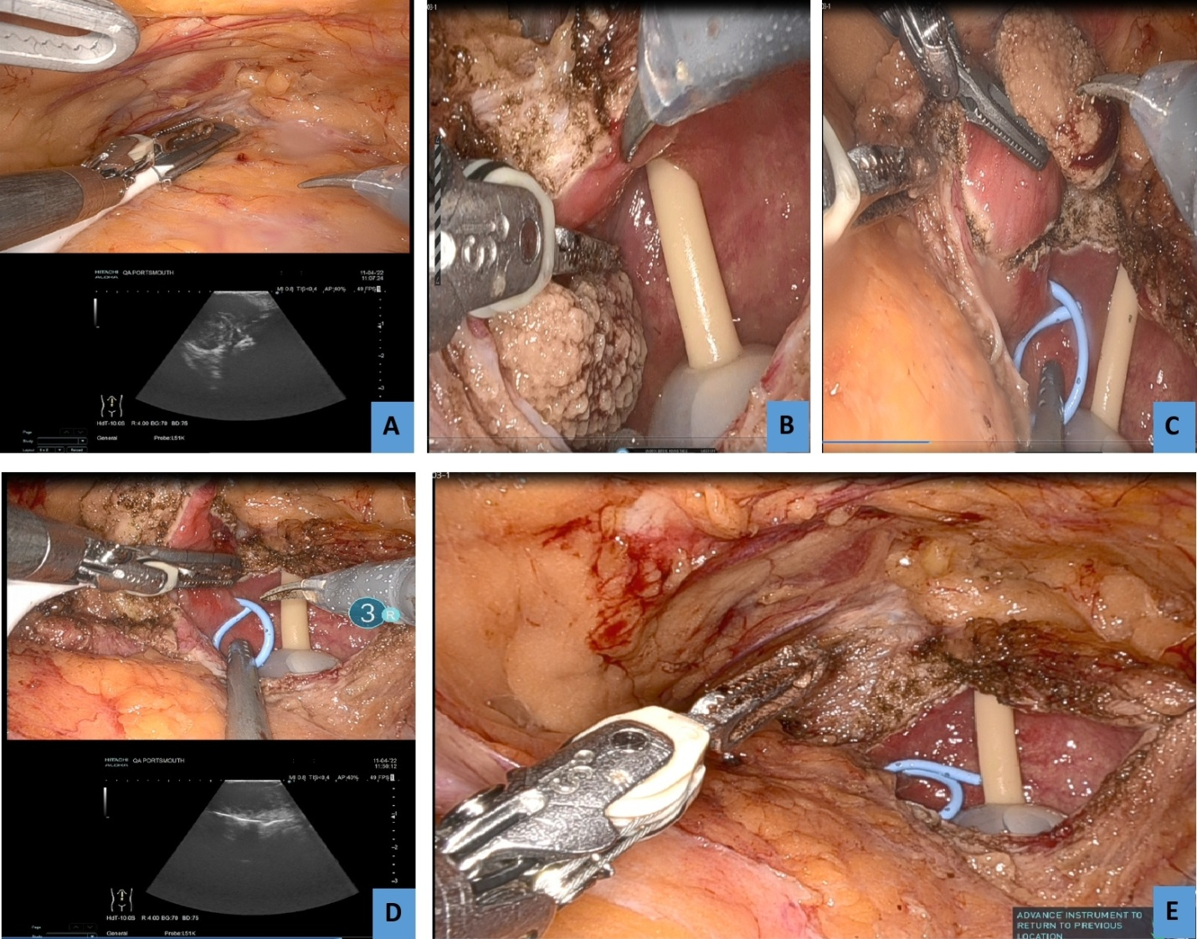
Figure (3): (A) Identification of the extent of the leiomyoma by Ultrasound extravesically; (B) cystostomy and visualisation of the boundaries of the lesion; (C) Stenting the left ureter and demarcation of the cutting margins; (D) confirmation of the margins by ultrasound intravesically prior to excision; (E): Bladder after excision of the lesion.

Figure (4): Cystogram prior catheter removal confirming no leakage

Point-by-point response to Reviewers
We greatly appreciate the reviewers’ time and effort in crafting the insightful and supportive comments. We have been incorporated the required amendments in the manuscript with their clarification. The changes within the manuscript have been underlined. We hope these modifications are satisfactory for the manuscript acceptance in your respectful journal.
Here is a point-by-point response to the reviewers' comments and concerns.

Reviewer (1)
You report a case report concerning robotic assisted transvesical excision of recurrent bladder leiomyoma. I commend you for this manuscript, considering that in literature we find few studies about this topic. The study is well presented.
I would just suggest to improve the Introduction by introducing and describing the actual role of robotic surgery in Urology and its advantages in comparing to open surgery.
Even the discussion results too scanty. Please refer to other studies on this topic; i.e. Yoshioka T, Kawakita M, Kameoka H.Cystoscope-Assisted Laparoscopic Enucleation of a Large Progressive Bladder Leiomyoma. J Endourol Case Rep. 2019 Aug 30;5(3):120-123.
Furthermore, you could also discuss alternative endoscopic therapies (Gok A. Transurethral Resection of a Large Urinary Bladder Leiomyoma: A Rare Case Report. Urol J. 2017 Jul 2;14(4):4052-4054 and Zachariou A, Filiponi M, Dimitriadis F, Kaltsas A, Sofikitis N. Transurethral resection of a bladder trigone leiomyoma: a rare case report.BMC Urol. 2020 Oct 7;20(1):152 and Li A, Zhang P, Zhang M, Yang T, Yue Y, Chen G, Li W, Fan J. Transurethral Enucleation of Bladder Leiomyoma: A Series of Six Cases and Review of the Literature.Urol Int. 2019;102(1):102-108), explaining why robotic surgery could be better than endoscopic procedures. Please discuss better the previous study on this topic (reference 2), highlighting the clinical and surgical advantages of intracorporeal USS guidance.
Response:
We sincerely appreciate praising our manuscript. The manuscript has been revised and more details describing the robotic surgery role in Urology has been added to the introduction section with shedding lights on robotic surgery advantages in relation to open surgery. Meanwhile, the discussion section has been enriched with more details supporting our study results taking in consideration your recommended references that you have kindly provided. We have also mentioned why robotic surgery in urology is now better that other endoscopic procedures and highlighed the advantages of intracorporeal USS guidance both clinically and surgically.
All added and modified parts have been underlined in the revised manuscript file.

Reviewer (2)
In the current paper the Authors provide an interesting case report highlighting the feasibility and safety of robot assisted trasnvesical resection of a bladder leyomioma with intraoperative ultrasound guidance. The clinical case is quite peculiar. The manuscript is well written and references are accurate.
Response: We would like to greatly thank the reviewer for this comment.
I have several issues / edit suggestions to point out:
- Was a drain placed? Do the authors usually never place a drain after cystotomy/ partial cystectomy?
Response: Drain never placed after partial cystectomy unless challenges with bladder closure which we have not experienced in any of our cases till now. We are doing water tight closure and testing after with bladder filling to confirm no leakage.
- Authors state a bladder neck reconstruction was performed. Please be more specific. It would be interesting to better understand the reconstructive phase as well.
Response: The bladder neck was reconstructed ventrally to the left due to involvement of the excision margins of the tumor to the BN.
- The quality of Figure 1 could be further improved.
Response: The quality Figure (1) has been improved.
Sincerely yours,

