Original Article Creative Commons 4.0
Title: Laparoscopic nephrectomy with mini-incision kidney autotransplantation in severe ureteral strictures

Forename Surname¹, Forename Surname^{1,2}, Forename Surname³
¹Department, Institution, City Postcode, Country.
²Department, Institution, City, State Postcode, Country.
³Department, Institution, City Postcode, Province, Country.
Correspondence to: Prof./Dr. Forename Surname, Department, Institution, Detailed Address, City Postcode, Country.
E-mail: xxxx@xxxx.xxx

Abstract
Background: The purpose of this study, i.e., the reason why authors write this manuscript.
Methods: The detailed methods applied to this study, including description of patients, materials, software, experimental apparatus, experiment object (human or animals), etc.
Results: The main findings of this study, including conclusive description, analysis, and comparison with other related research results, etc.
Conclusion: The conclusion of this study. We suggest that authors may highlight its significance, emphasize the value of this study and state expectation on future studies that may need to be carried out.
Keywords: Ureteral stricture, autotransplantation, kidney, surgery

INTRODUCTION
The introduction is a beginning section of a manuscript which states the purpose of the study, overviews or summarizes previous findings and progress related to this study, and indicates its significance in this research field. It is generally followed by the body and discussion.
METHODS
In this section, we suggest that authors may set headings and provide all the details of how you conducted your study and what you did for it. In detail, it may contain description of participants selection, materials, software, experimental apparatus (state the manufacturer’s name and address in parentheses), experiment object (human or animals), methods, procedures, technical information, necessary statistics, etc. All the information should be given in sufficient detail so that other scholars are able to reproduce the results.
RESULTS
This section shows the main findings of your study. It may contain conclusive description, analysis, and comparison with other related research results, etc. Authors may set headings to separate the results of different experiments in this section. Table 1 (other forms: Tables 1 and 2; Tables 1-3), Equation (1) [other forms: Equations (2) and (3); Equations (4-6)] and Figure 1 (other forms: Figure 1A and B; Figure 2A-C; Figures 1 and 2A; Figures 1, 2A and 3-5) show the examples of diagrams. All the tables, equations and figures should be cited in sequence in the main content near to the first time they appear. For supplementary material, authors may cite table, equation and figure like Supplementary Table 1, Supplementary Equation (1) and Supplementary Figure 1.
Table 1. This is a table caption. A summary description of this table should be written here
Authors | Regimen | n | Age (year) | CR (%) | 2-year (3-year) EFS/PFS (%) | 2-year (3-year) OS (%)
Our current study | CHOP  CVP | 251  67 | 17-82  45-87 | 69.8  29.9* | 55.3 (46.0)  18.0 (12.0)* | 58.0 (52.0)  25.0 (19.0)*
Khaled et al.^{[1]} | CHOP | 40 | 19-75 | 67 | 54 (54) | 82 (71)
Burton et al.^{[2]} | CHOP  CIOP | 105  106 | 22-66  25-67 | 70  52 | 4-year PFS: 56  4-year PFS: 40* | 4-year OS: 65  4-year OS: 56#
This part is footer. *P < 0.05, #P ≥ 0.05. EFS: event-free survival; PFS: progression-free survival; OS: overall survival; CHOP: cyclophosphamide, doxorubicin, vincristine, and prednisone; CVP: cyclophosphamide, vincristine, and prednisone; CIOP: cyclophosphamide, idarubicin, vincristine, and prednisone; CR: complete response. This table is cited with permission from Li et al.^{[1]} published in xxx
 |  | (1)
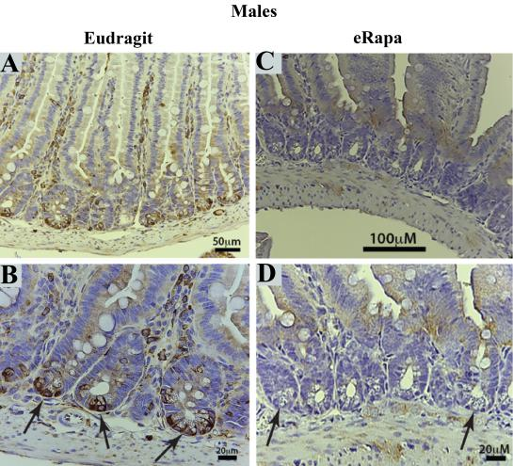  A | 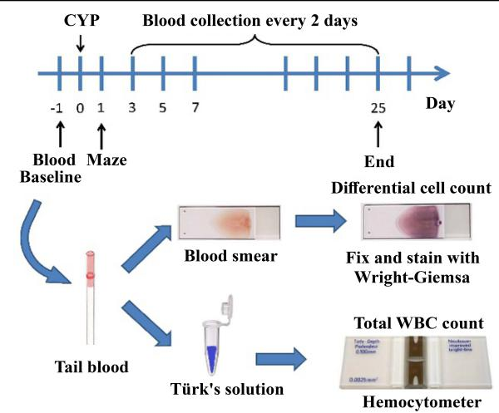  B
C
Figure 1. We present examples of electron micrograph, non-editable and editable images in Figure 1A-C. A: description of what the Figure 1A is; B: description of what the Figure 1B is; C: description of what the Figure 1C is.
DISCUSSION
In this part, authors should discuss the significance of the study, emphasize its value and state expectation on future studies that may need to be carried out. In details, it may include summary of key findings, strengths and limitations of the study, controversies raised by this study, and future research directions, etc.
DECLARATIONS
Acknowledgments
Anyone who contributed towards the article but does not meet the criteria for authorship, including those who provided professional writing services or materials, should be acknowledged. Authors should obtain permission to acknowledge from all those mentioned in the Acknowledgments section. This section is not added if the author does not have anyone to acknowledge.
Authors’ contributions
Made substantial contributions to conception and design of the study and performed data analysis and interpretation: Salas H, Castaneda WV; Performed data acquisition, as well as provided administrative, technical, and material support: Castillo N, Young V
Availability of data and materials
Authors should declare where the data supporting their findings can be found. Data can be deposited into data repositories or published as supplementary information in the journal. Authors who cannot share their data should state that the data will not be shared and explain it.
Financial support and sponsorship
If there are sources of funding for the study reported, any relevant grant numbers and the link of funder’s website should be provided if any. The role of the funding body in the experiment design, collection, analysis and interpretation of data, and writing of the manuscript should be declared: This work was supported by Grant name XX (No. XXXX; No. XXX).
Conflicts of interest
If there are any potential conflicts of interest that may be perceived as inappropriately influencing the representation or interpretation of reported research results, please declare here.
Ethical approval and consent to participate
Research involving human subjects, human material or human data must be performed in accordance with the Declaration of Helsinki and approved by an appropriate ethics committee. An informed consent to participate in the study should also be obtained from participants, or their parents or legal guardians for children under 16. A statement detailing the name of the ethics committee (including the reference number where appropriate) and the informed consent obtained must appear in the manuscripts reporting such research.
Consent for publication
Manuscripts containing individual details, images or videos, must obtain consent for publication from that person, or in the case of children, their parents or legal guardians. If the person has died, consent for publication must be obtained from the next of kin of the participant. Manuscripts must include a statement that a written informed consent for publication was obtained. Authors do not have to submit such content accompanying the manuscript. However, these documents must be available if requested.
Copyright
Authors retain copyright of their works through a Creative Commons Attribution 4.0 International License that clearly states how readers can copy, distribute, and use their attributed research, free of charge. Authors are required to sign License to Publish before formal publication.

REFERENCES
[1] Decaestecker K, Van Parys B, Van Besien J, Doumerc N, Desender L, Randon C, et al. Robot-assisted Kidney Autotransplantation: A Minimally Invasive Way to Salvage Kidneys. Eur Urol Focus, 2018, 4(2): 198-205.
[2] Bodie B, Novick AC, Rose M, & Straffon RA. Long-term results with renal autotransplantation for ureteral replacement. J Urol, 1986, 136(6): 1187-1189.
[3] Voet D, Voet JG. Biochemistry. New York: John Wiley & Sons 1990. 1223 p.

