Case report

Spontaneous renal pelvis rupture: a case report and literature review.

Pizzarello Javier¹; Rico Luis¹; Blas Leandro¹; Rios Pita Hernando¹
¹Department of Urology, Hospital Aleman, Buenos Aires, Argentina

Corresponding Author: Javier Pizzarello
Email: javierpizzarello@gmail.com
Abstract
Introduction: Spontaneous rupture of the renal pelvis (SRPR) is a rare entity. Diagnosis is made with a contrast-enhanced computed tomography scan or retrograde pyelography, and the management may be active or conservative. Case Presentation: We present a case of a 79-year-old woman who developed a SRPR of the left kidney on the fifth postoperative day of a right laparoscopic nephroureterectomy with endoscopic bladder cuff resection. Active management was decided and a ureteral catheter was placed. The symptoms improved and the patient did not develop any complications during follow-up. Discussion: This case report explores spontaneous renal pelvis rupture (SRPR), a condition with traumatic and nontraumatic causes, including urethral calculi and congenital abnormalities. SRPR results from a sudden increase in intraluminal pressure, often exceeding 20-75 mmHg, causing tissue tearing at the weakest urinary tract point, the fornix. In this instance, the patient experienced contralateral renal pelvis rupture following nephroureterectomy, with no apparent cause for elevated intrarenal pressure. We propose that bladder irritation after ureteral cuff resection induced spasms, triggering the rupture. Diagnostic challenges arise as initial symptoms mimic renal colic, later manifesting as an urinoma. Imaging techniques, such as ultrasonography and contrast-enhanced CT, aid in diagnosis. Treatment options encompass ureteral stent placement and conservative management, with the choice depending on patient condition. This case underscores the significance of early recognition and management of SRPR, especially following nephroureterectomy. Conclusion: SRPR is an entity that demands immediate treatment. It is important to evaluate if there are any features that will require active treatment.
Key Words: Spontaneous renal pelvic rupture; laparoscopic nephroureterectomy; urinoma; active management, Renal function impairment.

Introduction:
Spontaneous renal pelvic rupture (SRPR) is a rare condition characterized by urinary extravasation. This entity is developed when there is a sudden elevation of intraluminal pressure. The most common etiology is obstructive urolithiasis, representing almost three-quarters of SRPR cases, followed by malignant compression, ureteropelvic junction, and bladder outlet obstruction. (1) The clinical presentation varies from asymptomatic to acute abdomen, with abdominal pain, distention, nausea, and vomiting. (2) Diagnosis is made with a contrast-enhanced Computed Tomography (CT) Scan or a retrograde pyelography, as we can identify urinary extravasation. (3) We present a case of a left renal pelvis rupture in a 79-year-old woman on the fifth postoperative day of a right laparoscopic nephroureterectomy.

Case Presentation:
A 79-year-old woman with a recent incidental diagnosis of high-grade urothelial cancer in the right kidney underwent laparoscopic nephroureterectomy with conventional cuff resection. The patient presented a history of hypothyroidism and arterial hypertension. In the preoperative CT scan no urolithiasis or signs of obstructive pathology on her left kidney was observed.
The surgery was performed without intraoperative complications and the patient was discharged 72 hours postoperatively, with a bladder urine catheter. On the fifth postoperative day, she developed diffuse abdominal pain and consulted the urology department. The pain increased progressively and developed nausea and vomiting during observation, for which was hospitalized for pain control and evaluation. Analgesic drug therapy was administered. Laboratory tests showed leukocytosis of 10,6 mil/mm³ and an elevation of creatinine levels of 2.42 mg/dl. Later, her diuretic rhythm diminishes to 200 ml in 12 hours and associated abdominal distention. The abdominal pain persisted despite analgesic drug therapy with 100mg of tramadol. A bedside ultrasonography showed an empty bladder with the bladder urine catheter well-positioned.
Thus, a contrast-enhanced CT scan of the abdomen and pelvis and a retrograde pyelography was performed within the first six-hour at the emergency department. Extraluminal contrast surrounding the left renal pelvis and the proximal left ureter was observed. The exact site of extravasation could not be identified, and no sign of urine extravasation was observed in the bladder (Figures A). No obstructive urolithiasis or masses were noted.
A cystoscopy with a pyelography confirming contrast extravasation was performed and a retrograde ureteral catheter 6 fr, was placed. The patient’s symptoms improved, the pain diminished, and the abdominal distension resolved by the first 24 hours, and 48 hours later she was discharged with the bladder urinary catheter. The bladder catheter was removed on the third day and the ureteral catheter at three weeks postoperatively. The creatinine value diminished to 0.7mg/dl in the third month postoperatively. The patient did not present complications in the next eight months (Figure B).

Discussion
The etiology of SRPR is divided into traumatic and nontraumatic, being the urethral calculi the most frequent (nontraumatic). The nontraumatic etiologies can be congenital abnormalities, retroperitoneal fibrosis, urethral strictures, external compression by intra-abdominal masses, etc. (4)
SRPR is caused by a sudden elevation of the intraluminal pressure, in this scenario the tissue cannot adjust and ends up tearing the fornix, which is the weakest area of the urinary tract. This mechanism prevents the kidney from suffering damage produced by persistently elevated pressures. (3) According to You et al. the pressure in which the fornix rupture is produced ranges between 20-75 mmHg. (5)
In our case, the patient presented with contralateral renal pelvis rupture after a nephroureterectomy. No signs of compromise were detected in the left renal unit and ureter during the surgery. Moreover, there were no other known causes for the sudden elevation of intrarenal pressure leading to tissue tearing. We hypothesize that bladder irritation secondary to the ureteral cuff resection developed bladder spasms, which could have caused the sudden elevation of intraluminal pressure in the renal pelvis and its subsequent rupture. We assume that the ureteral reflux was responsible for the SRPR and that there was no bladder leakage due to the closure of the bladder wall. It is unclear why the rupture occurred despite having a permeable bladder catheter to lower urinary pressure.
The symptomatology of SRPR, in the beginning, is similar to a renal colic, an acute pain in the lower back, but when the fornix breaks this disappears due to the decrease in the intraluminal pressure. Later, symptoms are secondary to the urinoma, and range from asymptomatic to mimicking an acute abdomen, with peritoneal irritation and abdominal distention, nausea, and vomiting which makes it difficult to diagnose without an imaging study. (6) In our case, the patient developed pain associated with abdominal distension and nausea.
Ultrasonography scan is a good tool for an initial approach. It is fast, cheap, without radiation, and helps us to discard differential diagnoses such as appendicitis and renal colic. In SRPR, hydronephrosis is absent, and clear fluid collections can be identified. Also, in our case, the bladder was empty and the urinary rhythm diminished despite the adequate hydration of the patient.
Contrast-enhanced CT is the optimal imaging modality for identifying urine leakage and urinoma formation. Delayed acquisition of images is essential to allow for the visualization of extravasated contrast material in the study. In the present case, the patient had a bladder urine catheter, therefore we instilled contrast through the urinary catheter, where we were able to observe, due to the generated vesicoureteral reflux, contrast extravasation in the upper urinary tract rather than in the bladder. This helped us to determine that the urinoma originated in the upper urinary tract and that the bladder sutures from the bladder cuff resection were not compromised.
SRPR treatment can be active or conservative. The active treatment is made by placing a ureteral stent which can be performed retrograde or antegrade, in our case the ureteral stent was placed retrograde. The stent drains the urine from the kidney to the bladder and prevents the urinoma progression, and promotes the healing of the urothelial tissue. (6) Conservative management has great results, but it should not be chosen when the patient presents fever, leukocytosis, positive urine cultures, emesis, or renal function impairment. (7) In these scenarios active treatment is mandatory, as in this case.

Conclusion
SRPR is an entity in which we must discard the differential diagnosis that demands immediate treatment. It is crucial to evaluate if there are any features that will require active treatment, on the other hand, conservative management is feasible.

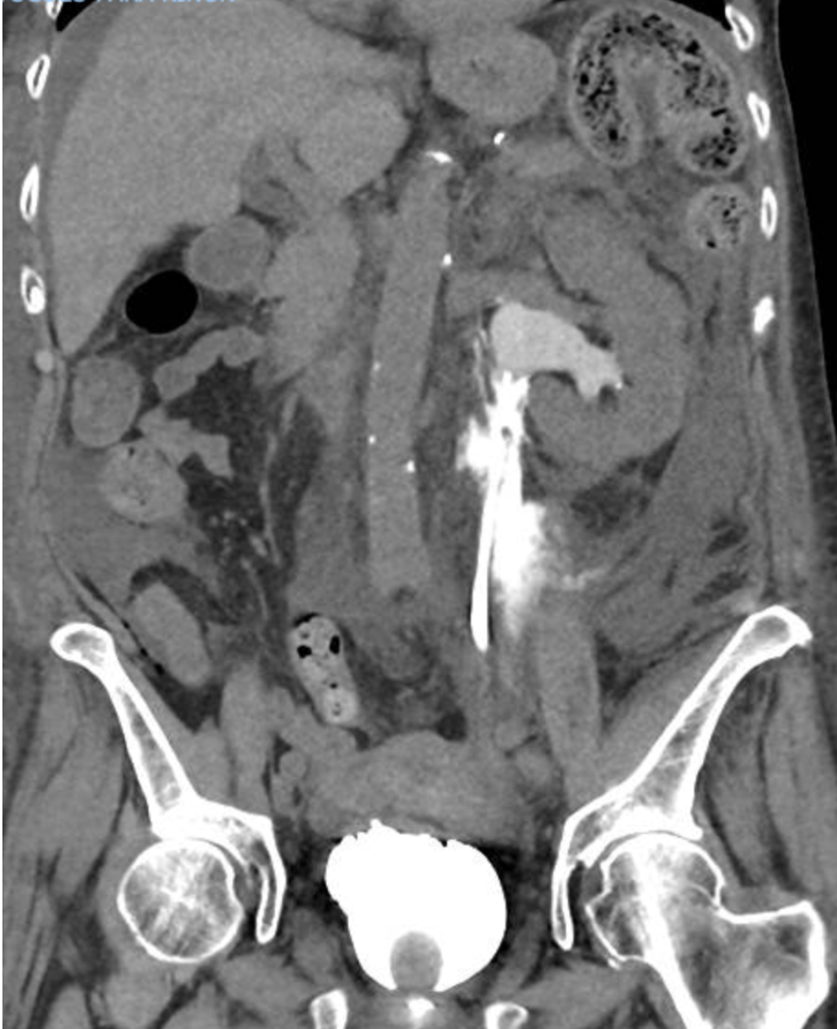
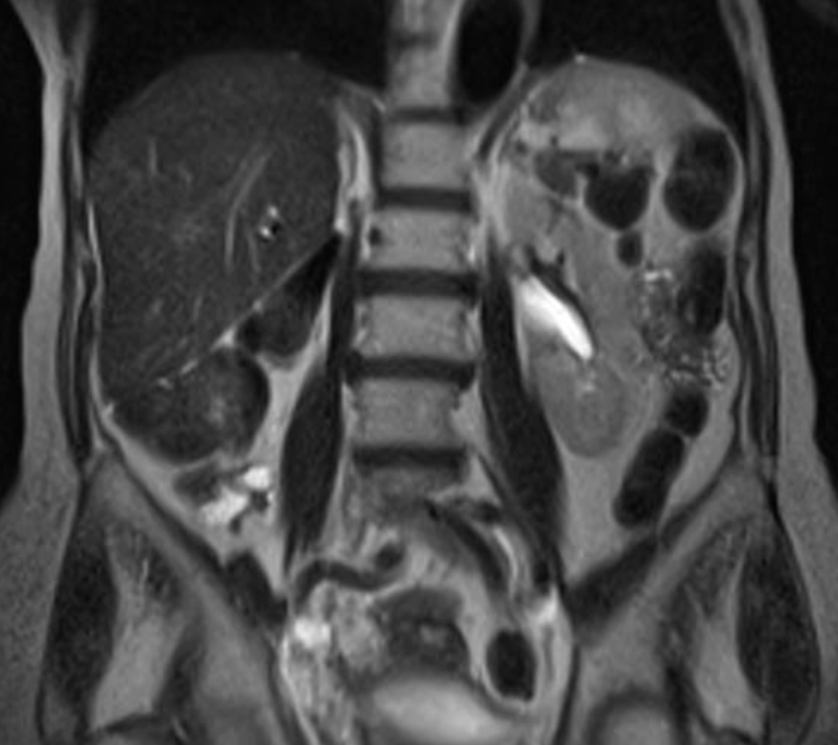
Fig. A.
Fig. B.
Figure A. First diagnostic contrast-enhanced CT of the abdomen and pelvis. The green arrow shows extraluminal contrast surrounding the left renal pelvis and the proximal left ureter. The blue arrow shows that there isn't any perivesical contrast, assuming that the bladder closure isn't compromised. Figure B. Contrast-enhanced CT of abdomen and pelvis 4 months later. No collection or urinoma is found in the study

- Yanaral F, Ozkan A, Cilesiz NC, Nuhoglu B. Spontaneous rupture of the renal pelvis due to obstruction of pelviureteric junction by renal stone: a case report and review of the literature. Urol Ann. 2017;3:293–295.
- Pampana E, Altobelli S, Morini M, Ricci A, D'Onofrio S, Simonetti G. Spontaneous ureteral rupture diagnosis and treatment. Case Rep Radiol. 2013;2013:851859.
- Blas L, Bonanno N, Mieggi M, Ringa M, Contreras P, Ameri CA. Factores de riesgo para extravasación de contraste en cólico renal [Risk factors for contrast extravasation in renal colic]. Arch Esp Urol. 2022 Apr;75(3):256-261.
- Chen GH, Hsiao PJ, Chang YH, Chen CC, Wu HC, Yang CR, Chen KL, Chou EC, Chen WC, Chang CH. Spontaneous ureteral rupture and review of the literature. Am J Emerg Med. 2014 Jul;32(7):772-4..
- You JS, Chung YE, Lee JY, Lee HJ, Chung TN, Park YS, Park I. The spontaneous rupture of the renal fornix caused by obstructive nephropathy. J Emerg Med. 2012 Sep;43(3):488-9.
- Al-Mujalhem AG, Aziz MS, Sultan MF, Al-Maghraby AM, Al-Shazly MA. Spontaneous forniceal rupture: Can it be treated conservatively? Urol Ann. 2017 Jan-Mar;9(1):41-44.
- Morgan TN, Bandari J, Shahait M, Averch T. Renal Forniceal Rupture: Is Conservative Management Safe? Urology. 2017 Nov;109:51-54.

