Case report: Torsion of a cryptorchidism testicle in a toddler
Faisal Ilyas, Maria Aslam, Shahid Ali, Muhamamd Irfan Nazir

INTRODUCTION
Cryptorchidism or undescended testis is the absence of one or both testes in normal position in scrotal pouch. It may be palpable or impalpable.[2,9]
While previous reports of testicular torsion on cryptorchidism advocate that this is an entity seen in patients with neuro-muscular disorders, torsion of an undescended testis can be seen in normal children. As the likelihood of rescuing a twisted testis associates strongly with the duration of torsion, it is important that the emergency medicine fraternity be aware of the presenting characteristics and imaging findings of testicular torsion. Up till now, there are only a few reports of torsion of the undescended testicle in normal children in the literature. In this paper, we present a case of testicular torsion of the undescended testes in an otherwise normal toddler and give a brief statement of the related literature to further highlight this urologic emergency.[1,3,10]
Testicular torsion results from twisting of testis which results in decrease blood flow to the affected testis. Testicular torsion is seen most frequently in the age group of 10 to 25 years. If not treated timely the blood supply to testis may be completely diminished which leads to ischemia, necrosis and death of testis. It is an emergency condition and instantaneous surgical repair can lead to testicular salvage. Testicular salvage rate is about 100 percent if surgery (untwisting of testis) is done within 6 hours, salvage rate drops to 20 percent if surgery is delayed for 24 hours.[1,3]
Testicular torsion is of two types it can be intravaginal or extravaginal. Extravaginal testicular torsion is seen most commonly in neonates. The attachment of tunica vaginalis to the scrotal wall is inadequate or in developing phase in the early infancy, it accounts for higher chances of bilateral torsion in this age group. With advancing age, while the tunica attachments become stronger, the incidence of this type of torsion reduces.[2,10]

Intravaginal torsion is mostly seen in older children and adults and the familiar anatomic abnormality responsible for it, is the bell clapper malformation. Usually the tunica vaginalis surrounds the testis all over except at the epididymis and the posterior scrotal wall. While in case of bell clapper anomaly, there is high investment of tunica vaginalis to testis permitting the rotation of spermatic cord within the sac and thus leading to intravaginal torsion of the testis. This abnormality is present bilaterally and thus justifies bilateral exploration and fixation of both testes even in cases of one sided testicular torsion.[1,2,9]

CASE REPORT
A 2-year-old toddler with known history of bilateral cryptorchidism presented to our emergency department at Shalamar Hospital with fussiness, right groin swelling, pain, and decrease movement of right leg. He was a full term otherwise healthy baby. Prior to the current presentation, he had been evaluated at an outside hospital for pain in right inguinal region, vomiting, fussiness and low-grade fever and had been discharged home on oral antibiotics and pain killers. He continued to do poorly and the parents noticed decreased movement in his right leg, so they brought him to our department at Shalamar Hospital for reevaluation. Examination revealed an extremely tender, edematous, indurated and erythematous area along his right inguinal canal and no palpable bilateral testicles in scrotum. Scrotum was poorly developed.
An ultrasound examination of inguinoscrotal region demonstrated the empty scrotal sac. The right testis was seen in the right inguinal canal measuring 15×12×8 mm with the volume of 0.7 ml. This shows paratesticular heterogenicity as well with a possible early mass like morphology.
Undescended left testis was seen in the left inguinal canal measuring 12×10×6 mm with the volume of 0.4 ml, without any paratesticular mass formation or epidydimal enlargement.
Suspicion of right testicular tumor was made and testicular tumor markers were sent. Emergency right inguinal exploration was done at the department of Urology, Shalamar Hospital (Fig 1 & 2). Right testis was firmly adherent with the surrounding tissues in inguinal canal on right side. Intraoperatively a necrotic right testis with torsion of spermatic cord was found. The patient underwent right orchiectomy and left sided orchidopexy.

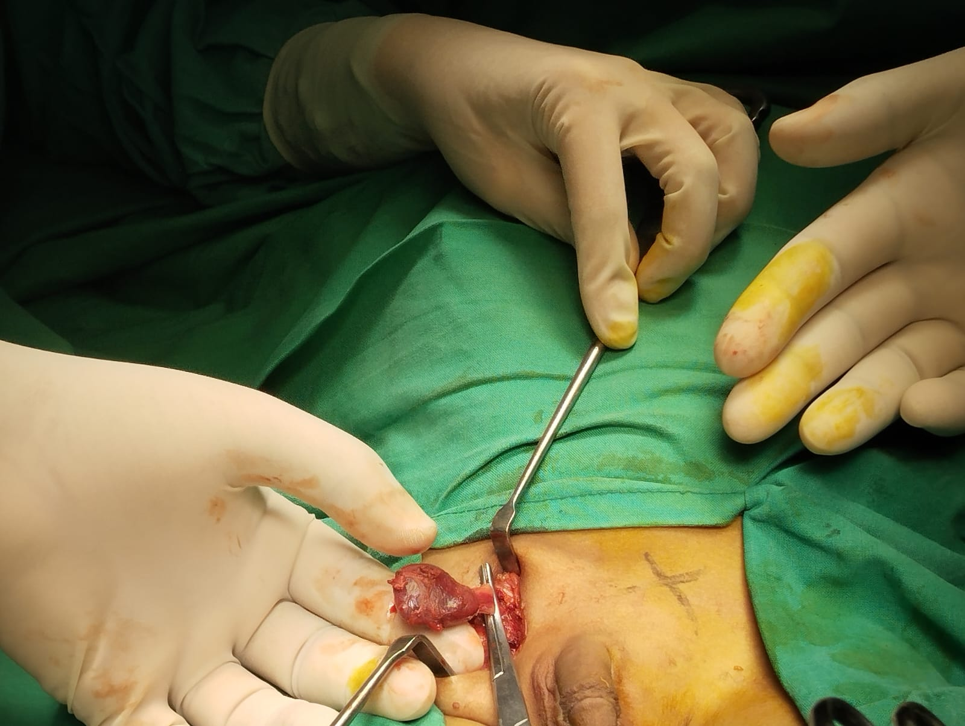
Fig 1.
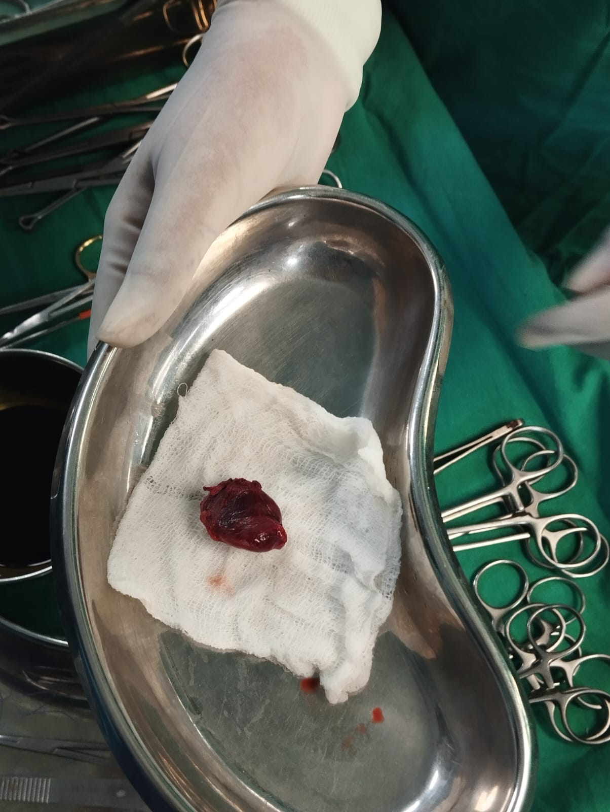
Fig 2.

DISCUSSION
Cryptorchidism or undescended testis (a testis that is not present in the scrotum) is the most common genitourinary disease in male neonates. Normal testicular descent to the scrotum commonly occurs between 25 and 35 weeks of intrauterine life. At birth the rate of diagnosis of undescended testis is 1-4% in term infants and up to 45% in preterm infants. Most cases of undescended testes descend voluntarily to the scrotum by 3 months of age. Testicular descent after 3 months of age is also feasible. In some preterm infants, the testes do not descend until term age or disappear in abdomen. In few cases, testis that was present in the scrotum re ascends after birth. The process of normal testicular descent, testicular re ascent and testicular relapse has not been fully known yet. About 1-2% boys older than 6 months of age develop undescended testis after its initial postnatal descent. Undescended testis is known to be associated with increase malignancy rates and decrease fertility. Prompt referral to urology department and timely surgical amendment may improve fertility rates and decrease malignancy rates associated with undescended testis [3,7,10].
Testicular torsion is a widely known urologic emergency in the pediatric population. It can be divided into two types based on the mechanism of occurrence: “intravaginal” and “extravaginal.” About 90% of torsion cases are categorized as intravaginal, suggesting that the torsion occurred within the tunica vaginalis. This frequently occurs in the setting of bell clapper deformity in which, instead of the tunica vaginalis reflecting off the epididymis, it covers the epididymis and spermatic cord so that the testis hangs freely in the scrotum and permitting their free mobility. In older children and adults intravaginal torsion is mostly seen. Extravaginal torsion is commonly seen in neonates and indicates the twisting of the spermatic cord external to the tunica vaginalis [1,2,10].
Impalpable testis and an inguinal mass on ipsilateral side are the classic presentations and must raise a suspicion of torsion of an undescended testis. Urgent Doppler ultrasound may lead to the correct and prompt diagnosis in most of the cases: the affected testis is swollen, may present heterogeneous and lack of signals on doppler ultrasound. The twisted spermatic vessels may shows whirl-sign on doppler. Though differentiating undescended testicular torsion from incarcerated hernia can be challenging and misdiagnosis may occur: in both cases immediate surgical exploration via inguinal approach is necessary [6].
The “golden window of opportunity” to rescue testicular function after the symptoms has started is suggested to be 4 to 8 hours, as not step in within this time decreases testicular function and increases the rate of testis removal (orchiectomy). A retrospective data involving 558 children from Croatia indicated the importance of early presentation and surgical correction within 6 hours was associated with a testicular salvage rate of 90-100%, whereas children arriving 6 to 12 hours and 12 to 24 hours after symptoms onset had 20-50% and 0-10% salvage rates respectively. However, early presentation is a well-documented and crucial step to increasing rates of testicular preservation [1,3,4].
In our opinion the above case a key learning point for many reasons. First of all, the intraoperative findings, the scrotal examination and the absence of the bilateral testes indicate that the diagnosis of undescended testes had eluded routine clinical examination for years. If the diagnosis had been carried out earlier, the testis could have been reinstated to the scrotal position and this presentation may have been avoided. The above highlights the importance of clinical perception for the clinicians (e.g. pediatricians and general practitioners) who usually perform routine examinations during early years and most important the education of patients and their guardians. Unluckily, lack of apprehension by healthcare professionals and patients has been noted to be associated with delayed presentation and adverse results. Over and above that, the necessity of the clinical examination needs to be highlighted. The presence of pain and a mass in the groin region along with an empty scrotum should raise immediate suspicion of a suffering, undescended testis. Thorough physical examination contributes significantly to the early diagnosis of torsion [5].
CONCLUSION
Torsion of the undescended testis is a relatively rare entity in a normal child. However, as the likelihood of testicular preservation correlates strongly with the duration of torsion, it is advisable that all physicians, especially those seeing patients in the emergency setting, be aware of this emergency condition. Inguinal swelling with an ipsilateral empty scrotum should raise suspicion for torsion of an undescended testicle and further assessment with Doppler ultrasonography and urologic consultation should be performed.
In this particular case there was marked twisting of the right spermatic cord and testis was ischemic and necrosed. Testicular tumor markers were unremarkable. Right orchiectomy and left orchidopexy was done.
REFRENCES
- Sheref YM, Johnson MH, Traxel EJ, Khanna G. Case report: torsion of a cryptorchid testicle in an infant. Emergency radiology. 2011 Dec;18:487-9.
- Pal DK, Tiwari AK, Choudhury S. A rare case of simultaneous bilateral testicular torsion in inguinal canal: A case report. Journal of Pediatric and Adolescent Surgery. 2020;1(2):95-7.
- Komarowska MD, Pawelczyk A, Matuszczak E, Dębek W, Hermanowicz A. Is testicular torsion a real problem in pediatric patients with cryptorchidism?. Frontiers in Pediatrics. 2021 Jan 12;8:575741.
- Shunmugam M, Goldman RD. Testicular torsion in children. Canadian Family Physician. 2021 Sep 1;67(9):669-71.
- Reed B, Banerjee R, Tsampoukas G, Gray R. Testicular torsion in an undescended testicle: chasing a diagnosis. Journal of Surgical Case Reports. 2022 Jun;2022(6):rjac263.
- Kargl S, Haid B. Torsion of an undescended testis—a surgical pediatric emergency. Journal of Pediatric Surgery. 2020 Apr 1;55(4):660-4.
- Shin J, Jeon GW. Comparison of diagnostic and treatment guidelines for undescended testis. Clinical and experimental pediatrics. 2020 Nov;63(11):415.
- Laher A, Ragavan S, Mehta P, Adam A. Testicular torsion in the emergency room: a review of detection and management strategies. Open Access Emergency Medicine. 2020 Oct 12:237-46.
- Cohen S, Gans W, Slaughenhoupt B. Acute scrotum: American Urological Association Guidelines. 2016. Available from: https://www.auanet.org/education/auauniversity/f or-medical-students/medical-students- curriculum/medical-student-curriculum/acute- scrotum. Updated May 18, 2021. Accessed on May 24, 2021.
- Jung YJ, Chung JM. Testicular torsion in the inguinal region in an extremely low birth weight infant. Korean Journal of Pediatrics. 2010 Sep;53(9):852.

