Case report

Retrograde Intra Renal Surgery (RIRS): The most minimally invasive Stone surgery, its safety and efficacy in patient with Sickle Cell Anaemia. A case report and review of literature for the optimal peri-operative management in Sickle cell patients

Jain R J¹, Dhameliya J¹, Brahmbhatt H¹

¹ Department of Urology and Renal Transplantation, GCS Medical College and Research Centre, Asarwa, Ahmedabad, India.

Coresponding author: Jain R J

Mailing Address: Department of Urology and Renal Transplantation, GCS Medical College and Research Centre, Asarwa, Ahmedabad, India.

Email: ravijainy2k@gmail.com

Abstract
Sickle Cell Anaemia (SCA) is a genetic haematological disorder, characterised by repeated haemolytic and vaso-occlusive episodes. Surgical procedures in such patients carry the risk of bleeding and coagulation related problems. Kidney stone is a common health problem in India. The optimal management depends on various stone related factors (stone burden, location, hardness, degree of hydronephrosis) and patient related factors. Kidney stone surgery in patients with bleeding disorders can be challenging. Extra Corporeal Shock Wave Lithotripsy (ESWL) and Percutaneous Nephrolithotomy (PCNL) are minimally invasive procedures. Yet, they pose the risk of bleeding and are relatively contra-indicated in patients with bleeding disorders. Retrograde Intra Renal Surgery (RIRS) is the most minimally invasive modality for upper tract calculi due to the least risk of bleeding. Since there is no puncture in the kidney, it is relatively safe in patients with bleeding disorders, cardiac patients on anti-platelets, recurrent stone formers, solitary kidneys and stones in anatomically abnormal kidneys.
Our patient presented with 13 x 12 mm upper ureteric calculus with hydronephrosis. During pre-operative work up, he was diagnosed with SCA. We could achieve complete stone clearance with the help of RIRS. No post-operative complication such as bleeding, urosepsis, sickling crisis, renal infarction etc. was noted. The patient was discharged within 48 hours and is doing well. Till date, there is no reported case of RIRS for renal stone management in Sickle Cell Anaemia patients. We aim to report this case and review the literature for the ideal peri-operative management of Sickle cell anaemia patients.

Introduction
Sickle Cell Disease (SCD) is the most common genetically inherited haematological disorder. Sickle Cell Anaemia (SCA) represents the most severe form of SCD due to its renal manifestations. It is characterised by the mutant sickle β-globin resulting from replacement of valine for glutamic acid at sixth amino acid position. Sickle Cell Haemoglobin (HbS) polymerizes when the concentration of its deoxygenated form (deoxyHbS) exceeds resulting in vaso-occlusive crisis and repeated haemolytic episodes.¹ Sickling of Red Blood Cells (RBC) can cause clumping and early destruction of RBC. Sickle Cell Nephropathy can cause myriad of complications such as haematuria, proteinuria, renal papillary necrosis, renal tubular disorders, acute and chronic kidney injury, sickle cell glomerulopathy, renal medullary carcinoma etc. ^{2,3}
Kidney stones is a common global urological problem, especially in India. Various modalities exist for the optimal management of upper tract calculi such as Extra Corporeal Shock Wave Lithotripsy (ESWL), Percutaneous Nephrolithotomy (PCNL), Mini PCNL (MPCNL) and Retrograde Intra Renal Surgery (RIRS). Kidneys receive almost 25% of the cardiac output (1.1 Liter/minute). Hence, any puncture in the kidney can carry risk of bleeding requiring major blood transfusion (0-20%, mean 7%).⁴ Unlike PCNL and ESWL, RIRS is a completely endoscopic procedure where there is no cut on the body or puncture on the kidney. The procedure involves passing a flexible ureteroscope straight from the urethra till the Pelvi Calyceal System (PCS) in the kidney. Following this, the stone in the kidney is fragmented or dusted with the help of laser. A Double J stent (DJ stent) is deployed at the end of procedure which is removed after 2-4 weeks. The existing literature shows that RIRS has the least risk of bleeding as compared to MPCNL. ^{5,6,7,8} Bleeding, dehydration, hypoxia etc. can trigger the sickling crisis and need to be avoided in SCA patients. ^{9,10, 11} RIRS is considered to be the safest modality for patients with bleeding disorders, patients on anti-platelets, solitary kidney, anatomically abnormal kidney and recurrent stone formers.⁵⁻⁷ Most of the complications of RIRS are of lower Clavien grade and major complications are uncommon. ¹² Till date, RIRS for stone management in SCA patient is not reported in literature.
Case history
A 45-year-old gentleman presented with right flank pain, haematuria and dysuria for 2 months. On evaluation, he was found to have an impacted and hard 15x13 mm upper ureteric stone (Hounsfield value 1400 HU), just distal to the Pelvi-Ureter Junction (PUJ). His blood investigations revealed anaemia with Haemoglobin 7gm/dL. Rest investigations were normal. Urine culture was sterile. Haematologist opinion was taken and on Haemoglobin electrophoresis, he was diagnosed with Sickle Cell Anaemia (Image 1). Under expert Haematologist guidance, the patient was transfused with 1 unit of Packed Cell Volume (PCV) and the patient was pre-stented. 2 weeks later, pre-operative Hb was 9 gm/dL and he was planned for RIRS.
During RIRS, despite pre-stenting, it was extremely difficult to reach up to the upper ureteric stone. With the help of two glide wires, initially semirigid ureteroscope (6.5/8Fr) followed by disposable digital ureteroscope (7.5 Fr) was negotiated till the level of upper ureteric stone. (Image 2a). Thulium Fiber Laser (IPGTM 35 Watt) was used. Initially, upper ureteric stone was fragmented using laser settings of 0.8-1.0 Joules and frequency of 10-15 Hertz. The stone was fragmented from centre to periphery safeguarding the ureteric mucosa. Gentle hand-held irrigation with 100 cm extension tube is used. Once the stone got dis-impacted, it got pushed into the Pelvicalyceal system (PCS). Now, Ureteric Access sheath (10/12 Fr, 35 cm) was deployed up to the upper ureter. Disposable limited use digital ureteroscope (Seeshen TM) was used for RIRS. The stone was completely dusted into fine golden dust (Image 2b). Intra renal laser settings were 1.0-1.2 Joules and 30-35 Hertz for dusting. At the end, popcorn settings of 0.05-0.1 Joule and 200 Hertz was used. Complete on-table stone clearance was observed. Post procedure contrast study in the form of Retrograde Pyelography was normal. DJ stent (5Fr/26 cm) was placed as routine. The total ureteroscopy time was 40 minutes. No complication in the form of sepsis or bleeding was noted. Stent removal was done after 2 weeks.
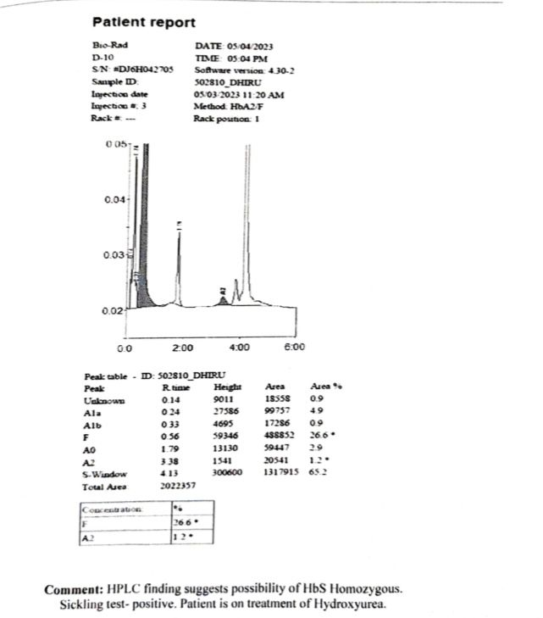
Figure 1

Figure 2a
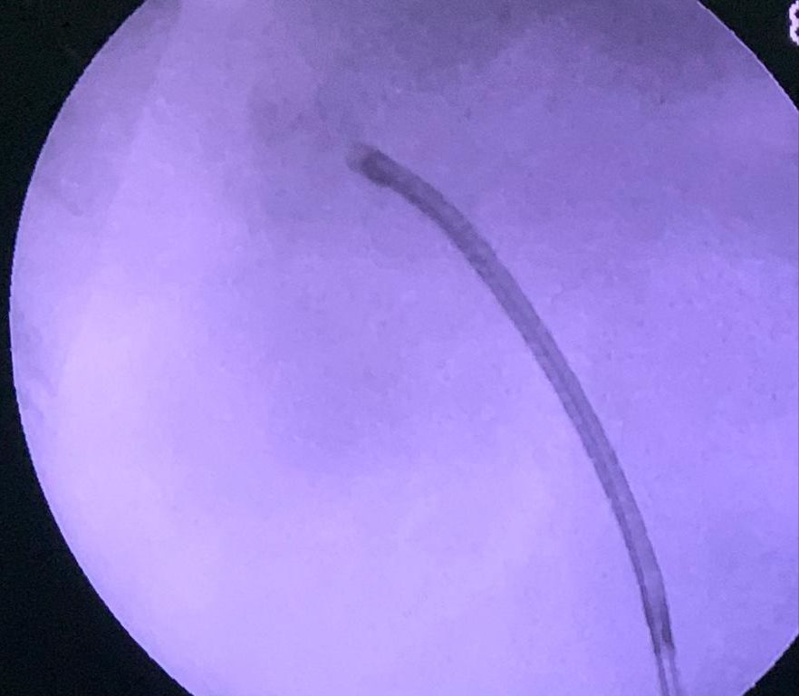
Figure 2b

Discussion
The normal adult haemoglobin, Haemoglobin A (HbA), is formed by two α and two β globin chains (αβ), located on chromosomes 16 and 11. The sickle Haemoglobin mutation (Hb S) results from the substitution of valine for glutamic acid in the 6th position of the β globin chain.¹ The resulting HbS polymerises in response to stress, dehydration, hypothermia, hypovolemia, acidosis etc. and causes sickling of RBC and early destruction. SCD is characterised by recurrent vaso-occlusion. ^{2, 3}
Surgery in SCA patients can be challenging due to the high risk of complications. SCA patients carry high risk of per-operative mortality, acute chest syndrome, congestive cardiac failure, sepsis etc.⁹ Surgical management of SCA patients requires a multi-disciplinary team management involving the Urologist, Haematologist, Pathologist and nursing staff. Pre-operative anaemia is crucial for any surgery. There are various schools of thought for pre-operative blood transfusion in SCA patients undergoing surgery. The Cooperative Study of Sickle Cell Disease performed the largest cohort study of surgery in SCD patients. They concluded beneficial effects of preoperative transfusion in Hb SC patients for all surgical procedures. ^{9,10} However, few studies refute the role of pre-operative transfusion. It is important to avoid the triggering factors for sickle cell crisis such as dehydration, hypoxia, hypovolemia, hypothermia, stress, infection, vascular stasis and increased blood viscosity. ⁹⁻¹¹
Renal stone disease is a common global urological problem. Mini PCNL and RIRS are currently the mainstay of management of upper tract calculi. As per the European Association of Urology (EAU) guidelines, RIRS is the first line modality for non-lower pole renal stones up to 20 mm.¹² RIRS scores over MPCNL in terms of safety due to lesser risk of bleeding, pain and hospital stay. The risk of bleeding requiring blood transfusion after PCNL can be up to 20% (mean 7%) whereas with RIRS, it’s negligible.^{4-8, 13} RIRS is equally efficacious in terms of stone clearance for 1.5-2 cm upper tract calculi. Newer lasers such as Thulium Fiber Laser are proving as game changer for RIRS. With TFL laser, there has been significant improvement in stone clearance, decreased operative time and larger stone burdens can be successfully dealt with RIRS. ¹⁴ Hence, RIRS is the modality of choice in high-risk patients such as bleeding disorders with excellent outcomes and minimal morbidity.
Conclusion
RIRS is safe, effective and minimally invasive modality for upper tract calculi management. It is the procedure of choice in patients with haematological disorders such as SCA. Adequate peri-operative management of these patients is required to prevent major complications.

References
- Hebbel RP. Beyond hemoglobin polymerization: the red blood cell membrane and sickle disease pathophysiology. Blood. 1991;77:214–237.
- Aeddula NR, Bardhan M, Baradhi KM. Sickle Cell Nephropathy. [Updated 2022 Sep 12]. In: StatPearls [Internet]. Treasure Island (FL): StatPearls Publishing; 2023 Jan-. Available from: https://www.ncbi.nlm.nih.gov/books/NBK526017/
- Kassim AA, DeBaun MR. Sickle cell disease, vasculopathy, and therapeutics. Annual Review of Medicine. 2013;64:451–466
- Zumrutbas AE, Toktas C, Baser A, Tuncay OL. Percutaneous Nephrolithotomy in Rare Bleeding Disorders: A Case Report and Review of the Literature. J Endourol Case Rep. 2016 Nov 1;2(1):198-203.
- Akgül M, Çakır H, Çinar Ö, Özman O, Başataç C, Sıddıkoğlu D, Doğan Ç, Başeskioğlu AB, Yazıcı CM, Sancak E, Akpınar H, Önal B. The Efficacy and Safety of Retrograde Intrarenal Surgery: A Multi-Center Experience of the RIRSearch Group Study. J Urol Surg 2023;10:119-128.
- Binbin Jiao, Zhenkai Luo, Xin Xu, Meng Zhang, Guan Zhang. Minimally invasive percutaneous nephrolithotomy versus retrograde intrarenal surgery in surgical management of upper urinary stones - A systematic review with meta-analysis, International Journal of Surgery, Volume 71, 2019, Pages 1-11, ISSN 1743-9191.
- Lai D, Chen M, He Y, Li X, Wan S. Safety and efficacy of retrograde intrarenal surgery for the treatment of renal stone in solitary kidney patients. Ren Fail. 2018 Nov;40(1):390-394.
- Kallidonis P, Panagopoulos V, Kyriazis I, et al. Complications of percutaneous nephrolithotomy: Classification, management, and prevention. Curr Opin Urol 2016;26:88–94.
- Vichinsky EP, Neumayr LD, Haberkern C, et al. The perioperative complication rate of orthopedic surgery in sickle cell disease: report of the National Sickle Cell Surgery Study Group. American Journal of Hematology. 1999;62(3):129–138.
- Koshy M, Weiner SJ, Miller ST, et al. Surgery and anesthesia in sickle cell disease. Cooperative Study of Sickle Cell Diseases. Blood. 1995;86(10):3676–3684.
- Adjepong KO, Otegbeye F, Adjepong YA. Perioperative Management of Sickle Cell Disease. Mediterr J Hematol Infect Dis. 2018 May 1;10(1):e2018032.
- EAU Guidelines. Edn. Presented at the EAU Annual Congress Milan 2023. ISBN 978-94-92671-19-6.
- Parikh KP, Jain RJ, Kandarp AP. Is retrograde intrarenal surgery the game changer in the management of upper tract calculi? A single-center single-surgeon experience of 131 cases. Urol Ann. 2018 Jan-Mar;10(1):29-34.
- Traxer O, Corrales, M. Managing Urolithiasis with Thulium Fiber Laser: Updated Real-Life Results—A Systematic Review. J. Clin. Med. 2021, 10, 3390.

